
Republic of Iraq
Ministry of Higher Education and Scientific Research
University of Al-Qadisiyah / College of Science
Department of Ecology
Fluorometric detection of same bianalytes in human urine

A Thesis
Submitted to the Council of the College of Science, University of Al-Qadisiyah, in Partial Fulfilment of the Requirements for the Degree of Master of Science in Ecology
BY
Alkawther Hatif Odah
B.Sc. in Ecology
College of Environmental Sciences, Al-Qasim Green University, 2023
Supervised by
Prof. Dr. Hazem Abd Wali
Prof. Dr. Bassam Faroun Abd

بسم الله الرحمن الرحيم

﴿يَرْفَعِ اللَّهُ الَّذِينَ آمَنُوا مِنكُمْ وَالَّذِينَ أُوتُوا الْعِلْمَ دَرَجَاتٍ وَاللَّهُ بِمَا تَعْمَلُونَ خَبِيرٌ﴾

صدق الله العظيم
سورة المجادلة (الآية 11)

Dedication
I would like to dedicate this thesis to the most important people in my life: To my beloved parents, whose unwavering love, support, and guidance have been the foundation of all my achievements. Your sacrifices, encouragement, and belief in me have been my constant source of strength.
To my dear husband, whose patience, understanding, and companionship have been invaluable. Thank you for being my rock and for supporting me through this journey with love and care. To my in-laws, for their continuous support and kindness, which have played a significant role in my personal and academic growth. To my precious siblings and my dear sister, whose love, laughter, and encouragement have made this journey even more special. You have been my constant companions in both good and challenging times. To my esteemed supervisors, whose knowledge, expertise, and mentorship have been instrumental in shaping this research. Your invaluable insights and constructive feedback have contributed greatly to the completion of this work. Finally, to my friends, who have been there for me in both moments of joy and challenge. Your encouragement, companionship, and positivity have made this journey more meaningful. With all my gratitude and love, this work is for all of you.
Alkawther Hatif Alseedy
Acknowledgments
Praise be to Allah, Lord of the Worlds, whose grace and blessings made this study possible. With His guidance and support, this achievement has come to fruition. I express my deep gratitude to Allah for His countless blessings, and for making this accomplishment a reality. I would like to extend my heartfelt thanks and appreciation to: Professor Dr. Hazem Abd Wali, for his unwavering support, insightful guidance, and constant encouragement throughout this research. His valuable feedback and suggestions have played a significant role in shaping this work. Professor Dr. Bassam Faroun, for his exceptional supervision, dedication, and continual support. His expertise and advice have been crucial in completing this thesis, and I am deeply grateful for his guidance. I would also like to express my sincere thanks to the Department of Environmental Science and Chemistry for providing an enriching and supportive academic environment. I appreciate all the resources and assistance offered, which contributed greatly to the success of this research. A special thank you to my dear family, who have been my constant source of support and strength. To my parents, whose love, sacrifices, and belief in me have been immeasurable, and to my siblings, whose presence and encouragement have always been a source of comfort and motivation.
Summary
This study aimed to prepare tannic-acid-coated iron oxide nanoparticles and evaluate their use as a fluorescence-assisted interface for ibuprofen detection in aqueous solution and fortified human urine. The experimental work was carried out during 2025 in the Analytical Chemistry Branch, Department of Chemistry, College of Science, University of Al-Qadisiyah. Ibuprofen was selected as a model pharmaceutical because of its widespread use, documented occurrence in wastewater, and relevance to environmental and bioanalytical monitoring.
Commercial iron oxide nanopowder (Fe3O4) was dispersed in deionized water, sonicated, coated with tannic acid under continuous mixing, washed, and dried at 50 °C. The prepared material was characterized in the unified sequence FESEM, XRD, AFM, and FTIR. FESEM showed quasi-spherical primary particles with an image-based size range of approximately 20–80 nm within larger agglomerates. AFM showed heterogeneous nanoscale topography with a maximum height of approximately 24.69 nm in the selected scan. XRD showed a broad low-intensity diffraction profile, whereas FTIR bands at 3430.92, 1631.39, 1061.87, and 635.43 cm⁻¹ provided the principal chemical evidence for tannic-acid-related surface functionalization together with the Fe–O framework.
A 1 mg/mL ibuprofen stock solution was used to prepare ordered working levels in distilled water and fortified urine. Equal volumes of prepared sample and coated nanoparticle suspension were mixed before fluorescence measurement using a Shimadzu RF-5301PC spectrofluorometer. An excitation maximum near 224 nm was selected. The principal responsive emission region was approximately 290–295 nm in water and 290–300 nm in fortified urine, with a secondary band near 365–375 nm. The aqueous fitted relationship was y = 17.495x + 74.944 (R² = 0.944), while the fortified-urine relationship was y = 16.898x + 53.008 (R² = 0.9765).
The results demonstrate a consistent fluorescence response across the tested preparation levels and show that the response remained measurable after transfer from water to a complex urinary matrix. The combined FESEM, XRD, AFM, and FTIR evidence supports formation of a tannic-acid-modified iron-based nanosystem, with FTIR providing the strongest direct chemical evidence of surface functionalization. The work establishes a laboratory platform suitable for further analytical development and for future environmental applications involving pharmaceutical monitoring in wastewater and other water matrices.

TABLE OF CONTENTS
.No | Contents | .Page No
 | Summary | 6
 | List of Tables | 11
 | List of Figures | 12
 | List of Abbreviations | 13
CHAPTER ONE – INTRODUCTION
1.0 | Introduction | 15
1.1 | Background and Scientific Context | 16
1.2 | Research Problem and Rationale of the Study | 22
1.3 | Aim of the Study | 24
CHAPTER TWO – LITERATURE REVIEW
2.1 | Environmental Pollution, Pharmaceutical Residues, and the Analytical Context of the Study | 30
2.1.1 | Sources and Environmental Pathways of Pharmaceutical Residues | 30
2.1.2 | Environmental Relevance of Ibuprofen | 31
2.1.3 | From Environmental Contamination to Human Biomonitoring | 32
2.1.4 | Analytical Requirements for Pollution-Related Bioanalysis | 33
2.1.5 | Link with the Experimental Design of the Present Study | 34
2.2 | Urine as a Bioanalytical Matrix | 34
2.2.1 | Urine in Human Biomonitoring and Environmental Bioanalysis | 36
2.2.2 | Classification of Urinary Bioanalytes | 36
2.2.3 | Pre-analytical Variation and Urine Normalization | 38
2.3 | Fundamental Principles of Fluorescence | 39
2.3.1 | Instrumentation for Fluorescence Measurement | 41
2.3.2 | Sources of Nonlinearity and Spectral Distortion | 41
2.4 | Fluorescence Strategies in Urinary Bioanalysis | 43
2.4.1 | Criteria for Selecting a Fluorescence Strategy | 44
2.5 | Nanostructured Interfaces and Tannic-Acid-Coated Nano-Iron | 45
2.5.1 | Metal-Polyphenol Coordination at the Iron-Oxide Interface | 47
2.5.2 | Colloidal Stability, Aggregation, and Analytical Reproducibility | 48
2.6 | Ibuprofen as a Model Pharmaceutical Analyte | 49
2.7 | Analytical Factors Affecting Fluorescence Detection in Urine | 50
2.7.1 | Mechanistic Classification of Urine-Matrix Effects | 52
2.8 | Analytical Validation Requirements | 53
2.8.1 | Validation Decision Framework for the Proposed Method | 54
2.9 | Previous Studies and Critical Synthesis | 55
2.9.1 | Critical Comparison with Established Analytical Approaches | 58
2.10 | Research Gap and Relevance of the Present Study | 59
CHAPTER THREE – MATERIALS AND METHODS
3.1 | Experimental Design | 62
3.2 | Chemicals and Laboratory Equipment | 63
3.2.1 | Reagent and Instrument Traceability | 65
3.3 | Preparation of Tannic-Acid-Coated Nano-Iron | 66
3.4 | Characterization of the Prepared Nanoparticles | 67
3.4.1 | Field-Emission Scanning Electron Microscopy (FESEM) | 67
3.4.2 | X-Ray Diffraction (XRD) | 67
3.4.3 | Atomic Force Microscopy (AFM) | 68
3.4.4 | Fourier-Transform Infrared Spectroscopy (FTIR) | 68
3.5 | Preparation of Ibuprofen Solutions and Test Samples | 69
3.5.1 | Stock Solution | 69
3.5.2 | Aqueous Working Levels | 69
3.5.3 | Urine-Based Working Levels | 70
3.5.4 | Preparation of the Working Nanoparticle Suspension | 70
3.5.5 | Concentration Reconstruction and Mass-Balance Requirements | 71
3.6 | Fluorescence Spectroscopic Measurement | 72
3.7 | Calibration and Data Treatment | 73
3.7.1 | Prospective Statistical Treatment for a Validation Study | 74
3.8 | Quality Assurance and Methodological Safeguards | 75
3.8.1 | Proposed Quality-Control Architecture | 76
3.9 | Ethical and Biosafety Considerations | 78
CHAPTER FOUR – RESULTS AND DISCUSSION
4.1 | Overview of the Experimental Findings | 81
4.2 | Physicochemical Characterization of the Prepared Nanoparticles | 82
4.2.1 | Field-Emission Scanning Electron Microscopy (FESEM) | 82
4.2.2 | X-Ray Diffraction (XRD) | 83
4.2.3 | Atomic Force Microscopy (AFM) | 86
4.2.4 | Fourier-Transform Infrared Spectroscopy (FTIR) | 87
4.2.5 | Integrated Interpretation and Discussion of the Characterization Evidence | 88
4.3 | Fluorescence Response and Preliminary Calibration | 91
4.3.1 | Selection of the Excitation Wavelength | 91
4.3.2 | Aqueous-Matrix Emission Response | 92
4.3.3 | Preliminary Aqueous Response Relationship | 93
4.3.4 | Urine-Matrix Emission Response | 95
4.3.5 | Preliminary Urine Response Relationship | 97
4.3.6 | Direct Cross-Matrix Comparison | 99
4.3.7 | Interpretation of the Non-Monotonic High-Level Urine Response | 102
4.4 | Comparative Interpretation and Study Limitations | 103
4.4.1 | Evidence Hierarchy and Alternative Explanations | 104
4.5 | Alignment of the Current Evidence with Analytical Standards | 105
CHAPTER FIVE – CONCLUSIONS AND RECOMMENDATIONS
5.1 | Conclusions | 108
5.2 | Recommendations | 110
CHAPTER SIX – REFERENCES
LIST OF TABLES
.No | Tables | .Page No
2.1. | Major classes of urinary bioanalytes and their analytical relevance | 37
2.2. | Complementary characterization techniques and the limits of the evidence they provide | 49
2.3. | Selected previous studies and their relevance to the present thesis | 56
3.1. | Chemicals and materials used in the study | 64
3.2. | Principal laboratory equipment used in the study | 65
3.3. | Summary of sample preparation for fluorescence analysis | 70
4.1. | Integrated interpretation of the nanoparticle characterization results | 89
4.2. | Descriptive comparison of the aqueous and fortified-urine fluorescence results | 100
LIST OF FIGURES
.No | Figures | .Page No
1.1. | Conceptual progression from aqueous response testing to defensible urine-matrix evaluation. | 22
2.1. | Principal spectral, chemical, and colloidal pathways through which urine can modify a fluorescence response. | 53
3.1. | Experimental workflow and analytical decision sequence used in the present thesis. | 63
3.2. | Proposed control architecture for separating background, mechanistic, and analytical-performance contributions. | 77
4.1. | FESEM micrographs of tannic-acid-coated iron oxide nanoparticles at 5,000× to 150,000× magnification. | 83
4.2. | X-ray diffraction pattern of the prepared tannic-acid-coated iron-based nanoparticles. | 86
4.3. | Two- and three-dimensional AFM topography of the prepared coated nanoparticles. | 87
4.4. | FTIR spectrum and identified absorption bands of the prepared coated nanoparticles. | 88
4.5. | Excitation scan of the complete analyte-nanoparticle mixture, with maximum response near 224 nm. | 92
4.6. | Emission spectra of the aqueous ibuprofen preparation series at 224 nm excitation. | 93
4.7. | Preliminary fitted response relationship for the aqueous preparation series. | 94
4.8. | Emission spectra of the fortified urine preparation series at 224 nm excitation. | 97
4.9. | Descriptive comparison of the reported response slopes in water and fortified urine. | 101
4.10. | Descriptive comparison of the reported coefficients of determination. | 102
4.11. | Preliminary fitted response relationship for the fortified urine preparation series. | 103
List of Abbreviations
Abbreviation | Meaning
AFM | Atomic force microscopy
CDC | Centers for Disease Control and Prevention
CLSI | Clinical and Laboratory Standards Institute
DLS | Dynamic light scattering
Fe3O4 | Magnetite / iron oxide
FESEM | Field-emission scanning electron microscopy
FTIR | Fourier-transform infrared spectroscopy
HBM | Human biomonitoring
HPLC | High-performance liquid chromatography
ICH | International Council for Harmonisation
LC-MS/MS | Liquid chromatography-tandem mass spectrometry
LOD | Limit of detection
LOQ | Limit of quantification
NSAID | Non-steroidal anti-inflammatory drug
QC | Quality control
R² | Coefficient of determination
RFI | Relative fluorescence intensity
RSD | Relative standard deviation
SOP | Standard operating procedure
UV | Ultraviolet
WHO | World Health Organization
XRD | X-ray diffraction
TEM | Transmission electron microscopy
UV–Vis | Ultraviolet–visible spectroscopy

Chapter One
Introduction

Chapter One – Introduction
1.Introduction
Pharmaceutical residues increasingly enter wastewater and receiving waters through excretion, disposal, hospital discharge, and incomplete treatment. Ibuprofen is widely used and frequently reported in aquatic systems, making it an appropriate model for environmental and bioanalytical method development (aus der Beek et al., 2016; Wilkinson et al., 2022; Jan-Roblero & Cruz-Maya, 2023).
1.1 Background and Scientific Context
Fluorescence spectroscopy was selected because it is rapid, sensitive to the local chemical environment, and compatible with small sample volumes. It measures emitted light after excitation and is widely applied in spectrofluorometry, microscopy, flow cytometry, immunoassays, biosensors, and nanomaterial-assisted sensing. Signal intensity can be affected by pH, polarity, ionic strength, quenching, turbidity, and inner-filter effects (Lakowicz, 2006; Valeur & Berberan-Santos, 2012).
Iron oxide nanoparticles were selected because they provide a high surface-to-volume ratio, chemically active iron–oxygen surface groups, magnetic behavior that can facilitate separation, comparatively low material cost, and broad applicability in sensing and environmental remediation. Their principal limitations are aggregation, size-dependent reactivity, possible changes in colloidal stability, and the need to control surface chemistry. Coating the particles with tannic acid introduces multiple phenolic hydroxyl groups capable of coordination and hydrogen bonding, improves interfacial functionality, and provides a chemically richer surface for interaction with ibuprofen (Laurent et al., 2008; Mourdikoudis et al., 2018; Chaudhari et al., 2024).
1.2 Research Problem and Rationale of the Study
The research problem was whether the tannic-acid/iron-oxide nanosystem could produce an interpretable fluorescence response to ibuprofen and retain that response in a complex biological matrix. Distilled water establishes basic spectral behavior, whereas urine introduces salts, metabolites, endogenous fluorophores, variable pH, and other matrix effects. Fortified urine was used because a known amount of ibuprofen can be added under controlled conditions; authentic exposed urine differs because concentration, metabolism, dose, collection time, and physiology are not controlled.
The study is environmentally justified by direct Iraqi evidence. Mohammed et al. (2025) detected ibuprofen in all investigated influent and effluent wastewater samples from five treatment plants in Babylon Governorate, with influent concentrations of 10.45–1096 µg/L and effluent concentrations of 7.52–945 µg/L. International reviews likewise document ibuprofen in aquatic matrices and report cytotoxic, genotoxic, oxidative-stress, growth, reproductive, and behavioral effects in aquatic organisms at study-dependent concentrations (Jan-Roblero & Cruz-Maya, 2023).
The study is also consistent with the One Health concept, which recognizes the close interdependence of human, animal, and ecosystem health. Pharmaceutical residues illustrate this connection because human medicine use can generate wastewater contaminants that affect environmental systems and may subsequently influence exposure pathways. A method that links environmental monitoring with bioanalytical measurement therefore has value within an integrated One Health perspective (One Health High-Level Expert Panel, 2022).

1.3 Aim of the Study
The aim of this study was to prepare and characterize tannic-acid-coated iron oxide nanoparticles and evaluate them as a fluorescence-assisted platform for detecting ibuprofen in aqueous solution and fortified human urine.
The specific objectives were:
Objective 1: Prepare tannic-acid-coated iron oxide nanoparticles under controlled laboratory conditions.
Objective 2: Characterize the material in the sequence FESEM, XRD, AFM, and FTIR and relate the findings to surface modification.
Objective 3: Establish the excitation wavelength and principal fluorescence emission regions of the ibuprofen–nanoparticle system.
Objective 4: Compare fluorescence responses in distilled water and fortified human urine under comparable conditions.
Objective 5: Provide a basis for future environmental monitoring of pharmaceutical residues in wastewater and related waters.

Chapter Two
Literature Review

Chapter Two – Literature Review
2.1 Environmental Pollution, Pharmaceutical Residues, and the Analytical Context of the Study
Environmental pollution is not limited to visibly contaminated air, water, or soil. It also includes complex mixtures released in small quantities but often enough to sustain exposure in receiving environments. Among these mixtures, pharmaceutical residues are regarded as contaminants of emerging concern because their occurrence and effects have only recently received systematic attention. Their importance depends on biological activity, persistence, transformation, exposure frequency, and interaction with other stressors; detection alone does not establish immediate harm (Daughton & Ternes, 1999; Boxall et al., 2012).
2.1.1 Sources and Environmental Pathways of Pharmaceutical Residues
Pharmaceuticals reach the environment through connected routes. After administration, parent compounds and metabolites may be excreted and transported to municipal wastewater systems. Additional inputs arise from disposal of unused medicines, hospital and manufacturing discharges, veterinary use, and application of sewage sludge or wastewater to land. Source importance differs by compound and location, but human excretion and wastewater conveyance are central pathways for medicines used widely in the community (Daughton & Ternes, 1999; aus der Beek et al., 2016).
Conventional wastewater treatment was developed mainly to reduce solids, biodegradable organic matter, nutrients, and pathogens, so removal of individual pharmaceuticals is variable. A compound may be biodegraded, retained in sludge, transformed, or discharged in the final effluent. Performance changes with plant design, operating conditions, microbial activity, temperature, and compound properties. Monitoring should therefore consider the parent drug and relevant transformation products where evidence supports their inclusion (Boxall et al., 2012; aus der Beek et al., 2016).
International monitoring shows that pharmaceutical contamination is geographically widespread. A coordinated survey of rivers in many countries identified active pharmaceutical ingredients across diverse social, climatic, and wastewater-management settings. Concentrations and mixture profiles varied with medicine use, sanitation, waste management, and hydrology. This distribution supports analytical approaches suited to different resource settings, provided that limits on specificity and quantitative interpretation remain explicit (Wilkinson et al., 2022).

2.1.2 Environmental Relevance of Ibuprofen
A recent Iraqi study provides direct evidence for the environmental relevance of ibuprofen. Mohammed et al. (2025) monitored five wastewater treatment plants in Babylon Governorate from January to December 2024 and detected ibuprofen in all analyzed sewage samples. Reported influent concentrations were 10.45–1096 µg/L and effluent concentrations were 7.52–945 µg/L, demonstrating that appreciable amounts can remain after treatment. At the international level, ibuprofen has been reported in wastewater and surface water across many countries, commonly from ng/L to µg/L depending on matrix and location (Jan-Roblero & Cruz-Maya, 2023). In environmental waters, ibuprofen occurs mainly as dissolved parent drug and transformation/metabolic products; because it is a weak acid (pKa about 4.9), the ionized ibuprofen anion predominates at circumneutral pH, affecting mobility, sorption, and treatment behavior.
Ibuprofen is clinically safe when used appropriately, but high-dose or overdose exposure can produce gastrointestinal, renal, neurological, and metabolic toxicity; severe and fatal overdose is uncommon and usually involves very high doses or complicating factors. In aquatic organisms, chronic exposure has been associated with oxidative stress, tissue injury, altered growth, reproduction, and behavior. These clinical and ecotoxicological observations should not be equated with effects at ordinary environmental concentrations; they are included to explain why occurrence, fate, and exposure monitoring are important (Jan-Roblero & Cruz-Maya, 2023; Volans et al., 2003).
Ibuprofen is a non-steroidal anti-inflammatory drug used extensively for pain, fever, and inflammation. It undergoes metabolism and renal elimination, so urine contains drug-related metabolites together with a smaller proportion of unchanged compound. After discharge, ionization, biodegradation, sorption, dilution, and treatment conditions influence its environmental fate. These characteristics support its use as a model analyte, although fortified unchanged ibuprofen must be distinguished from the parent-metabolite mixtures encountered in authentic excretion and environmental monitoring (Davies, 1998; aus der Beek et al., 2016).
Aquatic organisms may experience repeated exposure to pharmaceutical mixtures over periods longer than acute toxicity tests. Non-steroidal anti-inflammatory drugs have been associated with biochemical, physiological, behavioral, and reproductive responses in non-target species, although effects differ among compounds, organisms, exposure levels, and designs. Risk assessment must compare environmental concentrations with appropriate effect data and should not infer ecological harm from detection alone (Fent et al.,

2.1.3 From Environmental Contamination to Human Biomonitoring
Fortified urine (also called spiked urine) is a urine matrix to which a known amount of an analyte is deliberately added during method development. Its purpose is to evaluate recovery, matrix influence, response behavior, and analytical performance under controlled conditions. It differs from authentic urine collected after real exposure or medication use, where the analyte concentration is unknown and the specimen may contain metabolites and conjugates formed in vivo. Thus, fortified urine is a controlled analytical model, whereas authentic urine represents biological exposure and metabolism.
Environmental monitoring and human biomonitoring answer related but different questions. Measurements in water, air, soil, food, or consumer products characterize external contamination and possible exposure sources. Human biomonitoring measures a chemical, metabolite, or response marker in a biological specimen and thus provides evidence that uptake has occurred. It integrates exposure from several routes, but it usually cannot identify the source without accompanying environmental, behavioral, and temporal information. This distinction is essential when a biological matrix is used in research framed by environmental pollution (WHO Regional Office for Europe, 2023).
Urine is widely used for chemicals that are eliminated rapidly or converted to water-soluble metabolites. Collection is non-invasive, repeat sampling is feasible, and sufficient volume can often be obtained for several analytical procedures. At the same time, a spot sample reflects recent exposure, renal handling, hydration, and the interval since the previous void. Concentrations may also be affected by age, diet, medication, disease, collection time, storage, and normalization method. These factors make urine informative but analytically demanding (Vorkamp et al., 2021; Bouatra et al., 2013).
The present work uses fortified urine rather than urine collected to assess population exposure. Fortification provides a controlled way to test whether a response observed in water remains measurable after introduction of proteins, salts, metabolites, endogenous fluorophores, and other matrix constituents. It does not reproduce absorption, metabolism, excretion, or the distribution of analytes in an exposed population. Accordingly, the experimental result should be interpreted as evidence about matrix compatibility and analytical feasibility, not as evidence of environmental exposure or body burden.
2.1.4 Analytical Requirements for Pollution-Related Bioanalysis
Pollution-related bioanalysis requires an explicit definition of the measurand. Quantifying unchanged ibuprofen is not equivalent to measuring a collective response from the drug, metabolites, endogenous fluorophores, or nanoparticle-associated species. Chromatography with mass spectrometric detection is commonly used when identity and individual metabolites must be resolved. Simpler optical methods may support screening, but their signals require blanks, interferents, matrix-matched standards, and reference-method comparison before chemical selectivity can be claimed (Tkalec et al., 2023; Piechocka et al., 2023).
Fluorescence measurements are influenced by the chemical environment as well as analyte concentration. pH and polarity can change ionization and excited-state behavior; absorbing compounds can attenuate excitation or emission; turbidity and particles can scatter light; and high absorbance can produce inner-filter effects. Urine introduces all of these possibilities simultaneously. A difference between water and urine may therefore reflect matrix-dependent optical or interfacial effects rather than a simple change in sensitivity (Lakowicz, 2006; Valeur & Berberan-Santos, 2012).
2.1.5 Link with the Experimental Design of the Present Study
One Health is an integrated approach that aims to balance and optimize the health of people, animals, and ecosystems. In this thesis, the concept is relevant because pharmaceutical use in humans can lead to drug residues in wastewater, environmental exposure of non-target organisms, and a need for analytical tools that connect environmental and biological monitoring (One Health High-Level Expert Panel, 2022).
The practical design of this thesis follows a staged analytical logic. Tannic-acid-coated iron oxide nanoparticles are prepared and characterized before use as a modifiable interfacial material in the optical experiments. Ibuprofen is then examined in distilled water, where matrix complexity is limited, before transfer to fortified urine under comparable conditions. This sequence helps separate a basic analyte-nanoparticle response from changes introduced by the biological matrix and provides a basis for identifying the controls required in later work (Laurent et al., 2008; Mourdikoudis et al., 2018).
The environmental relevance of the study lies in method development at the boundary between pharmaceutical contamination and internal-exposure assessment. A rapid fluorescence platform could eventually support preliminary screening where advanced instrumentation is not immediately available, but only after concentration traceability, selectivity, recovery, precision, detection capability, robustness, and agreement with a reference method have been demonstrated. The present experiments address the earlier question of whether an ordered response can be observed in water and retained in fortified urine. They do not quantify pharmaceutical pollution, establish environmental risk, or constitute a validated human biomonitoring method.
2.2 Urine as a Bioanalytical Matrix
Urine is a complex aqueous biological fluid produced through glomerular filtration, tubular reabsorption, and tubular secretion. It contains inorganic ions, urea, creatinine, organic acids, amino acids, low-molecular-weight metabolites, proteins, peptides, hormones, pharmaceuticals, and xenobiotic metabolites. Metabolomic resources demonstrate the extraordinary chemical diversity of this matrix, while biomonitoring literature shows its value for assessing internal exposure and biological status (Bouatra et al., 2013; Wishart et al., 2022).
The practical advantages of urine include non-invasive collection, the possibility of repeated sampling, and the availability of sufficient volume for multiple tests. These features support longitudinal biomonitoring, therapeutic monitoring, and the development of simplified analytical devices. The ease of collection does not eliminate the need for standardized timing, storage, and normalization, because pre-analytical variation can be larger than the analytical difference under investigation (Bernini et al., 2011; Vorkamp et al., 2021).
However, urinary concentrations are influenced by hydration and time since the previous void. A dilute urine sample may contain the same total excreted amount of an analyte as a concentrated sample but yield a lower measured concentration. In clinical and epidemiological studies, this variation may be addressed through standardized collection, specific-gravity adjustment, creatinine normalization, or timed urine sampling. In proof-of-concept spiking experiments, matrix consistency and identical preparation procedures remain essential even when population-level normalization is not undertaken.
Urine also presents optical challenges. Endogenous fluorophores may generate broad background emission, while salts and metabolites can alter pH, ionic strength, and molecular interactions. Turbidity or suspended particles can increase light scattering. These effects can shift emission maxima, change fluorescence intensity, or reduce the apparent sensitivity of the assay. Therefore, the analytical behavior observed in water must be re-examined in urine rather than transferred by assumption.
2.2.1 Urine in Human Biomonitoring and Environmental Bioanalysis
Human biomonitoring integrates exposure from multiple routes and sources, but a biological measurement does not identify the source by itself. Source attribution is strongest when urine data are combined with exposure questionnaires, product or environmental measurements, and analyte-specific toxicokinetic information. The present study does not perform population biomonitoring; it evaluates an analytical platform that could, after validation, contribute to such work (Vermeulen et al., 2020; Vorkamp et al., 2021).
Environmental bioanalysis also requires a clear distinction between a screening signal and a chemically identified biomarker. Broad fluorescence changes may be useful for preliminary profiling, whereas selective measurement of ibuprofen or another target requires matrix-matched standards, appropriate blanks, interference testing, and confirmatory analysis. This distinction is central to the scientific interpretation of the present results.
2.2.2 Classification of Urinary Bioanalytes
Urinary bioanalytes may be classified according to biological origin, molecular size, and analytical purpose. The classification is useful because each group has different concentration ranges, stability requirements, and detection challenges. Small endogenous metabolites may be naturally fluorescent or readily derivatized, whereas proteins and nucleic acids usually require selective probes or affinity-based recognition. Pharmaceutical compounds can be measured as unchanged drugs, metabolites, or conjugates, depending on their pharmacokinetic behavior and the objective of the analysis. (Bouatra et al., 2013; Wishart et al., 2022).
Table 2.1 Major classes of urinary bioanalytes and their analytical relevance
Bioanalyte class | Representative examples | Analytical relevance | Fluorescence consideration
Endogenous metabolites | Organic acids, amino acids, creatinine, vitamins | Metabolic profiling and assessment of physiological status | Some compounds exhibit intrinsic fluorescence; others require probes or derivatization.
Hormones and hormone metabolites | Steroid metabolites, catecholamine-related compounds | Endocrine and stress-related assessment | Often present at low levels and may require selective recognition.
Proteins and peptides | Albumin, small peptides, disease-associated proteins | Renal function and disease biomarker research | Usually detected with labelled probes, antibodies, or fluorescence assays.
Nucleic-acid-related markers | Cell-free DNA and RNA fragments | Non-invasive molecular diagnostics and monitoring | Requires highly selective dyes, probes, or amplification strategies.
Pharmaceuticals and xenobiotics | Ibuprofen, drug metabolites, environmental contaminants | Therapeutic monitoring, exposure assessment, and toxicology | Signal may be intrinsic, probe-mediated, or nanomaterial-assisted.
Inorganic constituents | Electrolytes and trace elements | Renal, nutritional, and exposure assessment | Usually measured indirectly through fluorescent chemosensors or other instrumental methods.
Source: Adapted from Bouatra et al. (2013), Wishart et al. (2022), and Lakowicz (2006).

2.2.3 Pre-analytical Variation and Urine Normalization
Pre-analytical variation can exceed the analytical difference being investigated. Delayed processing, exposure to room temperature, microbial growth, repeated freeze-thaw cycles, and inconsistent mixing may alter the matrix before it reaches the instrument. A method cannot recover information lost through uncontrolled collection or storage; these variables must therefore be documented as part of the analytical procedure rather than treated as administrative details (Bernini et al., 2011; Delanghe & Speeckaert, 2014).
Normalization is intended to separate changes in analyte excretion from changes in urinary dilution. Creatinine correction is widely used in biomonitoring, but it introduces biological variability related to muscle mass, age, diet, sex, and renal function. Specific gravity provides an alternative estimate of concentration, although it is influenced by all dissolved constituents. Timed collections estimate excretion over a defined interval but are more difficult to collect accurately (Barr et al., 2005; Waikar et al., 2010).
No single normalization strategy is universally correct. The choice must reflect the analyte, study population, renal handling, sampling design, and intended inference. For a laboratory fortification study using one matrix, strict consistency may be more important than normalization. For future multi-donor work, both raw and appropriately normalized values should be examined, and the selected correction should be justified prospectively.
The present thesis therefore distinguishes matrix standardization from biological normalization. Matrix standardization concerns use of the same urine pool, preparation volumes, storage history, and measurement timing. Biological normalization concerns comparison across specimens collected from different individuals or at different times. Only the first was relevant to the completed proof-of-concept experiment.
Urine-standardization options have different trade-offs. Fixed-volume spot samples are simple but strongly affected by hydration; creatinine correction is common but varies with muscle mass, diet, age, sex, and renal function; specific-gravity correction avoids dependence on creatinine production but is influenced by all dissolved constituents; timed collections can estimate excretion over a defined interval but are burdensome and vulnerable to incomplete collection; and pooled or standardized matrices improve consistency during method development but do not represent authentic interindividual diversity (Barr et al., 2005; Delanghe & Speeckaert, 2014).
2.3 Fundamental Principles of Fluorescence
Fluorescence is the emission of light by a molecule after absorption of electromagnetic energy and relaxation from an excited electronic state. The phenomenon is exploited in several analytical techniques, including steady-state spectrofluorometry, fluorescence microscopy, flow cytometry, fluorescence immunoassays, time-resolved fluorescence, fluorescence lifetime measurements, fluorescence resonance energy transfer (FRET), fluorescent biosensors, and nanomaterial-assisted sensing. These approaches differ in spatial resolution, selectivity, time resolution, and the type of molecular information obtained (Lakowicz, 2006; Valeur & Berberan-Santos, 2012).
Fluorescence is a radiative process in which a molecule absorbs energy at an excitation wavelength, undergoes rapid vibrational relaxation, and then emits light as it returns from an excited electronic state to the ground state. Because part of the absorbed energy is dissipated before emission, the emitted photon usually has lower energy and a longer wavelength than the excitation photon. The difference between excitation and emission maxima is commonly described as the Stokes shift.
An excitation spectrum identifies the wavelengths that most effectively generate fluorescence, whereas an emission spectrum shows the distribution of emitted intensity after excitation at a selected wavelength. Analytical method development therefore requires two related decisions: selection of an excitation wavelength that produces adequate signal and selection of an emission region that provides the greatest change with analyte level while minimizing background interference.
At sufficiently low concentrations and under stable experimental conditions, fluorescence intensity can increase approximately in proportion to analyte concentration. This relationship is the basis of calibration-based quantification. At higher concentrations, however, linearity may deteriorate because excitation light is absorbed before reaching the entire sample, emitted light is reabsorbed, molecules interact with one another, or quenching becomes important. These phenomena are collectively relevant to inner-filter and concentration-quenching effects and must be considered when interpreting calibration behavior.
Fluorescence intensity is influenced by quantum yield, solvent polarity, pH, temperature, dissolved oxygen, ionic strength, and molecular binding. In nanoparticle suspensions, particle-size distribution, sedimentation, and aggregation introduce additional variability through changes in surface accessibility and light scattering. Reliable comparison therefore requires consistent preparation, mixing, sonication, cuvette orientation, slit width, detector settings, and the interval between sample preparation and measurement (Kubista et al., 1994; Lakowicz, 2006; Valeur & Berberan-Santos, 2012).
2.3.1 Instrumentation for Fluorescence Measurement
A spectrofluorometer generally contains a light source, an excitation monochromator, a sample compartment, an emission monochromator, and a detector. Xenon lamps are widely used because they provide continuous ultraviolet-visible output. The monochromators isolate defined excitation and emission bands, while the detector converts emitted photons into an electrical signal reported as relative fluorescence intensity.
Instrument settings influence both signal magnitude and resolution. Wider slit widths increase the amount of light reaching the sample and detector but reduce spectral resolution. Narrower slits improve resolution but may produce a weaker signal. Scan speed, detector sensitivity, integration time, and cuvette material must also be controlled. Quartz cuvettes are required for ultraviolet measurements because ordinary glass absorbs strongly in the ultraviolet region.
2.3.2 Sources of Nonlinearity and Spectral Distortion
The proportional relationship between concentration and fluorescence intensity is conditional. At low absorbance, a larger number of emitting molecules can produce a larger signal. As absorbance increases, however, the excitation beam is attenuated before reaching the entire optical volume and emitted photons may be reabsorbed before reaching the detector. These primary and secondary inner-filter effects can produce curvature or even an apparent decline at the highest preparation level (Lakowicz, 2006; Kubista et al., 1994).
A commonly used approximate correction relates the observed fluorescence to absorbance at the excitation and emission wavelengths. The relation is useful only when absorbance is measured under matched conditions and the assumptions of the correction are reasonable. It cannot compensate for aggregation, scattering, chemical quenching, or a change in the fluorescent species.
F_corrected = F_observed × 10^[(A_excitation + A_emission)/2]
Dynamic quenching reduces fluorescence through collisions during the excited-state lifetime, whereas static quenching arises from formation of a non-fluorescent ground-state complex. The two mechanisms can produce similar changes in steady-state intensity but differ in their effect on fluorescence lifetime. Lifetime measurements, temperature studies, and Stern-Volmer analysis are therefore needed before a quenching mechanism can be assigned.
Nanoparticle suspensions introduce additional optical complications. Large aggregates can scatter both excitation and emission light, and sedimentation can change the effective particle concentration during the measurement sequence. A strong signal is not necessarily enhancement, and a weak signal is not necessarily quenching. Both outcomes must be interpreted against nanoparticle-only, analyte-only, coated/uncoated, and matrix blanks.
These principles are directly relevant to the urine series in this thesis. The slight inversion between the 1.00 and 2.00 mL preparations is consistent with several possible mechanisms, but the completed experiment cannot distinguish among them. The scientifically correct conclusion is that the highest level requires controlled reinvestigation, not that a particular mechanism has already been demonstrated.
2.4 Fluorescence Strategies in Urinary Bioanalysis
Fluorescence spectroscopy differs from UV–visible absorption spectroscopy in the measured signal. UV–Vis records the amount of incident light absorbed by a sample as a function of wavelength, whereas fluorescence records emitted light after excitation. Fluorescence can therefore provide higher sensitivity for fluorescent species, while UV–Vis is often more direct for assessing absorbance, spectral overlap, and inner-filter effects. In the present study the two techniques are complementary rather than interchangeable.
Fluorescence analysis of urinary compounds can be performed through direct or indirect strategies. Direct detection uses the intrinsic fluorescence of the analyte. This approach is experimentally simple and avoids a labelling reaction, but its selectivity may be limited when other urinary constituents emit in the same spectral region. Indirect detection introduces a fluorescent probe, derivatization reagent, recognition element, or nanostructured interface whose signal changes after interaction with the target.
Probe-assisted methods can provide greater selectivity when the probe is designed to recognize a particular functional group, ion, enzyme, nucleic-acid sequence, or molecular structure. The analytical response may appear as fluorescence enhancement, quenching, wavelength shift, or a ratio between two emission bands. Such probes transform a chemically selective interaction into an optical response, but their specificity must still be demonstrated under the intended matrix conditions (Lakowicz, 2006; Valeur & Berberan-Santos, 2012).
Nanomaterial-assisted fluorescence uses nanoparticles as emitters, quenchers, carriers, adsorbents, or signal-modifying interfaces. Quantum dots, carbon-based nanomaterials, metal nanoclusters, metal oxides, and hybrid materials have been investigated for pharmaceutical and biomarker analysis. Their high interfacial area may improve analyte interaction, but aggregation, scattering, and non-specific adsorption can compromise reproducibility. The analytical contribution of a nanomaterial must therefore be demonstrated by controlled experiments rather than inferred from nanoscale dimensions alone (Laurent et al., 2008; Mourdikoudis et al., 2018).
Chromatographic separation coupled with fluorescence or other detectors remains important when multiple compounds or metabolites must be distinguished. Separation reduces matrix interference and improves chemical specificity, but it requires more complex instrumentation and sample preparation. Piechocka et al. (2023), for example, demonstrated the relevance of chromatographic analysis for major ibuprofen metabolites and creatinine in human urine. Such methods provide a reference point against which simpler fluorescence platforms may eventually be compared.
2.4.1 Criteria for Selecting a Fluorescence Strategy
Selection of a fluorescence strategy should be driven by the analytical question rather than by instrument availability alone. Direct fluorescence is appropriate when the analyte has a sufficiently distinct spectrum and the matrix background is manageable. Probe-based or recognition-assisted methods are preferable when structural selectivity is essential. Separation methods remain necessary when several metabolites or co-administered drugs must be distinguished.
Nanomaterial-assisted fluorescence occupies an intermediate position. A nanostructured interface can increase local analyte concentration, change microenvironmental polarity, support energy transfer, or provide a quenching surface. These effects may improve the measurable response, but they do not create chemical specificity automatically. A surface coating that interacts with many carboxylates or aromatic molecules may remain analytically non-selective.
For the present thesis, the chosen system is best described as a signal-modifying interface evaluated in a proof-of-concept setting. The next methodological decision is whether the intended endpoint is broad screening or selective ibuprofen quantification. Selective quantification would require a recognition mechanism or chromatographic separation in addition to the current optical response.
Selection of an analytical strategy should follow the intended use. Direct intrinsic fluorescence offers rapid, low-reagent screening but weak selectivity in urine; derivatization or molecular probes can improve selectivity but require control of reaction yield, stability, and cross-reactivity; nanomaterial-assisted responses provide adaptable surface chemistry but are vulnerable to aggregation and non-specific adsorption; excitation-emission matrices or lifetime analysis can separate overlapping responses but require advanced instrumentation; and HPLC or LC-MS/MS remains the preferred reference when chemical identity and metabolites must be resolved (Lakowicz, 2006; Piechocka et al., 2023; ICH, 2023b).

2.5 Nanostructured Interfaces and Tannic-Acid-Coated Nano-Iron
A nanoparticle is generally a particle with at least one external dimension in the nanoscale, approximately 1–100 nm. At this scale, high surface-to-volume ratio and size-dependent physical and chemical properties can produce behavior different from bulk materials. Advantages of nanoparticles include large reactive surface area, tunable surface chemistry, high adsorption capacity, catalytic activity, and—in iron oxides—magnetic separation. Limitations include aggregation, variable colloidal stability, possible ecotoxicity, batch-to-batch variation, and the need for careful characterization. Applications extend across environmental remediation and water treatment, chemical and biological sensing, catalysis, drug delivery, imaging, magnetic separation, energy technologies, and antimicrobial systems (Laurent et al., 2008; Mourdikoudis et al., 2018; Chaudhari et al., 2024).
Iron oxide nanoparticles are attractive for analytical applications because they can be prepared at nanoscale dimensions and separated magnetically from liquid media. Their surfaces contain iron-oxygen groups that can interact with organic coatings and aqueous solutes. However, unmodified particles may aggregate because of magnetic and surface forces, decreasing the accessible area and producing unstable optical scattering. Surface modification is therefore commonly used to improve interfacial behavior.
Tannic acid is a polyphenolic compound containing multiple hydroxyl groups that can coordinate with iron-containing surfaces and participate in hydrogen bonding with aqueous solutes. Metal-polyphenol coordination and polyphenol-derived coatings have been widely used to modify surface chemistry and interfacial behavior (Quideau et al., 2011; Ejima et al., 2013; Sileika et al., 2013). In the present study, coating was expected to provide a more functional interface for ibuprofen interaction; its specific contribution to fluorescence cannot be established without comparison with uncoated particles.
Material characterization is essential because different analytical techniques answer different questions. FTIR can identify functional groups associated with the coating and the iron-oxygen framework. XRD provides information about crystallographic order and phase-related diffraction behavior. AFM measures surface topography and nanoscale height variation over a selected scan area. FESEM provides direct information about particle morphology and aggregation at high magnification. Consistency among these observations strengthens the interpretation that the intended coated nanomaterial was obtained.
The optical behavior of nanoparticle suspensions requires particular caution. A stronger measured signal may result from a genuine change in fluorescence yield, but it may also reflect altered adsorption, particle scattering, or background emission. Conversely, iron-containing materials can quench fluorescence under some conditions. The analytically relevant question is therefore not whether nanoparticles are universally enhancing, but whether the complete analyte-nanosystem mixture produces a stable, concentration-dependent, and matrix-tolerant response under defined conditions.
2.5.1 Metal-Polyphenol Coordination at the Iron-Oxide Interface
Iron oxides present hydroxylated surface sites in aqueous media. The charge and reactivity of these sites depend on phase, pH, ionic composition, and prior surface treatment. Polyphenols such as tannic acid contain multiple oxygen-donor groups capable of coordinating iron and forming extended interfacial networks. This chemistry has been used to construct metal-polyphenol films and multifunctional particle coatings (Cornell & Schwertmann, 2003; Ejima et al., 2013).
The coating can influence dispersion and adsorption in several ways. It may increase hydrophilicity, introduce additional hydrogen-bonding sites, alter surface charge, and provide aromatic domains capable of interacting with organic molecules. At the same time, bridging between particles can promote aggregation if one polyphenol molecule binds more than one surface. The outcome therefore depends on coating ratio, pH, ionic strength, mixing history, and washing efficiency.
FTIR evidence of phenolic, C-O, and Fe-O bands supports coexistence of organic and iron-based components, but it does not quantify surface coverage. Direct comparison with pure tannic acid and uncoated Fe3O4, together with thermogravimetric analysis or surface-sensitive spectroscopy, would provide stronger evidence. The current characterization should therefore be interpreted as consistent with modification rather than as complete structural proof.
2.5.2 Colloidal Stability, Aggregation, and Analytical Reproducibility
Nanoparticle aggregation is an analytical variable, not merely a morphological observation. Aggregation changes accessible surface area, sedimentation rate, effective concentration, and light scattering. Two samples with the same nominal particle mass can therefore produce different signals if their aggregate-size distributions differ (Gupta & Gupta, 2005; Hotze et al., 2010).
FESEM and AFM describe dried or surface-deposited material. They are valuable for morphology and topography, but they do not provide the hydrodynamic size of particles in the actual measurement suspension. Dynamic light scattering would estimate the intensity-weighted hydrodynamic distribution, while zeta potential would provide information related to electrostatic stability. Both measurements should be performed in water and in the urine matrix because salts and biomolecules may alter the colloidal state.
A reproducible procedure should specify particle mass concentration, sonication device, power or bath conditions, sonication time, mixing sequence, temperature, and delay before reading. Without these controls, differences attributed to analyte level may partly reflect time-dependent settling or variable dispersion. This issue is particularly important at 224 nm, where scattering contributions can be pronounced.
Table 2.2. Complementary characterization techniques and the limits of the evidence they provide
Technique | Primary information | Important limitation
FTIR | Chemical functional groups and bonding-related bands. | Does not quantify coating thickness or particle size.
XRD | Crystallographic phase and long-range order. | Broad or weak peaks may prevent reliable phase and crystallite-size analysis.
AFM | Surface topography and height over a selected deposited area. | Small field of view; deposited state may differ from suspension.
FESEM | Particle morphology and image-based primary-particle dimensions. | Requires dry/vacuum preparation; agglomerates may obscure primary particles.
DLS | Hydrodynamic size distribution in suspension. | Strongly weighted toward larger aggregates; requires controlled dilution.
Zeta potential | Electrokinetic indicator of dispersion stability. | Interpretation depends on medium composition, pH, and model assumptions.
BET surface area | Accessible gas-adsorption surface area and porosity. | Dry-state measurement does not directly describe aqueous accessibility.
Source: Synthesized from Laurent et al. (2008), Mourdikoudis et al. (2018), and Hotze et al. (2010).
2.6 Ibuprofen as a Model Pharmaceutical Analyte
Ibuprofen is a widely used non-steroidal anti-inflammatory drug. Its analytical determination is relevant to pharmaceutical quality control, pharmacokinetic studies, therapeutic and exposure assessment, and environmental monitoring. Following administration, ibuprofen undergoes metabolism and is excreted mainly as metabolites and conjugated products, although analytical studies may target the parent compound or selected metabolites depending on the purpose of the method (Davies, 1998; Piechocka et al., 2023).
The molecular structure of ibuprofen includes an aromatic chromophore and a carboxylic-acid group that can participate in ultraviolet absorption and surface interactions under suitable conditions. However, any fluorescence response observed in the present nanoparticle-containing system may reflect a combination of analyte emission, adsorption, changes in local polarity, scattering, enhancement, and quenching. The signal mechanism must therefore be established experimentally rather than inferred from molecular structure alone (Lakowicz, 2006; Valeur & Berberan-Santos, 2012).
In this thesis, ibuprofen is used as a model analyte rather than as a claim of direct clinical measurement in patient urine. Fortification experiments allow the response of the proposed platform to be examined at known preparation levels. This approach is appropriate for proof of concept, but clinical application would require analysis of authentic specimens, metabolite specificity, recovery studies, and comparison with an established reference method.
2.7 Analytical Factors Affecting Fluorescence Detection in Urine
Matrix background is a primary analytical concern. Urine contains naturally fluorescent molecules whose broad emission may overlap with the target signal. The magnitude of this background can vary among samples. Appropriate blank measurements and matrix-matched calibration are therefore important when a method is developed beyond feasibility testing.
pH can change the ionization state of both ibuprofen and tannic-acid functional groups, altering adsorption and fluorescence behavior. Ionic strength can also influence nanoparticle stability and intermolecular interactions. Unless these variables are standardized or measured, they may contribute to between-sample variability that is incorrectly attributed to analyte concentration.
Sample turbidity and nanoparticle aggregation can increase scattering, particularly at short ultraviolet wavelengths. Sonication before measurement can improve dispersion, but excessive or inconsistent sonication may introduce temperature changes or different particle-size distributions. A reproducible procedure should therefore specify sonication time, power, suspension concentration, and the interval between preparation and measurement.
High analyte concentration can reduce linearity through inner-filter effects or self-quenching. Conversely, low concentrations may approach the background signal and increase relative uncertainty. The working range should therefore be established experimentally, and concentrations outside the linear interval should be diluted or evaluated with an alternative model.
Pre-analytical conditions are equally important. Collection container, sampling time, storage temperature, delay before analysis, freeze-thaw cycles, microbial growth, and contamination may alter either the urine matrix or the analyte. Human-biomonitoring guidance therefore requires transparent documentation of sample collection and handling because analytical precision cannot compensate for uncontrolled pre-analytical variation (Bernini et al., 2011; WHO Regional Office for Europe, 2015; Vorkamp et al., 2021).
Finally, analytical selectivity must be distinguished from linearity. A method may show an excellent calibration coefficient for ibuprofen-spiked samples while still responding to other drugs or endogenous constituents. Selectivity testing against common urinary components and structurally related pharmaceuticals is required before the signal can be interpreted as specific to ibuprofen.
2.7.1 Mechanistic Classification of Urine-Matrix Effects
Matrix effects can be classified as spectral, chemical, colloidal, and procedural. Spectral effects include background emission, absorption, and scattering. Chemical effects include changes in ionization, binding, quenching, and local polarity. Colloidal effects include aggregation, sedimentation, and altered surface accessibility. Procedural effects arise from sample handling, mixing, storage, and timing.
This classification is useful because each category requires a different control. A matrix blank addresses background emission but cannot reveal whether salts change particle aggregation. A nanoparticle-only blank reveals part of the particle contribution but not the effect of urine on ibuprofen adsorption. Controlled dilution, absorbance measurements, DLS, pH adjustment, and recovery experiments are therefore complementary rather than interchangeable.
The apparent signal in the completed experiment should be understood as the net result of these contributions. The observed value may contain analyte fluorescence, nanoparticle-associated modification, urinary background, and instrument response. The role of future controls is to partition these components sufficiently for a specific analytical claim.
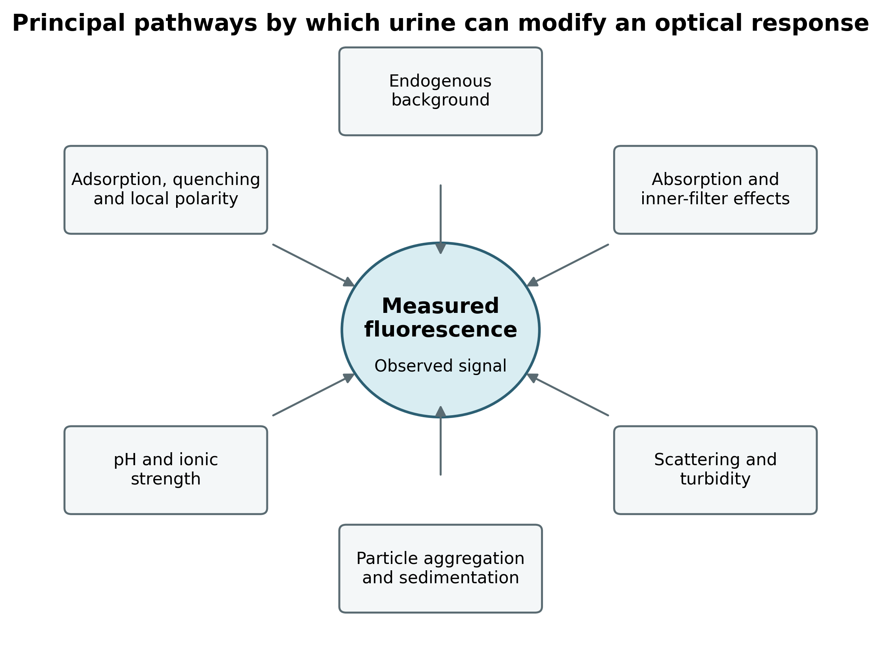
Figure 2.1. Principal spectral, chemical, and colloidal pathways through which urine can modify a fluorescence response.
Source: Original conceptual synthesis based on Lakowicz (2006), Bouatra et al. (2013), and Hotze et al. (2010).
2.8 Analytical Validation Requirements
International guidance distinguishes analytical-procedure development from validation. Development defines the analytical principle, operating conditions, expected range, and control strategy, whereas validation demonstrates that performance is suitable for the intended purpose. For a quantitative fluorescence procedure, relevant characteristics commonly include specificity or selectivity, response function and range, accuracy, precision, limits of detection and quantification, robustness, and system suitability (U.S. Food and Drug Administration [FDA], 2018; International Council for Harmonisation [ICH], 2023a, 2023b).
Linearity must not be judged from R² alone. The concentration axis must be traceable, replicate responses should be available at each level, residuals should be examined, and the range should exclude regions affected by quenching or inner-filter behavior. A high R² can occur despite systematic bias, non-constant variance, or a single influential point; it therefore cannot replace accuracy and precision studies.
For urine analysis, validation should also include matrix blanks from multiple donors, recovery at several fortification levels, assessment of dilution integrity, stability during storage and analysis, and comparison with an established method. These requirements explain why the current work is described as proof of concept and why its regression equations are interpreted descriptively.
2.8.1 Validation Decision Framework for the Proposed Method
Validation characteristics must be connected to an intended use. A screening procedure may tolerate greater uncertainty than a confirmatory quantitative method, but both require a defined measurand, matrix, reportable range, and decision rule. The intended purpose of the proposed system should therefore be stated before numerical acceptance criteria are selected (ICH, 2023a, 2023b; Magnusson & Örnemark, 2014).
Selectivity is the first critical decision because urine contains many potential interferents and ibuprofen is not the only aromatic carboxylic acid that may interact with a polyphenol-coated iron surface. Accuracy and recovery then assess whether fortified amounts can be recovered from the matrix. Precision must include repeatability within a run and intermediate precision across days, preparations, and, where relevant, operators.
Detection capability should be estimated from low-level data using a defined statistical approach rather than by dividing an arbitrary signal by a slope. LOD and LOQ estimates should be verified experimentally near the proposed limits and interpreted together with false-positive and false-negative risk (Long & Winefordner, 1983; CLSI, 2012).
Robustness testing should examine variables that are plausible in the actual procedure: pH, urine dilution, particle concentration, sonication time, measurement delay, excitation wavelength, slit width, and temperature. The result should be a control strategy that specifies which variables must be fixed and which can vary without changing the conclusion.
Future validation must address selectivity, calibration model and range, accuracy and recovery, repeatability and intermediate precision, LOD and LOQ, stability, robustness, and reference-method agreement. Each characteristic requires prospectively defined criteria, traceable concentration levels, independent preparations, matrix-matched controls, and experimental verification rather than reliance on fitted-line statistics alone (ICH, 2023a, 2023b; FDA, 2018).
2.9 Previous Studies and Critical Synthesis
The literature supports the feasibility of fluorescence-based urinary analysis, but it also demonstrates that analytical performance depends on the interaction among the target analyte, recognition interface, biological matrix, instrumental configuration, and validation design. The studies summarized below were selected because they directly inform the methodological choices and the limits of interpretation in the present work.
Table 2.3. Selected previous studies and their relevance to the present thesis
Study | Analytical focus | Principal contribution | Relevance to the present study
Bouatra et al. (2013) | Comprehensive characterization of the human urine metabolome | Documented the extensive chemical diversity of urine and the large number of endogenous urinary constituents. | Supports treating urine as a complex matrix requiring direct matrix evaluation and appropriate blanks.
Bernini et al. (2011) | Pre-analytical handling of urine for metabolomic studies and biobanks | Defined standardized procedures for collection, processing, storage, and quality control. | Supports strict control of sampling and storage variables before optical measurement.
Lakowicz (2006) | Fundamental fluorescence spectroscopy | Established the principles of excitation, emission, quenching, inner-filter effects, and fluorescence measurements. | Provides the theoretical basis for interpreting the observed spectra and their limitations.
Laurent et al. (2008) | Iron oxide nanoparticle synthesis, stabilization, characterization, and applications | Reviewed aggregation, surface modification, dispersion, and physicochemical characterization of iron oxide nanoparticles. | Supports the selection of an iron-based nanoscale interface and the need to control aggregation.
Mourdikoudis et al. (2018) | Complementary nanoparticle characterization techniques | Compared the information and limitations provided by different characterization methods. | Supports combining FTIR, XRD, AFM, and FESEM rather than relying on a single technique.
Piechocka et al. (2023) | HPLC-ELSD determination of major ibuprofen metabolites and creatinine in human urine | Demonstrated targeted chromatographic analysis of ibuprofen-related compounds in a complex urinary matrix. | Provides a suitable reference-method concept for future validation of the fluorescence platform.
ICH (2023a, 2023b) | Analytical procedure development and validation guidance | Defines the performance characteristics required before a method is suitable for its intended purpose. | Supports classifying the present work as proof of concept rather than a validated quantitative method.
Mohammed et al. (2025) | HPLC monitoring of ibuprofen in five wastewater treatment plants in Babylon Governorate, Iraq. | Detected ibuprofen in all investigated influent and effluent sewage samples; influent 10.45–1096 µg/L and effluent 7.52–945 µg/L. | Provides direct local evidence that ibuprofen persists in Iraqi wastewater and supports the environmental monitoring rationale of the present thesis.
Jan-Roblero & Cruz-Maya (2023) | Review of ibuprofen occurrence, toxicology, and biodegradation as an emerging contaminant. | Summarized international occurrence in aquatic matrices and reported cytotoxic, genotoxic, oxidative-stress, growth, reproductive, and behavioral effects in aquatic organisms. | Supports the environmental significance of ibuprofen and the need for practical detection and treatment strategies.

2.9.1 Critical Comparison with Established Analytical Approaches
The literature provides three distinct reference frames for the present work. Urine-metabolome and biomonitoring studies define the complexity of the matrix; fluorescence texts define the optical mechanisms; and chromatographic studies define the level of chemical specificity available when separation is used. These bodies of evidence should not be collapsed into a single claim of method equivalence.
Compared with chromatography, the present approach is operationally simpler and potentially less costly, but it lacks separation and confirmed molecular identity. Compared with direct fluorescence in water, the urine experiment is more realistic but also more vulnerable to background and interaction effects. Compared with selective probe systems, the tannic-acid coating is easier to prepare but is not, by itself, a demonstrated molecular-recognition element.
The appropriate research position is therefore comparative rather than competitive. The present system may become a useful screening or preconcentration interface, but its role must be determined experimentally. A future study could test whether nanoparticle treatment improves signal-to-background ratio, recovery, or selectivity relative to uncoated particles and analyte-only controls, and whether any improvement remains after comparison with HPLC or LC-MS/MS.
Compared with comprehensive metabolomic profiling and targeted chromatographic analysis, the present platform is simpler and more adaptable but provides less chemical specificity. Selective molecular probes may offer stronger recognition, whereas nanomaterial-assisted optical systems share the present method’s advantages and its vulnerability to aggregation and non-specific interactions. Accordingly, this thesis establishes feasibility and a defined validation pathway; HPLC or LC-MS/MS remains necessary for confirmation of identity and quantitative agreement (Piechocka et al., 2023; Laurent et al., 2008; ICH, 2023a).

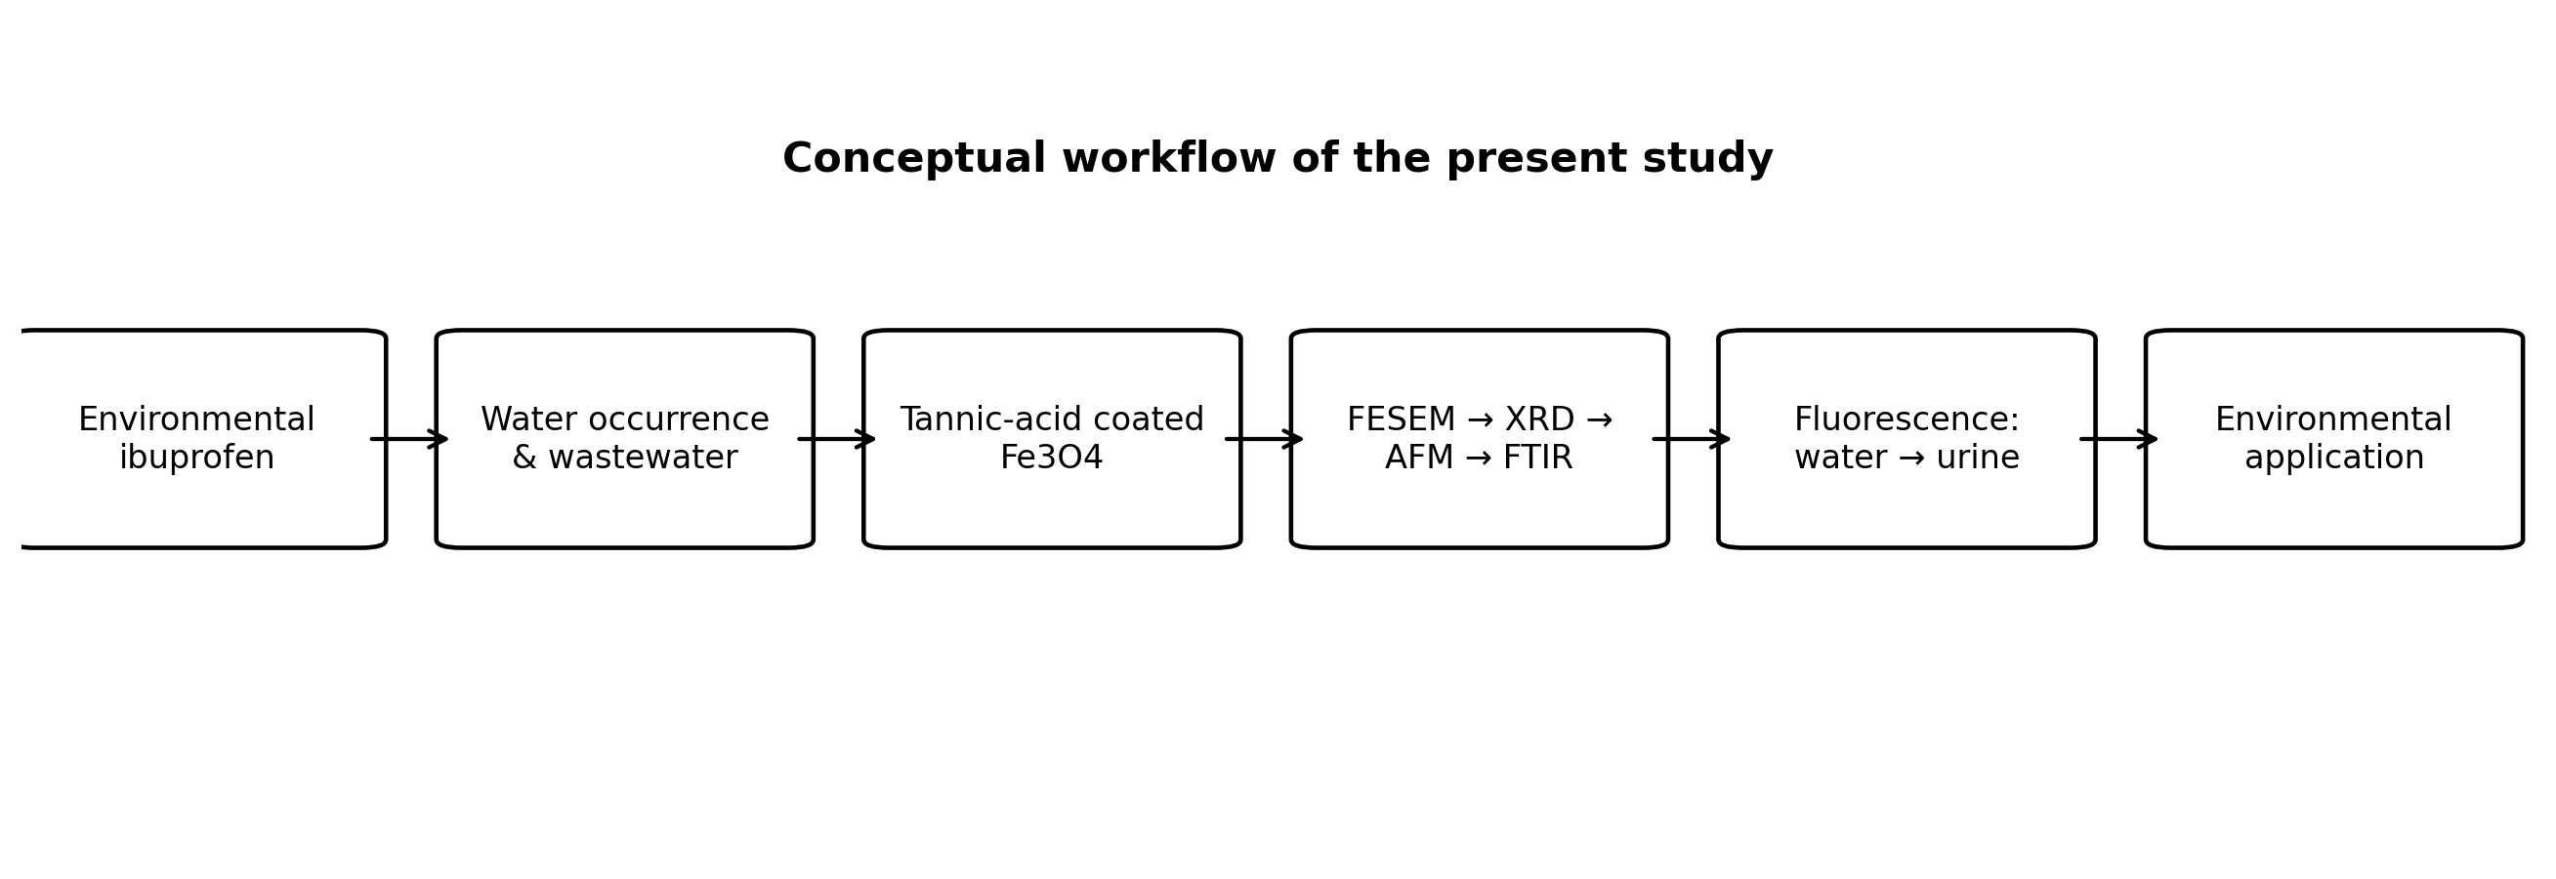
Figure 2.2. Conceptual workflow linking environmental ibuprofen occurrence, nanomaterial preparation, characterization, fluorescence testing, and environmental application.

2.10 Research Gap and Relevance of the Present Study
Previous research demonstrates the broad analytical potential of fluorescence and nanomaterial-assisted platforms, while chromatographic work confirms that ibuprofen-related compounds can be measured in human urine. Many optical systems, however, rely on specialized nanomaterials, selective probes, or carefully controlled standards. Fewer studies combine a comparatively simple tannic-acid-modified iron material with a direct comparison of response behavior in water and fortified urine while explicitly distinguishing proof of concept from method validation (Laurent et al., 2008; Piechocka et al., 2023; Valeur & Berberan-Santos, 2012). The present study addresses this gap by using a clearly defined sequence: preparation of tannic-acid-coated nano-iron, characterization through four complementary techniques, optimization of fluorescence excitation, measurement across several ibuprofen levels, and comparison of calibration behavior between aqueous and urine matrices. This sequence provides a coherent link between material properties and analytical function. The present study therefore adopts a conservative analytical position. A high coefficient of determination in fortified urine is treated as preliminary evidence of an orderly response, not as proof of selectivity, accuracy, reproducibility, clinical validity, or diagnostic usefulness. This distinction keeps the conclusions proportional to the completed measurements and defines a defensible pathway for subsequent validation.
Chapter Three
Materials and Methods
Chapter Three – Materials and Methods
3.1 Experimental Design
The study was designed as a laboratory investigation of a nanomaterial-assisted fluorescence system and was carried out in the Analytical Chemistry Branch, Department of Chemistry, College of Science, University of Al-Qadisiyah. As shown in Figure 3.1, the workflow comprised four sequential stages: preparation of tannic-acid-coated iron oxide nanoparticles, physicochemical characterization, preparation of ordered ibuprofen levels in water and fortified urine, and fluorescence measurement followed by comparative data analysis.
Aqueous samples were evaluated first to establish the fundamental spectral response under relatively simple conditions. The procedure was then transferred to fortified human urine using the same sample-to-nanosuspension ratio and comparable instrumental settings. This paired design allowed the analytical behavior in water to be compared with that in a more complex biological matrix while limiting differences attributable to sample preparation.
The experimental design established the principal excitation and emission regions, the direction of response across prepared levels, and the persistence of the fluorescence signal after transfer from water to fortified urine. These predefined outcomes were used to evaluate the analytical behavior of the system under the tested conditions.

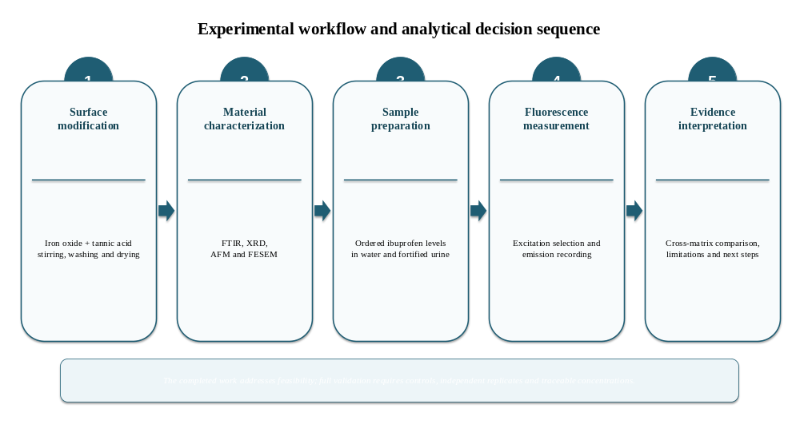
Figure 3.1. Experimental workflow and analytical decision sequence used in the present thesis. Source: Prepared by the researcher from the completed experimental procedure.
3.2 Chemicals and Laboratory Equipment
The chemicals and instruments used in the experimental work are summarized in Tables 3.1 and 3.2. Reagents were used as received unless otherwise indicated. Distilled or deionized water was used for solution preparation, washing, and nanoparticle suspension. Where manufacturer information was not available in the laboratory record, it is shown by a dash rather than inferred. The laboratory work and fluorescence measurements were conducted in the Analytical Chemistry Branch, Department of Chemistry, College of Science, University of Al-Qadisiyah.
Table 3.1 Chemicals and materials used in the study
Material | Specification / source | Function in the study
Iron oxide nanoparticles (Fe3O4) | Commercial Fe3O4 nanopowder; supplier/manufacturer not documented in the original laboratory record. Primary-particle size used in the study was estimated from FESEM images as approximately 20–80 nm after coating/preparation. | Iron-based nanoscale core used for surface coating.
Tannic acid | Loba Chemie, India | Polyphenolic surface-coating agent.
Ethanol | 99.99%; manufacturer not recorded | Washing solvent used to remove unbound material.
Pure ibuprofen | Reference compound; manufacturer, purity, and batch not recorded in the available thesis file | Model pharmaceutical analyte.
Methanol | Analytical reagent; manufacturer not recorded | Laboratory solvent available for analytical preparation.
Distilled / deionized water | Laboratory supply | Dispersion, washing, dilution, and aqueous matrix.
Human urine | Biological matrix; source and handling details require completion from the original records | Evaluation of fluorescence performance in a complex matrix.

Table 3.2 Principal laboratory equipment used in the study
Equipment | Model and manufacturer | Country | Experimental use
Laboratory oven | Memmert UN55 | Germany | Drying the coated nanoparticles at 50 °C.
Hot plate / magnetic stirring unit | Retsch; model not recorded | Germany | Controlled mixing during surface coating.
Laboratory shaker | KS 260 Basic | Germany | Mixing prepared solutions and suspensions.
Ultrasonic bath | Branson 1510 | USA | Dispersing nanoparticles and reducing aggregation.
Micropipette | Eppendorf Research plus | Germany | Accurate transfer of solution aliquots.
Spectrofluorometer | Shimadzu RF-5301PC | Japan | Recording excitation and emission spectra using a 150 W xenon lamp over an instrumental wavelength range of 220–900 nm.
UV–Vis spectrophotometer | Shimadzu PC 1800 | Japan | Recording absorption spectra and assessing potential inner-filter effects at the selected excitation and emission regions.
FTIR spectrometer | Bruker Tensor 27 | Germany | Identifying functional groups and supporting evidence for tannic-acid modification of the iron oxide nanoparticle surface.
FESEM | TESCAN MIRA3 FEG-SEM | Czech Republic | Particle morphology, aggregation, image-based size, and surface texture; embedded micrographs record 15.00 kV accelerating voltage.
TEM | Philips CM120 | Netherlands | Examining internal morphology and image-based particle dimensions at high spatial resolution.
XRD diffractometer | Siemens D500 | Germany | Evaluating diffraction behavior, crystallographic order, and phase-related structural features.

3.2.1 Reagent and Instrument Traceability
Analytical reproducibility depends on traceability of reagents, standards, and instrumental settings. Reference-compound purity, batch number, preparation date, storage condition, balance calibration, pipette verification, and instrument performance checks should be recorded. Where these data are absent, the omission must be stated rather than replaced by inferred information.
The current thesis retains missing manufacturer or batch information as an explicit limitation. This is preferable to introducing unsupported details, but the original laboratory notebook and instrument files should be reviewed before final institutional submission. Recovered information should be inserted consistently in the methods tables and, where relevant, in the uncertainty assessment.
For future work, a preparation sheet should accompany every batch of coated nanoparticles and every analytical run. The sheet should include actual masses, volumes, timing, sonication conditions, suspension age, urine identifier, pH, instrument method file, and analyst initials. This documentation converts a descriptive protocol into an auditable analytical procedure (Taverniers et al., 2004; Magnusson & Örnemark, 2014).
3.3 Preparation of Tannic-Acid-Coated Nano-Iron
Commercial iron oxide nanopowder (Fe3O4) was used as the nanoscale core. The coating work was conducted in the Analytical Chemistry Branch, Department of Chemistry, College of Science, University of Al-Qadisiyah. The powder was dispersed in deionized water and sonicated to reduce visible agglomeration and maximize contact between the particle surface and tannic acid.
Tannic acid was added gradually while the suspension was continuously stirred for up to 7 h. The coating step was used to introduce a polyphenolic surface rich in hydroxyl groups that can coordinate with iron sites and participate in hydrogen bonding. This surface modification can increase interfacial functionality, improve wettability/dispersion behavior, and provide additional interaction sites for ibuprofen (Ejima et al., 2013; Laurent et al., 2008).
The particles were washed three times with deionized water and three times with ethanol to remove unbound tannic acid and soluble residues, then dried at 50 °C to obtain the coated powder. In the present study, formation of the modified surface was established from convergent characterization, with FTIR providing the principal chemical evidence through the coexistence of tannic-acid-related organic bands and the Fe–O region; FESEM and AFM supplied complementary morphological evidence, while XRD described the structural order of the iron-based material.
3.4 Characterization of the Prepared Nanoparticles
The prepared material was characterized using complementary methods. Each technique was selected to examine a different property of the nanosystem, thereby reducing the risk of drawing conclusions from a single type of measurement.
3.4.1 Field-Emission Scanning Electron Microscopy (FESEM)
FESEM imaging was performed using a TESCAN MIRA3 field-emission scanning electron microscope. The embedded micrographs record an accelerating voltage of 15.00 kV, working distance of approximately 5.3 mm, and InBeam detection. Therefore, 15 kV is retained as the experimentally documented value rather than 20 kV. This voltage provides high spatial resolution while maintaining strong surface/morphological contrast for nanoscale iron-oxide aggregates; published MIRA3 specifications report approximately 1.5 nm SE resolution at 15 kV in high-vacuum mode (TESCAN, MIRA3 specifications). Images were used to evaluate particle morphology, aggregation, surface texture, and an image-based primary-particle size range.
3.4.2 X-Ray Diffraction (XRD)
X-ray diffraction analysis was performed using a Siemens D500 diffractometer with Cu Kα radiation (λ approximately 0.15405 nm). The diffraction pattern was evaluated from peak position, breadth, and definition to assess crystallographic order and phase-related structural features. Crystallite-size calculations and definitive phase assignment were not undertaken because the observed profile did not contain sufficiently resolved peaks for defensible quantitative analysis.
3.4.3 Atomic Force Microscopy (AFM)
AFM was used to examine nanoscale surface topography and height variation over the scanned area. Two-dimensional and three-dimensional surface maps were interpreted to assess roughness, heterogeneity, and local aggregation. AFM height values were considered surface-topography measurements and were not treated as directly equivalent to the particle diameter observed by FESEM.

3.4.4 Fourier-Transform Infrared Spectroscopy (FTIR)
FTIR spectra were recorded using a Bruker Tensor 27 Fourier-transform infrared spectrometer over the range 400–4000 cm⁻¹. The analysis was used to identify bands associated with tannic-acid functional groups and the iron–oxygen framework, thereby providing supporting evidence for surface modification. Because spectra of uncoated nanoparticles and pure tannic acid were not reported as direct controls, the FTIR result was interpreted as supportive rather than conclusive evidence of coating.
The characterization techniques were interpreted in a unified sequence: FESEM for particle morphology and aggregation, XRD for structural order, AFM for nanoscale surface topography, and FTIR for chemical functional groups and surface modification. This order is retained consistently in Chapters Three and Four.
3.5 Preparation of Ibuprofen Solutions and Test Samples
3.5.1 Stock Solution
A stock solution of pure ibuprofen was prepared by dissolving 0.1 g of the reference compound in 100 mL of distilled water, corresponding to a nominal concentration of 1 mg/mL. The solution was mixed until no visible undissolved material remained. The absence of a documented pH-adjustment or co-solvent step should be considered when reproducing the procedure because ibuprofen has limited aqueous solubility.
3.5.2 Aqueous Working Levels
Aqueous preparation levels were generated from stock aliquots of 2.00, 1.00, 0.50, 0.20, and 0.02 mL. Each preparation was completed with distilled water to the working volume used in the laboratory, after which 2 mL was mixed with 2 mL of coated nanoparticle suspension to give a 4 mL analytical mixture. The exact make-up volume before withdrawal of the 2 mL test portion was not stated in the available record; therefore, the levels are reported as ordered preparation volumes rather than converted into absolute final concentrations.
3.5.3 Urine-Based Working Levels
The same stock-aliquot sequence was used for urine-based preparations. Each aliquot was combined with urine to the laboratory working volume, and 2 mL of the fortified matrix was then mixed with 2 mL of coated nanoparticle suspension. The source, collection time, storage conditions, and ethical status of the urine sample must be documented in the final thesis from the original study records. In the present analysis, the urine served solely as a matrix and no participant-level clinical inference was made.

3.5.4 Preparation of the Working Nanoparticle Suspension
The dried coated nanoparticle powder was dispersed in distilled water to prepare the working suspension. The suspension was sonicated immediately before use, and equal volumes from the same preparation were added to all samples. The nanoparticle mass concentration was not available in the source record and therefore was not invented in this thesis; this omission limits exact reproducibility and should be corrected from the laboratory notebook before submission.
Table 3.3. Summary of sample preparation for fluorescence analysis
The purpose of Table 3.3 is to present the aqueous and fortified-urine preparation schemes side by side so that matrix composition, transferred volumes, nanoparticle addition, and final analytical volume can be compared directly.
Experimental component | Aqueous series | Urine series
Stock solution | 0.1 g ibuprofen in 100 mL distilled water (1 mg/mL) | The same stock solution was used.
Stock aliquots / ordered preparation levels | 2.00, 1.00, 0.50, 0.20, and 0.02 mL | 2.00, 1.00, 0.50, 0.20, and 0.02 mL
Matrix used for make-up | Distilled water | Human urine
Test portion | 2 mL of each prepared level | 2 mL of each fortified urine level
Nanoparticle suspension added | 2 mL | 2 mL
Final analytical volume | 4 mL | 4 mL
Pre-measurement treatment | Shaking and sonication | Shaking and sonication under comparable conditions

3.5.5 Concentration Reconstruction and Mass-Balance Requirements
A concentration-based calibration requires an unbroken record from stock preparation to the final cuvette. For each level, the amount transferred from the stock must be divided by the total make-up volume, and any subsequent mixing with nanoparticle suspension must be incorporated into the final concentration. The nominal final analyte concentration can be expressed as follows:
C_final = (C_stock × V_stock / V_make-up) × (V_sample / V_analytical mixture)
In the completed record, the stock concentration and stock aliquots are available, but the make-up volume before withdrawal of the 2 mL test portion is not stated. The absolute final concentrations therefore cannot be reconstructed without returning to the laboratory record. Assigning concentration values by assumption would introduce a false level of precision and has deliberately been avoided.
Once the make-up volume is verified, the calibration should be rebuilt using concentration units rather than preparation order. The calculation should also account for reference-standard purity, volumetric tolerances, and any co-solvent or pH adjustment. A preparation table with independent checks should be retained as part of the raw data.
The same mass-balance logic applies to the nanoparticle suspension. Nominal particle mass concentration, coating-batch identity, suspension volume, and dilution in the cuvette must be documented. Without this information, reproducibility across material batches cannot be separated from fluorescence variability.

3.6 Fluorescence Spectroscopic Measurement
Fluorescence measurements were performed at room temperature using a Shimadzu RF-5301PC spectrofluorophotometer (Shimadzu, Japan) equipped with a 150 W xenon lamp and an instrumental wavelength range of 220–900 nm. Quartz cuvettes were used for ultraviolet excitation. The recorded thesis procedure specified excitation and emission slit widths of 3 nm. Instrumental settings must be checked against the original instrument files because the accompanying manuscript reports different settings; the final thesis should contain one verified set of conditions only.
An excitation scan beginning at 220 nm was used to identify the wavelength producing the maximum response for the complete analyte–nanoparticle mixture. The selected excitation wavelength was then held constant while emission spectra were collected for the aqueous and urine series. Cuvette type, analytical volume, mixing procedure, and the recorded instrument settings were kept consistent within each comparison.
The fluorescence signal was evaluated at the emission region showing the clearest and most systematic separation among the prepared analyte levels. A secondary emission band was also recorded and considered during interpretation, but quantitative evaluation focused on the region with the greater concentration-dependent response.
UV–visible absorption spectra were recorded using a Shimadzu PC 1800 spectrophotometer. The absorbance at and around the selected excitation and emission wavelengths was examined to identify potential spectral overlap and to assess whether inner-filter effects could influence the measured fluorescence response.
3.7 Calibration and Data Treatment
For each matrix, fluorescence intensity in the selected emission region was plotted against the ordered preparation level. A linear model of the form y = mx + b was fitted, where y was the measured intensity and x was the preparation-order variable used in the original plot. Because the exact absolute concentrations could not be reconstructed from the available make-up-volume record, m is a response slope per plotted level and not a validated analytical sensitivity in concentration units.
R² was used only as a descriptive measure of agreement with the fitted line. It does not demonstrate accuracy, precision, selectivity, or absence of curvature. In a validated study, replicate measurements, residual analysis, uncertainty estimates, and a traceable concentration scale would be required before quantitative claims could be made (ICH, 2023a, 2023b).
Comparison between aqueous and urine calibration behavior focused on the direction of response, slope, intercept, and R². Because complete validation data and independent replicate statistics were not available for every analytical parameter, the regression results were interpreted as preliminary evidence of feasibility rather than as final estimates of accuracy or uncertainty.
3.7.1 Prospective Statistical Treatment for a Validation Study
A future calibration design should include independently prepared replicates at each concentration. Replication of instrument readings from a single preparation estimates only reading repeatability, whereas independent preparation replicates incorporate dilution, mixing, and suspension variability. Both components are relevant to the proposed method.
The calibration model should be selected from the data-generating process rather than from R² alone. Residual plots should be examined for curvature, influential points, and increasing variance. If variance increases with concentration, weighted regression may be more appropriate than unweighted least squares. Model choice and exclusion rules should be specified before final analysis.
Recovery at each fortification level can be expressed as the measured increment after subtraction of the matrix blank divided by the fortified amount. Precision can be reported as the relative standard deviation of independent results:
Recovery (%) = [(measured fortified sample − measured matrix blank) / fortified amount] × 100
RSD (%) = (standard deviation / mean) × 100
Detection and quantification limits should be derived using a method appropriate to the variance structure and verified with low-level samples. Estimates based only on a regression intercept or a single blank standard deviation can be unstable. The decision should consider the probability of false detection and the precision and bias achievable near the proposed limit (Long & Winefordner, 1983; CLSI, 2012).
Agreement with a reference method should be evaluated with paired matrix samples across the intended range. Correlation is not sufficient because two biased methods can be highly correlated. Difference plots, regression appropriate to error in both methods, and predefined allowable bias provide stronger evidence of agreement.
A subsequent validation study should use at least five to seven traceable calibration levels with independent preparations, within-run replicates for repeatability, multiple days or batches for intermediate precision, low/middle/high fortified urine samples for recovery, repeated blanks and low-level samples for LOD/LOQ, and paired fluorescence–HPLC or fluorescence–LC-MS/MS measurements for method comparison. Outputs should include residual and lack-of-fit analysis, bias, SD, RSD, confidence intervals, variance components, and agreement limits (ICH, 2023a; CLSI EP17-A2; Thompson et al., 2002; Magnusson & Örnemark, 2014).
3.8 Quality Assurance and Methodological Safeguards
Procedural consistency was sought by using the same sample-to-nanoparticle volume ratio, similar mixing and sonication, the same cuvette type, and the same nominal instrumental conditions. These measures reduce avoidable variation but do not substitute for independent replicates, control materials, or formal quality control.
Interpretation was restricted to the completed measurements. The study did not infer selectivity from linearity, did not treat fortified urine as equivalent to authentic clinical specimens, and did not assign the response to a single molecular mechanism. These safeguards are necessary because fluorescence in a particle-containing biological matrix may reflect absorption, scattering, adsorption, enhancement, and quenching simultaneously.
Subsequent validation should include solvent and reagent blanks, unfortified urine from multiple sources, nanoparticle-only and tannic-acid controls, uncoated iron oxide particles, independent preparation and measurement replicates, recovery and interference studies, stability assessment, and comparison with an established chromatographic method. None of these requirements should be implied by the reported R² values.
3.8.1 Proposed Quality-Control Architecture
A complete control set is required to determine which component produces the recorded signal. Background controls quantify emission and scattering from solvents, reagents, particles, and urine. Mechanistic controls compare coated and uncoated particles and test whether tannic acid or the iron-based core contributes independently. Performance controls assess recovery, precision, drift, and reference-method agreement.
The controls should be measured within the same analytical sequence as samples. Separate experiments performed on different days or with different particle batches cannot isolate small effects reliably. Each control must therefore have the same final volume, solvent composition, particle concentration, timing, and instrument settings as the test mixture.
This structure is intentionally more extensive than the completed proof-of-concept experiment. Its purpose is to convert the current observations into partitioned evidence that supports or rejects specific mechanistic and quantitative interpretations.
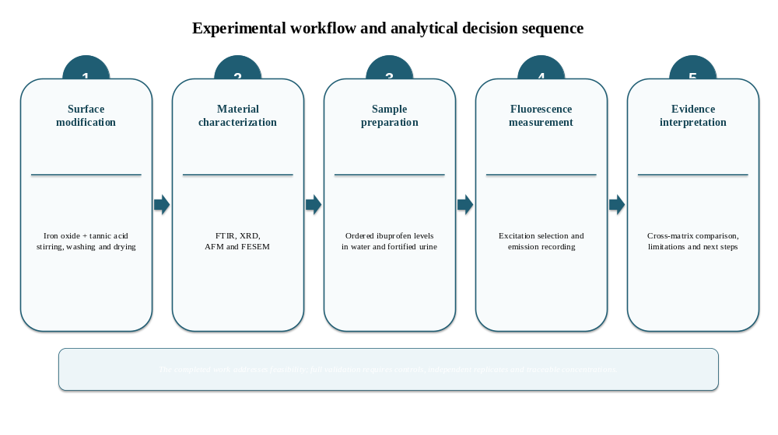
Figure 3.2. Proposed control architecture for separating background, mechanistic, and analytical-performance contributions.
Source: Original design by the researcher based on ICH (2023a, 2023b) and Matuszewski et al. (2003).
Mechanistic interpretation and validation require a complete control set: solvent/reagent blanks, nanoparticle-only blanks, analyte-only controls, uncoated-particle controls, unfortified urine blanks, an interference panel, independent low/middle/high quality-control samples, and samples measured by HPLC or LC-MS/MS. These controls distinguish baseline fluorescence, particle scattering, intrinsic analyte response, the effect of tannic-acid coating, endogenous matrix background, cross-response, run precision, and reference-method agreement (FDA, 2018; ICH, 2023a; Matuszewski et al., 2003).

3.9 Ethical and Biosafety Considerations
Human urine was used only as an analytical matrix for method-feasibility testing. The final submitted thesis must state whether the specimen was self-collected or obtained from another individual, the institutional ethics or exemption decision and reference number, the collection and storage conditions, and the biosafety procedure. These details cannot be supplied by editorial revision and must be taken from the original approved records. No clinical, demographic, or exposure inference was made from the specimen in the present study.
Urine should nevertheless be handled as potentially infectious biological material. A defensible laboratory record should specify use of gloves and protective clothing, restricted handling areas, decontamination of work surfaces, validated waste disposal, and procedures for accidental exposure. These controls protect personnel and also reduce sample contamination that could alter optical measurements (World Health Organization, 2020).
Ethical documentation should distinguish research involving identifiable participants from the use of an anonymized or self-collected specimen for analytical method development. The final thesis should retain the institutional decision, consent or waiver basis, and sample-coding procedure. Editorial revision cannot replace these records, and no retrospective ethics number should be inferred or created. This approach is consistent with the principles of traceability, participant protection, and proportional review expressed in the Declaration of Helsinki (World Medical Association, 2013).
For subsequent multi-donor validation, the sampling plan should define inclusion criteria, minimum specimen volume, anonymization, storage, and whether medication history is collected. Donor variability should be treated as an analytical design factor rather than as clinical information unless the study has specific ethical approval for participant-level interpretation.

Results and Discussion

Chapter Four – Results and Discussion
4.1 Overview of the Experimental Findings
The results are presented in the same sequence as the experimental workflow: structural and surface characterization of the coated nanoparticles, selection of the excitation wavelength, assessment of the aqueous response, and evaluation in fortified urine. Interpretation is restricted to the evidence generated by the study. Characterization results are discussed as mutually supportive observations, while the fluorescence data are treated as preliminary response profiles because independent replicates, full blanks, and analytical validation were not available.
The discussion follows an evidence-to-inference sequence. Instrumental outputs and image-based observations are described first, then compared across complementary techniques, and only then interpreted in relation to the proposed analytical function. This order reduces the risk of treating a plausible coating mechanism or sensing pathway as if it had been measured directly (Mourdikoudis et al., 2018).
The fluorescence findings are evaluated at three levels: spectral observability, ordering of response across the prepared levels, and transfer of that behavior from water to fortified urine. None of these levels independently establishes selectivity or quantitative fitness for purpose. Their value is to identify whether a controlled validation study is scientifically justified and which variables must be controlled in that study (ICH, 2023a, 2023b).
Particular weight is given to discordant observations, especially the non-monotonic highest urine level and the broad XRD profile. Rather than conceal these features, the discussion treats them as evidential limits that generate testable explanations involving concentration effects, particle dispersion, matrix background, and measurement variance (Lakowicz, 2006; Kubista et al., 1994).
4.2 Physicochemical Characterization of the Prepared Nanoparticles
4.2.1 Field-Emission Scanning Electron Microscopy (FESEM)
FESEM micrographs showed a heterogeneous material composed of nanoscale primary particles arranged in larger agglomerates. The higher-magnification images show approximately quasi-spherical primary particles with an image-based size range of about 20–80 nm. This range is the particle-size estimate used in the present thesis. The recorded magnifications extend from 5,000× to 150,000×, and the embedded image metadata records 15.00 kV accelerating voltage and an approximately 5.3 mm working distance.
Agglomeration remained substantial despite surface modification. The observation is consistent with the AFM topography and indicates that tannic acid did not eliminate interparticle association under the preparation conditions. Aggregation may influence fluorescence through sedimentation, optical scattering, and reduced surface accessibility; it is therefore both a structural finding and a potential source of analytical variability.
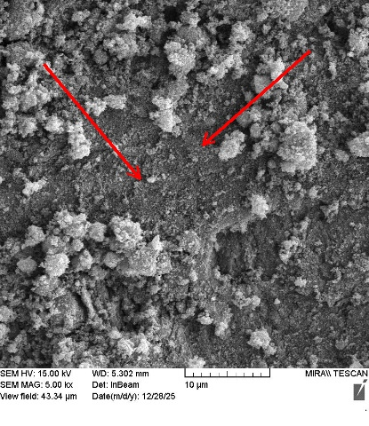 | 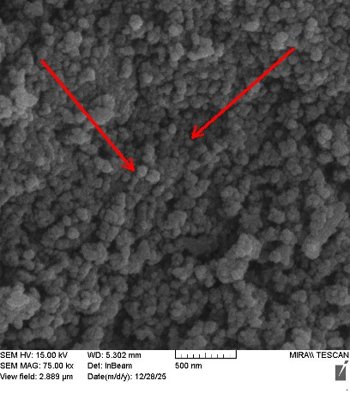 | 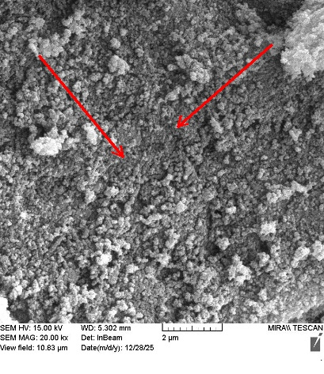
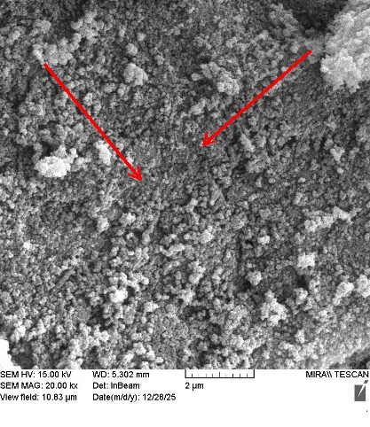 | 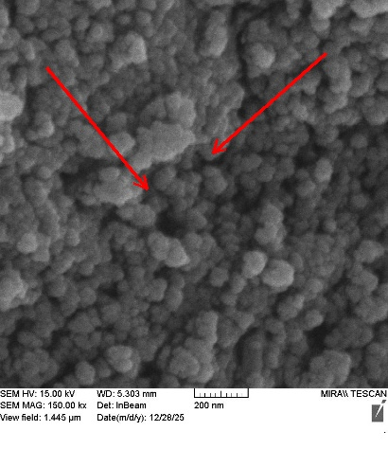 | 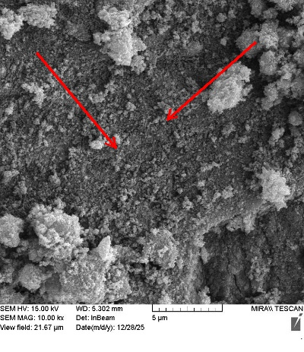
Figure 4.1. FESEM micrographs of tannic-acid-coated iron oxide nanoparticles at 5,000×, 10,000×, 20,000×, 20,000×, 75,000×, and 150,000× magnification, showing nanoscale primary particles within larger agglomerates.
4.2.2 X-Ray Diffraction (XRD)
In Figure 4.2, the horizontal (X) axis represents diffraction angle as Position (°2θ), while the vertical (Y) axis represents measured X-ray intensity in counts. The broad diffuse response is interpreted from the shape and distribution of intensity across this angular range.
The XRD pattern displayed a broad, low-intensity profile rather than sharp, well-resolved reflections. A diffuse feature was evident approximately within 20–35° 2θ, followed by a gradual decline in intensity at higher angles. This profile indicates low long-range order in the measured material and is compatible with a predominantly amorphous or poorly crystalline coated sample.
The broad response may arise from the organic tannic-acid layer, nanoscale disorder, small coherent domains, aggregation, or attenuation of diffraction from the iron-based core. Peak broadening and reduced definition are common interpretive limitations in nanoscale or poorly ordered materials, and phase assignment should not be made without resolved characteristic reflections and suitable reference patterns (Laurent et al., 2008; Mourdikoudis et al., 2018). However, the present pattern does not permit definitive phase identification or crystallite-size calculation because characteristic peaks were not sufficiently resolved.
Accordingly, XRD supports a low-crystallinity structural interpretation but does not independently prove surface coating. The conclusion regarding modification is based on convergence with FTIR, AFM, and FESEM rather than on the diffraction pattern alone.
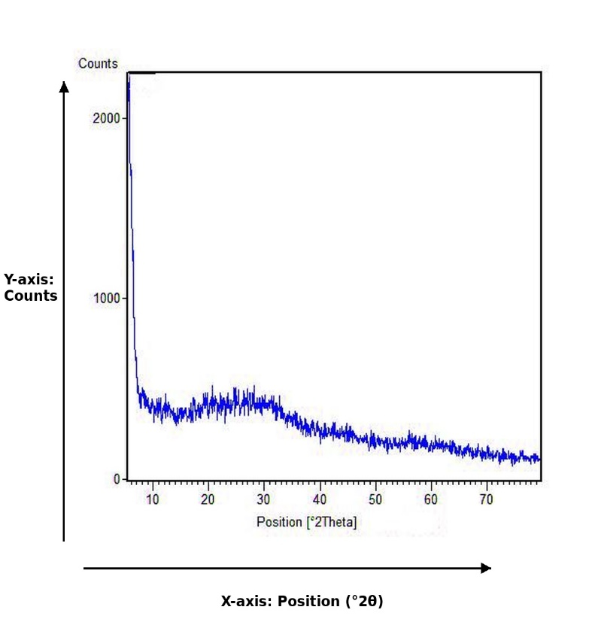
Figure 4.2. X-ray diffraction pattern of the prepared tannic-acid-coated iron-based nanoparticles. X-axis: diffraction angle, Position (°2θ); Y-axis: intensity (Counts).
4.2.3 Atomic Force Microscopy (AFM)
AFM showed a heterogeneous nanoscale topography with irregularly distributed elevations and localized clusters. The line profile indicated a peak-to-valley variation of approximately 8.114 nm, and the maximum height in the 4 × 4 µm scan was approximately 24.69 nm. These values describe the selected surface area and should not be interpreted as a complete particle-size distribution.
The two- and three-dimensional maps indicate partial aggregation and a rough surface. Such heterogeneity is compatible with the strong interparticle interactions expected for iron-based nanoparticles and with non-uniform deposition during sample preparation. AFM complements FESEM by providing height information, but it does not establish suspension stability or hydrodynamic size.
The rough nanoscale morphology may increase the number of accessible interfacial sites, although specific surface area was not measured. It is therefore appropriate to describe the topography as potentially relevant to analyte interaction rather than to claim demonstrated enhancement.

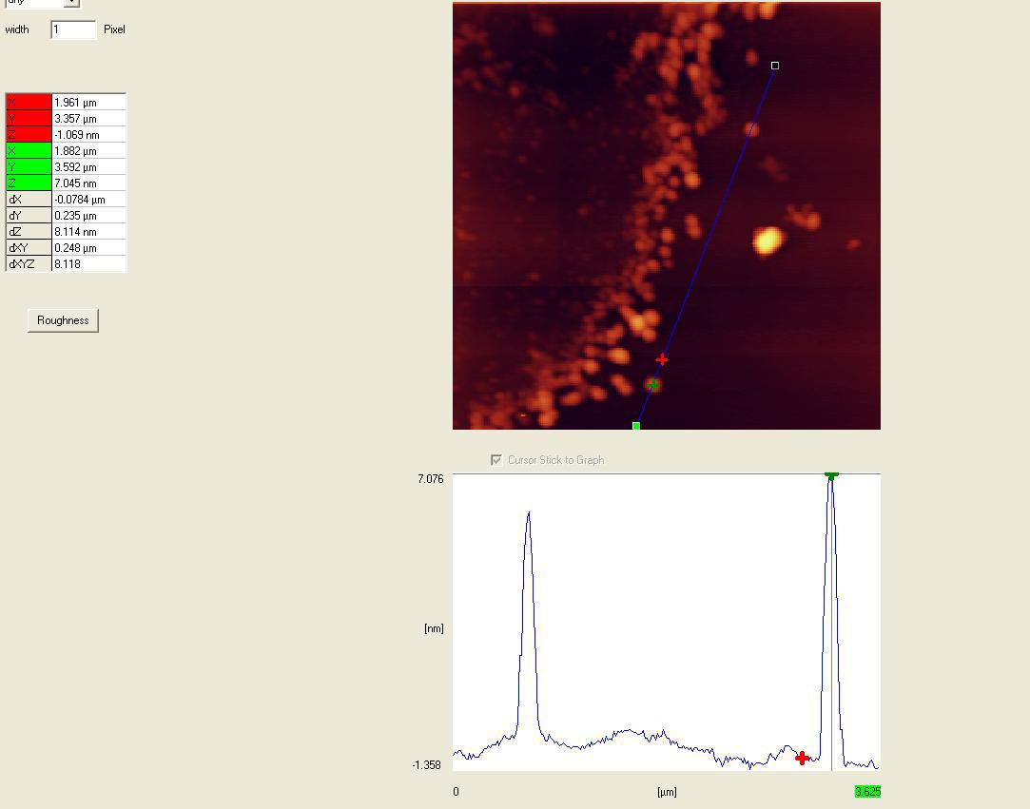 | 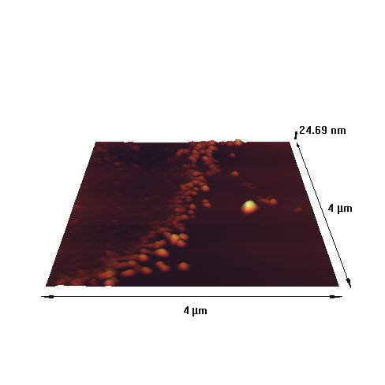
Figure 4.3. Two- and three-dimensional AFM topography of the prepared coated nanoparticles; scan area 4 × 4 µm and maximum recorded height approximately 24.69 nm.
4.2.4 Fourier-Transform Infrared Spectroscopy (FTIR)
The FTIR spectrum contained prominent bands at 3430.92, 1631.39, 1061.87, and 635.43 cm⁻¹. The broad 3430.92 cm⁻¹ band is consistent with O–H stretching from phenolic groups and adsorbed water. The 1631.39 cm⁻¹ band may include aromatic C=C or carbonyl-related contributions together with water-bending vibration, while the 1061.87 cm⁻¹ band is consistent with C–O stretching. The band at 635.43 cm⁻¹ is assigned to an Fe–O vibration.
The simultaneous presence of organic functional-group bands and the Fe-O region is consistent with an organic-inorganic iron-based material and supports the proposed tannic-acid modification. Comparable metal-polyphenol coordination and polyphenol-coating behavior have been described in established studies of functional surface assembly (Quideau et al., 2011; Ejima et al., 2013; Sileika et al., 2013).
The FTIR result provides the principal chemical evidence for surface modification because tannic-acid-related O–H, aromatic/carbonyl-related, and C–O bands occur together with the Fe–O vibration of the iron-oxide framework. The coating interpretation is strengthened by the complementary FESEM and AFM observations of a modified, heterogeneous nanoscale surface. XRD supports the iron-based structural framework but is not, by itself, a coating-specific technique.

Samples View 24 Results

Spectrum Name | Number Of Peaks
L44_1_1 | 4

L44_1_1 Details:

Peak Number | X (cm-1) | Y (%T)
1 | 3430.92 | 75.31
2 | 1631.39 | 92.57
3 | 1061.87 | 96.96
4 | 635.43 | 85.16

L44_1_1 Spectra:

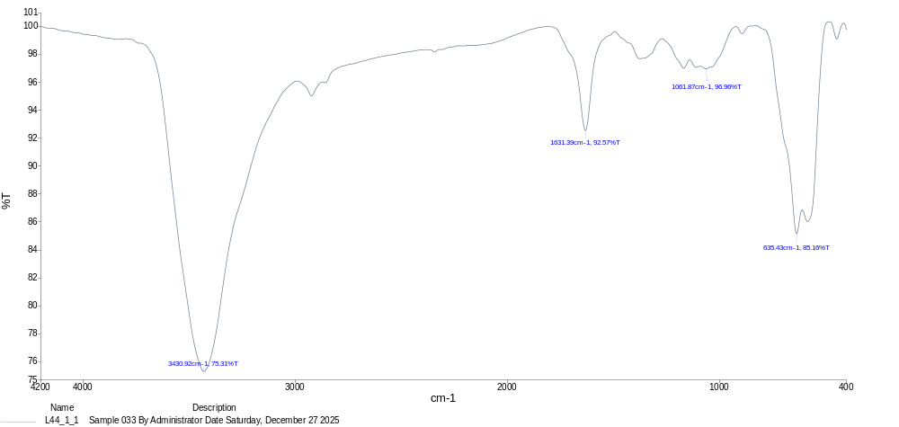

Figure 4.4. FTIR spectrum of the prepared tannic-acid-coated iron oxide nanoparticles with the principal absorption bands identified at 3430.92, 1631.39, 1061.87, and 635.43 cm⁻¹.
4.2.5 Integrated Interpretation and Discussion of the Characterization Evidence
The purpose of integrating these results is to link material structure to analytical behavior. Tannic-acid functionalization introduces phenolic groups capable of hydrogen bonding and interfacial interactions with ibuprofen, while the nanoscale morphology provides a large accessible surface. At the same time, the FESEM evidence of agglomeration explains why sonication and standardized dispersion are important before fluorescence measurements. Thus, the characterization findings directly support the design and interpretation of the fluorescence experiment.
The combined characterization demonstrates a tannic-acid-modified iron-based nanosystem. FESEM establishes nanoscale morphology and the presence of 20–80 nm primary particles within agglomerates; XRD describes the relatively low long-range structural order; AFM confirms a heterogeneous nanoscale topography; and FTIR provides the most direct chemical evidence of coating through the coexistence of tannic-acid-related functional-group bands with the Fe–O vibration. The interpretation is therefore based on convergence among complementary techniques rather than on a single measurement.
The characterization results are strongest when interpreted collectively. FTIR provides evidence of organic functional groups together with an Fe-O region; XRD indicates low long-range order; AFM demonstrates nanoscale surface heterogeneity; and FESEM shows nanoscale primary particles within larger agglomerates. No single technique establishes coating efficiency or suspension behavior, but the combined observations are consistent with a modified iron-based nanoscale material.
The convergence also reveals a methodological limitation. AFM and FESEM show heterogeneity and aggregation in deposited or dried samples, while the fluorescence experiment was performed in suspension. The physical state during optical measurement may therefore differ from the imaged state. DLS and zeta-potential measurements in the actual matrices would be required to bridge this gap.
The broad XRD pattern prevents a defensible crystallite-size calculation or detailed phase assignment. Similarly, FTIR band coexistence does not quantify the amount of tannic acid on the surface. The appropriate result is a qualitative structural interpretation supported by complementary methods, not a precise model of coating thickness or crystallinity.
This integrated reading is scientifically preferable to treating each instrument as independent proof. It identifies which conclusions are supported, which remain plausible, and which require additional measurements.
Table 4.1. Integrated interpretation of the nanoparticle characterization results
Technique | Observed evidence | Supported interpretation | Not established by the evidence
FESEM | Quasi-spherical primary particles, approximately 20-80 nm, within larger agglomerates. | Nanoscale morphology with substantial aggregation. | Colloidal stability in water or urine and coating efficiency.
XRD | Broad, low-intensity profile with diffuse response near 20-35° 2θ. | Low long-range order or poorly crystalline coated material. | Definitive phase assignment and crystallite size.
AFM | Heterogeneous topography; peak-to-valley ≈8.114 nm; maximum height ≈24.69 nm in the selected scan. | Rough nanoscale deposited surface with local clusters. | Suspension hydrodynamic size and population-wide distribution.
FTIR | Bands at 3430.92, 1631.39, 1061.87, and 635.43 cm⁻¹. | Organic functional groups coexist with an Fe-O vibration. | Coating amount, coverage, and bonding geometry.
Integrated conclusion | Convergent organic, iron-based, nanoscale, and heterogeneous features. | Consistent with a modified iron-based nanosystem. | A complete molecular structure or validated structure-function mechanism.
Source: Constructed from the experimental results and the interpretive limits described by Laurent et al. (2008) and Mourdikoudis et al. (2018).

4.3 Fluorescence Response and Preliminary Calibration
4.3.1 Selection of the Excitation Wavelength
The excitation scan showed a maximum response at approximately 224 nm under the recorded conditions; this wavelength was therefore selected for the subsequent emission measurements. The maximum belongs to the complete analyte–nanoparticle mixture and should not be assigned exclusively to ibuprofen without separate spectra for the analyte, coated particles, uncoated particles, tannic acid, and the corresponding blanks.
Excitation in the short-ultraviolet region can increase sensitivity to background absorption and scattering. Consequently, the selected wavelength is suitable for the present feasibility comparison but requires verification of blank contributions, photostability, and inner-filter behavior during formal method development.
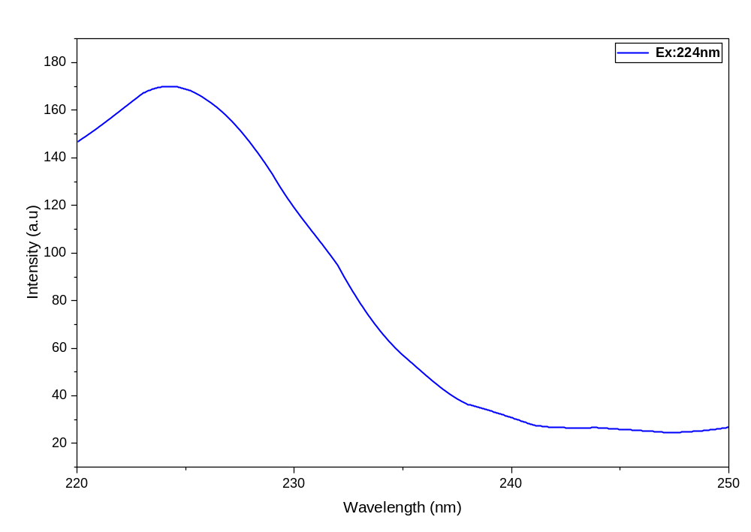
Figure 4.5. Excitation scan of the complete analyte-nanoparticle mixture, with maximum response near 224 nm.

4.3.2 Aqueous-Matrix Emission Response
The purpose of this section is to determine whether the prepared ibuprofen levels produce a systematic fluorescence response in the simpler aqueous matrix and to identify the emission region that provides the clearest separation among levels.
At an excitation wavelength of 224 nm, the aqueous preparations showed a principal emission band near 290–295 nm and a secondary band near 365–375 nm. Separation among the prepared levels was greatest in the first region, whereas the secondary band changed less markedly. The 290–295 nm region was therefore used for preliminary response evaluation.
2.00 mL > 1.00 mL > 0.50 mL > 0.20 mL > 0.02 mL
The principal-band intensity increased from approximately 45–50 a.u. at the lowest level to approximately 165–170 a.u. at the highest level, giving an approximately 3.4-fold difference. The ordered spectral pattern supports level-dependent behavior in water. Because measurements were not independently replicated, the data cannot establish repeatability, precision, or measurement uncertainty.
y = 17.495x + 74.944
with:
R² = 0.944
The reported R² of 0.944 is consistent with an approximately linear trend over the plotted preparation sequence. It should not be described as validated linearity because x was not expressed on a fully documented concentration scale and no replicate variability or residual analysis was available.
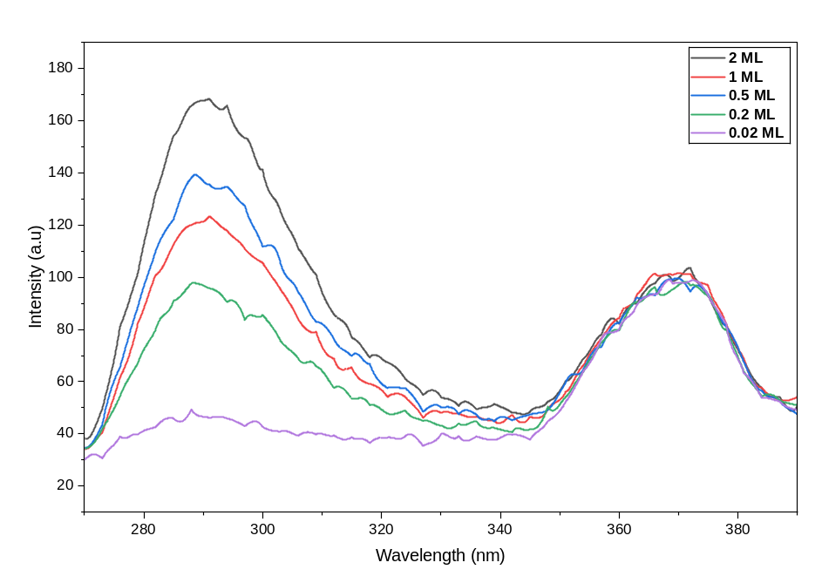
Figure 4.6. Emission spectra of the aqueous ibuprofen preparation series at 224 nm excitation.
4.3.3 Preliminary Aqueous Response Relationship
Fluorescence intensity at the selected emission region was plotted against the ordered aqueous preparation levels. The reported linear model was:
y = 17.495x + 74.944
with
R² = 0.944
The positive slope indicates increasing signal across the plotted sequence. Because x represents a preparation-order variable rather than a traceable final concentration in mg/mL, the numerical slope cannot be interpreted as analytical sensitivity. The intercept represents the combined baseline of the solvent, nanoparticle suspension, instrument, and any unmeasured background contribution.
These findings justify proceeding to matrix testing but do not establish accuracy or specificity. Formal calibration would require verified concentrations, independent preparations, replicate measurements, matrix-appropriate blanks, and residual evaluation.

Figure 4.7. Preliminary fitted response relationship for the aqueous preparation series.

4.3.4 Urine-Matrix Emission Response
The fortified urine preparations retained a measurable emission band near 290–300 nm at 224 nm excitation. A secondary band occurred near 365–375 nm but showed less separation among levels. The persistence of the principal band demonstrates that the response remained observable in the biological matrix; it does not, by itself, prove that the signal was selective for ibuprofen.
The reported order of principal-band intensity was:
1.00 mL > 2.00 mL > 0.50 mL > 0.20 mL > 0.10 mL > 0.02 mL
The 1.00 mL preparation produced a slightly stronger signal than the 2.00 mL preparation. This non-monotonic feature is analytically important and should not be concealed by the overall regression. It may reflect inner-filter behavior, concentration quenching, matrix interaction, particle dispersion, or measurement variability; only replicated experiments with appropriate blanks can distinguish among these possibilities.
Across the full series, the principal-band intensity ranged approximately from 50-55 a.u. to 155-160 a.u. The broad spectral shape is consistent with overlap among the analyte response, nanoparticle-associated optical effects, and endogenous urinary fluorescence. Because component-resolved blanks were not available, the relative contribution of each source cannot be quantified from these spectra alone (Bouatra et al., 2013; Lakowicz, 2006; Wishart et al., 2022).
The secondary band showed relatively limited level dependence and was therefore unsuitable as the primary quantitative region under the present conditions. Its persistence may reflect urinary background or the optical behavior of the nanosystem. Fluorescence-lifetime measurements and component controls would be needed to resolve its origin.
Overall, the urine experiment demonstrates matrix tolerance at a preliminary level: the principal signal remained detectable and broadly related to the preparation sequence. The irregular response at the highest level and absence of replicate uncertainty prevent stronger quantitative conclusions.
The result should therefore be stated as proof of feasibility in a fortified matrix, not as validated detection in authentic clinical urine and not as evidence of diagnostic capability.

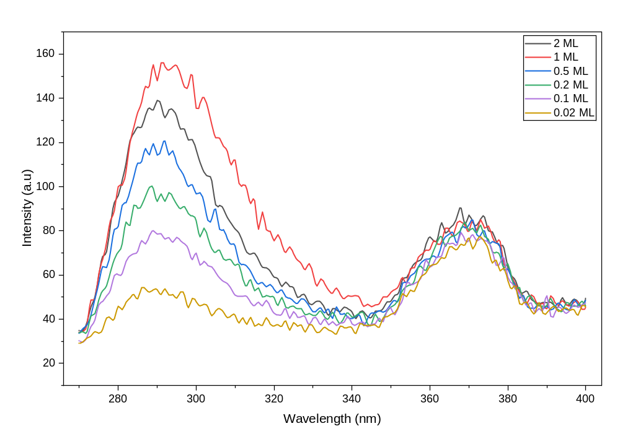
Figure 4.8. Emission spectra of the fortified urine preparation series at 224 nm excitation.
4.3.5 Preliminary Urine Response Relationship
A response plot was constructed for the urine series using fluorescence intensity and the original ordered preparation variable. The reported regression equation was:
The reported regression equation was:
$$y=16.898x+53.008$$
with a coefficient of determination of:
$$R^{2}=0.9765$$
The reported model yielded a slope of 16.898, an intercept of 53.008, and R² = 0.9765. The coefficient of determination describes agreement with the fitted line for the available points; it does not validate quantification, particularly because the highest spectral response occurred at 1.00 mL rather than 2.00 mL and because replicate variance was not measured.
The aqueous and urine slopes differed by approximately 3.4%. This similarity suggests that the response scale was not grossly attenuated in the tested urine matrix, but it cannot be interpreted as equivalence of analytical sensitivity because the x-axis was not a verified concentration scale and only one matrix source was examined.
The lower urine intercept relative to water indicates a difference in baseline response between the two series. The direction of this difference cannot be assigned mechanistically without matrix blanks, nanoparticle-only controls, and replicate measurements. Background fluorescence, absorption, scattering, and particle distribution are all plausible contributors.
Taken together, the urine data support continuation to a properly controlled validation study. They do not support claims of selective ibuprofen quantification, method accuracy, reproducibility, or clinical applicability. A defensible next step is matrix-matched calibration with traceable concentrations, independent sample preparations, multiple urine sources, component blanks, interference testing, and comparison with HPLC or LC–MS/MS.
Within these limitations, the experiment achieved its proof-of-concept objective by demonstrating an observable fluorescence response in fortified urine and by identifying the specific methodological issues that control subsequent method development.
4.3.6 Direct Cross-Matrix Comparison
The purpose of the direct cross-matrix comparison is to determine how transfer from distilled water to fortified urine changes the principal emission region, fitted response slope, intercept, coefficient of determination, and high-level response pattern under otherwise comparable preparation conditions.
The aqueous and urine series can be compared descriptively because they were prepared using the same nominal sample-to-nanoparticle volume ratio and measured under comparable settings. The principal emission region remained close to 290-300 nm in both matrices, indicating that the dominant responsive region persisted after matrix transfer.
The reported response slopes were 17.495 for water and 16.898 for fortified urine, a relative difference of approximately 3.4%. This numerical similarity suggests that the plotted response scale was not grossly suppressed in the tested urine sample. It must not be described as equivalence of analytical sensitivity because the x-axis represented ordered preparation levels rather than verified concentrations and no uncertainty was available for either slope.
The intercept decreased from 74.944 in water to 53.008 in urine, while R² increased from 0.944 to 0.9765. Neither change has a unique mechanistic interpretation. Intercepts can include blank response, particle background, instrument baseline, and extrapolation outside the observed range. A larger R² can result from point placement and does not compensate for the non-monotonic highest-level response.
The cross-matrix comparison therefore supports one limited conclusion: a measurable level-dependent response remained observable in the tested fortified urine matrix. It does not establish equal sensitivity, absence of matrix effect, or quantitative agreement.
Table 4.2. Descriptive comparison of the aqueous and fortified-urine fluorescence results
Analytical feature | Aqueous matrix | Fortified urine | Interpretation
Principal emission region | Approximately 290-295 nm | Approximately 290-300 nm | Responsive region remained broadly similar.
Secondary emission region | Approximately 365-375 nm | Approximately 365-375 nm | Limited separation among levels in both matrices.
Reported slope | 17.495 | 16.898 | Urine value approximately 3.4% lower; descriptive only.
Reported intercept | 74.944 | 53.008 | Different baseline/extrapolated response; mechanism unresolved.
Reported R² | 0.944 | 0.9765 | Both show fitted-line agreement; neither validates linearity.
Ordering at highest level | Monotonic across reported sequence | 1.00 mL exceeded 2.00 mL | Urine series contains a high-level non-monotonic feature.
Defensible conclusion | Aqueous feasibility | Preliminary matrix feasibility | Further controlled validation is justified.
Source: Calculated and summarized by the researcher from the reported experimental results. Slopes are per plotted preparation level, not concentration-based analytical sensitivities.
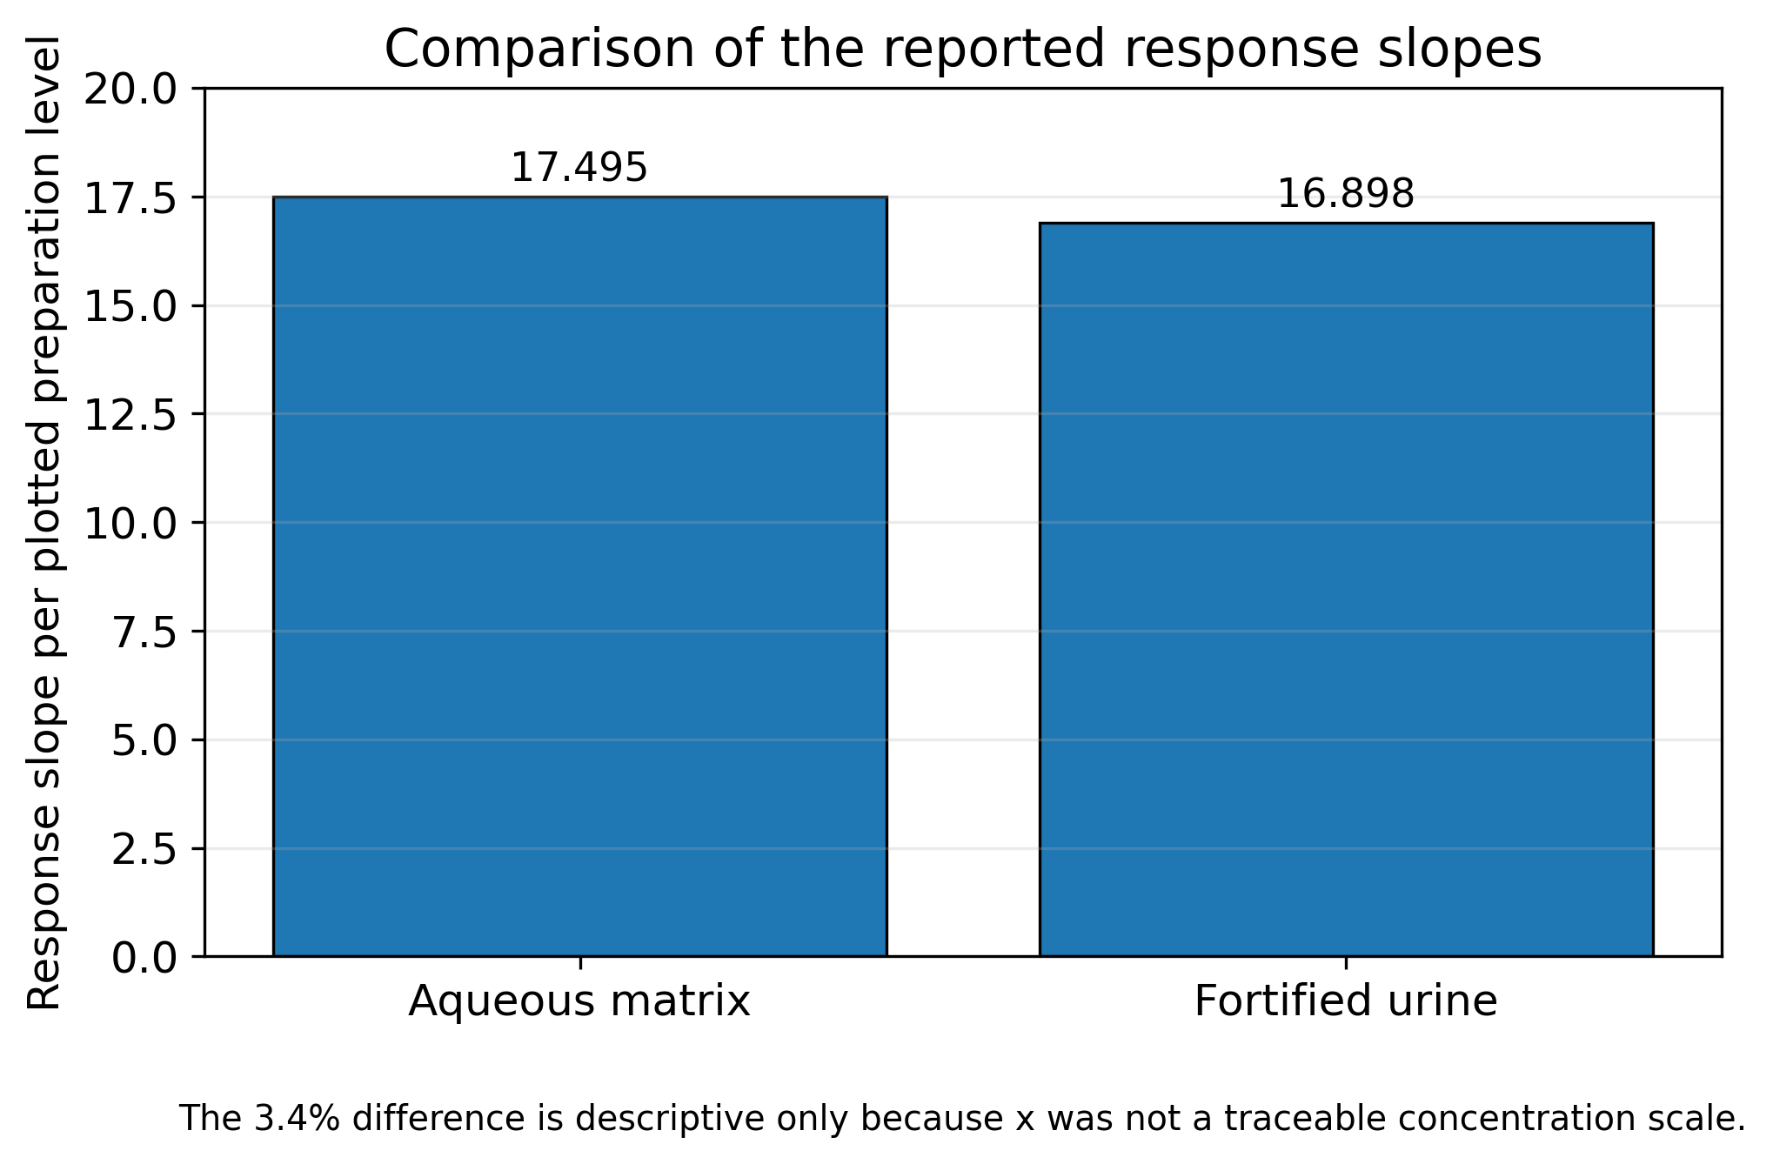
Figure 4.9. Descriptive comparison of the reported response slopes in water and fortified urine.
Source: Prepared from the reported regression equations in the present study.
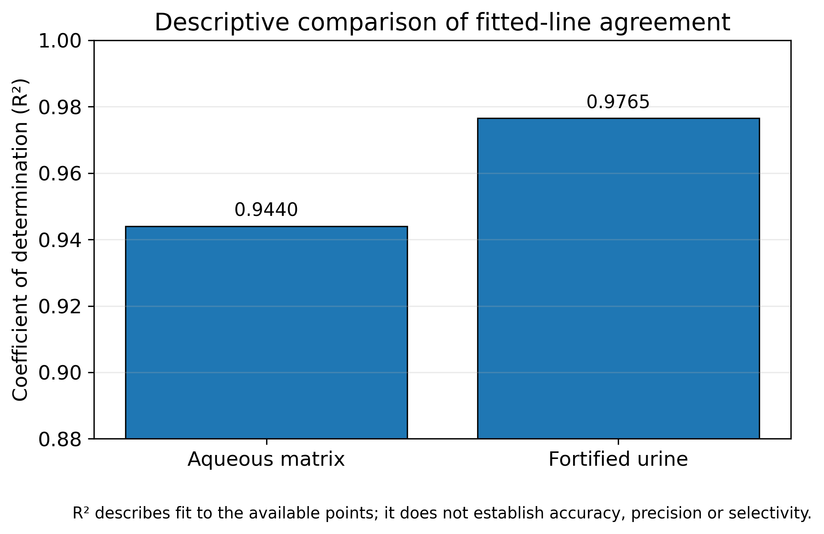
Figure 4.10. Descriptive comparison of the reported coefficients of determination.
Source: Prepared from the reported regression equations in the present study.
4.3.7 Interpretation of the Non-Monotonic High-Level Urine Response
The observation that the 1.00 mL urine preparation produced a slightly larger response than the 2.00 mL preparation is the most important deviation from monotonicity in the dataset. It should be retained in the discussion because suppressing or averaging the feature without replication would obscure a genuine uncertainty in the analytical behavior.
Several explanations are plausible. Higher absorbance can produce inner-filter effects; greater analyte or matrix concentration can increase static or dynamic quenching; particle aggregation can reduce accessible surface area; and preparation or reading variability can change the effective suspension concentration. A single steady-state spectrum cannot discriminate among these alternatives (Lakowicz, 2006; Kubista et al., 1994).
The correct follow-up experiment is a focused high-level dilution study with independently prepared replicates. Absorbance at the excitation and emission wavelengths should be measured, and the samples should be evaluated with and without particles. If the inversion disappears after dilution, an optical concentration effect becomes more plausible; if it varies across particle preparations, dispersion variability becomes more plausible.
Until those experiments are completed, the feature should be reported as an unresolved high-level deviation that constrains the working range. It is not appropriate to select the stronger of the two points or infer a mechanistic optimum from the existing data.

Figure 4.11. Preliminary fitted response relationship for the fortified urine preparation series.
4.4 Comparative Interpretation and Study Limitations
The combined evidence shows that the coated iron-based material produced an observable fluorescence response in both water and fortified urine. The most important scientific result is not the numerical R² alone, but the demonstration that matrix transfer was possible while revealing a non-monotonic high-level response and several unresolved background contributions. The study is limited by incomplete concentration documentation, one urine matrix source, absence of independent replicates and essential controls, unverified instrument-setting inconsistency between the thesis and manuscript, lack of recovery and selectivity studies, and absence of a reference-method comparison. These limitations define the work as an early proof of concept and materially restrict any claim of quantitative or clinical performance.
4.4.1 Evidence Hierarchy and Alternative Explanations
The results can be arranged in an evidence hierarchy. Direct observations include band positions, relative intensities, the broad XRD profile, AFM topography, FESEM morphology, and the fitted equations. Interpretations such as surface modification, matrix tolerance, and aggregation-related optical variability are supported but remain inferential. Claims of selective ibuprofen measurement, validated sensitivity, or diagnostic use are not supported.
Alternative explanations should be evaluated explicitly because fluorescence in a particle-containing matrix is a composite measurement. The signal may reflect intrinsic ibuprofen emission, endogenous urinary fluorescence, tannic-acid-associated absorption or emission, iron-oxide quenching, adsorption-driven changes in local environment, and scattering. The completed design does not partition these contributions.
A strong thesis discussion does not eliminate uncertainty through wording. It ranks explanations according to compatibility with the data and identifies the experiment that would discriminate among them. This approach converts limitations into a specific research plan and prevents the statistical appearance of a fitted line from replacing chemical evidence.
The evidence is interpreted hierarchically. Direct observations include spectral bands, relative intensity order, the XRD profile, AFM/FESEM images, and fitted equations. Supported interpretations include a modified iron-based nanosystem, a level-dependent aqueous response, and an observable response in fortified urine. Inner-filter effects, quenching, adsorption, and matrix-induced aggregation remain plausible but unresolved, whereas selective quantification, validated LOD/LOQ, diagnostic utility, and clinical exposure assessment were not established (ICH, 2023a).
4.5 Alignment of the Current Evidence with Analytical Standards
International guidance does not require every exploratory study to complete full validation, but it does require claims to remain proportional to the evidence. The present work meets the exploratory objective of demonstrating an observable response in a simple medium and a fortified biological matrix. It also identifies the principal conditions that require control before a quantitative procedure can be defined.
The study does not yet meet the requirements for a validated analytical procedure because concentration traceability is incomplete, independent replicates are absent, and selectivity, recovery, precision, detection capability, robustness, stability, and reference-method agreement were not established. These are not editorial deficiencies; they are experimental requirements.
The most defensible academic interpretation is therefore a staged one. The completed work is Phase I proof of concept. Reconstruction of concentrations, control experiments, and replicate feasibility testing constitute Phase II. Formal validation according to a defined intended use constitutes Phase III. Only after successful method comparison and multi-matrix testing should routine or clinical application be considered.
This alignment strengthens the thesis by locating the results within an internationally recognized development pathway. It also prevents future readers from treating the reported slopes and R² values as if they represented a complete analytical performance specification.
Relative to analytical-development requirements, the study partly defined the fluorescence principle and achieved a proof-of-concept response in fortified urine. It did not establish a documented concentration range, selectivity, accuracy and recovery, precision, LOD/LOQ, robustness, stability, or reference-method agreement. These deficiencies require concentration reconstruction, independent matrix-matched replication, interference and coated/uncoated controls, deliberate variation studies, stability testing, and paired HPLC or LC-MS/MS comparison (ICH, 2023a, 2023b; FDA, 2018).

Chapter Five
Conclusions and Recommendations

Chapter Five – Conclusions and Recommendations
5.1 Conclusions
The study evaluated a tannic-acid-coated iron oxide nanoparticle platform for fluorescence response to ibuprofen in water and fortified urine. The conclusions below are limited to the recorded experimental conditions and distinguish direct observations from interpretation.
The findings establish preliminary feasibility but not a validated analytical method. No conclusion is made regarding clinical diagnosis, patient exposure, therapeutic monitoring, or selective measurement of endogenous urinary biomarkers.
Based on the available characterization and fluorescence data, the following conclusions were reached:
1. The preparation procedure produced an iron-based nanoscale material containing tannic-acid-related functional groups. Convergence of FTIR, XRD, AFM, and FESEM findings supports surface modification, although coating efficiency and bonding mechanism were not quantified.
2. The XRD pattern was broad and poorly resolved, indicating low long-range crystallographic order. The data were insufficient for definitive phase assignment or crystallite-size calculation.
3. FTIR bands at 3430.92, 1631.39, 1061.87, and 635.43 cm⁻¹ were consistent with O–H, aromatic/carbonyl-related, C–O, and Fe–O vibrations. These bands provide qualitative support for an organic–inorganic coated material but do not quantify surface coverage.
4. AFM demonstrated heterogeneous nanoscale topography, with a peak-to-valley variation of approximately 8.114 nm and a maximum height of approximately 24.69 nm in the selected scan. The values describe local surface features rather than a complete particle-size distribution.
5. FESEM showed quasi-spherical nanoscale primary particles, approximately 20–80 nm by image-based estimation, together with substantial agglomeration. Aggregation is a likely source of optical and reproducibility variation and should be controlled in future studies.
6. The excitation scan identified approximately 224 nm as the maximum-response wavelength under the recorded conditions. The principal responsive emission region was near 290–295 nm in water and 290–300 nm in urine; the secondary band near 365–375 nm was less level-dependent.
7. The aqueous series showed an ordered increase in the principal-band intensity and produced the reported model y = 17.495x + 74.944 with R² = 0.944. This result supports preliminary level-dependent behavior but does not establish validated linearity, sensitivity, accuracy, or precision.
8. The urine series remained measurable and produced the reported model y = 16.898x + 53.008 with R² = 0.9765. However, the 1.00 mL preparation exceeded the 2.00 mL preparation in spectral intensity, indicating a possible high-level matrix, quenching, inner-filter, dispersion, or measurement effect that requires replication.
9. Similar response slopes in water and urine suggest that the tested matrix did not grossly suppress the plotted signal scale. Because exact final concentrations, replicate variability, and multiple urine sources were unavailable, this comparison cannot be interpreted as validated matrix equivalence or analytical sensitivity.
10. Overall, the study achieved a proof-of-concept demonstration of a nanoparticle-assisted fluorescence response to fortified ibuprofen in a urine matrix. Selective quantification, routine laboratory use, environmental biomonitoring, and clinical application remain unproven and require complete method development and validation.
5.2 Recommendations
The following focused recommendations are proposed to extend the method toward environmental application:
1. Apply the fluorescence platform to environmentally relevant matrices, particularly wastewater-treatment influent/effluent and surface water, using matrix-matched calibration and appropriate blank controls.
2. Validate the method using independent replicates and determine selectivity, recovery, precision, LOD, LOQ, robustness, and agreement with HPLC or LC–MS/MS before routine environmental quantification.
3. Optimize nanoparticle coating and dispersion by comparing coated and uncoated Fe3O4, measuring suspension size/zeta potential, and relating aggregation to fluorescence response.
4. Extend the approach to additional pharmaceutical contaminants and evaluate its potential as a rapid, low-cost screening tool within wastewater monitoring and One Health environmental-surveillance programs.

Chapter Six
References

References
aus der Beek, T., Weber, F.-A., Bergmann, A., Hickmann, S., Ebert, I., Hein, A., & Küster, A. (2016). Pharmaceuticals in the environment-Global occurrences and perspectives. Environmental Toxicology and Chemistry, 35(4), 823-835. https://doi.org/10.1002/etc.3339
Chapter Six – References
Barr, D. B., Wilder, L. C., Caudill, S. P., Gonzalez, A. J., Needham, L. L., & Pirkle, J. L. (2005). Urinary creatinine concentrations in the U.S. population: Implications for urinary biologic monitoring measurements. Environmental Health Perspectives, 113(2), 192-200. https://doi.org/10.1289/ehp.7337
Bernini, P., Bertini, I., Luchinat, C., Nincheri, P., Staderini, S., & Turano, P. (2011). Standard operating procedures for pre-analytical handling of blood and urine for metabolomic studies and biobanks. Journal of Biomolecular NMR, 49, 231-243. https://doi.org/10.1007/s10858-011-9489-1
Boxall, A. B. A., Rudd, M. A., Brooks, B. W., et al. (2012). Pharmaceuticals and personal care products in the environment: What are the big questions? Environmental Health Perspectives, 120(9), 1221-1229. https://doi.org/10.1289/ehp.1104477
Bouatra, S., Aziat, F., Mandal, R., Guo, A. C., Wilson, M. R., Knox, C., et al. (2013). The human urine metabolome. PLOS ONE, 8(9), e73076. https://doi.org/10.1371/journal.pone.0073076
Bushra, R., & Aslam, N. (2010). An overview of clinical pharmacology of ibuprofen. Oman Medical Journal, 25(3), 155-166. https://doi.org/10.5001/omj.2010.49
Centers for Disease Control and Prevention. (2009). Fourth national report on human exposure to environmental chemicals. U.S. Department of Health and Human Services.
Clinical and Laboratory Standards Institute. (2012). Evaluation of detection capability for clinical laboratory measurement procedures; Approved guideline—Second edition (CLSI document EP17-A2). CLSI.
Cornell, R. M., & Schwertmann, U. (2003). The iron oxides: Structure, properties, reactions, occurrences and uses (2nd ed.). Wiley-VCH.
Daughton, C. G., & Ternes, T. A. (1999). Pharmaceuticals and personal care products in the environment: Agents of subtle change? Environmental Health Perspectives, 107(Suppl. 6), 907-938. https://doi.org/10.1289/ehp.99107s6907
Davies, N. M. (1998). Clinical pharmacokinetics of ibuprofen: The first 30 years. Clinical Pharmacokinetics, 34(2), 101-154. https://doi.org/10.2165/00003088-199834020-00002
Delanghe, J. R., & Speeckaert, M. M. (2014). Preanalytical requirements of urinalysis. Biochemia Medica, 24(1), 89-104. https://doi.org/10.11613/BM.2014.011
Ejima, H., Richardson, J. J., Liang, K., Best, J. P., van Koeverden, M. P., Such, G. K., Cui, J., & Caruso, F. (2013). One-step assembly of coordination complexes for versatile film and particle engineering. Science, 341(6142), 154-157. https://doi.org/10.1126/science.1237265
Fent, K., Weston, A. A., & Caminada, D. (2006). Ecotoxicology of human pharmaceuticals. Aquatic Toxicology, 76(2), 122-159. https://doi.org/10.1016/j.aquatox.2005.09.009
Gupta, A. K., & Gupta, M. (2005). Synthesis and surface engineering of iron oxide nanoparticles for biomedical applications. Biomaterials, 26(18), 3995-4021. https://doi.org/10.1016/j.biomaterials.2004.10.012
Hotze, E. M., Phenrat, T., & Lowry, G. V. (2010). Nanoparticle aggregation: Challenges to understanding transport and reactivity in the environment. Journal of Environmental Quality, 39(6), 1909-1924. https://doi.org/10.2134/jeq2009.0462
International Council for Harmonisation of Technical Requirements for Pharmaceuticals for Human Use. (2023a). ICH harmonised guideline Q2(R2): Validation of analytical procedures.
International Council for Harmonisation of Technical Requirements for Pharmaceuticals for Human Use. (2023b). ICH harmonised guideline Q14: Analytical procedure development.
Khanbabaee, K., & van Ree, T. (2001). Tannins: Classification and definition. Natural Product Reports, 18(6), 641-649. https://doi.org/10.1039/B101061L
Kubista, M., Sjöback, R., Eriksson, S., & Albinsson, B. (1994). Experimental correction for the inner-filter effect in fluorescence spectra. Analyst, 119, 417-419. https://doi.org/10.1039/AN9941900417Lakowicz, J. R. (2006). Principles of fluorescence spectroscopy (3rd ed.). Springer.
Laurent, S., Forge, D., Port, M., Roch, A., Robic, C., Vander Elst, L., & Muller, R. N. (2008). Magnetic iron oxide nanoparticles: Synthesis, stabilization, vectorization, physicochemical characterizations, and biological applications. Chemical Reviews, 108(6), 2064-2110. https://doi.org/10.1021/cr068445e
Long, G. L., & Winefordner, J. D. (1983). Limit of detection: A closer look at the IUPAC definition. Analytical Chemistry, 55(7), 712A-724A. https://doi.org/10.1021/ac00258a001
Lu, A.-H., Salabas, E. L., & Schüth, F. (2007). Magnetic nanoparticles: Synthesis, protection, functionalization, and application. Angewandte Chemie International Edition, 46(8), 1222-1244. https://doi.org/10.1002/anie.200602866
Magnusson, B., & Örnemark, U. (Eds.). (2014). Eurachem guide: The fitness for purpose of analytical methods—A laboratory guide to method validation and related topics (2nd ed.). Eurachem.
Matuszewski, B. K., Constanzer, M. L., & Chavez-Eng, C. M. (2003). Strategies for the assessment of matrix effect in quantitative bioanalytical methods based on HPLC-MS/MS. Analytical Chemistry, 75(13), 3019-3030. https://doi.org/10.1021/ac020361s
Mourdikoudis, S., Pallares, R. M., & Thanh, N. T. K. (2018). Characterization techniques for nanoparticles: Comparison and complementarity upon studying nanoparticle properties. Nanoscale, 10, 12871-12934. https://doi.org/10.1039/C8NR02278J
Nel, A. E., Mädler, L., Velegol, D., Xia, T., Hoek, E. M. V., Somasundaran, P., Klaessig, F., Castranova, V., & Thompson, M. (2009). Understanding biophysicochemical interactions at the nano-bio interface. Nature Materials, 8, 543-557. https://doi.org/10.1038/nmat2442
Piechocka, J., Matwiej, N., Gaweł, M., Matyjaszczyk, M., Głowacki, R., & Chwatko, G. (2023). Application of the HPLC-ELSD technique for the determination of major metabolites of ibuprofen and creatinine in human urine. Scientific Reports, 13, 20268. https://doi.org/10.1038/s41598-023-47594-8
Quideau, S., Deffieux, D., Douat-Casassus, C., & Pouységu, L. (2011). Plant polyphenols: Chemical properties, biological activities, and synthesis. Angewandte Chemie International Edition, 50(3), 586-621. https://doi.org/10.1002/anie.201000044
Sequeira-Antunes, B., Silva, A., Veiga, A., Figueira, M., & Diniz, M. S. (2023). Urinary biomarkers and point-of-care urinalysis devices for early disease diagnosis. Biosensors, 13(4), 421. https://doi.org/10.3390/bios13040421
Sileika, T. S., Barrett, D. G., Zhang, R., Lau, K. H. A., & Messersmith, P. B. (2013). Colorless multifunctional coatings inspired by polyphenols found in tea, chocolate, and wine. Angewandte Chemie International Edition, 52(41), 10766-10770. https://doi.org/10.1002/anie.201304922
Świacka, K., Michnowska, A., Maculewicz, J., Caban, M., & Smolarz, K. (2021). Toxic effects of NSAIDs in non-target species: A review from the perspective of the aquatic environment. Environmental Pollution, 273, 115891. https://doi.org/10.1016/j.envpol.2020.115891
Taverniers, I., De Loose, M., & Van Bockstaele, E. (2004). Trends in quality in the analytical laboratory. II. Analytical method validation and quality assurance. TrAC Trends in Analytical Chemistry, 23(8), 535-552. https://doi.org/10.1016/j.trac.2004.04.001
Thompson, M., Ellison, S. L. R., & Wood, R. (2002). Harmonized guidelines for single-laboratory validation of methods of analysis. Pure and Applied Chemistry, 74(5), 835-855. https://doi.org/10.1351/pac200274050835
Tkalec, Ž., Runkel, A. A., Kosjek, T., Horvat, M., & Heath, E. (2023). Contaminants of emerging concern in urine: A review of analytical methods for determining selected emerging contaminants. Environmental Science and Pollution Research, 30, 95106-95138. https://doi.org/10.1007/s11356-023-29070-y
U.S. Food and Drug Administration. (2018). Bioanalytical method validation: Guidance for industry.
Valeur, B., & Berberan-Santos, M. N. (2012). Molecular fluorescence: Principles and applications (2nd ed.). Wiley-VCH.
Vermeulen, R., Schymanski, E. L., Barabási, A.-L., & Miller, G. W. (2020). The exposome and health: Where chemistry meets biology. Science, 367(6476), 392-396. https://doi.org/10.1126/science.aay3164
Vorkamp, K., Castaño, A., Antignac, J.-P., et al. (2021). Biomarkers, matrices and analytical methods targeting human exposure to chemicals selected for a European human biomonitoring initiative. Environment International, 146, 106082. https://doi.org/10.1016/j.envint.2020.106082
Waikar, S. S., Sabbisetti, V. S., & Bonventre, J. V. (2010). Normalization of urinary biomarkers to creatinine during changes in glomerular filtration rate. Kidney International, 78(5), 486-494. https://doi.org/10.1038/ki.2010.165
WHO Regional Office for Europe. (2015). Human biomonitoring: Facts and figures. World Health Organization.
WHO Regional Office for Europe. (2023). Human biomonitoring: Assessment of exposure to chemicals and their health risks. World Health Organization. https://www.who.int/europe/publications/i/item/WHO-EURO-2023-7574-47341-69480
Wild, C. P. (2005). Complementing the genome with an “exposome”: The outstanding challenge of environmental exposure measurement in molecular epidemiology. Cancer Epidemiology, Biomarkers & Prevention, 14(8), 1847-1850. https://doi.org/10.1158/1055-9965.EPI-05-0456
Wilkinson, J. L., Boxall, A. B. A., Kolpin, D. W., et al. (2022). Pharmaceutical pollution of the world's rivers. Proceedings of the National Academy of Sciences, 119(8), e2113947119. https://doi.org/10.1073/pnas.2113947119
Wishart, D. S., Guo, A., Oler, E., Wang, F., Anjum, A., Peters, H., et al. (2022). HMDB 5.0: The Human Metabolome Database for 2022. Nucleic Acids Research, 50(D1), D622-D631. https://doi.org/10.1093/nar/gkab1062
World Health Organization. (2020). Laboratory biosafety manual (4th ed.). World Health Organization.
World Medical Association. (2013). World Medical Association Declaration of Helsinki: Ethical principles for medical research involving human subjects. JAMA, 310(20), 2191-2194. https://doi.org/10.1001/jama.2013.281053
Chaudhari, D. S., Upadhyay, R. P., Shinde, G. Y., Gawande, M. B., Filip, J., Varma, R. S., & Zbořil, R. (2024). A review on sustainable iron oxide nanoparticles: Syntheses and applications in organic catalysis and environmental remediation. Green Chemistry, 26, 7579–7655. https://doi.org/10.1039/D4GC01870B
Jan-Roblero, J., & Cruz-Maya, J. A. (2023). Ibuprofen: Toxicology and biodegradation of an emerging contaminant. Molecules, 28(5), 2097. https://doi.org/10.3390/molecules28052097
Mohammed, A. M., Abbas, A. F., & Hussein, H. M. (2025). Performance evaluation of wastewater treatment plants in removing ibuprofen: A case study of Babylon Governorate, Iraq. International Journal of Environmental Impacts, 8(2), 311–320. https://doi.org/10.18280/ijei.080211
One Health High-Level Expert Panel (OHHLEP), Adisasmito, W. B., Almuhairi, S., Behravesh, C. B., et al. (2022). One Health: A new definition for a sustainable and healthy future. PLOS Pathogens, 18(6), e1010537. https://doi.org/10.1371/journal.ppat.1010537
TESCAN. MIRA3 FEG-SEM: Instructions for use and instrument specifications. Accelerating-voltage range 200 V–30 kV; high-vacuum SE resolution approximately 1.5 nm at 15 kV.
Volans, G. N., Monaghan, J., & Colbridge, M. G. (2003). Ibuprofen overdose. International Journal of Clinical Practice Supplement, 135, 54–60. PMID: 12723749.

الخلاصة
استهدفت هذه الدراسة المخبرية، التي تهدف إلى إثبات المفهوم، التحقق من جدوى استخدام جسيمات أكسيد الحديد النانوية المغلفة بحمض التانيك كسطح مساعد للكشف الفلوري عن الإيبوبروفين، الذي تم اختياره كنموذج لمادة تحليلية حيوية دوائية، في محلول مائي وعينة بول بشري مُدعّمة. صُمم العمل لربط تحضير المواد النانوية وتوصيفها الفيزيائي والكيميائي بالتقييم التحليلي الأولي في وسط بسيط ومصفوفة بيولوجية معقدة.
تم تعديل سطح جسيمات أكسيد الحديد النانوية بحمض التانيك، وتم توصيفها باستخدام مطيافية الأشعة تحت الحمراء بتحويل فورييه (FTIR)، وحيود الأشعة السينية (XRD)، ومجهر القوة الذرية (AFM)، ومجهر المسح الإلكتروني ذي الانبعاث الميداني (FESEM). أظهرت تقنية FTIR حزمًا عند 3430.92 و1631.39 و1061.87 و635.43 سم⁻¹، تتوافق مع اهتزازات الهيدروكسيل، والروابط العطرية/الكربونيلية، وC–O، وFe–O. وأظهرت تقنية XRD نطاقًا واسعًا منخفض الشدة، بينما أوضحت تقنيتا AFM وFESEM مورفولوجيا نانوية خشنة مع تكتل جزئي. تدعم هذه النتائج التكميلية، ولكنها لا تثبت بحد ذاتها، نجاح تعديل سطح الجسيمات النانوية الحديدية. استُخدم محلول إيبوبروفين بتركيز 1 ملغم/مل لتحضير تراكيز عمل منتظمة في الماء المقطر وبول الإنسان. خُلطت أحجام متساوية من كل عينة مُحضّرة مع معلق الجسيمات النانوية المغلفة قبل قياس التألق. وحدد مسح الإثارة الطول الموجي 224 نانومتر كطول موجي يُنتج أقوى استجابة في ظل الظروف المسجلة. كان نطاق الانبعاث الرئيسي المستجيب للتركيز تقريبًا 290-295 نانومتر في الماء و290-300 نانومتر في البول؛ بينما أظهر نطاق ثانوي بالقرب من 365-375 نانومتر تباينًا أقل بين المستويات المختبرة.
أعطت سلسلة المحاليل المائية معادلة الانحدار المذكورة y = 17.495x + 74.944 بمعامل تحديد R² = 0.944، بينما أعطت سلسلة البول y = 16.898x + 53.008 بمعامل تحديد R² = 0.9765. ولأن x يمثل مستويات تحضير مرتبة وليس مقياس تركيز مطلق موثق بالكامل، فلا ينبغي تفسير قيم الميل على أنها حساسية تحليلية معتمدة. إضافةً إلى ذلك، أظهرت أطياف البول سمة غير رتيبة عند أعلى مستوى، مما يشير إلى أن تأثيرات المصفوفة، أو سلوك المرشح الداخلي، أو التثبيط، أو تباين التشتت قد تكون أثرت على الاستجابة.
تُظهر النتائج أن النظام المقترح قد ولّد استجابة فلورية قابلة للقياس، تعتمد على مستوى التركيز، في كلا الوسطين، مما يُثبت جدواه المبدئية لتطوير الطريقة لاحقًا. مع ذلك، لم تتضمن الدراسة قياسات مُكررة مستقلة، أو عينات تحكم سلبية كاملة للكواشف والمصفوفة، أو اختبارات انتقائية، أو تجارب استرداد، أو حدود الكشف والقياس الكمي، أو تقدير عدم اليقين، أو مقارنة مع طريقة مرجعية. وعليه، لا تُشكل هذه النتائج طريقة كمية مُعتمدة، أو فحصًا سريريًا انتقائيًا، أو دليلًا على إمكانية تطبيقها تشخيصيًا.
تتمثل المساهمة الرئيسية للدراسة في دمج تعديل سطح الجسيمات النانوية، والتحليل متعدد التقنيات، واختبار الفلورة في المصفوفة الحقيقية ضمن إطار تجريبي واحد. ينبغي أن تُحدد الدراسات المستقبلية معايرة دقيقة قائمة على التركيز، وتقييم عينات بول متعددة، وإدراج ضوابط وتكرارات أساسية، وتحديد الأداء التحليلي وفقًا لإرشادات التحقق الدولية، ومقارنة الاستجابة المقترحة مع طريقة كروماتوغرافية مُعتمدة.

جمهورية العراق
وزارة التعليم العالي والبحث العلمي
جامعة القادسية / كلية العلوم
قسم البيئة
الكشف الفلوري عن بعض المحللات البيولوجية في بول الانسان

رسالة مقدمة إلى مجلس كلية العلوم /جامعة القادسية كجزء من متطلبات نيل شهادة الماجستير في علوم البيئة
من قبل
الكوثر هاتف عوده
بكالوريوس علوم بيئة جامعة القاسم الخضراء 2023
بإشراف
أ.د حازم عبد والي
أ.د بسام فرعون عبد

