Analysis of the Relationship between Investment Expenditure and Financial Inclusion in Iraq using the model (Granger Causality)
Prof. Dr. Salim Sallal Rahi Al-Hassnawi
salim.rahi@qu.edu.iq

Zinah Sadq Zwer
zenoqween772@gmail.com
University of Al-Qadisiya / College of Administration and Economics
Abstract:
The study dealt with the relationship between investment expenditure and financial inclusion in Iraq for the period (2010-2021), as the importance of this relationship is determined by the success of governments in the task of employing the available capabilities and resources in achieving financial inclusion. The analytical quantitative method used Granger Causality to clarify the aforementioned relationship based on the dynamic relationship that exists between the time series of the study variables, and the study aimed to identify the scientific implications of both investment expenditure and financial inclusion, and the researcher reached some conclusions and recommendations.
Firstly: Introduction:
The issue of the relationship between investment expenditure and financial inclusion has received the attention of many developers and financiers, in an attempt to answer the following question: Does investment expenditure lead to an increase in financial inclusion, especially in the long term, through improving the living conditions of individuals and expanding the range of opportunities and choices in front of them (opportunities to live a secure life and Karima)? An intellectual trend has emerged in this regard that confirms that investment expenditure in any country is a necessary and not sufficient condition for increasing financial inclusion, since investment expenditure is linked to the rate of growth of the gross domestic product first and the method of distributing that output to members of society secondly, when it is accompanied by investment expenditure a high rate of economic growth and a decrease in inequality in income distribution, which could lead to an increase in financial inclusion.
It must be noted that the effectiveness of investment expenditure in enhancing financial inclusion in any society is determined by the extent to which the community owns the sources of investment expenditure and its ability to control and dispose of them to maximize wealth on the one hand, and on the other hand the pattern of performance in managing these sources to generate and maximize income.
Secondly: Methodology of the Study
Through the methodology of the study, the researcher seeks to answer the knowledge problems that arise in it through the use of financial and statistical means to reach acceptable scientific results according to sound scientific foundations that contribute to achieving the goal of the study. In this section, we discuss the most important contents related to the methodology of the study that is known and applied scientifically, namely:
1. Study problem
The study problem centered on the following questions:
Is there a relationship between investment expenditure and financial inclusion in Iraq?
2. Study Hypothesis:
According to the question raised by the problem of the study, and to achieve its objectives, the following hypothesis can be put forward:
There is a causal relationship between investment expenditure and financial inclusion in Iraq.
3. The importance of the study:
The importance of the study is evident by identifying the role of investment expenditure in enhancing financial inclusion in Iraq, as these variables contribute to the growth and strengthening of the production wheel through the provision of financial inclusion of all banking services to all segments of society.
4. Objectives of the study:
The study aims to identify the following:
• The scientific implications of each investment expenditure and financial inclusion in Iraq.
• The reality of investment expenditure and financial inclusion in Iraq in light of its most important indicators and analysis.
• The role of investment expenditure in promoting financial inclusion in Iraq.
5. Limitations of the study:
• Spatial boundaries: The spatial boundaries of the study are the Iraqi economy.
• Temporal limits: the period of investment expenditure data and financial inclusion indicators that were approved in the study for the period (2010-2021).
• Knowledge limits: represented by the variables (investment expenditure and financial inclusion).
Third: The theoretical framework for investment expenditure and financial inclusion
Economic schools, in their various orientations, have long been interested in studying the concepts of investment expenditure and financial inclusion, and intellectual contributions have appeared in finding specific and accurate definitions of these concepts:
1. The concept of investment expenditure
Investment expenditure has a special importance as it is the second component of income after consumption, and its vulnerability to fluctuations leads to several fluctuations in the economy, and that government investment in its general sense is a stream of expenditure on new fixed capital goods such as factories, machinery or roads, as well as additions to inventory such as raw materials or Final goods and new housing construction over some time. In other words, it refers to the expenditure on capital equipment for long periods (more than a year), building new projects, or expanding its production capacities, which means adding to stock and implementing long-term plans and strategies set by the state. (Hamsa, Omar , 2019, pp. 22-89).
Investment is defined as "the use of savings in the formation of investments necessary for the production of goods and services and the maintenance or renewal of existing productive capacities" (Omar, 2000, 37).
It was also defined as "abandoning the use of current funds for a certain period to obtain more cash flows in the future that serve as compensation for the present value of the invested funds, as well as compensation for the expected decrease in the purchasing power of the invested funds due to inflation with the possibility of obtaining a reasonable return in return for bearing The element of risk, which is the possibility that these flows will not materialize (Kazem, 2001, 16).
2. The concept of financial inclusion:
After the global financial crisis in 2008, the interest of international financial institutions, central banks, and monetary institutions increased in achieving financial inclusion. To provide innovative and diverse services at a low cost to the poor.
The generalization of financial services and facilitating access to them by all segments of society, according to World Bank experts, constitutes a major lever for combating unemployment and poverty, improving living conditions, and increasing citizens' options and their ability to initiate the establishment of their small projects and exploit opportunities. Increasing growth in the volume of its operations and profits on the other hand, in other words, the basic idea behind what is meant by financial inclusion is to promote and facilitate access for all segments of society to financial services and enable them to use them properly, as well as providing various and innovative financial services at a low cost through these providers of the services.
There are many concepts of financial inclusion. Perhaps the most prominent of these concepts is financial inclusion or comprehensive financing. Some of them called it financial support, and some called it financial inclusion or financial access, but they all revolve around one circle and the same purpose, which is to work on developing financial institutions and banking, intensifying its efforts and diversifying its tools to attract people with limited incomes and link them to the official financial system that may support their financial decisions and confront them with financial shocks (Hassan, 2018: 6). Accordingly, financial inclusion has been defined by several definitions that differ among themselves according to the opinions of researchers, but in general they revolve around one meaning.
3. The relationship between investment expenditure and financial inclusion
The issue of the relationship between investment expenditure and financial inclusion has received the attention of many development lists , financiers, and the rest of the economic thinkers, in an attempt to answer the following question: Does investment expenditure lead to an increase in financial inclusion, especially in the long term, through improving the living conditions of individuals and expanding the range of opportunities and choices before them (opportunities to live a safe and decent life), and an intellectual trend has emerged in this regard confirming that investment expenditure in any country is a necessary and not sufficient condition for increasing financial inclusion, since investment expenditure is linked to the rate of growth of the gross domestic product first and the method of distributing that output to the members of society secondly, when Investment expenditure is accompanied by a high rate of economic growth and a decrease in inequality in income distribution, which can lead to an increase in financial inclusion.
The increase in investment expenditure results in generating new investments in capital goods and building a large stock of human capital through increased investment in education and training, which may require institutional changes necessary to maximize the potential return from new physical and human investments, in addition to that these changes may include Some different activities, such as making a change in credit systems and the existing banking structure, and modifying the structures of educational and training programs to make them more appropriate to the needs of members of society, as well as achieving better governance that contribute to enhancing financial inclusion and expanding the base of financial participation of individuals in the economy.
Improving productivity is an important source of sustainable, non-inflationary improvements in living standards and employment opportunities; Because increasing productivity may lead to an increase in wages and to activating the cycle of economic growth and investment expenditure, which in turn leads to additional increases in productivity and members of society will enjoy better health and more education, and this will enable them to increase demand or expenditure on consumption, which activates the national economy, and with increased income The level of personal saving and investment increases, and then the level of financial inclusion in society improves. On the contrary, when investment is not done adequately, this leads to weak economic growth and deterioration of the financial conditions of individuals and leads to the inability to obtain basic financial services, and thus decreases. The level of financial inclusion in society.
Finally, it must be pointed out that the effectiveness of investment expenditure in enhancing financial inclusion in any society is determined by the extent to which the community owns the sources of investment expenditure and its ability to control and dispose of them to maximize wealth on the one hand, and on the other hand, the performance pattern in managing these sources to generate and maximize income.
Fourthly. Description and analysis of investment expenditure data in Iraq for the period (2010-2021)
Investment is one of the most important pillars of the economic growth process and one of the determinants of productive capacities, as there is no production without investment. Figure (1) shows trends in the development of investment expenditure in Iraq.
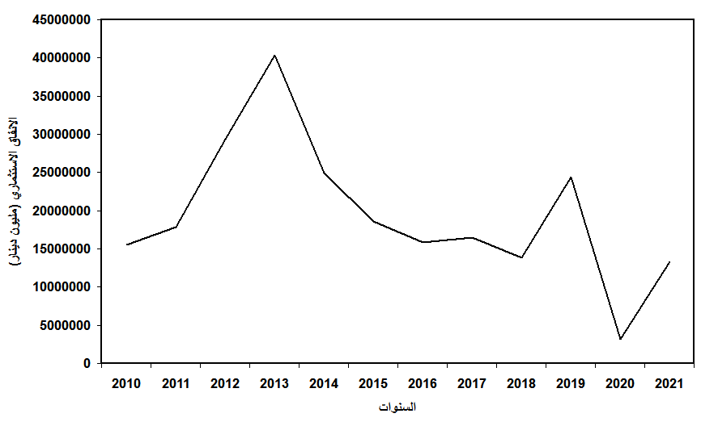
Figure (1) The evolution of investment expenditure in Iraq for the period (2010-2021)
Reference: Central Bank of Iraq, General Directorate of Statistics and Research, Annual Statistical Bulletin for the years (2010-2021)
The above figure shows that the values of investment expenditure fluctuated from the total government expenditure during the period (2010-2021), as it increased in a certain year and decreased in another year. This is because the Iraqi economy is a rentier economy in which the economy depends on oil revenues, which are linked to global supply and demand.
The data indicates that investment expenditure in 2010 reached about (15.5) trillion dinars. It rose in 2011 to (17.8) trillion dinars, with a growth rate of about (14.65%) as a result of the increase in oil revenues and the rise in the price of the barrel of oil to (103) dollars after it was (75) dollars per barrel in (2010), and investment expenditure continued to rise in (2012) as it reached about (29.3) trillion dinars, an increase of (11.5) trillion dinars over the previous year; This increase is due to the increase in government expenditure to about (105.1) trillion dinars in the year (2012).
In 2013, investment expenditure recorded an increase of about (37.85%), bringing a total of about (40.3) trillion dinars, or (13.3%) of government expenditure, which amounted to about (11.9) trillion dinars; This is due to the rise in oil prices and the increase in the quantities exported from it, and the improvement of the security situation, which in turn was reflected in the increase in oil revenues. Investment expenditure is (24.9) trillion dinars, a decrease of (38.26%) compared to the year (2013), and it constituted (29.84%) of government expenditure.
The economic and financial crisis that Iraq went through since the middle of the year (2014) continued, in addition to the unstable political and security conditions affecting the Iraqi economy negatively, causing contraction and clear stagnation in the various activities of the economic sectors, which was reflected in the decrease in public revenues in the year (2015), as the figure indicates (1) This decline is mainly due to the decrease in the activity of the crude oil sector by (44%) compared to the year (2014) and the result of the decrease in the price of a barrel of crude oil to (54.4) dollars in the second quarter of the year (2015) compared to (101.4) dollars in In the year (2014), this resulted in a decrease in total investment expenditure to (18.5) trillion dinars, a decrease of (6.4) trillion dinars from the previous year, and a percentage of (26.3) of government expenditures.
In the year (2016), the decline in investment expenditure continued and amounted to about (15.8) trillion dinars, a decrease of (3.2) trillion dinars from the previous year, and it constituted (23.7) percent of government expenditure.
The security situation improved during the year (2017), and oil prices rose, making investment expenditure return to the forefront of the rise. This is due to the rise in the price of a barrel of crude oil, as it recorded (48.3) dollars compared to (24.9) dollars per barrel for the same quarter in 2016. This resulted in an increase in investment expenditure to (16.4) trillion dinars, and the total government expenditure to (16.4) trillion dinars. (75.5) trillion dollars, with an increase of (8.4) over the previous year, as the proportion of investment expenditure out of government expenditure was about (21.8%).
Government expenditure in 2018 recorded a growth of about (7.13%), with a value of (80.8) trillion dinars, compared to (75.5) trillion dinars for the year (2017), while investment expenditure recorded a decrease of about (16.0) compared to the previous year, with a value of (13.8). ) trillion dinars. The same applies to the proportion of investment expenditure from government expenditure, as it decreased to (17.0%).
As for the year (2019), public revenues recorded a slight increase due to the increase in oil revenues by (3.8%) as a result of the increase in the amount of crude oil production, as oil revenues accounted for the largest share of total revenues, with a contribution rate of (92.2%) and an amount of (92.2%). (99.2) trillion Iraqi dinars, this was reflected in government expenditure, which grew by (38.1%) to reach (111.7) Iraqi dinars, compared to (80.8) trillion Iraqi dinars in 2018; This increase is due to the growth of investment expenditure by (76.7%), with value of about (24.4) trillion, which constitutes (21.8%) of government expenditure.
The year (2020) witnessed a significant decrease in investment expenditure, amounting to about (86.9-%), to reach (3.2) trillion dinars, compared to (24.4) trillion dinars, compared to the previous year, and this decrease is attributed to the Corona pandemic and the suspension of most projects, in addition to the decline in public revenues, which It led to a reduction in public expenditures by about (31.9%), and investment expenditures as well, and for all sectors of the national economy, so that the percentage of investment expenditure from government expenditure reached about (4.22%).
Investment expenditure rose again in (2021) to reach (13.3) trillion and grew by (315.2%) compared to the year (2020). Of it, about (12.9%), all of which is attributed to the increase in public revenues by (72.6%) compared to the previous year, which led to an increase in public expenditures to cover the economic and administrative requirements of the state.
Fifth: Description and analysis of financial inclusion data in Iraq for the period (2010-2021)
The focus will be on some indicators of financial inclusion in Iraq, which show us the extent to which the financial sector enjoys the flexibility and the ability to be applied within society, and these indicators are as follows:
1. An indicator of the number of bank branches in Iraq.
The indicator of number of bank branches is one of the most important indicators of financial inclusion. Increasing the number of branches facilitates the process of its spread, helps in improving the efficiency of distributing financial services, and contributes to providing more choices of services that are offered by banks.
They lead to an increase in investment rates and economic growth. Also, through the number of banking branches, it is possible to know the banking density and banking spread, which are among the important indicators that depend upon when measuring financial inclusion. Figure (2) shows these indicators in Iraq.
The number of bank branches varied during the study period from (2010-2021), as the number of bank branches in (2010) reached about (871) bank branches, with a banking density of (37.3) for each single branch, and with a banking penetration rate of (2.6).

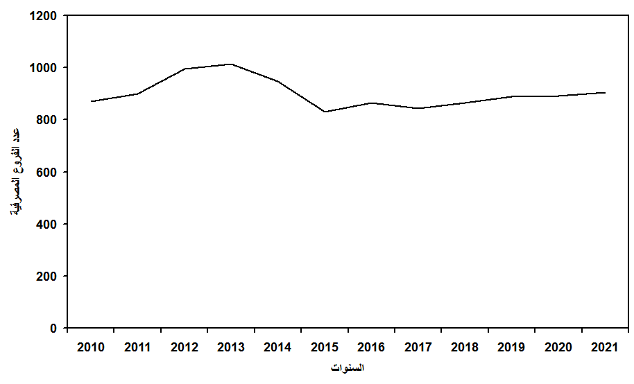
Figure (2) The evolution of the number of bank branches in Iraq for the period (2010-2021)
Source: Prepared by the researcher based on the annual statistical releases of the Central Bank of Iraq (2010-2021).
Then the number of banking branches continued to increase gradually, as it became in the year (2011) an estimated (899) branches, while the banking density reached about (37.0) for every single branch, and the banking spread was (2.7), as the increase in the ratios of this indicator reflects the high efficiency of the banking system In the establishment of new branches until it reached about (994) bank branches in the year (2012) and the increase in the banking spread rate to approximately (2.90), with the decrease in banking density to about (34.4), and as a result of the continuous increase in the number of bank branches, it reached (1014). A bank branch in (2013) and an increase in the banking penetration rate to (2.96) and a decrease in the banking density to (34.6).
Through the above figure, we notice that banking proliferation and density continue to maintain their levels in Iraq as a result of the deterioration of the security situation since mid-2014 and the occupation of several Iraqi governorates by terrorist organizations, which led to the closure of several governmental and private banking branches, in addition to the small number of widespread banks. In the whole country, the lack of solid banking plans to expand the network of banking branches and the decline in the banking prevalence index during the subsequent years, and this in turn prevented the process of access and access to financial services and the benefit of a larger number of segments of society, which led to a decline in the quality of services and a decline in performance efficiency, and decreased Banking branches fell to the lowest level in the subsequent years, until the number of banking branches reached (948) in (2014), so that the banking density became (37.9) for each single branch, and the banking spread reached (2.63).
The decline continued until the year (2015) to become (830) bank branches for the same previous reasons, so that the banking density became (44.4) for each single branch and the banking spread was (2.24), then it increased after that in the year (2016) when it reached about (866) bank branches by (43.74) for each single branch, with a banking spread of (2.28), after which the banking branches decreased again in the year (2017) to become (843) bank branches as a result of the closure of some private or private banks due to their violation of the regulations and legislation approved by the Central Bank, which led to a decline The banking penetration rate is about (2.27), so that the banking density rises to (44.05) for each bank branch, and after that the banking branches began to gradually increase to reach approximately (865) bank branches, which led to an increase in the banking density ratio by about (44.16) for each branch to become Banking spread is (2.26), and in the year (2019) the number of bank branches reached (888) bank branches, so that the banking density becomes (44.25) and the banking spread is (2.25).
Based on the figure, we note that the number of bank branches continued to increase, as it reached (891) bank branches in 2020, and this increase was reflected in the increase in the banking intensity index, as it reached (45.06) after the decline witnessed in the year (2019), which was also accompanied by a decrease in banking proliferation. It reached about (2.21) after it was (2.25) in the previous year.
As a result of the growth of the population by a rate greater than the growth of the number of bank branches in Iraq in the year (2021), this was reflected in an increase in the banking density index, reaching a percentage of (45.51), and this was accompanied by a decrease in banking penetration, as it reached (2.2) after it was (2.21). in the previous year, bringing the number of branches this year to about (905) banking branches.
In light of this, it becomes clear to us that the level of prevalence and banking density in Iraq seemed real compared to global indicators or even the levels of real and economic needs to raise the levels of access to banking services and their availability to the largest segment of society, which reflects positively on the level of awareness and financial and banking education, and the exercise of the role of the economic banking sector and developmental.
2. Indicator of the number of automated teller machines (ATM) in Iraq.
ATMs are an important tool and an important indicator of financial inclusion, as they represent one of the most important electronic payment tools and one of the indicators of access to banking financial services.
Figure (3) shows the ratio of the number of automated teller machines per (100) thousand adults, which requires banks to increase the number of these machines to provide the best services to individuals, which contributes to increasing the number of individuals who enter the financial system and increasing the level of financial inclusion which the central bank aims at, and this can be shown through the following figure:
The figure below shows the increase in the number of automated teller machines (ATMs) and their gradual growth during the study period, because the Iraqi banking sector tended towards electronic banking tools, as these cards experienced development and growth during the study period, and reflects the development of one of the important indicators of financial inclusion, which is the size of electronic payment methods This is positively reflected in the possibility of adopting and adopting a strategy and mechanisms to achieve financial inclusion (Al-Amiri, 81, 2018), and the payment system plays an important decisive role in any economy.
The number of automated teller machines (ATMs) in 2010 reached about (415) ATMs, at a rate of one machine for every (46.4) thousand adults. One ATM for every (42.6) thousand adults, and it was noted that the number of (ATM) machines remained stable during the year (2012), as it did not record any growth rate during that year due to the lack of introduction of new machines and the sufficiency of the same number for the Iraqi banking sector, and the increase returned in the year (2013). As the number of automated teller machines reached (647) automatic teller machines an average growth of (38.5%), with one device for every (32.8) thousand.
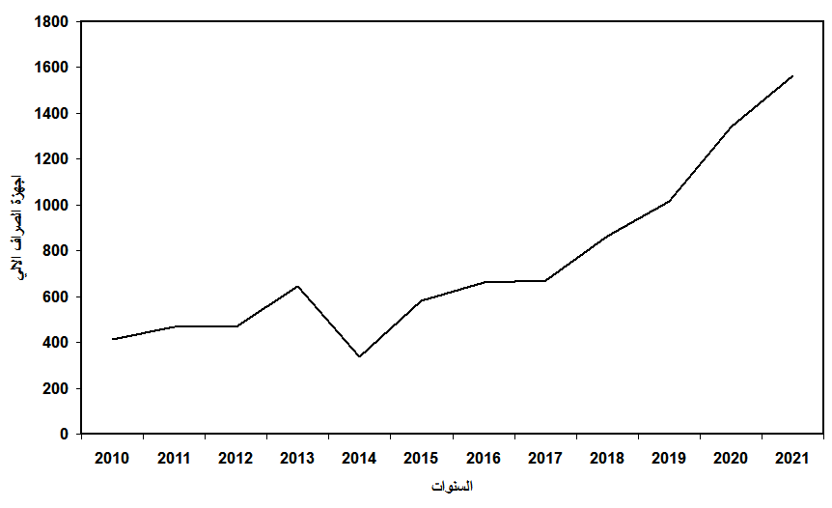
Figure (3) The evolution of the number of ATMs in Iraq for the period (2010-2021)
Source: Prepared by the researcher based on the annual statistical releases of the Central Bank of Iraq (2010-2021).
The year (2014) recorded a significant decrease in the number of (ATMs) by about (310) ATMs, a decrease of (47.9%) compared to the year (2013) and by (65.5) thousand for every single ATM; This is because of the terrorist operations that led to the closure of some banks in the western and northern governorates of Iraq, and then increased after that in the year (2015) to (580) ATMs, with a growth rate of about (72.1%), and each (39) thousand automatic machines had one, and the number continued Increasing in the remaining years, and in 2016 it reached about (660) ATMs, with a growth rate of (13.7%), and each (34.8) thousand ATMs (one).
The increase continued gradually in the year (2017), as it reached about (669) ATMs, with a growth rate of (1.3%), at the rate of (one) ATM for every (34.3) thousand, and the number of machines increased in the year (2018) to (879) ATMs, with a growth rate of (31.3%), with one ATM for every (26.5) thousand adults, and in the year (2019) the number of ATMs reached (1100), with a growth rate of (25.1), with (21.7) thousand adults for every ((one ATM), the number of devices reached In the year (2020) there were approximately (1340) ATMs, bringing the growth rate in this year to about (32.1%), with one ATM for every (18.30) thousand, while the year (2021) recorded the highest rate compared to previous years. (ATM) machines during this year about (1566) automatic teller machines, with a growth rate of (16.0%), at the rate of one (ATM) for every (15.65) thousand.
3. Point of sale (POS) index in Iraq.
The point of sale index is one of the most important measures of the level of spread of electronic payment services, the extent to which banks can expand in electronic banking operations, and shift from dealing in cash to dealing with electronic money that is in the form of salaries, wages, or any financial transfer to become a balance that the individual has in his bank card. By withdrawing it whenever he wants through the payment tools represented by (POS).
The number of points of sale for the years of study can be shown in the following figure:
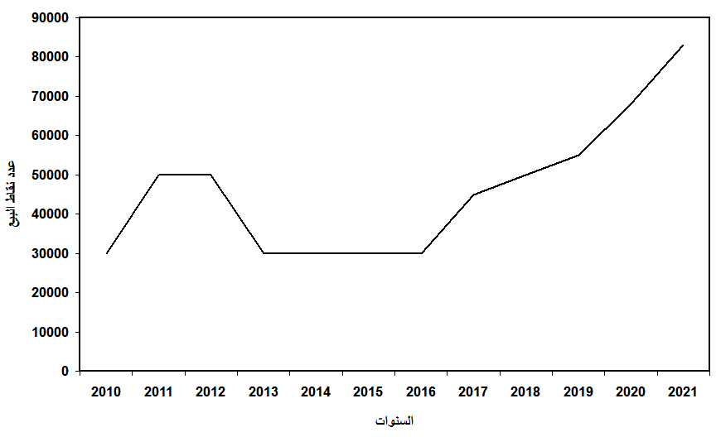
Figure (4) The evolution of the number of sales points in Iraq for the period (2010-2021)
Source: Prepared by the researcher based on the annual statistical releases of the Central Bank of Iraq (2010-2021).
The figure above shows that the number of points of sale (POS) increased in years and decreased in other years during the study period. It began to increase gradually during that period, and because of the decision of the Central Bank of Iraq to settle the salaries of all state employees, social welfare, and retirees, which led to the expansion of financial inclusion by Using electronic payment, as points of sale reached in the year (2010) about (30,000) points of sale, at the rate of (643) individuals, with one point of sale, i.e. (155) points of sale for every (100) thousand adults.
The figure shows that the number of devices continues to increase, as points of sale reached (50,000) points in the year (2011), with a growth rate of (66%), which is the highest growth rate during the period (2010-2021), so every (398) individual With one point of sale, at the rate of (251) points of sale for every (100) thousand adults, while the number remained the same in 2012 so that the number of adults was (411) individuals with one point of sale; to increase the number of residents and not to increase the points of sale, the number of points of sale will be reduced to (243) points for every (100) thousand adults.
Through the figure, we notice a decline in the number of points of sale in the years (2013, 2014, 2015 and 2016) to (30,000) points of sale due to the lack of political stability in the country and the closure of some of the main banks with their branches in the western governorates and the governorates of Diyala and Mosul; Because of the poor security conditions and the entry of ISIS; This negatively affected the financial sector in general and the banking sector in particular, as the percentage of adult individuals per one point of sale for the years referred to was (707, 730, 736, 755), respectively, and points of sale per 100 thousand adults reached (141, 136, 135, 132) points of sale, respectively, and the year (2016) was the year with the least number of points of sale at the level of (100) thousand adults, despite maintaining its numbers of (30,000) points of sale, and it also recorded the largest number in terms of adult individuals with one point of sale Where there were (755) individuals, and this number represents the largest according to the years of study.
The year (2017) witnessed a gradual increase to reach (45,000) points of sale, with a growth rate of about (50%) by (510) individuals in one point of sale, so that the points of sale for the adult population became (196) points of sale for every (100) thousand adults And it recorded an increase in the year (2018) to reach (50,000) points of sale, with a growth rate of (11%), i.e. for every (460) individual, one point of sale, so that the number of points of sale relative to (100) thousand adults is (217). Point of sale, and continued to increase gradually to become in the year (2019) about (55,000) points of sale, with a growth rate of (10%) by (423) individuals with one point of sale, bringing the number of points of sale relative to the number of adults to (236) points of sale for every (100) ) thousand adults.
It turns out that the levels of POS devices continued to increase during recent years to reach (68000) points of sale in the year (2020), with a growth rate of (22%), so that every (351) individual has one point of sale, and the points of sale increase for adults (284) points of sale per (100) thousand people and the year 2021 recorded the highest number of points of sale, reaching (83,000) points of sale, that is, for each (295) individual there is one point of sale, and this increase positively affected the increase in points of sale relative to the adult population, which amounted to (338) A point of sale for every (100) thousand adults and this percentage is the highest among the years of study, as a result of the improvement in economic conditions and the stability of security conditions, which positively affected the Iraqi banking sector, through the dissemination of electronic payment tools throughout the country.
In general, it can be said that the previous indicators, which are somewhat witnessing continuous growth, clearly show and confirm the keenness of the banking sector and those in charge of it to expand and spread in the provision of financial and banking services and confirm the tendency to achieve the desired financial inclusion.
Sixthly: Standard analysis of the relationship between investment expenditure and financial inclusion in Iraq for the period (2010-2021) using (Granger Causality)
To clarify the relationship between the economic variables, and the subject of the study, the causality test was adopted in the time series models of the Swedish scientist (Clive Granger). The direction of the causal relationship between those variables, so this method will help us determine whether the change in investment expenditure caused a change in financial inclusion or vice versa, and to achieve this framework it will be dealt with from different aspects:
1. Characterization of the standard model used
At this stage, the variables of the model will be determined, and here the researcher relies on economic theory or prior convictions, or on the available information on the phenomenon in question, which he investigates from previous research and applied studies.
In line with the objective of the study and to determine the nature of the relationship between investment expenditure and financial inclusion in Iraq for the time series data for the period (2010-2021), which data were converted to quarterly as a result of our lack of a long series of financial inclusion data due to the recent adoption of the financial inclusion program in Iraq, as it was Adopting data for indicators of investment expenditure and financial inclusion that were included in the Central Bank's bulletins so that the total number of observations is (48).
Depending on the analytical aspect, the study variables can be described quantitatively, according to the following:
a. Investment Expenditure (IE) Variable:
It is expressed as a stream of expenditure on new fixed capital goods such as factories, machinery, or infrastructure and infrastructure necessary to stimulate economic activity and leads to increased production, as well as additions to inventory such as raw materials or final goods and new housing constructions over some time. It was based on the estimates contained in the data of the Central Bank of Iraq.
B. Financial Inclusion Variables (FI):
It is expressed through the most important foundations that represent its infrastructure, which are:
• FI1: represents the number of automated teller machines (ATM).
• FI2: represents the number of bank branches in Iraq.
• FI3: It represents the number of points of sale (POS).
2. Drafting of the standard form
The formulation of the standard model is intended to determine the mathematical form of the model or the number of equations it contains, and to prove (or not prove) the mutual effect between investment expenditure and financial inclusion, the previously mentioned variables were collected in a standard form and according to the following:
3. Estimating and analyzing the relationship between investment expenditure and financial inclusion in Iraq for the period (2010-2021) using (Granger Causality)
The study adopted Granger's test for causality, especially in the field of discovering the direction of the relationship between investment expenditure and financial inclusion in Iraq of those variables.
3. 1. Time series stability tests for the study variables
After performing the unit root test for the data series of the study variables using the Augmented Dickey-Fuller test (ADF), we obtained the results shown in Table (1), and all formulas certainly got rid of the autocorrelation problem after the inclusion of the first gap for the first difference since ( ), and then The (ADF) test gives accurate results regarding the root of the unit.

Table (1) Results of testing the stability of the data series of the study variables
Augmented Dickey-Fuller Test (ADF)
Result | ADF stat | Test Critical Values |  |  | The Test | Variables
 |  | 10 % | 5 % | 1 %
Stationary | -4.37 | -3.19 | -3.53 | -4.21 | The Level | IE
 |  |  |  |  | 1st difference
 |  |  |  |  | 2nd difference
Non | -1.35 | -3.19 | -3.52 | -4.19 | The Level | FI₁
Stationary | -4.07 | -3.19 | -3.52 | -4.19 | 1st difference
 |  |  |  |  | 2nd difference
Non | -1.77 | -2.60 | -2.92 | -3.58 | The Level | FI₂
Stationary | -3.39 | -1.61 | -1.94 | -2.61 | 1st difference
 |  |  |  |  | 2nd difference
Stationary | -4.56 | -3.19 | -3.53 | -4.21 | The Level | FI₃
 |  |  |  |  | 1st difference
 |  |  |  |  | 2nd difference
Source: The results were extracted by the researcher based on the Eviews12 statistical program
From the above table, it is clear that the series of variables (investment expenditure and the number of points of sale) are stable at the level, that is, they are of rank zero and symbolized by I (0), while the time series of variables (the number of ATMs, the number of bank branches) were stable after obtaining the differences The first, therefore, is of the first order and is denoted by the symbol I (1).
Since the time series are not integrated to the same degree, it is not possible to apply the cointegration test that determines the relationship between the variables in the long run, and the causal inference of (Granger) will be invalid, that is, the normal causality test cannot be performed. To avoid this problem, each of ( Toda Yamamoto 1995 and Dolado & Lutkepohl 1996 developed a new procedure for Granger Causality based on the developed VAR model by introducing the modified Wald test statistic (MWALD) on the constraints of the VAR(k) model (Tamar, 2018: p. 261), and it is abbreviated as (TYDL) and it is characterized by the fact that it does not require the stability of the time series at the same level or rank as what is required by (Granger Causality), as it can be used in the case of different degrees of integration of the time series (I (0), I (1), I) 2), and this method does not require the existence of joint integration between the time series, and to study causality in this way, the following steps are followed:
3. 2. Determine the delay times for the model:
To determine the optimal number of time lag time VAR (k) is done through the statistical criteria: (AIC) criterion and (SIC) ... as the lowest value is chosen for each criterion, which corresponds to the optimal time lag, and the table ( ) shows that, as we note that all standards A deceleration period equal to five was determined, and accordingly, the degree of deceleration agrees (P = 5).
Table (2) Test results for determining the optimal delay times for the (VAR) model for the relationship between investment expenditure and financial inclusion in Iraq
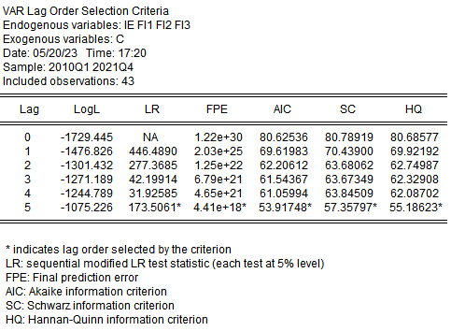
Source: The results were extracted by the researcher based on the Eviews12 statistical program
3 . 3 . Study the stability of the model:
Before passing on to causality, we must first make sure that the Var(1) model is valid and fulfills all the conditions. Accordingly, we will verify the stability of the model using multiple roots tests, as the results of the autoregressive ray are considered stable if the reciprocal of the single roots of all terms inside the circle, and the following figure shows the results This test:
Figure (5) The stability of the (VAR) model estimated using the unary circle of reciprocal single roots to model the relationship between investment expenditure and financial inclusion in Iraq
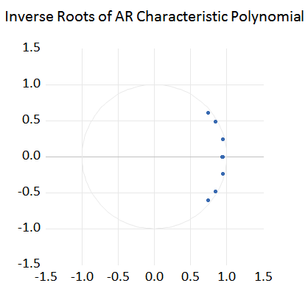
Source: The results were extracted by the researcher based on the Eviews12 statistical program
Through the above figure, it became clear to us that the reciprocal of the single roots of all terms lies inside the monolithic circle, as the results of the autoregressive ray are considered stable if the reciprocal of the single roots of the polynomial is inside the circle, and from it, the Var (P = 5) model is stable, which indicates that the model does not suffer from Error correlation problem or variance instability.
Table (3) The results of the multiple roots test of the relationship between investment expenditure and financial inclusion in Iraq
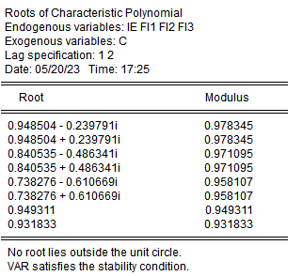
Source: The results were extracted by the researcher based on the Eviews12 statistical program
We notice from the above table that all values are less than one (Modulus), which indicates that the model is stable.
3. 4. Normal distribution test for residuals:
The (Berra-Jarque) test is used to detect the nature of the distribution of the residuals of the model and Table (4) shows that:
Through the table, it is clear that the probability values for all tests are greater than (5%), meaning that the null hypothesis is accepted, and the remainder of the model follows the normal distribution.
Based on the previous diagnostic tests, it can be said that the estimated Var (1) model has acceptable statistical quality.
Table (4) Results of the (Jarque-Berra) test of the relationship model between investment spending and financial inclusion in Iraq
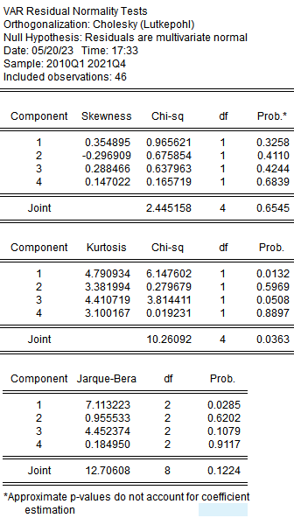
Source: The results were extracted by the researcher based on the Eviews12 statistical program
After determining the maximum degree of integration of the two series, which was estimated at (dmax = 1) and the number of optimal lag periods is at (P = 5), so here the causal relationship between investment spending and financial inclusion will be tested according to the (Toda Yamamoto) methodology, and the results are according to the table (5):
Through the results of testing the causal relationship between investment spending and financial inclusion in Iraq, the following can be seen:
1. We reject the null hypothesis, which states: There is no causal relationship that leads from investment spending to financial inclusion at the (5%) level, because the calculated probability level is less than (5%).
2. We reject the null hypothesis, which states: There is no causal relationship moving from financial inclusion towards investment spending, at the level of (5%); This is because the calculated probability level is less than (5%).
Table (5) Results of testing the causal relationship between investment spending and financial inclusion in Iraq
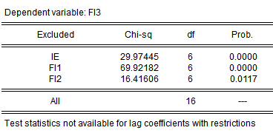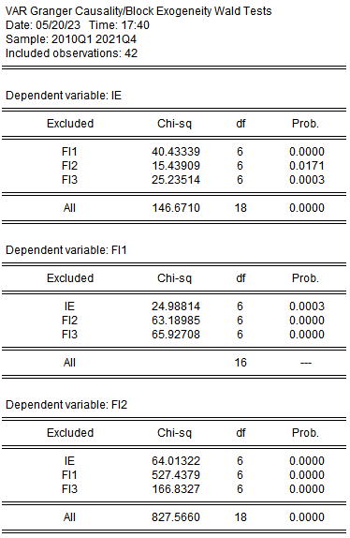
Source: The results were extracted by the researcher based on the Eviews12 statistical program
With regard to the direction of the relationship from investment spending to financial inclusion in Iraq, it came to confirm that investment spending is an important factor in the development of the economy, as it helps to enhance production and innovation and improve economic performance in general, and therefore an increase in investment spending can lead to an increase in employment opportunities Improving the standard of living for the members of society, and through improving economic performance, individuals and companies can benefit from investment opportunities and expansion in business, and this means an increase in demand for financial services and various financial products, and these services include bank accounts, financing, insurance and investment.
As for the direction of the relationship from financial inclusion to investment spending in Iraq, it was identical to reality, as financial inclusion can contribute to improving the access of individuals and companies to financial services and providing capital for investment in economic activities, and by providing the funds required for investment spending, financial inclusion increases The percentage of spending on targeted projects and achieving better economic growth in the long run. Therefore, financial inclusion is one of the main incentives for investment spending and economic growth.
Seventh. Conclusions:
1. The low level of financial inclusion in Iraq compared to the neighboring Arab countries, due to the low number of electronic payment tools represented by (ATM) and (POS), as well as the low number of bank branches compared to the population density.
2. Decrease in the percentage of banking density and the absence of the need to deal with the banking system due to the high levels of unemployment and poverty.
3. Not attracting foreign capital to the country and investing it in real projects and directing the state's financial policy towards consumer spending.
4. A new procedure was followed for (Granger Causality) called (Toda Yamamoto) or (TYDL) developed by (Toda Yamamoto 1995) and (Dolado & Lutkepohl 1996) based on the developed (VAR) model by entering the Wald test statistic ) modified (MWALD) on the limitations of the VAR(k) model.
5. The existence of a causal relationship that moves from financial inclusion towards investment spending and from investment spending to financial inclusion, as financial inclusion can contribute to improving individuals and companies’ access to financial services and providing capital for investment in economic activities, and by providing the funds required for investment spending, inclusion is established This is on the one hand, and on the other hand, increasing investment spending can lead to an increase in job opportunities and an improvement in the standard of living for members of society, and by improving economic performance, individuals and companies can benefit from Investment opportunities and business expansion, which means an increase in demand for financial services and various financial products. These services include bank accounts, financing, insurance and investment.
Eighth: Recommendations
1. The necessity of expanding financial inclusion by spreading electronic payment tools throughout the country and not limiting them to banks and government departments, and moving towards electronic banks by following innovative methods of banking operations, and keeping pace with the global banking system to enhance financial inclusion.
2. The need to work to enhance the reality of financial inclusion in the financial sectors and increase the number of banking branches, which contributes to strengthening the ability of excluded groups to improve their economic aspects and enable them to benefit from financial inclusion services and thus achieve social justice
3. Presenting investment projects to foreign investors, providing them with the opportunity and attracting them, allocating part of the federal budget for investment spending, and not monopolizing consumption expenditures, as well as encouraging local labor and local investors to establish investment projects with sustainable economic return.
4. Work to provide an appropriate political and administrative environment and good governance in state administration and investment policy, to raise the efficiency of the performance of government investment activity that leads to increasing levels of capital formation, enhancing production capacity, reducing growth rates, and achieving economic growth.
5. Creating and providing an appropriate and suitable climate for local and foreign investment, which increases investment and employment opportunities, with a focus on directing investment to industries that provide real job opportunities that are able to absorb a large part of the workforce.
6. The government should pay attention to the need to harmonize - when setting economic policy - between increasing the volume of investments and the absorptive capacity of the economy or the ability of its various sectors to absorb investment spending to the extent that investment achieves the maximum possible marginal return materially.
7. Work to increase the rates of investment spending, which can lead to an increase in job opportunities and an improvement in the standard of living for members of society, and by improving economic performance, individuals and companies can benefit from investment opportunities and expansion in business, and this means an increase in demand for financial services and various financial products These services include bank accounts, financing, insurance and investment.

References
Arabic References:
Firstly. Arabic books:
1. Al-Issawi, Kazem Jassim, (2001), (Economic Feasibility Studies and Project Evaluation), Dar Al-Manhaj, first edition, Jordan.
2. Omar, Hussein, (2000), (Investment and Globalization), Dar Al-Kitab Al-Hadith, first edition, Algeria.
Secondly. Researches and periodicals:
1. Fathi Hamsa, Adnan Omar, 2019. Government investment public spending in Iraq and its impact on addressing unemployment, Journal of Islamic Sciences, 22, 89.
Third: Dissertations and Thesis
1. Hassan, Ahmed Nouri (2018), (Requirements for the application of financial inclusion in Iraq and its measurement indicators, an applied study), Master Thesis, College of Business Economics, Al-Nahrain University, Iraq.
Fourthly: Official reports:
1. The Central Bank of Iraq, General Directorate of Statistics and Research, Statistical Bulletin 2010.
2. The Central Bank of Iraq, General Directorate of Statistics and Research, Statistical Bulletin 2011.
3. Central Bank of Iraq, General Directorate of Statistics and Research, Statistical Bulletin 2013.
4. Central Bank of Iraq, General Directorate of Statistics and Research, Statistical Bulletin 2014.
5. Central Bank of Iraq, General Directorate of Statistics and Research, Statistical Bulletin 2015.
6. Central Bank of Iraq, General Directorate of Statistics and Research, Statistical Bulletin 2017.
7. Central Bank of Iraq, General Directorate of Statistics and Research, Statistical Bulletin 2020.
8. The Central Bank of Iraq, General Directorate of Statistics and Research, Statistical Bulletin 2021.
9. Central Bank of Iraq, Annual Report of Financial Stability in Iraq, 2012.
10. Central Bank of Iraq, Annual Report of Financial Stability in Iraq, 2013.
11. Central Bank of Iraq, Annual Report of Financial Stability in Iraq, 2015.
12. Central Bank of Iraq, Annual Report of Financial Stability in Iraq, 2018.
13. Central Bank of Iraq, Annual Report of Financial Stability in Iraq, 2020.
14. Central Bank of Iraq, Annual Report of Financial Stability in Iraq, 2021.

