Republic of Iraq
Ministry of Higher Education and Scientific Research
University of AL-Qadisiyah
College of Computer Science and Information Technology
Multimedia department

DESIGEN DATABASE FOR RESEARCH TEACHERS
A graduation project is submitted to the Multimedia department in partial fulfillment of the requirements for the degree of Bachelor in information technology in multimedia
By
Zainab Fadhel Abbas
Fatima Faeq Jassim
Sarah Ahmed Jarad

Supervision
L . Mohammed Iqbal Dohan

2019A.D 1440A.H

Contents

Introduction 1
1 - General overview and explanation: 2
1-1 Programming Languages Used : 3
1-1 1 PHP (Programming Hypertext Preprocessor): .3
1-1-2 JavaScript : 4
1-2 Styling and Markup Languages : 5
1-2-1 HTML (Hypertext Markup Language) : 5
1-2-2 CSS(Cascading Style Sheets) : 7
1-3 Library Used : 8
1-3-1 AJAX : 8
1-3-2 PHP Spreadsheet : 9
1- 4 Database Used : 11
1- 4 -1 SQL database : 12
1-4-2 PHP my admin : 15
1-5 Server Used: 17
2 Main Project Structure and code samples : 18
2-1 Login page : 19
2-2 Form page : 20
2-3 Manage page : 21
2-4 Data edit page : 25

Abstract :

The project aims to be one of the sections of the website of the University of Qadisiyah with a future planning that this project and other student projects planning the governance of the joints of the State and linking all records and transfer data from paper to the giant databases in order to facilitate and provide safety and backup of this data and to combat incidents Which cause such important data to be lost .

Acknowledgment

The author wish to express his gratitude and appreciation to L. Mohammed Iqbal Dohanfor all his supports, guidance and supervision given throughout the project. We had weekly meeting to discuss the progress and the target we need to achieve from the project. Thus, the comments were given to me from him are helpful helps me to be more productive in my research.

Introduction

- This project is directed to the site of the University of Qadisiyah in order to help the staff responsible for the management of scientific publications in international journals through simplifying their work and easy access to data.
-The work mechanism of the project is a form for entering data and a special page to manage this data and extract data in excel format.
- Access to the form and the data management and modification page will be limited and assigned to the responsible department through a dedicated login interface with the possibility of more than one responsible officer .

1 - General overview and explanation:

This project was built based on the web application.
Web application:
The general distinction between a dynamic web page of any kind and a "web application" is unclear. Web sites most likely to be referred to as "web applications" are those which have similar functionality to a desktop software application, or to a mobile app. HTML5 introduced explicit language support for making applications that are loaded as web pages, but can store data locally and continue to function while offline.
Single-page applications are more application-like because they reject the more typical web paradigm of moving between distinct pages with different URLs. Single-page frameworks like Sencha Touch and AngularJS might be used to speed development of such a web app for a mobile platform.

Programming Languages Used :

Programming languages provide the interface between the graphical interface and the data in the database and the mechanism of data retrieval and display on the interface and provide security for data and give permission to use data and enter and modify them and extract files in the format execl and fill in the data .

1 -1 PHP (Programming Hypertext Preprocessor):

Is a general-purpose programming languageoriginally designed for web development. It was originally created by Rasmus Lerdorf in 1994 .
PHP code may be executed with a command line interface (CLI), embedded into HTML code, or it can be used in combination with various web template systems, web content management systems, and web frameworks. PHP code is usually processed by a PHP interpreter implemented as a module in a web server or as a Common Gateway Interface (CGI) executable. The web server combines the results of the interpreted and executed PHP code, which may be any type of data, including images, with the generated web page. PHP can be used for many programming tasks outside of the web context, suchas standalone graphical applications and robotic drone control.
This language was used in the project to connect to the SQl database with a PDO connection in order to use queries on the database and display data retrieved from the database in places designated in the HTML-designed graphical interface .

1-1-2 JavaScript :

Is a high-level, interpreted programming language that conforms to the ECMAScript specification. JavaScript has curly-bracket syntax, dynamic typing ,prototype-based object-orientation, and first-class functions.
Alongside HTML and CSS, JavaScript is one of the core technologies of the World Wide Web. JavaScript enables interactive web pages and is an essential part of web applications. The vast majority of websites use it, and major web browsers have a dedicated JavaScript engine to execute it.

As a multi-paradigm language, JavaScript supports event drivenfunctional. It has APIs for working with text, arrays, dates, regular expressions, and the DOM, but the language itself does not include any I/O, such as networking, storage, or graphics facilities. It relies upon the host environment in which it is embedded to provide these features.

Styling and Markup Languages :

The graphical interface is mainly designed to simplify access and management for project users.

1-2-1 HTML (Hypertext Markup Language) :

is the standard markup language for creating web pages and web applications. With Cascading Style Sheets (CSS (Cascading Style Sheets)) and JavaScript, it forms a triad of cornerstone technologies for the World Wide Web.
Web browsers receive HTML documents from a web server or from local storage and render the documents into multimedia web pages. HTML describes the structure of a web page semantically and originally included cues for the appearance of the document.
HTML elements are the building blocks of HTML pages. With HTML constructs, images and other objects such as interactive forms may be embedded into the rendered page. HTML provides a means to create structured documents by denoting structural semantics for text such as headings, paragraphs, lists, links, quotes and other items. HTML elements are delineated by tags, written using angle brackets. Tags such as <img /> and <input /> directly introduce content into the page.

1-2-2 CSS(Cascading Style Sheets) :

Is a style sheet language used for describing the presentation of a document written in a markup language like HTML. CSS is a cornerstone technology of the World Wide Web, alongside HTML and JavaScript.
CSS is designed to enable the separation of presentation and content, including layout, colors, and fonts. This separation can improve content accessibility, provide more flexibility and control in the specification of presentation characteristics, enable multiple web pages to share formatting by specifying the relevant CSS in a separate .css file, and reduce complexity and repetition in the structural content.
Separation of formatting and content also makes it feasible to present the same markup page in different styles for different rendering methods, such as on-screen, in print, by voice (via speech-based browser or screen reader), and on Braille-based tactile devices. CSS also has rules for alternate formatting if the content is accessed on a mobile device.

Library Used :

Libraries have been added to increase the overall performance of the project and to add additional features to the project. These libraries have been created by the programming languages mentioned above.

1-3-1 AJAX :
isasetof webdevelopment techniques using many web technologies on the client side to create asynchronous web applications. With Ajax, web applications can send and retrieve data from a server asynchronously (in the background) without interfering with the display and behavior of the existing page.
Ajax is not a single technology, but rather a group of technologies. HTML and CSS can be used in combination to mark up and style information. The webpage can then be modified by JavaScript to dynamically display—and allow the user to interact with—the new information. The built-in XMLHttpRequest object within JavaScript is commonly used to execute Ajax on webpages allowing websites to load content onto the screen without refreshing the page. Ajax is not a new technology, or different language, just existing technologies used in new ways.
This library was used in the project as a fast search engine, as it searches the database quickly and without going to other pages by displaying the results directly on the page and searching through the name of the researcher or the book number entered in the database in advance and also used this library to send a request To extract excel files in the background without going to a second page where data management is in one page.

1-3-2 PHP Spreadsheet :
PHP Spreadsheet is a library written in pure PHP and providing a set of classes that allow you to read from and to write to different spreadsheet file formats, like Excel and LibreOffice Calc.

Architecture :
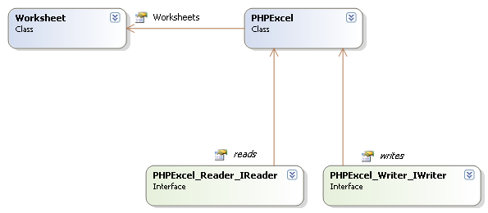
PhpSpreadsheet Architecture

Spreadsheet in memory
PhpSpreadsheet's architecture is built in a way that it can serve as an in-memory spreadsheet. This means that, if one would want to create a web based view of a spreadsheet which communicates with PhpSpreadsheet's object model, he would only have to write the front-end code.
Just like desktop spreadsheet software, PhpSpreadsheet represents a spreadsheet containing one or more worksheets, which contain cells with data, formulas, images, ...

Readers and writers:
By default, the PhpSpreadsheet package provides some readers and writers, including one for the Open XML spreadsheet format (a.k.a. Excel 2007 file format). You are not limited to the default readers and writers, as you are free to implement the \PhpOffice\PhpSpreadsheet\Reader\IReader and \PhpOffice\PhpSpreadsheet\Writer\IWriter interface in a custom class.

1- 4 Database Used :
The databases in the project were used to create a dynamic page and use the data saving and retrieval feature. The database was accessed and managed by a server interface to easily manage this type of database.

1- 4 -1 SQL database :
Is a domain-specific languageused in programming and designed for managing data held in a relational database management system (RDBMS), or for stream processing in a relational data stream management system (RDSMS). It is particularly useful in handling structured data where there are relations between different entities/variables of the data.
SQL offers two main advantages over older read/write APIs like ISAM or VSAM. First, it introduced the concept of accessing many records with one single command; and second, it eliminates the need to specify how to reach a record, e.g. with or without an index.
SQL became a standard of the American National Standards Institute (ANSI) in 1986, and of the International Organization for Standardization (ISO) in 1987 Since then, the standard has been revised to include a larger set of features. Despite the existence of such standards, most SQL code is not completely portable among different database systems without adjustments.

In this project I created database called it “research”
With twotables “users” and “researches” to holds the data .
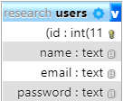
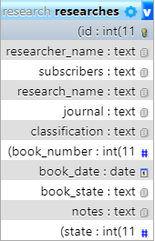
The previous images show the tables with their own fields with the id field installed as a primary key with the possibility of automatic increment .

1-4-2 PHPmyadmin :
PhpMyAdmin is a free and open source administration tool for MySQL and MariaDB. As a portable web applicationwritten primarily in PHP, it has become one of the most popular MySQL administration tools, especially for web hosting services.

By that time, phpMyAdmin had already become one of the most popular PHP applications and MySQL administration tools, with a large community of users and contributors. In order to coordinate the growing number of patches, a group of three developers registered ThephpMyAdmin Project at SourceForge and took over the development in 2001.

Features provided by the program include:
- Web interface
- MySQL and MariaDB database management
- Import data from CSV and SQL
- Export data to various formats: CSV, SQL, XML, PDF (via the TCPDF library), ISO/IEC 26300 - OpenDocument Text and Spreadsheet, Word, Excel, LaTeX and others
- Administering multiple servers
- Creating PDF graphics of the database layout
- Creating complex queries using query-by-example (QBE)
- Searching globally in a database or a subset of it
- Transforming stored data into any format using a set of predefined functions, like displaying BLOB-data as image or download-link
- Live charts to monitor MySQL server activity like connections, processes, CPU/memory usage, etc.
- Working with different operating systems.
- Make complex SQL queries easier.

1-5 Server Used:
XAMPP:
is a free and open-source cross-platform web server solution stack package developed by Apache Friends, consisting mainly of the Apache HTTP Server, MariaDB database, and interpretersfor scripts written in the PHP and Perl programming languages. Since most actual web server deployments use the same components as XAMPP, it makes transitioning from a local test server to a live server possible.
XAMPP's ease of deployment means a WAMP or LAMP stack can be installed quickly and simply on an operating system by a developer. With the advantage a number of common add-in applications such as Wordpress and Joomla!can also be installed with similarease using Bitnami.

2Main Project Structure and code samples :

Main structure of project

As shown above, the structure of the project starts from the login panel to access the other pages. There is also a page to create a new user that is accessed in particular.

2-1 Login page :
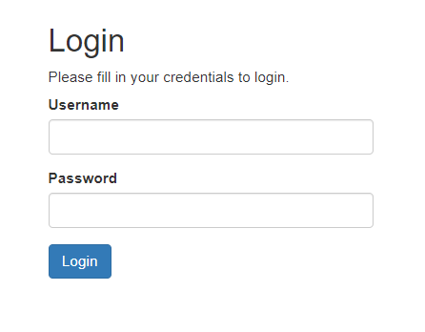

The login panel depends on the user's email address and password as a type of security as described above .

2-2 Form page :
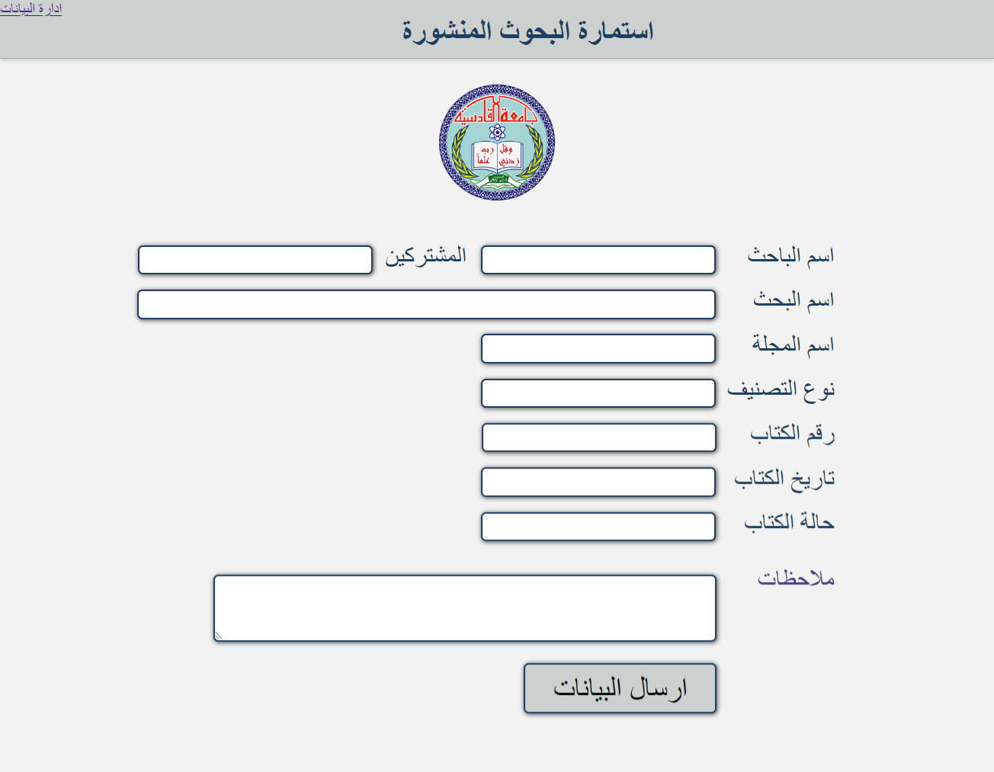

As indicated above, the data entry form contains the required data, all of which are required and the data is sent to the same current page using the method post, which carries the entered data, thus processing the request and sending the data to the storage database in a new record containing all the data in the correct order field.

2-3 Manage page :
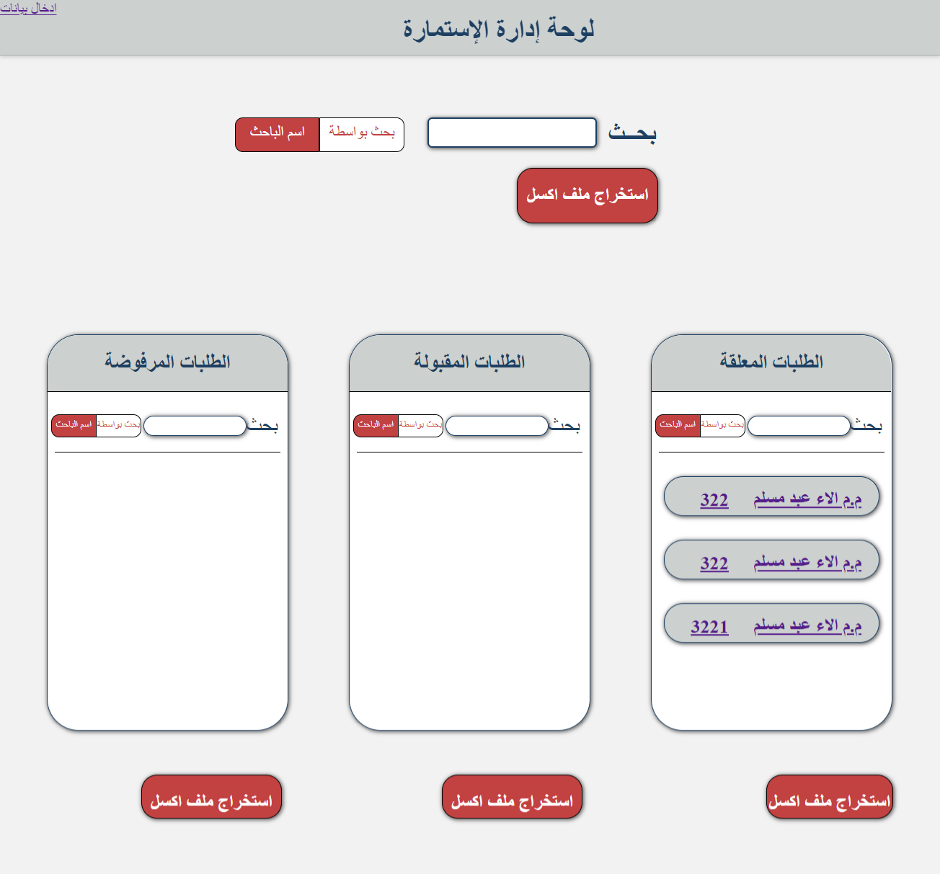

The data management panel contains the first field used for general search in the database using the name of the researcher or the number of the book and contains a key when clicking the switch between the name of the researcher or the number of the book responsible for the switch is the language of javascript and when written any shelf or modification in the search box is Send the text in the search box directly to another file responsible for the search process and send the query to the database and return to the data and display in this page The current responsible for this process is the library of AJAX.

Under the search box there is a button responsible for creating an Excel file that contains all the records within the database and saving them in a folder. The Excel file that was created is named according to the date and time the file was created.

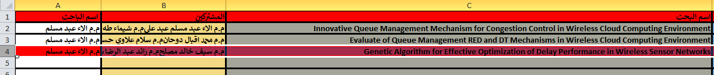

Above is an example of an Excel file that is created from the administration panel where the required fields are filled with the entered data and we notice that one of the records is colored in red. This indicates incomplete data or a line in this record .
The records are classified as pending, accepted, rejected and displayed in three places on the administration page with the possibility to search each classification of the records as each search box is broadcast in the classification of the appointee and also has a button to create an Excel file for the records of this classification. For example, an Excel file can be created for outstanding records only.

The process of converting data from the database into an Excel file is the responsibility of the PhpSpreadsheet library, some of whose functions are pre-assigned before the file is written in the volume, and the function is to assign the color of fields, field sizes, and write data in records.

2-4 Data edit page :
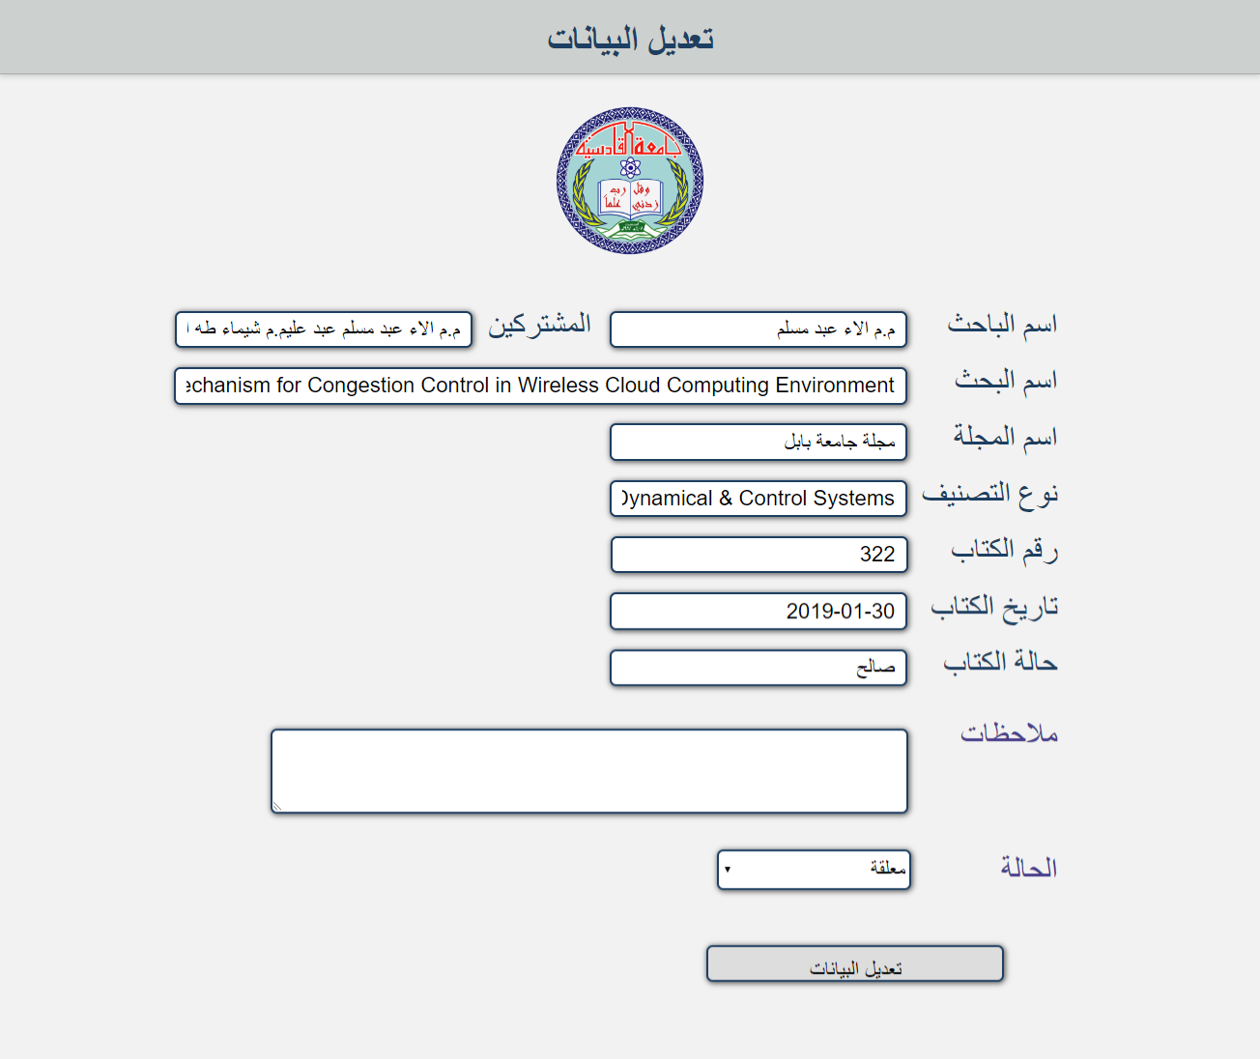
In this page you can modify and transfer the status of one record from one classification to another by choosing custom tricks that can transfer the log from outstanding to acceptable and vice versa.
As shown, the form of the modification page is similar to the input form page where the required fields are filled with all possible modifications.

It is worth mentioning that any new record added will be classified with outstanding as a default status for new records and can be modified at any time .
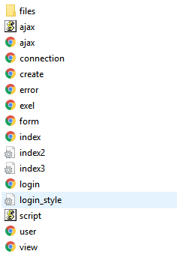

The images above show the files for the project and mention that the Vendor folder contains the help libraries .

References
[1] 450 Barron, B., et al., (1998) ‘Doing with understanding: lessons from research on problem-and
[2] project-based learning’, Journal of the Learning Sciences, vol. 7, no. 34, pp. 271311.
Beetham, H. & Sharpe, R. (2013) Rethinking Pedagogy for a Digital Age: Designing for 21st
[3] AQ7 Century Learning, Routledge.
[4] Y. Mor and O. Mogilevsky
14
(page number not for citation purpose)
[5] Citation: Research in Learning Technology 2013; 21: 22054 - http://dx.doi.org/10.3402/rlt.v21i0.22054
[6] Fuhrmann, T. R. & Kali, Y. (2010) ‘The role of concretization in acquiring design
455 knowledge’, Proceedings of the 9th International Conference of the Learning Sciences,
AQ7 vol. 1, pp. 468475.
[7] Fuhrmann, T. R., Kali, Y. & Hoadley, C. (2008) ‘Helping education students understand
[8] learning through designing’, Educational Technology, vol. 48, pp. 2633.
[9] Green, L. N. & Bonollo, E. (2003) ‘Studio-based teaching: history and advantages in the
460 teaching of design’, World Transactions on Engineering and Technology Education, vol. 2,
pp. 269272.
[10] Josselson, R. & Lieblich, A. (2001) ‘Narrative research and humanism’, in The Handbook of
AQ8 Humanistic Psychology, Sage, pp. 275288.
[11] Kali, Y. (2006) ‘Collaborative knowledge building using a design principles database’,
465 International Journal of Computer-Supported Collaborative Learning, vol. 1, pp. 187201.
[12] Kali, Y. & Ronen-Fuhrmann, T. (2011) ‘Teaching to design educational technologies’’,
International Journal of Learning Technology, vol. 6, no. 1, pp. 423.
[13] Kolodner, J. L., et al., (2003) ‘Problem-based learning meets case-based reasoning in the
middle-school science classroom: putting learning by designTM into practice’, Journal of the
470 Learning Sciences, vol. 12, no. 4, pp. 495547.
[14] Korthagen, F., et al., (2001) Linking Practice and Theory: The Pedagogy of Realistic Teacher
Education, Lawrence Erlbaum, Mahwah, NJ.
[15] Laurillard, D. (2008) ‘The teacher as action researcher: using technology to capture pedagogic
form’, Studies in Higher Education, vol. 33, pp. 139154.
[16] 475 Laurillard, D. (2012) Teaching as a Design Science: Building Pedagogical Patterns for Learning
and Technology, Routledge, Florence, KY.
[17] Mor, Y. (2011) ‘Context is what we take for granted: addressing context in design-
centric teacher training’, Context and Technology Enhanced Learning (ConTEL): Theory,
AQ9 Methodology and Design Workshop, at EC-TEL 2011, Italy.
[18] 480 Mor, Y. & Craft, B. (2012) ‘Learning design: reflections on a snapshot of the current
landscape’, Research in Learning Technology, vol. 20. DOI: 10.3402/rlt.v20i0.19196
Mor, Y. & Mogilevsky, O. (2012) ‘A learning design studio in mobile learning’, The 11th World
AQ9 Conference on Mobile and Contextual Learning (mLearn 2012).
[19] Mor, Y., Warburton, S. & Winters, N. (2012) ‘Participatory pattern workshops: a methodology
485 for open learning design inquiry’, Research in Learning Technology, vol. 20. DOI: 10.3402/
rlt.v20i0.19197
Mor, Y. & Winters, N. (2007) ‘Design approaches in technology enhanced learning’, Interactive
Learning Environments, vol. 15, pp. 6175.
[20] Voogt, J., et al., (2011) ‘Teacher learning in collaborative curriculum design’, Teaching and
490 Teacher Education, vol. 27, no. 8, pp. 12351244.
[21] Yeh, R., et al., (2006) ‘ButterflyNet: a mobile capture and access system for field biology
research’, Proceedings of the SIGCHI Conference on Human Factors in Computing Systems,
AQ10 AQ5 pp. 571580.

