Republic of Iraq
Ministry of Higher Education and Scientific Research
University of AL-Qadisiyah
College of Computer Science and Information Technology
Multimedia department

Edges detections by using
morphology operation

A graduation project is submitted to the Multimedia department in partial fulfillment of the requirements for the degree of Bachelor in information technology in multimedia

By.
Mustafa qassim Hussein Abir Khalid Salman
Amal Fadhil Mathbob

SUPERVISOR
Assist Prof Dr. Ali Muhsin Al-Juboori
   
 
 
1440 2019
الاهداء
إﻟﻰ اﻟﺬي وﻫﺒﻨﻲ ﻛﻞ ﻣﺎ ﻳﻤﻠﻚ ﺣﺘﻰ أﺣﻘﻖ ﻟﻪ آﻣﺎﻟﻪ، إﻟﻰ ﻣﻦ ﻛﺎن ﻳﺪﻓﻌﻨﻲ ﻗﺪﻣﺎ ﻧﺤﻮ اﻷﻣﺎم ﻟﻨﻴﻞ إﻟﻰ اﻟﺬي ﺳﻬﺮ ﻋﻠﻰ ﺗﻌﻠﻴﻤﻲ ﺑﺘﻀﺤﻴﺎت ﺟﺴﺎم ، إﻟﻰ اﻹﻧﺴﺎن اﻟﺬي إﻣﺘﻠﻚ اﻹﻧﺴﺎﻧﻴﺔ ﺑﻜﻞ ﻗﻮة ،اﻟﻤﺒﺘﻐﻰ ، إﻟﻰ ﻣﺪرﺳﺘﻲ اﻷوﻟﻰ ﻓﻲ اﻟﺤﻴﺎة ،ﻣﺘﺮﺟﻤﺔ ﻓﻲ ﺗﻘﺪﻳﺴﻪ ﻟﻠﻌﻠﻢ أﺑﻲ اﻟﻐﺎﻟﻲ
اﻟﻰ اﻟﺘﻲ وﻫﺒﺖ ﻓـﻠﺬة ﻛﺒﺪﻫﺎ ﻛﻞ اﻟﻌﻄﺎء و اﻟﺤﻨﺎن ﺣﻖ اﻟﺮّﻋﺎﻳﺔ و ﻛﺎﻧﺖ ﺳﻨﺪي ﻓﻲ اﻟﺸﺪاﺋﺪ، و ﻛﺎﻧﺖ دﻋﻮاﻫﺎ ﻟﻲ ﺑﺎﻟﺘﻮﻓﻴﻖ، ﺗﺘﺒﻌﺘﻨﻲ ﺧﻄﻮة ﺧﻄﻮة ﻓﻲ ﻋﻤﻠﻲ، إﻟﻰ ﻣﻦ إرﺗﺤﺖ ﻛﻠﻤﺎ ﺗﺬﻛﺮت إﺑﺘﺴﺎﻣﺘﻬﺎ ﻓﻲ وﺟﻬﻲ ﻧﺒﻊ اﻟﺤﻨﺎن أﻣﻲ
إﻟﻰ إ ﺧﻮﺗﻲ و أ ﺧﻮاﺗﻲ اﻟﺬﻳﻦ ﺗﻘـﺎﺳﻤﻮ ا ﻣﻌﻲ ﻋﺐء اﻟﺤﻴﺎة

اهديهم ثمرة جهدي وبحثي هذا

الباحث

الشكر والتقدير
ﻗـﺎل رﺳﻮل اﷲ ﺻﻠﻰ اﷲ ﻋﻠﻴﻪ و ﺳﻠﻢ: "ﻣﻦ ﻟﻢ ﻳﺸﻜﺮ اﻟﻨﺎس ﻟﻢ ﻳﺸﻜﺮ اﷲ" ﺻﺪق رﺳﻮل اﷲ ﺻﻠﻰ اﷲ ﻋﻠﻴﻪ و ﺳﻠﻢ اﻟﺤﻤﺪ ﷲ ﻋﻠﻰ إﺣﺴﺎﻧﻪ و اﻟﺸﻜﺮ ﻟﻪ ﻋﻠﻰ ﺗﻮﻓﻴﻘﻪ و إﻣﺘﻨﺎﻧﻪ و ﻧﺸﻬﺪ أن ﻻ إﻟﻪ إﻻ اﷲ وﺣﺪﻩ ﻻ ﺷﺮﻳﻚ ﻟﻪ ﺗﻌﻈﻴﻤﺎ ﻟﺸﺄﻧﻪ و ﻧﺸﻬﺪ أن ﺳﻴﺪﻧﺎ و ﻧﺒﻴﻨﺎ ﻣﺤﻤﺪ ﻋﺒﺪﻩ و رﺳﻮﻟﻪ اﻟﺪاﻋﻲ إﻟﻰ رﺿﻮاﻧﻪ ﺻﻠﻰ اﷲ ﻋﻠﻴﻪ و ﻋﻠﻰ آﻟﻪ و أﺻﺤﺎﺑﻪ و أﺗﺒﺎﻋﻪ و ﺳﻠﻢ . ﺑﻌﺪ ﺷﻜﺮ اﷲ ﺳﺒﺤﺎﻧﻪ و ﺗﻌﺎﻟﻰ ﻋﻠﻰ ﺗﻮﻓﻴﻘﻪ ﻟﻨﺎ ﻹﺗﻤﺎم ﻫﺬا اﻟﺒﺤﺚ اﻟﻤﺘﻮاﺿﻊ أﺗﻘﺪم ﺑﺠﺰﻳﻞ اﻟﺸﻜﺮ إﻟﻰ اﻟﻮاﻟﺪﻳﻦ اﻟﻌﺰﻳﺰﻳﻦ اﻟﺬﻳﻦ أﻋﺎﻧﻮﻧﻲ و ﺷﺠﻌﻮﻧﻲ ﻋﻠﻰ اﻹﺳﺘﻤﺮار ﻓﻲ ﻣﺴﻴﺮة اﻟﻌﻠﻢ و اﻟﻨﺠﺎح، و إﻛﻤﺎل اﻟﺪراﺳﺔ اﻟﺠﺎﻣﻌﻴﺔ و اﻟﺒﺤﺚ؛ ﻛﻤﺎ أﺗﻮﺟﻪ ﺑﺎﻟﺸﻜﺮ اﻟﺠﺰﻳﻞ إﻟﻰ ﻣﻦ ﺷﺮﻓﻨﻲ ﺑﺈﺷﺮاﻓﻪ ﻋﻠﻰ اﻟﺬي ﻟﻦ ﺗﻜﻔﻲ ﺣﺮوف ﻫﺬﻩ اﻟﻤﺬﻛﺮة ﻹﻳﻔـﺎﺋﻪ ﺣﻘﻪ ﺑﺼﺒﺮﻩ اﻟﻜﺒﻴﺮ ﻋﻠﻲ، و ﻟﺘﻮﺟﻴﻬﺎﺗﻪ اﻟﻌﻠﻤﻴﺔ اﻟﺘﻲ ﻻ ﺗﻘﺪر ﺑﺜﻤﻦ؛ و اﻟﺘﻲ ﺳﺎﻫﻤﺖ ﺑﺸﻜﻞ ﻛﺒﻴﺮ ﻓﻲ إﺗﻤﺎم و إﺳﺘﻜﻤﺎل ﻫﺬا اﻟﻌﻤﻞ؛ ﻛﻤﺎ أﺗﻮﺟﻪ ﺑﺨﺎﻟﺺ ﺷﻜﺮي و ﺗﻘﺪﻳﺮي إﻟﻰ ﻛﻞ ﻣﻦ ﺳﺎﻋﺪﻧﻲ ﻣﻦ ﻗﺮﻳﺐ أو ﻣﻦ ﺑﻌﻴﺪ ﻋﻠﻰ إﻧﺠﺎز و إﺗﻤﺎم ﻫﺬا اﻟﻌﻤﻞ. "رب أوزﻋﻨﻲ أن أﺷﻜﺮ ﻧﻌﻤﺘﻚ اﻟﺘﻲ أﻧﻌﻤﺖ ﻋﻠﻲ و ﻋﻠﻰ واﻟﺪي و أن أﻋﻤﻞ ﺻﺎﻟﺤﺎً ﺗﺮﺿﺎﻩ و أدﺧﻠﻨﻲ ﺑﺮﺣﻤﺘﻚ ﻓﻲ ﻋﺒﺎدك اﻟﺼﺎﻟﺤﻴﻦ

الاية
بسم الله الرحمن الرحيم

" قَالُوا سُبْحَانَكَ لَا عِلْمَ لَنَا إِلَّا مَا عَلَّمْتَنَا ۖ إِنَّكَ أَنتَ الْعَلِيمُ الْحَكِيمُ "

صدق الله العلي العظيم
سورة البقرة ( اية 32 )

Abstract of object
Dilation : grow image regions .
Erosion : shrink image regions .
Opening – Structured removal of image regions boundary pixels .
Closing – Structured filling in of image region boundary pixel .

Contents:
ID | Object
1 | 1.Introduction……………………………………………….2
2 | 1.2Aim of Project…………………………...………………4
3 | 1.3Research problem……………………………….……….4
4 | 1.4 Research importance………………………...………….4
5 | 2. Theoretical Principle……………………………………..5
6 | 2.1 Image Processing…………………………….…………6
7 | 2.2 Digital Image Processing…………………………...…..6
8 | 2.3 RGB (Red, Green, Blue)………………………….…….6
9 | 2.4 Grayscale Morphology………………………………….6
10 | 2.5 introduction………………………………………….….8
11 | 2.6Morphological Transformations………………..……….8
12 | 2.6.1 Dilation…………………………………...…………..9
13 | 2.6.1.2 Dilation Procedure ……...……………...…………..9
14 | 2.6.2Erosion…………………………..……………………10
15 | 2.6.2.1 Erosion Procedure…………………….……………11
16 | 2.6.3Opening……………………………………...………..11
17 | 2.6.3.1 Opening Procedure…………………………………12
18 | 2.6.4 Closing……………………………….………………12
19 | 2.6.4.1 Closing Procedure……………………….…………13
20 | 2.6.5 Skeletonization………………………….………..…..14
21 | 3.1 Introduction……………………………….……………18
22 | 3.2 Project Structure……………………………….………18
23 | 3.2.1Loading Image………………………………………..18
24 | 3.2.2Convert color image to gray then to binary…….…….18
25 | 3.2.3Dilation……………………………………….………20
26 | 3.2.4Erosion………………………………………………..21
27 | 3.2.5Opening …………………………………………..…..22
28 | 3.2.6Closing ……………………………………………….24
29 | 3.2.7 skeleton…………………...………………………….27
30 | 5.1 open matlab interface …………….……………………30
31 | 5.2 open new script ………………………………....……..31
32 | 5.3 convert the color image to binary image……………....32
33 | dilation method ……………………………………...…….33
34 | 5.4.2original image ……………………………..…………33
35 | 5.4 image after dilation…………………………………….34
36 | 4.5.1 original image ……………………………………….34
37 | 4.5.2 image after erosion……………………….…..………35
38 | 4.7.1 organl image …………………………………………36
39 | 4.7.2 image after closing ……  ……………………………..36
40 | 4.7.3 image after skeleton………………………………….37
41 | 5.1 Conclusions………………………………...…………..39
42 | 5.2 Future works …………………………………………..40
43 | References……………………………...…………………..41
Figures :
1 | Figure (1) RGB………………………………….………….5
2 | Figure(2)grayscale…………………………………………7
3 | Figure(3) example of grayscale……………………………7
4 | Figure (4) Morphological dilation…………………………9
6 | Figure(5)Morphological dilaiton technique………………….….10
6 | Figure (6) Morphological Erosion…………………...……10
7 | Figure(7)Morphological erosion technique……………………..11
8 | Figure (8) Morphological opinning………………………12
9 | Figure (9) Morphological of opinning processing……..…12
10 | Figure (10) Morphological closing…………………...…..13
11 | Figure(11) Morphological closing technique…………...…13
12 | Figure (2.12) skeleton processing…………………………14
13 | Figure (2.13) Example Skeletonization morphological image..16
14 | Figure(12) Project structure………………………………19
15 | Figure (14) Results of the skeleton character 'H' pening technique….28
16 | Figure (4.1) binary image ………...……………………….32
17 | Figure (4.2) image before dilation ………….…………….33
18 | Figure (4.3) image after dilation…...………………………33
19 | Figure (4.4) image before Erosion ….……………………..34
20 | Figure (4.5) image after Erosion …………………….........34
21 | Figure (4.6) image before opening…………………...……35
22 | Figure (4.7) image after opening……………...………..….35
23 | Figure (4.8) image before closing ……………………..….36
24 | Figure (4.9) image after closing……………………..….…36
25 | Figure (27) image after skeleton………………..………....37

Chapter One

General Introduction
  - Introductions

Morphological Image Processing is an important tool in the Digital Image processing, since that science can rigorously quantify many aspects of the geometrical structure of the way that agrees with the human intuition and perception.
Morphological processing is capable of removing noise and clutter as well as the ability to edit an image based on the size and shape of the objects of interest. Morphological Image Processing is used in place of a Linear Image Processing, because it sometimes distorts the underlying geometric form of an image, but in Morphological image processing, the information of the image is not lost[1].
Morphologic image processing technology is based on geometry. It emphasizes on studying geometry structure of image. We can find relationship between each part of image. When processing image with morphological theory. Accordingly, we can comprehend the structural character of image in the morphological approach an image is analyzed in terms of some predetermined geometric shape known as structuring element [2].
Morphological process, the original image can be rebuilding by using Dilation, Erosion, Opening,Closing,skeleton operations for a finite number of times[3].
Morphological filters can be used in many areas, such as, fingerprint discrimination, improve some sections clerical and unclear, using image processing Techniques for Automatic Extraction of Liver Suspicious Regions from X-Ray Computed Tomography Images.
require methods capable of enhancing pictorial information for human interpretation and analysis[2].
In image processing we use mathematical morphology as a means to identify and extract meaningful image descriptors based on properties of form or shape within the image. Key areas of application are segmentation together with automated counting and inspection. [1]

Employment of fingerprints as proof of crime has been one of the most important utilities in forensics, since the date 19th century. Where there are no witness to a certain crime, finger prints can be very useful in determining the offenders. [2]

Similarly successful applications of image processing concepts can be found in astronomy, biology, nuclear medicine, law enforcement, and defense [2]

1.2Aim of Project
The aim of this project that implement the morphological operation on digital image to reduce noise and confusion. The basic rule of the image does not spoil, but working on modifying the pixels.

Chapter two

Theoretical Principle
2.1 RGB (Red, Green, Blue)
The RGB color model is an additive color model in which red, green, and blue light are added together in various ways to reproduce a broad array of colors. The name of the model comes from the initials of the three additive primary colors, red, green, and blue[02], as shown in figure (2-1).
The purpose of the RGB color model is for the sensing, representation, and display of images in electronic systems, such as televisions and computers, though it has also been used in conventional photography. Before the electronic age, the RGB color model already had a solid theory behind it, based in human perception of colors[3].
Conversion from RGB (the brightness of the individual red, green, and blue signals at defined wavelengths) to YUV and to the other color encoding schemes is straightforward and loses no information [11].
Typical RGB input devices are color TV and video cameras, image scanners, video games, and digital cameras. Typical RGB output devices are TV sets of Computer and mobile phone displays, video projectors, and large screens such as Jumbo Ron. Color printers, on the other hand, are not RGB devices[3].
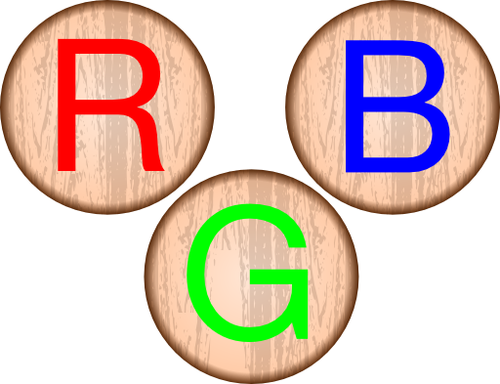
Figure (1) RGB

2.2Grayscale Morphology
The gray –scale image the basic of operation of dilation, erosion, opening, closing and skeleton. Who use the operation to developed several basic gray-scale morphological [92, 92].
In photography and computing, a grayscale digital image is an image in which the value of each pixel is a single sample, that is, it carries only intensity information. Images of this sort, also known as black-and-white, are composed exclusively of shades of grey, varying from black at the weakest intensity to white at the strongest [92, 92].
Grayscale images are distinct from one-bit bi-tonal black-and-white images, which in the context of computer imaging are images with only the two colors, black, and white (also called bi-level or binary image) Grayscale images have many shades of gray in between[Rraf92, Rac92].
Grayscale images are often the result of measuring the intensity of light at each pixel in a single band of the electromagnetic spectrum (e.g. infrared, visible light, ultraviolet, etc.), and in such cases they are monochromatic proper when only a given frequency is captured [Raf92, Rac92].

The average method simply averages the values:
(R + G + B) / 3 ………….. (2.1)
The luminosity method is a more developed version of the average method. It also averages the values, view the picture details more accuracy. Human beings are more sensitive to green than other colors, so green is weighted most heavily. Figure (2-2) shows the gray scale of the colored image, the formula for Y is computed as in equation (2.2).
0.299 * R + 0.587 * G + 0.114 *B ……………. (2.2)

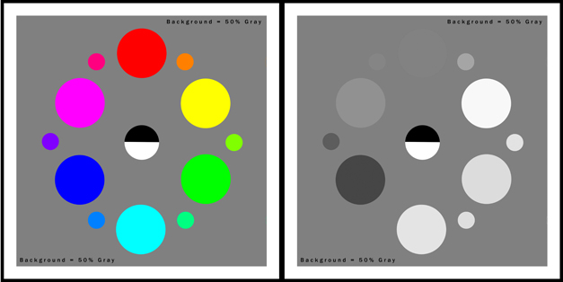
Figure(2.2)grayscale

The example of grayscale:
Original image
Average
Luminosity

Figure(2.3) example of grayscale

2.3introduction
The morphological its contain of many important filters (dilation, erosion, opening, closing and skeleton).

2.4Morphological Transformations:
Here we are trying to discuss most of the operations Morphological, which remained on the images after they converted images to grayscale and then to Binary(0,1), and these Morphological operations in the application may hiding noise or form undesirable as requested by the user of this operations or filling the image with the user's wants.
There is much kind of morphological transformations some of these:-
- Dilation.
- Erosion.
- Opening.
- Closing.

2.4.1 Dilation
Dilation causes objects to dilate or grow in size. The amount and the way that they grow depend upon the choice of the structuring element. Dilation makes an object larger by adding pixels around its edges [02].
The Dilation of an Image ‘A’ by a structuring element ‘B’. To compute the Dilation, we position ‘B’ such that its origin is at pixel coordinates
(x, y) and apply the rule. [02].

Image image after dilation

Figure (2.4) Morphological dilation

In figure (2.4) see how the pixel ”black” around the object is its growing and take the shape at last .

2.4.1.2 Dilation Procedure
The procedure of dilation is summarizes by these steps, where the structure element (matrix) 3x3 pixels is shown in figure(2.5) :
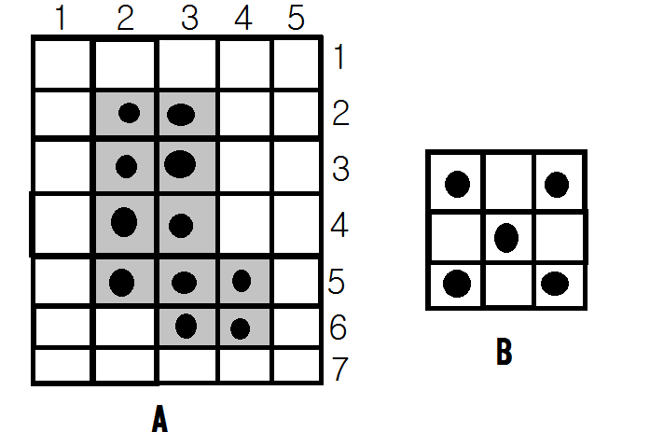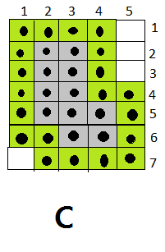

Figure(2.5)Morphological dilaiton technique

2.4.2Erosion
Erosion causes objects to shrink. The amount of the way that they shrink depends upon the choice of the structuring element. Erosion makes an object smaller by removing or eroding away the pixels on its edges. The Erosion of an image ‘A’ by a structuring element ‘B’[4].
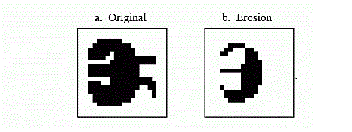

Figure (2.6) Morphological Erosion

In Figure(2.6) see how the pixel ”black” around the object is its narrowing and take the shape at last .
2.4.2.1 Erosion Procedure
The procedure of erosion is summarizes by these steps, where the structure element (matrix) 3x3 pixels is shown in figure (2.7):

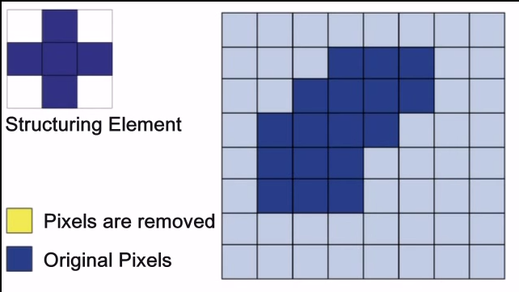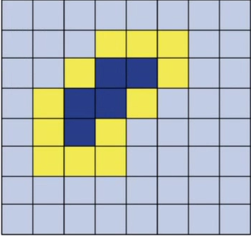

Figure(2.7)Morphological erosion technique

2.4.3Opening
It is a powerful operator, obtained by combining Erosion and Dilation. “Opening separates the Objects”. As we know, Dilation expands an image and Erosion shrinks it. Opening generally smoothest the contour of an image, breaks narrow Isthmuses and eliminates thin Protrusions. The Opening of an image ‘A’ by a structuring element ‘B’, and is defined as an Erosion followed by a Dilation [3].
Opening tends to smooth an image, break narrow joins, and remove thin protrusions.
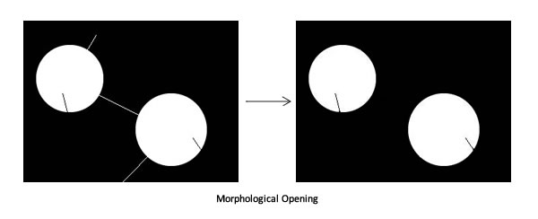
Orignal image image after opinnsing

Figure (2.8) Morphological opinning
2.4.3.1 Opening Procedure
The procedure of opening it is summarizes by these steps:
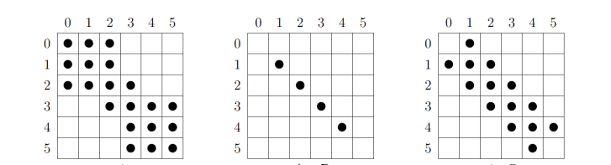
Figure (2.9) Morphological of opinning processing
2.4.4 Closing
It is a powerful operator, obtained by combining Erosion and Dilation. “Closing, join the Objects”. Closing also tends to smooth sections of contours but, as opposed to Opening, it generally fuses narrow breaks and long thin Gulf’s, eliminates small holes and fills gaps in the contour. The Closing of an image ‘A’ by a structuring element ‘B’, and defined as a Dilation followed by an Erosion [02].
Closing tends to smooth an image, Fuse narrow breaks and thin gulfs and Eliminates small holes.

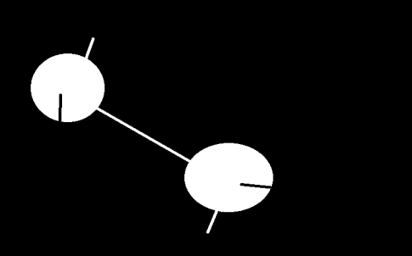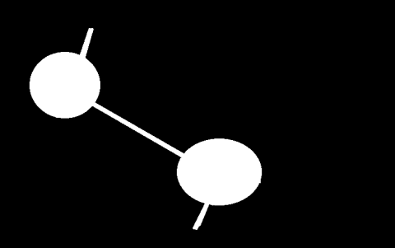
Orignal imag image after closing

Figure (2.10) Morphological closing

2.4.4.1 Closing Procedure
The procedure of closing it is summarizes by these steps:
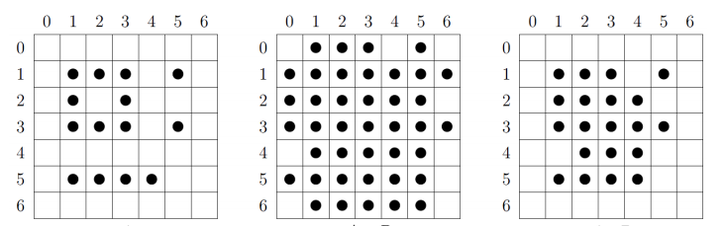
Figure (2.11) Morphological closing technique

Chapter Three

Design and Implementation
Method and Algorithms
3.1 Introduction
Matlab were used to implementation Project. Many morphological techniques were used, such as dilation, erosion, opening, closing.

3.2 Project Structure
The project structure is illustrated as a figure(3.1) were four morphological methods are used, two of them contain two filters, the other contain one filter: part1 (dilation and erosion), part 2 (opening and closing)

3.2.1Loading Image:
Load RGB image, the type of image is jpg ,the size of picture is 256 x 256 pixel that represent width x height,

3.2.2Convert color image to gray then to binary:
Convert RGB image to gray image by applying equation (2.1).The Gray image in turn will be converted to binary. This is done by extracting the highest value and the lowest value in the image, then compute the threshold by finding the average value between them.
If gray (X, Y) < threshold
Image binary(X, Y) = 0
Other
Image binary(X, Y) = 1

Start

Load image

Convert Color image to gray then to binary

Dilation Erosion Opening Closing Skeleton

End

Figure(3.1) Project structure

3.2.3Dilation:
Dilation procedure is implemented on binary image where the black pixel is growing in image.
- Start of Algorithm 1 , Dilation of image
- For loop to width of image
- For loop to height of image
- bin(x,y) , binary image .
- imgErose (x,y) , binary image , the Black pixel is growing image .
Step1
If bin(x, y) = 0 Then
imgErose(x - 1, y) = 1 : imgErose(x + 1, y) = 1
imgErose(x, y - 1) = 1: imgErose(x, y + 1) = 1
imgErose(x, y) = 1
End If
End for
End for

- For loop to width of image
- For loop to height of image
E = imgErose(x, y)
If E = 1 Then E = 0 Else E = 1
Bin(x,y)=E
- End for
- End for

end

3.2.4 Erosion
Erosion procedure is implemented on binary image as shown in figure (3.5), where the white pixel is growing in image, and the landmarks of image being disappear.
- Start of Algorithm 2 , Erosion of image
- For loop to width of image
- For loop to height of image
- bin(x,y) , binary image .
- imgErose (x,y) , binary image , the white pixel is growing image .
Step1
If bin(x, y) = 0 Then
imgErose(x - 1, y) = 1 : imgErose(x + 1, y) = 1
imgErose(x, y - 1) = 1: imgErose(x, y + 1) = 1
imgErose(x, y) = 1
End If
End for
End for
- For loop to width of image
- For loop to height of image
E = imgErose(x, y)
If E = 1 Then E = 1 Else E = 0
Bin(x,y)=E
- End for
- End for

end
notes E is an variable equaled to the array

3.2.5Opening
Opening procedure is done by applying erosion procedure then dilation procedure

Start of Algorithm 3 , Opening of image
- For loop to width of image
- For loop to height of image
Step 1
If bin(x, y) = 0 Then
imgErose(x - 1, y) = 1 : imgErose(x + 1, y) = 1
imgErose(x, y - 1) = 1: imgErose(x, y + 1) = 1
imgErose(x, y) = 1
End If
End for
End for
- For loop to width of image
- For loop to height of image
E = imgErose(x, y)
If E = 1 Then E = 1 Else E = 0
Bin(x,y)=E
- End for
- End for
- For loop to width of image
- For loop to height of image
If bin(x, y) = 0 Then
imgErose(x - 1, y) = 1 : imgErose(x + 1, y) = 1

imgErose(x, y - 1) = 1: imgErose(x, y + 1) = 1
imgErose(x, y) = 1
End If
End for
End for

- For loop to width of image
- For loop to height of image
E = imgErose(x, y)
If E = 1 Then E = 0 Else E = 1
Bin(x,y)=E
- End for
- End for

end

3.2.6Closing
Closing procedure is done by applying dilation procedure then erosion procedure,
Start of Algorithm 4 , Colsing of image
- For loop to width of image
- For loop to height of image
If bin(x, y) = 0 Then
imgErose(x - 1, y) = 1 : imgErose(x + 1, y) = 1
imgErose(x, y - 1) = 1: imgErose(x, y + 1) = 1
imgErose(x, y) = 1
End If
End for
End for
- For loop to width of image
- For loop to height of image
E = imgErose(x, y)
If E = 1 Then E = 0 Else E = 1
Bin(x,y)=E
- End for
- End for
- For loop to width of image
- For loop to height of image
If bin(x, y) = 0 Then
imgErose(x - 1, y) = 1 : imgErose(x + 1, y) = 1
imgErose(x, y - 1) = 1: imgErose(x, y + 1) = 1
imgErose(x, y) = 1
End If

End for
End for
- For loop to width of image
- For loop to height of image
E = imgErose(x, y)
If E = 1 Then E = 1 Else E = 0
Bin(x,y)=E
- End for
- End for

end

Chapter Four

Test and Result
  - open Matlab interface
Introduction In Matlab : Allow mathematical manipulation of matrices, mathematical graphing , implementation of various algorithms , creation of gtapical user interface , and communication with programs written in other languages , including C , C++ .

We used Laptop HP and Matlab programming language .

  - dilation method
    - original image

Figure (4.2) image before dilation
    - image after dilation

Figure (4.3) image after dilation

4.5.1 original image

Figure (4.4) image before Erosion

4.5.2 image after erosion

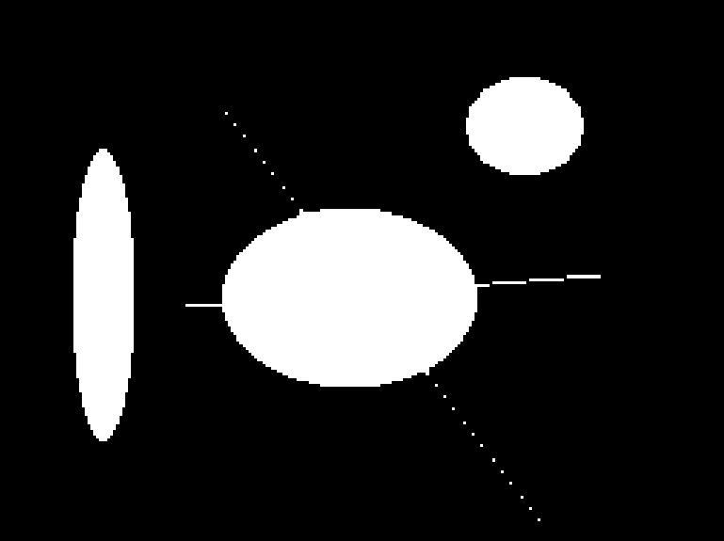

Figure (4.5) image after Erosion
4.6.1 original image

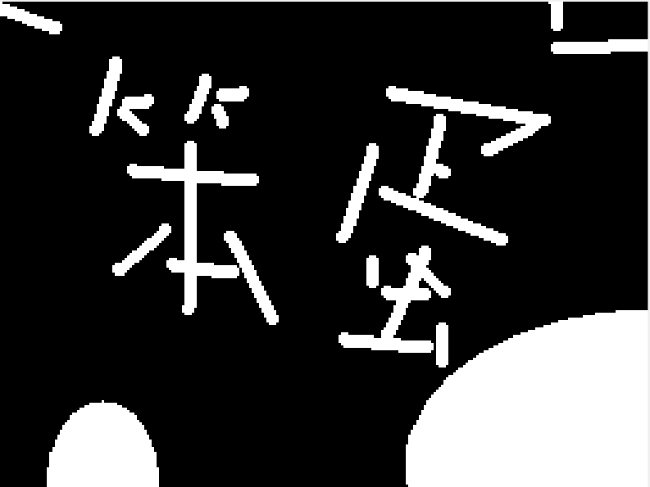
Figure (4.6) image before opening
4.6.2 image after opening

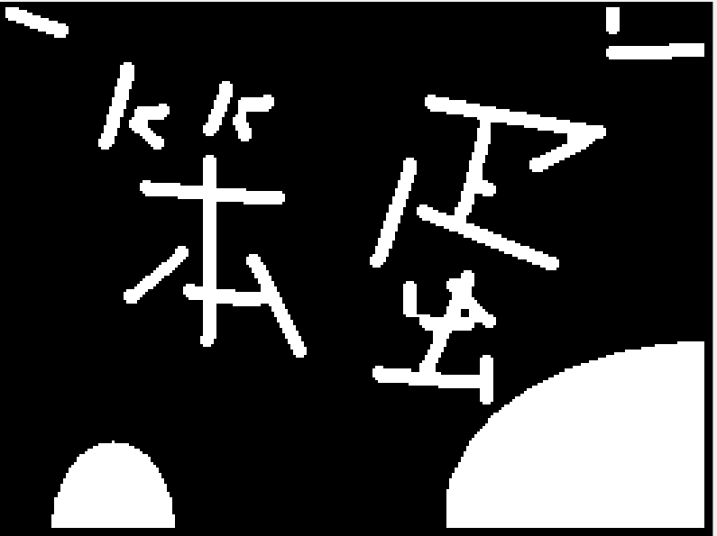
Figure (4.7) image after opening

4.7.1 organl image

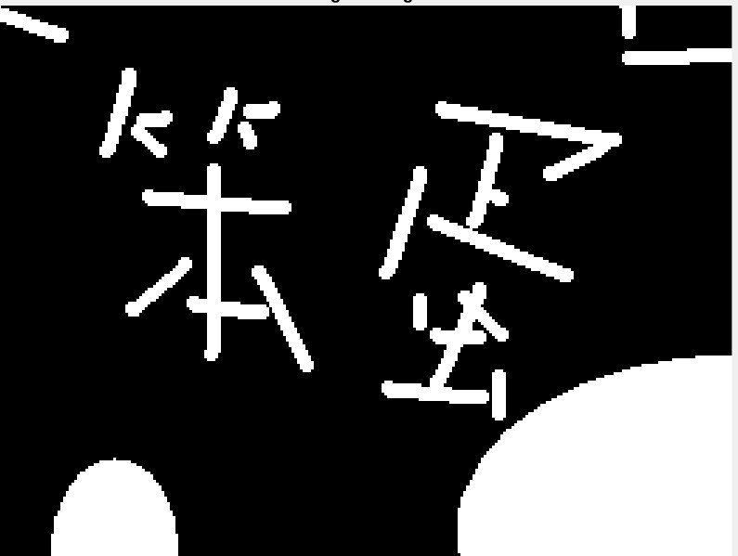

Figure (4.8) image before closing
4.7.2 image after closing

Figure (4.9) image after closing

Chapter five

Conclusions and Suggestions for Future Work

5.1 Conclusions
From the investigation of the results, the following conclusions were derived:
- Morphological it contains filters task (dilation , erosion , skeleton , opening , closing) and use them on images is clearly defined and the result was almost empty forms of unwanted increases omitted (Noise).

- the dilation after loading the image and apply the grayscale and binary on it found that the non-connected endings in the picture became stretching and relate to each course with an increase in thicken.

- the erosion when applied this filter the unwanted pixels gone in the original image by increasing the whiteness in the picture.

- the skeleton when convert the image to grayscale and binary then applied Zhang and suen algorithm the result was extracted structure image by deleting unwanted pixels and retain the desired pixels based on Zhang and suen algorithm.

5.2 Future works
The following topics are suggested for future work:
- For Skeleton extracted image and the future possible to use the discovery of the edges and extracted the difference in the image or use boundary and compared results.
- For the dilation and erosion possible that used to distinguish fingerprints, but you must add steps like smooth to make the process more details and clarification.
- And also we can use dilation, erosion, opening and closing it to clarify and unclear texts.

Reference
1-John Wiley and Sons , international journal of computer science and information technology ( IJCSIT) VOL5 , February 2013 .
2-Roberto A.Loutufo , Edward R.Dougherty , Hands , on Mophological image .
3- A.Walker and E.wolfart , Journal of Kerbala University , Scientific 2008 .
4- Gonzalez , Digital Image Processing , 2nd . Edition 2002 .
5- R.Gonzalez , R.Woods , Digital Image Processing , Scientific 2008
6- R.Fisher , Morphological operations on binary images1 , Laboratory 7 , 2003
7- Sarp Erturk , Digital Image Processing with LabView 2008 .

