Republic of Iraq
Ministry of Higher Education and Scientific Research
University of AL-Qadisiya
College of Computer Science and Information Technology
Computer Science department

Doctor Appointment Using Android Studio and SQL

Research done by :

AMENA ALI MOHAMMED
EMAN ALI KHUDHAIR NORA NASIR HAMID

SUPERVISOR
A.M.D
MUNTASIR JABER JAWAD
بسم الله الرحمن الرحيم
قَالَ الَّذِي عِنْدَهُ عِلْمٌ مِنَ الْكِتَابِ أَنَا آتِيكَ بِهِ قَبْلَ أَنْ يَرْتَدَّ إِلَيْكَ طَرْفُكَ فَلَمَّا رَآهُ مُسْتَقِرًّا عِنْدَهُ قَالَ هَذَا مِنْ فَضْلِ رَبِّي لِيَبْلُوَنِي أَأَشْكُرُ أَمْ أَكْفُرُ وَمَنْ شَكَرَ فَإِنَّمَا يَشْكُرُ لِنَفْسِهِ وَمَنْ كَفَرَ فَإِنَّ رَبِّي غَنِيٌّ كَرِيمٌ قَالَ نَكِّرُوا لَهَا عَرْشَهَا نَنْظُرْ أَتَهْتَدِي أَمْ تَكُونُ مِنَ الَّذِينَ لَا يَهْتَدُونَ .

صدق الله العلي العظيم

سورة النمل (40)

الإهداء

الى من تجرع الكأس فارغا ليسقيني قطرة حب
الى من كلت أنامله ليقدم لنا لحظة سعادة
الى من حصد الأشواك عن دربي ليمهد لي طريق العلم
الى القلب الكبير والدي العزيز الى رمز الحب وبلسم الشفاء
الى القلب الناصع بالبياض والدتي الحبيبه
الى من بها اكبر وعليها اعتمد
الى شمعه متقدة تنير ظلمة حياتي ورفقاء دربي منذ ان حملنا الحقائب الصغيرة وسرنا على الدرب خطوة بخطوة
الى اخوتي وأصدقائي
الى من وقف على المنابر وأعطى من حصيلة فكره لينير دربنا اهديكم مشروع تخرجي.

شكر وتقدير
(الى قسم علوم الحاسوب)

الحمد لله رب العالمين والصلاة والسلام على أشرف الأنبياء والمرسلين النبي محمَّد ( صلى الله عليه واله و سلم ).
فإني أشكر الله تعالى على فضله حيث أتاح لي إنجاز هذا العمل بفضله، فله الحمد أولاً وآخراً.
ثم أشكر أولئك الأخيار الذين مدوا لي يدَ المساعدة، خلال هذه الفترة، وفي مقدمتهم أستاذي المشرف على البحث الأستاذ ( منتصر جابر ) الذي لم يدَّخر جهداً في مساعدتي وكان يحثّني على البحث، ويرغِّبني فيه، ويقوّي عزيمتي عليه فله من الله الأجر ومني كل تقدير حفظه الله ومتّعه بالصحة والعافية ونفع بعلومه.

Chapter one

Chapter one Introduction

1.1 Introduction
1.2 What is Appointment Scheduling Software?
At a certain point, appointments in date books, calendars, and paper charts are not safe as they are more likely to be damaged or stolen than digital scheduling tools. These systems help you complete scheduling by enabling both customers and employees to book appointments and organize meetings. Scheduling programs have become a necessary technology for service-based companies. These programs enable appointment cancellation, rescheduling and online payment processing. It can also be used to send automated reminders and capture customer information that can be used to run effective marketing campaigns .These systems can help you schedule many different appointment types:
- Health and beauty (e.g., medical practices, spas and salons)
- Fitness and recreation (e.g., gyms, yoga studios and personal trainers)
- Financial services (e.g., tax consultants and accountants)
- Auto maintenance (e.g., mechanics and car washes)
- Food service (e.g., restaurants and caterers)
- Field service (e.g., pest control and housecleaning)
- Education (e.g., tutors and universities) [1]

Chapter one Introduction

If we have a client-based business, it takes effort to plan and manage the calendar. Let's say customers are sick. They'll call you to ask for an
appointment and you'll know when you can work. It's more complicated only when you have to enter emergency reservations or Reschedule someone at short notice, or reduce your loss of attendance. However, there is no need to do this manually, because scheduling applications can do this for you, and they can do it more easily and have less headaches.[2]

1.3 Benefits of Appointment Scheduling Software
There are many benefits to the applications of booking appointments. We talk about several points that illustrate the benefit and how to make the application great is as follows:[1]
Reducing no-shows: automatically, Scheduling tracks upcoming appointments and sends call, email, or text message notifications to customers to remind them of upcoming appointments. Where allowing customers to confirm appointments through these reminders. This helps reduce attendance and allows companies to better use their employees.
Improving staff efficiency: At peak hours service professionals have difficulty managing customer appointments. They can risk double reservation times, which could result in customer loss when the appropriate software is not available. Scheduling software makes it easy to reschedule customers without losing time.

Chapter one Introduction

Flexibility: Is one of the features that applications give customers to enjoy in-depth privacy. For example, a small gym that offers individual training courses should have a different booking experience than the community workshop that hires gardening equipment. From these aspects you specialize, do you want your customers to be able to choose a list of services? Should they be able to locate their appointment, such as services provided at home? [2]
Multiple points of access: In order for the client to access the service settings, the application gives you the best options. You may want to include some icons on your website to display the scheduling program, but you may also prefer a custom URL with all the booking tools in one place .Where all the number of options was all the better without any doubt. [2]
Driving revenue: With software automating the scheduling process, employees have more time to focus on revenue-generating activities, such as seeing more customers per day. Integration with electronic payment gateways can help expedite the billing process so businesses are paid more quickly.
Attract and retain clients: One of the valuable assets in marketing services is comfort to convince existing customers to stay loyal to your

Chapter one Introduction
business by making customers determine the right time to serve you where the experience is probably better. With scheduling appointments online 24 hours a day, 7 days a week, your customers do not have to adhere to normal hours of booking. A survey of program guidelines for chiropractic patients found that 25% are interested in scheduling appointments through an online portal.
1.4 Existing Applications
Today, there are many scheduling applications that make life easier for many people, whether they are working in a job or a free business. These applications can be easily acquired from the Internet [3].
1.4.1 Daily Appointment Calendar
The calendar displays the daily appointments. It does exactly what you expect -if you want to know what your day is, because it gives you an overview of your appointments for the next day. In addition to instant access to all your important data.

1.4.2 Customer management
All the access and tools you get from the web app are at your fingertips - only with more instant access!

Chapter one Introduction

1.4.3 Cross platform apps
All data is synced seamlessly across all your devices. Tablet and desktop applications for Windows and macOS work offline, so you can never access calendar data.

1.3.4 GnomGuru: In this application, customers can schedule appointments with various companies. This application only schedules appointment but does not handle any changes in the appointment. It assumes that every person arrives exactly on time without any delays, which is not practical. It doesn’t notify people about any delays or updates,which ultimately leads to waiting. It also doesn’t give priorities to the appointments and all the appointments are treated equally. It would be helpful if there is a way to prioritize the appointment so that the appointments with higher priorities will be handled accordingly.[4]

Chapter one Introduction

1.4.5 Trivago: Is an application that makes it easy for travelers to choose and book the best hotels at the right price where they are offered high quality hotels and when choosing a booking traveler one must specify the time of arrival and departure.

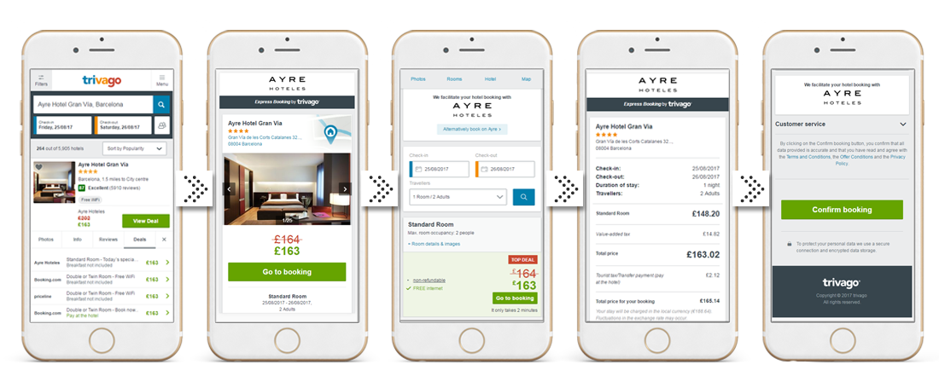

Figure 1.1 The Application interfaces of Trivago.

Summary of chapters

Project Outlines

Chapter 2: shows the android It shows how the android systems interact with the systems of the various devices and how to coordinate them and deal with each other, as it has many versions and this is shown in this chapter, by a table with pictures of the devices in different systems and sizes, as well as displays the features of the program Android Studio.

Chapter 3: the third chapter shows the practical part of the proposed work by investigate the follow chart of the proposed system and interface of the model and full description of each one. Also discussed the server that used in this work.

Chapter two

Chapter Two Android studio
Android studio
2.1 What is Android?
Android is a mobile operating system that is based on a modified version of Linux. It was originally developed by a startup of the same name, Android, Inc. In 2005, as part of its strategy to enter the mobile space, Google purchased Android, Inc. The android is a powerful operating system and it supports a large number of applications in Smartphones.
These applications are more comfortable and advanced for users. The hardware that supports android software is based on the ARM architecture platform. The android is an open source operating system means that it’s free and anyone can use it. Moreover, vendors (typically hardware manufacturers) can add their own proprietary extensions to Android and customize Android to differentiate their products from others.
This development model makes Android very attractive to vendors, especially those companies affected by the phenomenon of Apple’s iPhone. The android has got millions of apps available that can help you to manage your life one or other way and it is available to low cost in the market at that reasons android is very popular. Some companies that have taken advantage of Android’s open source policy include Motorola and Sony Ericsson, which have been developing their own mobile operating systems for many years. Android development supports the full java programming language. Even other packages that are API and JSE are not supported.

Code Name | Initial Release date | Code Name | Initial Release date
No codename | September 23, 2008 | Ice Cream Sandwich | October 18, 2011
Petit Four | February 9, 2009 | Jelly Bean | July 9, 2012
Cupcake | April 27, 2009 | KitKat | October 31, 2013
Donut | September 15, 2009 | Lollipop | November 12, 2014
Éclair | October 26, 2009 | Marshmallow | October 5, 2015
Froyo | May 20, 2010 | Nougat | August 22, 2016
Gingerbread | December 6, 2010 | Oreo | August 21, 2017
Honeycomb | February 22, 2011 | Pie | August 6, 2018

Table 2.1 Android Versions from 2008-2018.

Chapter Two Android studio

There are many devices in market work by Android system as shown in figure 2.1:

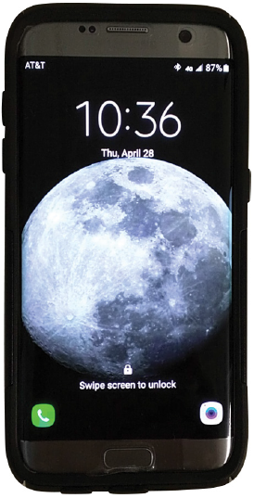Smartphones | 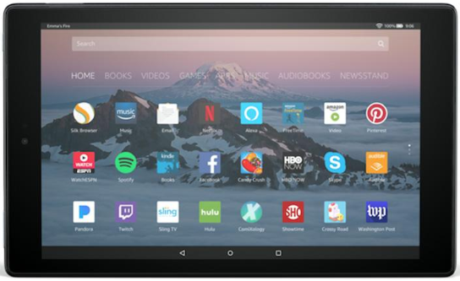  Tablets | 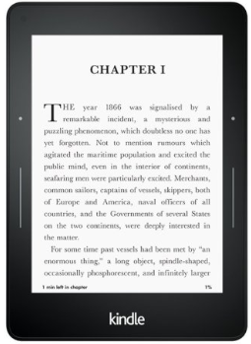  E-reader
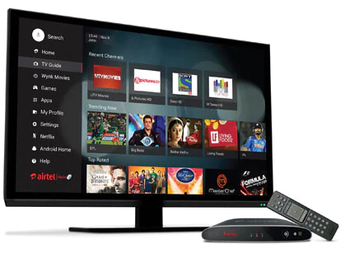  Internet TVs | Automobiles | 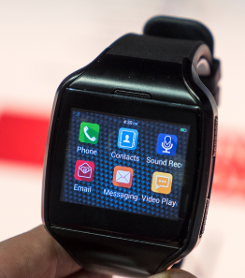  Smartwatches
Figure 2.1 Android devices with different forms.

2.2 Features of Android [5]
There are more features of Android Studio are:

Chapter Two Android studio

2.2.1 Instant App Run: It's a fast and advanced technique . it understand the smartness of the transmissions in applications and get them
immediately without the need to time to re-create the apk file and installations. Where you can see the changes in the app right away. This is done by running a URL on the Android app by installing native libraries using Android Instant applications.
2.2.2 Visual Layout Editor: Layout editor helps to build the layout quickly by adding different attributes either by hard-code or drag and drop. The preview of the codes can be seen easily on the visual editor screen and changes can be made accordingly by resizing it dynamically. This will make testing the application process more facile and more exhaustive.

Chapter Two Android studio

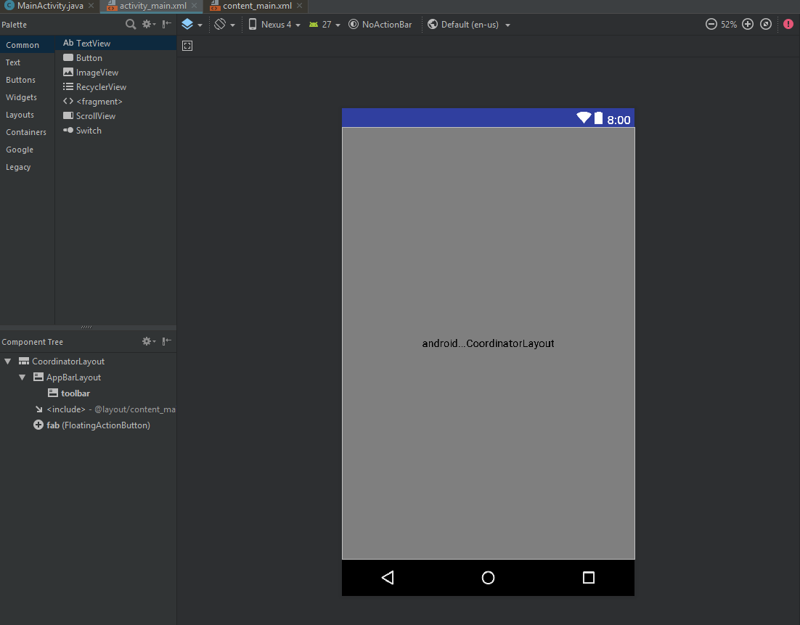

Figure 2.2 Layout Editor in Android Studio. [6]

2.2.3 Fast Emulator: To test the form of the application in physical devices. Android offers a great feature is Emulator, which is exactly like Android phones, allowing you to test your applications faster and on different configuration devices such as tablet, Android phone and so on. helps you make your application development cycle shorter and more
Chapter Two Android studio

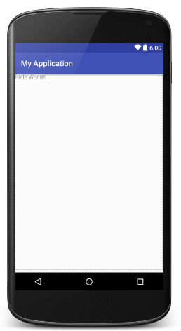
Figure 2.3 The Emulator of Android Studio. [7]

Chapter Two Android studio

2.2.4 Intelligence Code Editor: The Android Studio offers a special feature in code development through the drop-down menu with code suggestion that you can embed. This will help you and guide you with the
exact code.
.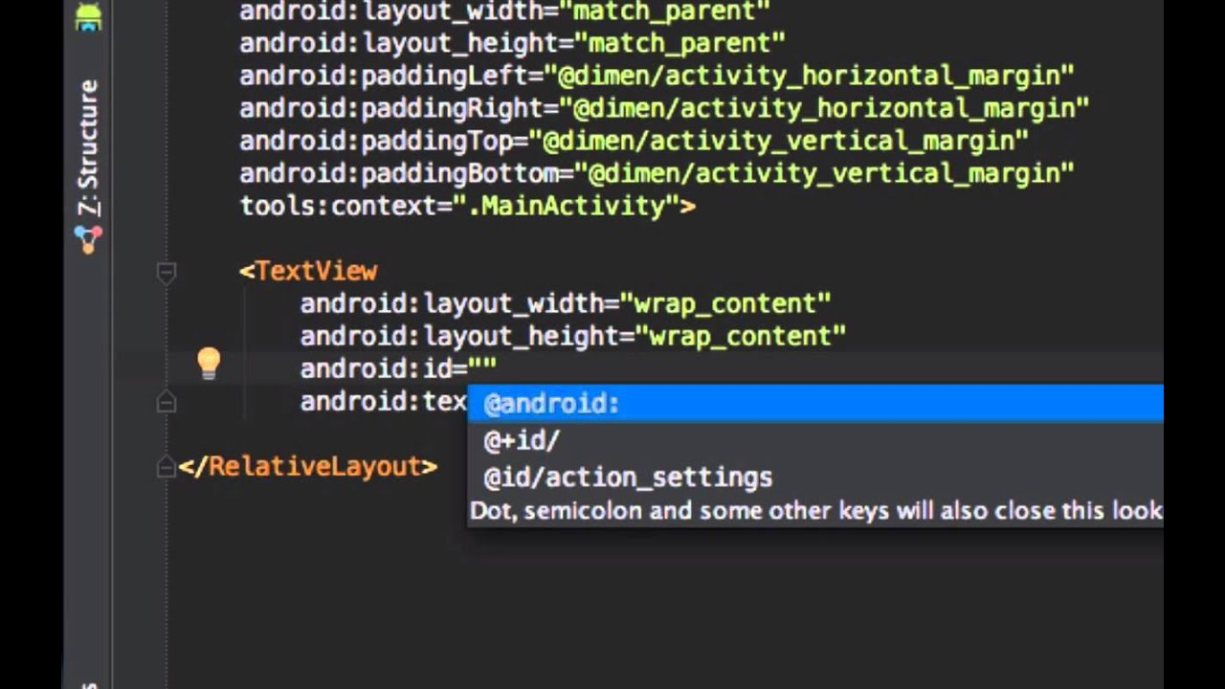
Figure 2.3 Intelligence Code Editor

2.2.5 Addition of New Activity as a Code Template: Android has the built-in templates feature. Not all templates are available because as an additional feature that helps the developer to create an application efficiently and effectively that provides effective solutions.

Chapter Two Android studio

2.2.6 Help to Build Up App for All Devices: Android studio has the advantage of saving screen size for all types of devices and can stimulate the different types of features enjoyed by the device such as GPS tracking or multi-touch.
. 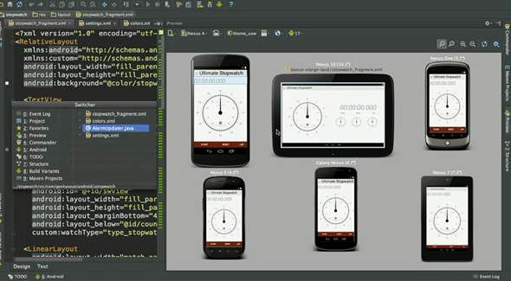
Figure 2.4 the forms of some Devices

2.2.7 Help to Connect with Firebase: Android Studio helps to give real-time experience with IOT based project development with dynamic upgrades in the application. Firebase connectivity help to create direct updates and provide databases connectivity. To build high-quality applications we must use Firebase connectivity it helps to build the scalable infrastructure for building the application. You can create chat
Chapter Two Android studio

applications by using firebase connectivity it helps you to do happy chat experience.

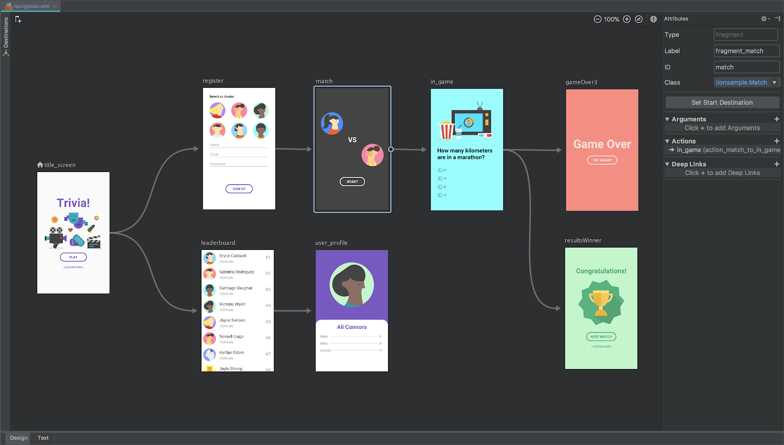
Figure 2.4 Connecting with Firebase.

2.2.8 Support KOTLIN: KOTLIN is a language without any new restrictions and has different advantages as it can be considered as the official language of Android studio can be run without any disruptions in the old versions of Android, meaning no problems in specific Android versions. It runs fast and rewarding for Java. Java developers can hands-

Chapter Two Android studio

on Kotlin easily without problems because it relies on Java automation only.
2.2.9 Color Previews: Android studio helps to see the code XML part in a preview to know that how perfectly we are designing the application according to the need before launching the application. It provides powerful functionality and enhanced features of drag and drops or resizes the application. It contains drag and drop features but not support for every function, that's why be careful while doing that.

2.2.10 Maven Repository: In Android Studio, Maven integration of its repository can be done, within SDK manager support libraries of IDE is used. It’s a kind of a repository which is a directory in which various jar files like project jars, Plugin are stored.

2.4 Android Advantages
If you aspire to become an Android developer, you’ve made an excellent choice. Billions of people in the developing world will be coming online in the next decade. For most of these people, their first computers will be smartphones, and most of these smartphones will be powered by Android. There’s good reason for our optimism and already a lot of historical data from which we can extrapolate. Gartner Group projects that 1.25 billion Android devices will be sold in 2015iv.
At the time of this writing, Android accounts for over three-quarters of the Chinese market alones, and Chinese consumers are prepared to make staggeringly large investments in mobile devices, some spending as much

Chapter Two Android studio

as 70 percent of their monthly salary on a new mobile device because connectivity is a prerequisite for participation in the global economy.vi China is the largest market in sheer volume, but we can observe similar trends across the developing world. Furthermore, because the Android OS is open source and free, it is almost always the first choice among manufacturers of TV consoles, gaming systems, augmented reality systems, and other electronic devices, of which there are many. Android will continue to consolidate its dominant global market position for several reasons. Android’s modular architecture allows for a wide variety of configurations and customizations. All the core applications that ship standard with Android devices are interchangeable with any number of third-party applications, and that includes applications like the phone dialer, the e-mail client, the browser, and even the OS navigator. Android devices are available in an amazing variety of shapes and functions. There are Android augmented reality glasses, Android game consoles
(of which Ouya is the most notable), Android watches, Android tablets of every conceivable size, and, of course, Android smartphones. Android’s core technologies compare favorably to those of its principal competitors. Android’s inclusive and open source charter has attracted a large and impressive collection of allies, including Samsung, which is among the most innovative companies in the world. A free and customizable operating system means that Android device manufacturers can focus on bringing products to market with unrivaled value, and the highly competitive Android device market continues to produce inexpensive, high-quality, and architecturally open devices.[6]

Chapter Two Android studio

2.5 System Requirements
Android application development may be performed on any of the following system types:[8]

- Windows 2003 (32-bit or 64-bit)
- Windows Vista (32-bit or 64-bit)
- Windows 7 (32-bit or 64-bit)
- Windows 8 / Windows 8.1
- Mac OS X 10.8.5 or later (Intel based systems only)
- Linux systems with version 2.11 or later of GNU C Library (glibc)
- Minimum of 2GB of RAM (4GB is preferred)
- 1.5GB of available disk space

Chapter three

Chapter Three Project

3.1 General structure of the project

3.2 The project consists of two important components: the first server and the second client. The first is to process the processes and requests required by the client and store data and provide data protection either in the client, which is an android device that will send information to the server .

Chapter Three Project

3.3 Android section
This section represents the side of the graphical interfaces, movements, input and output of the project.
3.3.1 User Interface (UI) and Project Flow
The graphical interfaces are designed with the officially supported XML architecture from Android that will capture the overall look of the client application .
Since the project requires two types of users or customers (doctor and patient) at the first operation of the application will demonstrate a graphical interface that allows the client to determine the type of use.

Chapter Three Project

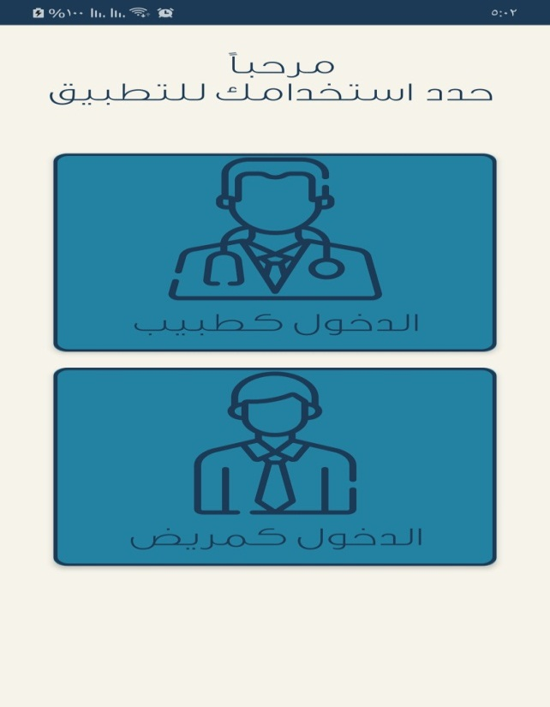

Figure 3.1 shown the interface contains two options that allow
the user to specify the application's uses.

Chapter Three Project

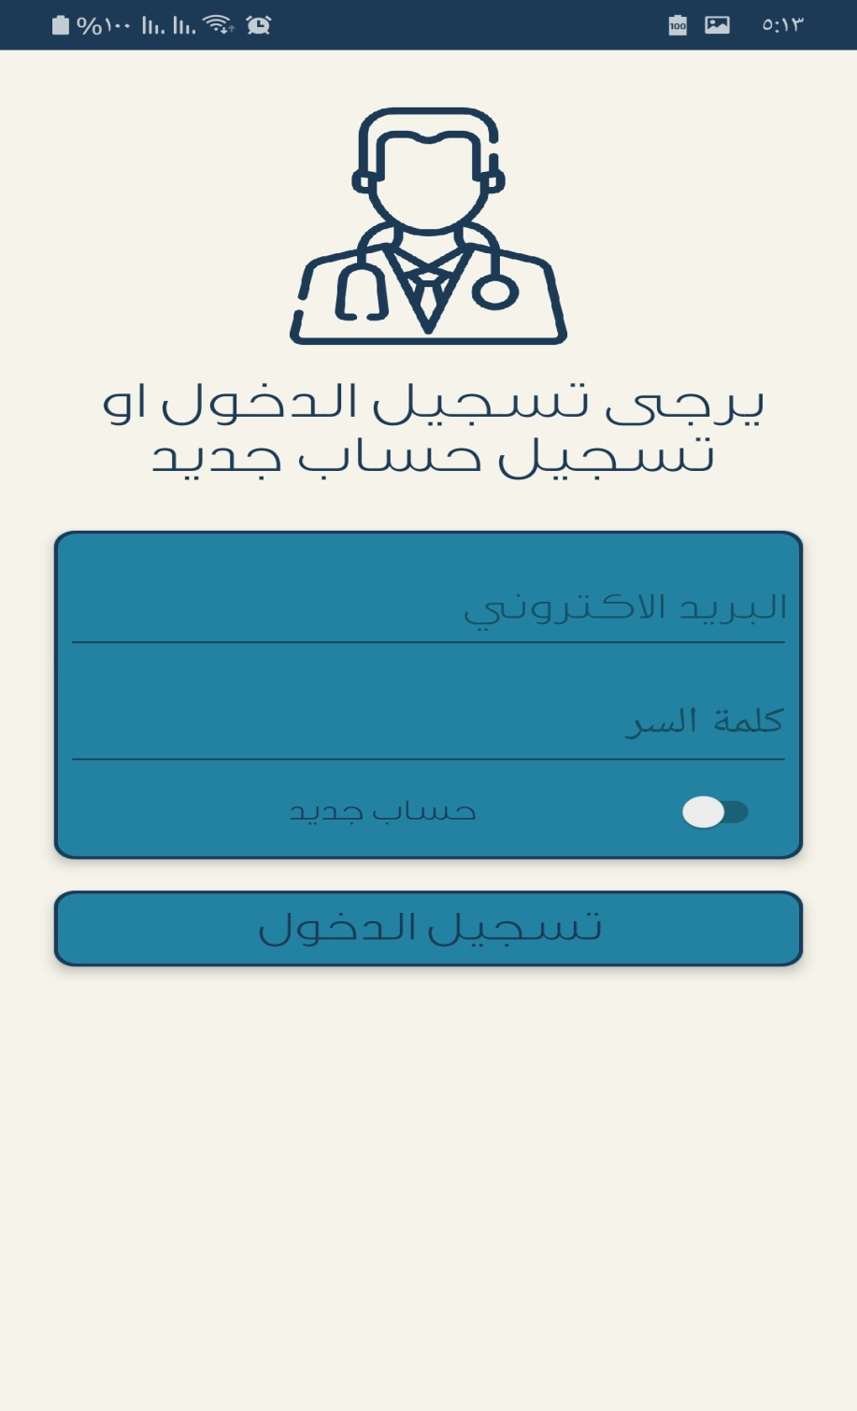

Figure 3.2 When the user inter as the Doctor.

Chapter Three Project

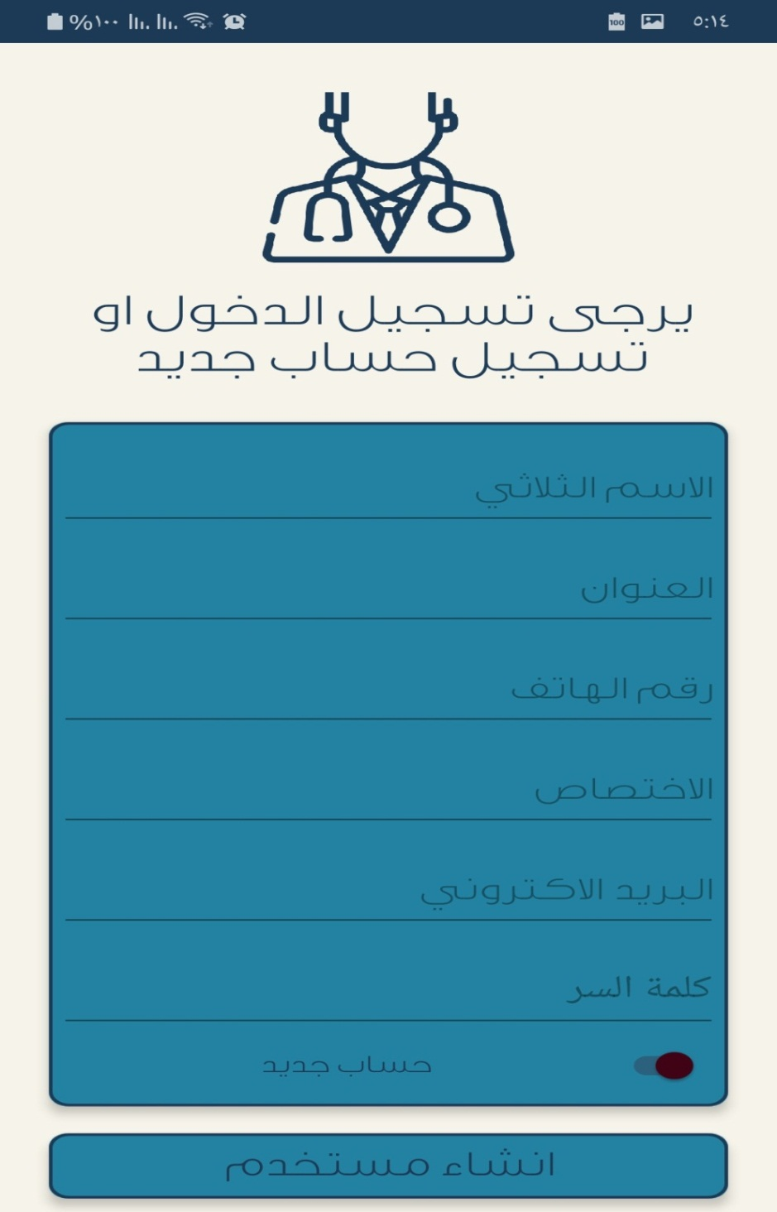

Figure 3.3 If the Docture want create new accuont.

Chapter Three Project

In the front of the doctor, we show the tab of the applications by patients who want to hold the doctor where the patient's
name is dashed with the status of the current request if accepted or rejected.
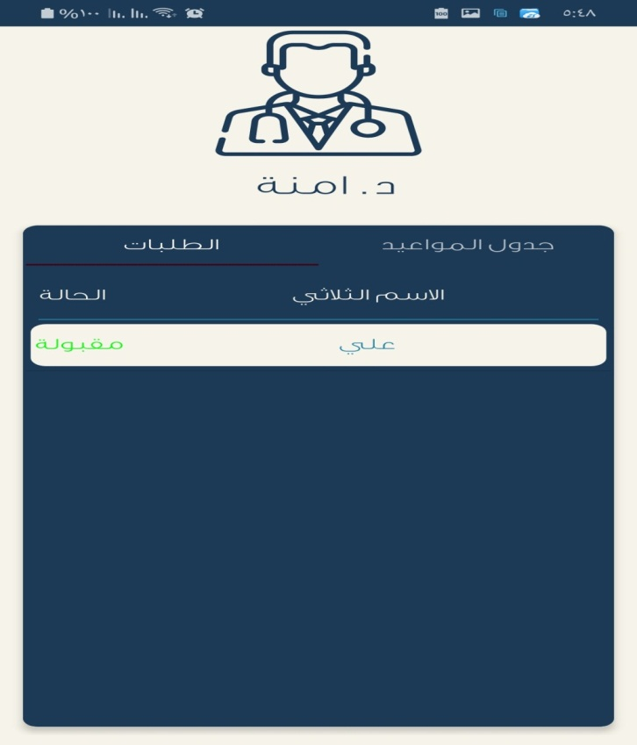

Figure 3.4 show the patients with the case of appointment.

Chapter Three Project

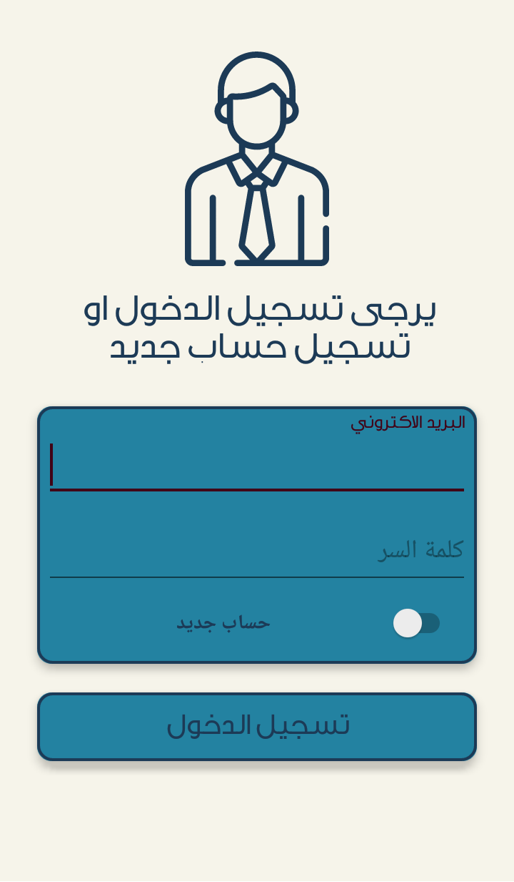
In the user interface, if it is a patient type, the interface contains appointments that have been booked by the doctor with the name of the doctor and the time set by the physician for the patient.

Figure 3.5 show the interface of the patient.

Chapter Three Project

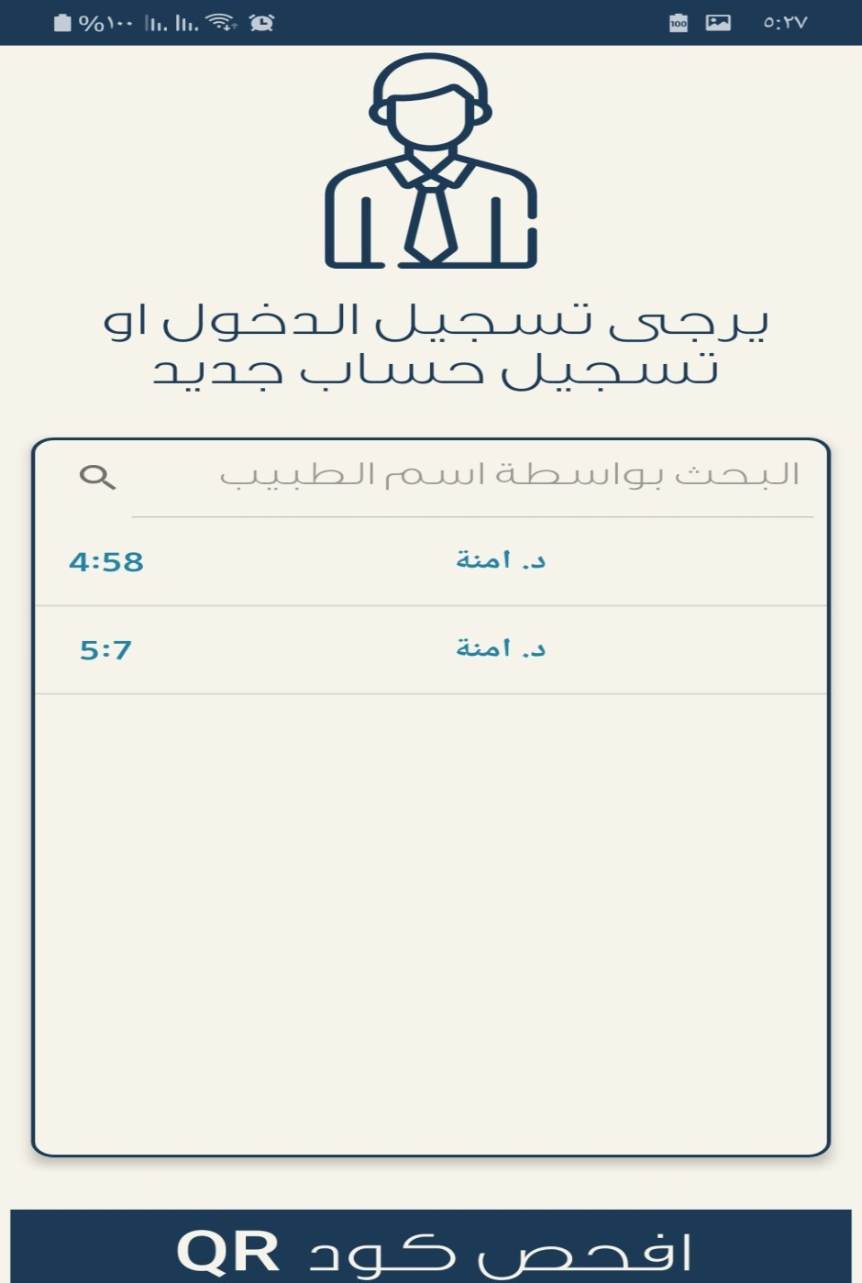

Figure 3.6 show the booked with the name of doctor and the time of appointment.

Chapter Three Project

When you click on a pending request, the doctor can determine the day and time that the patient wants to book him.
In the second tab, the doctor can show the appointments that are performed with the patient one day of the week.
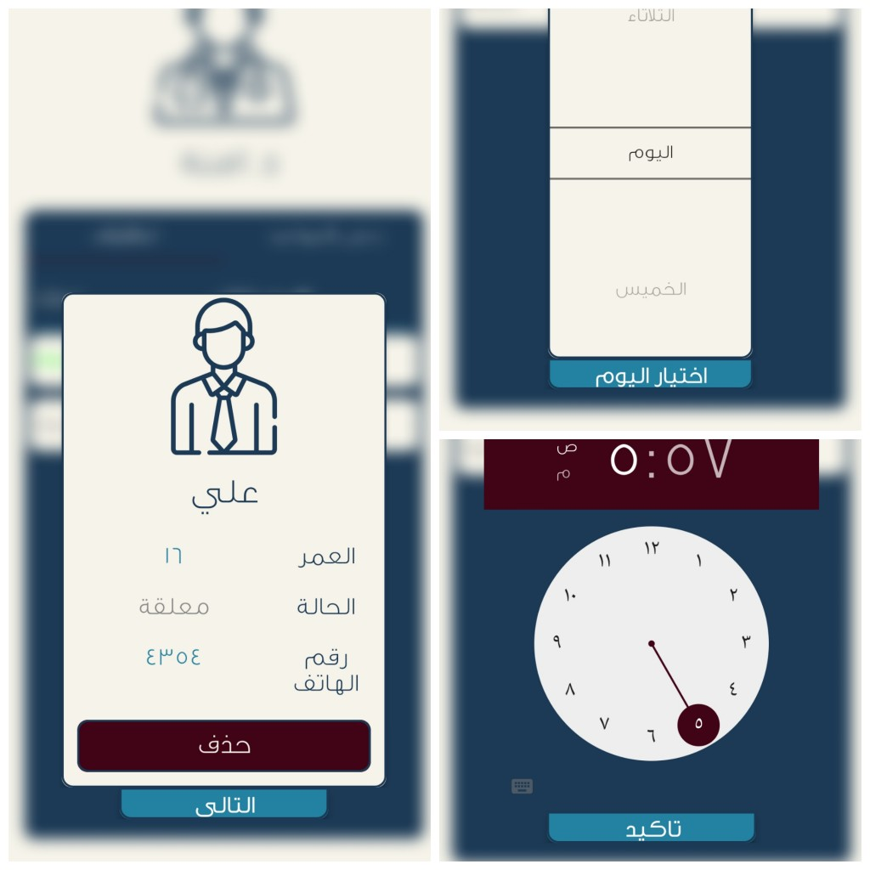

Figure 3.7 Show the How to determine the doctor dates.

Chapter Three Project

Once the doctor has determined the patients' dates, they will have an interface made up of the left side that shows the schedule of the week, while the right side shows the new applications.
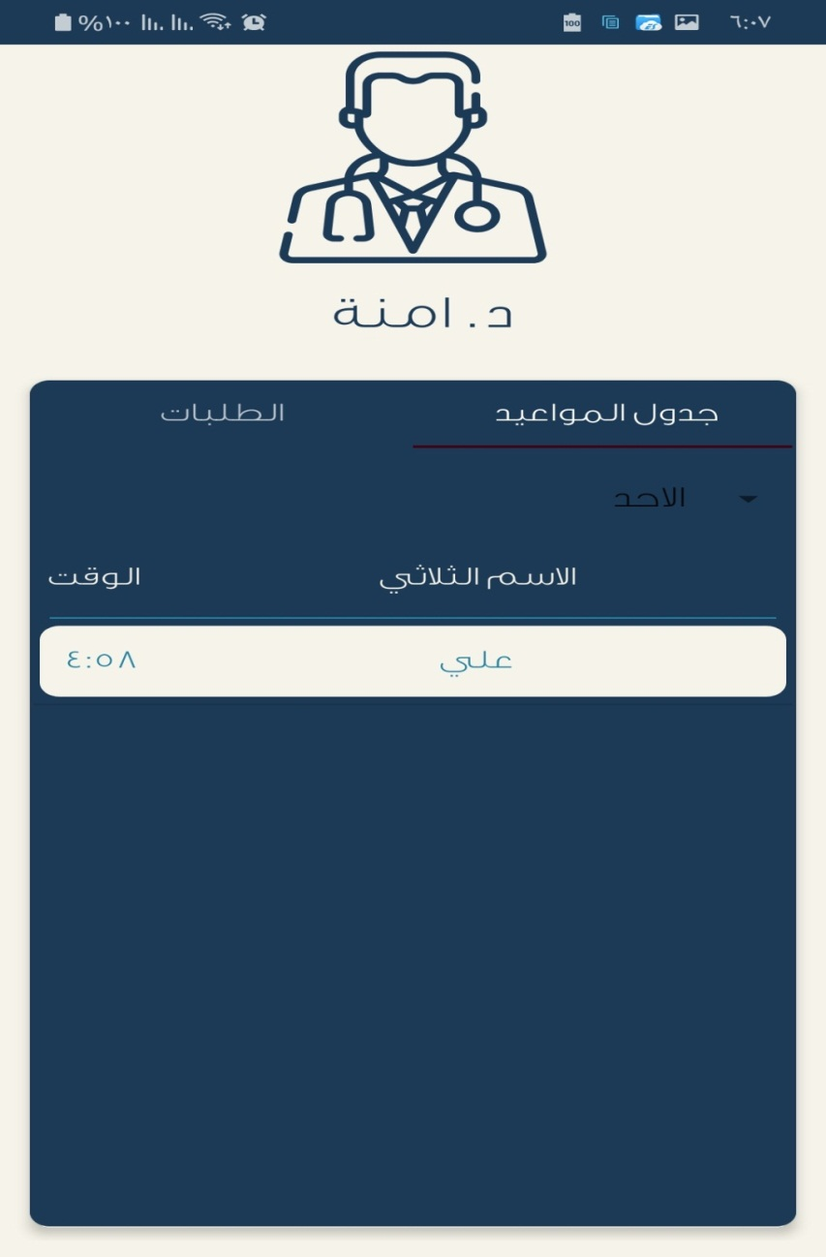

Figure 3.8 Show the appointments of Patients.

Chapter Three Project

Switch allows you to switch between creating a user and logging in to a previous account when you log in successfully. Only one value in the application data is stored in the web token, which is encrypted text that contains current user information.
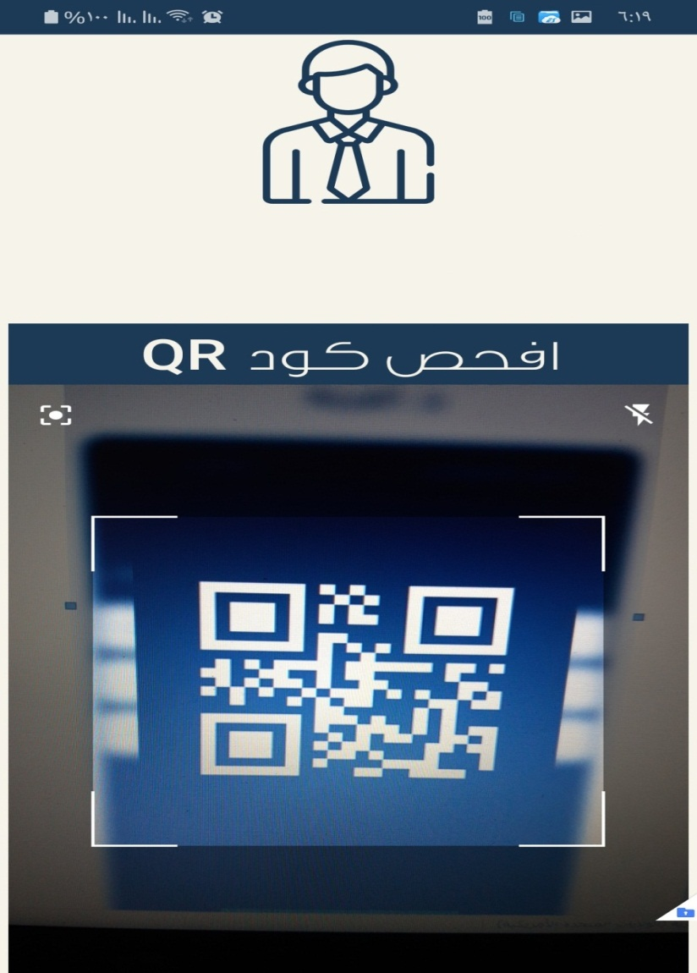

.
Figure 3.8 shown QR to checking

Chapter Three Project

As a kind of safety, the doctor makes sure that the current patient in the clinic is the same person who booked in advance. A QR code for this application cannot be repeated or similar. Its usefulness is to confirm the patient's incarceration of the clinic.
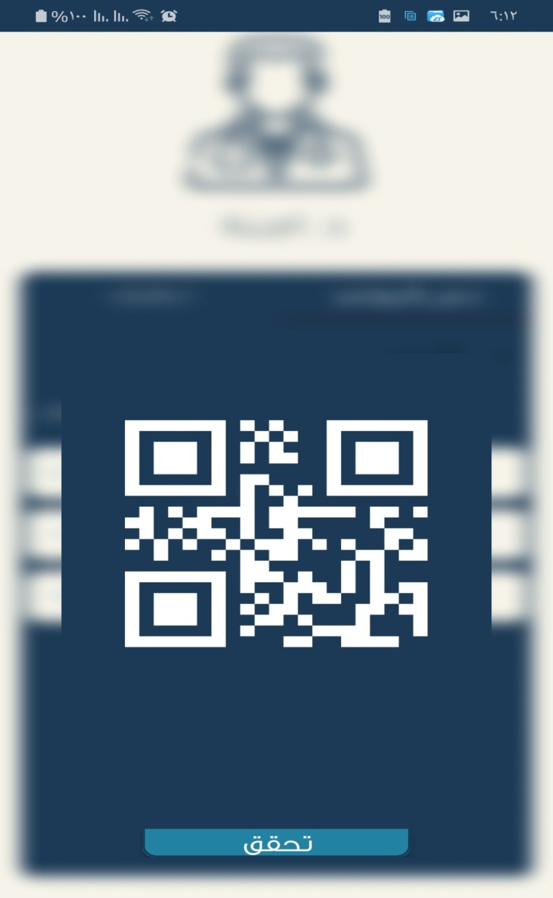

Figure 3.9 Show QR after the check

Chapter Three project
.
A QR code is checked by the patient to send a request to the server to be confirmed to the doctor of this patient's case and then this appointment will be sent to the expired dates.
Use the QR code to generate the dm77 / barcode scanner library on github where the library generates code by passing the parameters containing the text to be converted .
The yuriy-budiyev / code-scanner library was used to read the QR code and convert it into a string that can be sent to the server to be processed and to specify that this record of the physician's schedule has expired after the patient has been taken to the clinic to verify that the code.
3.2.2 server side
We used the PHP scripting language, which can connect to the SQL databases on the server to provide a connection between the server and the Android. At first you have to understand what the API is:
an application programming interface (API) is a set of subroutine definitions, communication protocols, and tools for building software. In general terms, it is a set of clearly defined methods of communication among various components. A good API makes it easier to develop a computer program by providing all the building blocks, which are then put together by the programmer. An API may be for a web-based system, operating system, database system, computer hardware, or software library,

Chapter Three Project

An API specification can take many forms, but often includes specifications for routines, data, structures, object classes, variables, or remote calls. POSIX, Windows API and ASPI are examples of different forms of APIs. Documentation for the API usually is provided to facilitate usage and implementation.
We used the API to communicate between the server and the android by sending and receiving JSON, which facilitates the interpretation, analysis and arrangement of data when sending and receiving them to and from the server. As a small example of JSON we can say:
is an open-standard file format that uses human-readable text to transmit data objects consisting of attribute–value pairs and array data types (or any other serializable (value). It is a very common data format used for asynchronous browser–server communication, including as a replacement for XML in some AJAX-style systems.
JSON is a language-independent data format. It was derived from JavaScript, but as of 2017 many programming languages

Check Three Project

include code to generate and parse JSON-format data. The official Internet media type for JSON is application/json. JSON filenames use the extension .json.
The JWT, a server-based help library, was used to encrypt data in static and global encryption methods. The basis of its work was to encrypt the data with a key for the library user.
The library's mechanism is to encrypt certain data and send it to the client. Upon receipt of a request from the client, the data is decrypted using a special key. The request that the library is unable to decrypt.
is a JSON-based open standard for creating access tokens that assert some number of claims. For example, a server could generate a token that has the claim "logged in as admin" and provide that to a client. The client could then use that token to prove that it is logged in as admin. The tokens are signed by one party's private key (usually the server's), so that both parties (the other already being, by some suitable and trustworthy means, in possession of the corresponding public key) are able to verify that the token is legitimate. The tokens are designed to be compact, URL-safe, and usable especially in a web-browser single-sign-on (SSO) context. JWT claims can be typically used to pass identity of authenticated users between an identity provider and a service provider, or any other type of claims as required by business processes.

Chapter Three Project

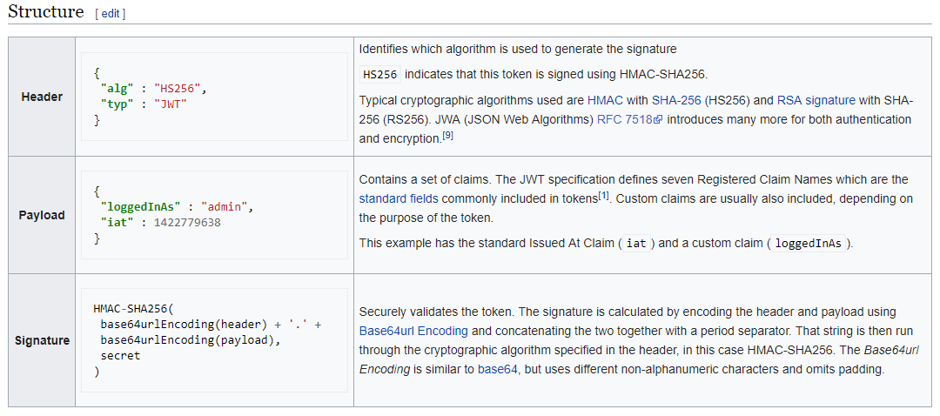

References

References
[1] Appointment Scheduling Software, https://www.softwareadvice.com/ie/appointment-scheduling/, 2006.
[2] Jill Duffy, The Best Appointment Scheduling Apps for 2019, Zapier,2019.
[3] Mobile App for Appointment Management, https://www.timify.com/en-gb/features/mobile-scheduling-app/,2013.
[4] GnomGuru, https://sourceforge.net/software/product/GnomGuru/, 2019.
[5 ] eBookFrenzy, Android Studio Development Essentials, Neil Smyth ,2015.
[6] Adam Gerber &Clifton Craig, Learn Android Studio , Apress,2015.
[7] واجهة المستخدم في أندرويد وأساسيات التعامل مع عناصرها المختلفة, https://academy.hsoub.com/,2019.
[8] Top 10 Features of Android Studio for Developers Not to Miss, https://www.admecindia.co.in/blog/top-10-features-android-studio-developers-not-miss,2015.

Contents:
1.1 Introduction
1.2 What is Appointment Scheduling Software?
1.3 Benefits of Appointment Scheduling Software
1.4 Existing Applications
1.4.1 Daily Appointment Calendar
1.4.2 Customer management
1.4.3 Cross platform apps
1.3.4 GnomGuru
1.4.5 Trivago
2.1 What is Android?
2.2 Features of Android
2.2.1 Instant App Run
2.2.2 Visual Layout Editor
2.2.3 Fast Emulator
2.2.4 Intelligence Code Editor
2.2.5 Addition of New Activity as a Code Template
2.2.6 Help to Build Up App for All Device
2.2.7 Help to Connect with Firebase
2.2.8 Support KOTLIN
2.2.9 Color Previews
2.2.10 Maven Repository
2.4 Android Advantage
2.5 System Requirements
3.1 General Structure of Project
3.2 The Project Consists of Two Important Compnents
3.3 Android Section
3.3.1 User Interface (UI) and Project Flow

