University of AL- Qadisiyah
College of Computer Science and Information Technology
Multimedia Department

(Medical Clinic Management Program)
Ophthalmology clinic model

Name of scientific research

Under the Supervisions of
assistant teacher wasan Abdallah Al-Awsi
2019

بِسْمِ اللَّـهِ الرَّحْمَـٰنِ الرَّحِيمِ

قَالُوا سُبْحَانَكَ لَا عِلْمَ لَنَا إِلَّا مَا عَلَّمْتَنَا ۖ إِنَّكَ أَنتَ الْعَلِيمُ الْحَكِيمُ

صدق اللهُ العظيم
القران الكريم - سورة البقرة: الآية 32

Acknowledgement

First of all Alhamdulillah. The final year project is able to be completed within the time frame given.
Secondly thanks to all the lecturers Faculty of Science Computer and Information Technology for be a good lecturer helps me to finish my final year project. Special thanks to the supervisor En Wasan Abdulla Abdullatif for the advices and time that he spends to help improve us final year project.
For all the participant that involve in evaluation and system testing, thank you very much.
For our families, thanks for the full support that they gave to us.
To all our friends thanks for the ideas and all the comments that has been given. I really appreciate.
Finally thanks to all the people that helps us in completing the final year project.

Table of Contents
Page | Chapter | Title
1 | Chapter I | Research problem
1 | Chapter I | Research Importance
2 | Chapter I | Research objectives
2 | Chapter I | Research limits
3 | Chapter II | Introduction
5 | Chapter II | Database management system (DBMS)
7 | Chapter II | Types of database management system
12 | Chapter II | Parts of Databases management system
15 | Chapter II | Database users
15 | Chapter II | Databases management system Architecture
17 | Chapter II | Advantages of Databases management system
20 | Chapter II | Disadvantages of Databases management
22 | Chapter III | Establishing and programming a clinic management system
23 | Chapter III | Why we use Microsoft sql server
24 | Chapter III | Sql server components
24 | Chapter III | Why we use Microsoft visual studio
37 | Chapter VI | Results
37 | Chapter VI | Conclusions
37 | Chapter VI | Recommendations

Chapter One
Introduction

Chapter One

Introduction

1-1 Introduction
ln this chapter researchers will talk about things that may be simple but very important for each project. Researchers will discuss the problems facing the management of medical clinics in general and ophthalmology in particular. Such as lost or mixed data for each patient. Researchers have designed a database program for medical clinics. Through the database researchers will be able to easily access patient data at any time. To save them from loss in addition to saving time and effort in the search or patient data among patient records. And the work of medical reports in a smooth and easy.

1-2 Research problem
Usually, the management of the clinic is done manually. There are some problem arise especially for the data retrieval. Clinic has a problem of loss of patient data. There is also redundant patient data if the patient not sure whether they have come to the clinic before. So the clerk considers the patient as a new patient and add new data. Currently, the inventory for the medicine is done manually. The management of the clinic also have to takes times to check for the medicine inventory and Medical supplies.
In addition to problems related to saving time and effort in the search for patient data and the work of medical reports smoothly and quickly.

1-3 Research importance
From the technical view, the system will help to make it easier to maintain the record of patient, doctor and medicine. It will help to reduce the number of lost record for the patient. At the same time, it will improve the data retrieval. It will be easier for the staff of the clinic to retrieve back the record of existing patient and doctor may view the patient history. For the doctor, it will record all the profile of doctor if the clinic has more than one doctor.
The most important thing is the management can view the payment record for the clinic.
At the same time, the system may generate report for the operation of the clinic. For example, report about the number of patient per day and total income for the clinic per day.

1-4 Research objectives
1. Improve the management process in clinic.
2. Improve process of recording data and data retrieval.
3. The risks of the system are been identified and evaluated.
4. Identify the tools that going to use in the development process.

1-5 Research limits
One of the main determinants is the lack of stability of the patients in one clinic, also the lack of interest in linking on the other diseases and the other hand, on the other hand, the greed of physicians not to rely on medical examination of the patient in another clinic, which is a major problem.

1-6 Research Contents
The rest of this thesis is organized in six chapters as follows:
Chapter 2 : The second chapter explains the previous work in the field of eye clinics, what databases are important characteristics.
Chapter 3 : The third chapter explains the design of the proposed system as well as discusses design steps and simulation screens with the user.
Chapter 4 : This chapter explains the results of the design of the system as well as future work that can be taken into account to develop the program

Chapter two
Background and
Related Works

2-1 Introduction:
In the previous chapter we talked about the importance of research in general, in this chapter we will talk about databases and types, as well as medical clinics and eye clinics and we will discuss the previous work in this area.

2-2 Related works
In this section we discussed the previous work in the field of medical clinics where Leonard B. Nelson on the importance of regular follow-up of premature infants for the development of ophthalmologic problems during early childhood [100]. While the eye Care Management of phthalmology Clinics manages more than a comprehensive medical clinic [101].
We found many sites containing programs ready for medical clinics, especially eye clinics, but they are not exploited by the local clinics because of the fear of the problem of the lack of software program for any possible defect in the program.
applications of the extended relational operators and the lattice relational model in solving the problems of statistical data manipulation in medical databases[11].

2-3 database technology
Databases and database technology have a major impact on the growing use of computers. It is fair to say that databases play a critical role in almost all areas where computers are used, including business, electronic commerce, on so on [1].
A database is a collection of related data [2]. By data, we mean known facts that can be recorded and that have implicit meaning. For example, consider the names, telephone numbers, and addresses of the people you know. You may have recorded this data in an indexed address book or you may have stored it on a hard drive, using a personal computer and software such as Microsoft Access or Excel.
This collection of related data with an implicit meaning is a database.
A database is designed, built, and populated with data for a specific purpose. It has an intended group of users and some preconceived applications in which these users are interested.
A database can be of any size and complexity, example of a large commercial database is Amazon.com.
2-3-1 Database management system (DBMS)
Is a collection of programs that enables users to create and maintain a database. The DBMS is a general-purpose software system that facilitates the processes of defining, constructing, manipulating, and sharing databases among various users and applications. Defining a database involves specifying the data types, structures, and constraints of the data to be stored in the data-base. The database definition or descriptive information is also stored by the DBMS in the form of a database catalog or dictionary; it is called meta-data. Constructing the database is the process of storing the data on some storage medium that is con-trolled by the DBMS.
Manipulating a database includes functions such as querying the database to retrieve specific data, updating the database to reflect changes in the miniworld, and generating reports from the data. Sharing a database allows multiple users and programs to access the database simultaneously[3]
Other important functions provided by the DBMS include protecting the database and maintaining it over a long period of time. Protection includes system protection against hardware or software malfunction (or crashes) and security protection against unauthorized or malicious access. A typical large database may have a life cycle of many years.
There are four main types of database management systems (DBMS) and these are based upon their management of database structures. In other words, the types of DBMS are entirely dependent upon how the database is structured by that particular DBMS[4].
1- Hierarchical Databases management system:
A DBMS is said to be hierarchical if the relationships among data in the database are established in such a way that one data item is present as the subordinate of another one or a sub unit.
The advantage of this structure it can be accessed and updated rapidly because in this model structure is like as a tree and the relationships between records are defined in advance. This feature is a two-edged.
The disadvantage This type of database structure is that each child in the tree may have only one parent, and relationships or linkages between children are not permitted, even if they make sense from a logical standpoint.

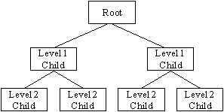
Hierarchical Databases
Figure 1

2- Network Databases management system:
A DBMS is said to be a Network DBMS if the relationships among data in the database are of type many-to-many. The many-to-many communication paradigm is one of three major Internet computing paradigms, characterized by multiple users contributing and receiving information, with the information elements often interlinked across different websites.
The network model is very similar to the hierarchical model really. Actually the hierarchical model is a subset of the network model. However, instead of using a single-parent tree hierarchy.
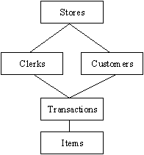
Figure 2
Network Databases
3- Relational Databases management system:
A DBMS is said to be a Relational DBMS or RDBMS if the database relationships are treated in the form of a table. There are three keys on relational DBMS: relation, domain and attributes.
A number of RDBMSs are available, some popular examples are Oracle, Sybase, Ingress, Informix, Microsoft SQL Server, and Microsoft Access.
The relational database has two major reasons
1-Relational databases can be used with little or no training.
2-Database entries can be modified without specify the entire body.
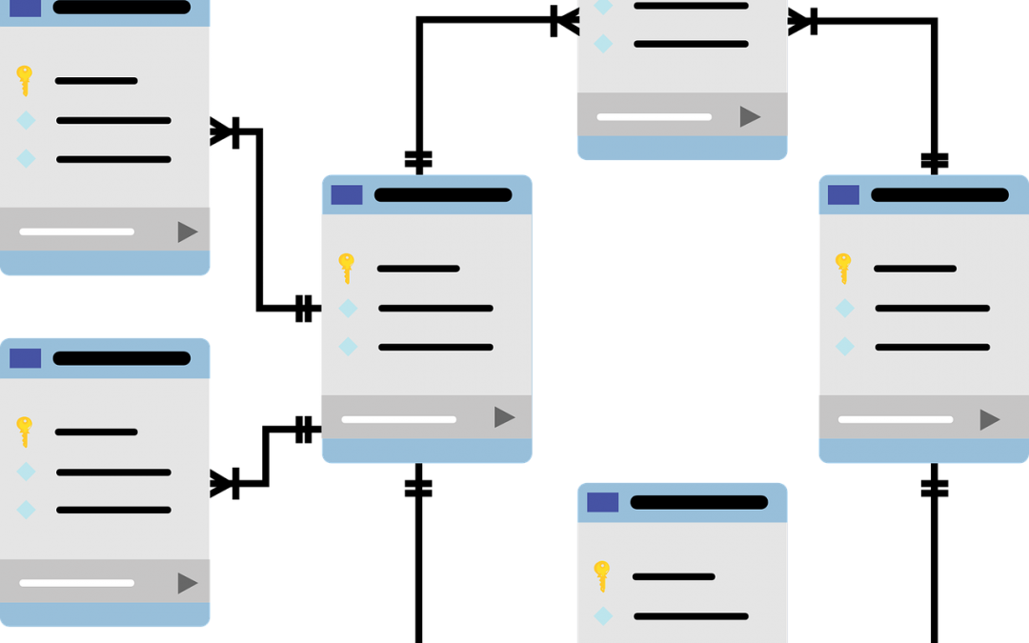
Figure 3
Relational Databases

4- Object-Oriented Databases Management System:
Able to handle many new data types, including graphics, photographs, audio, and video, object-oriented databases represent a significant advance over their other database cousins. Hierarchical and network databases are all designed to handle structured data; that is, data that fits nicely into fields, rows, and columns. They are useful for handling small snippets of information such as names, addresses, zip codes, product numbers, and any kind of statistic or number you can think of. On the other hand, an object-oriented database can be used to store data from a variety of media sources, such as photographs and text, and produce work, as output, in a multimedia format.
Object-oriented databases use small, reusable chunks of software called objects. The objects themselves are stored in the object-oriented database. Each object consists of two elements:
1- A piece of data (e.g., sound, video, text, or graphics).
2- The instructions, or software programs called methods.
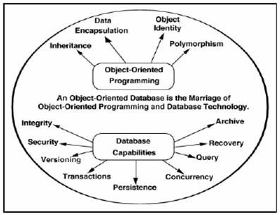
Figure 4
Parts of Databases management system
The database management system can be divided into five major components, they are: [5]
1- Hardware
2- Software
3- Data
4- Procedures
5-Database Access Language
Advantages of Databases management system
A number of advantages of applying database approach in application system are obtained including:

Chapter Three
System Design and Discussion

Chapter Three

System Design and Discussion

3-1 introduction
In previously chapter, knew that DBMS is a software program that enables the creation and management of databases.
From this basis, the system will be designed vision clinic based on the programming languages of C # and SQL databases. Each step of the design process will also be discussed.

3-2 System design
The main steps in the data movement within the system proposed in the Figure (5 ).
Figure ( 5 ): main steps in the data movement in the proposed model
The patient in the first case shall be registered for the first time where his general information, chronic diseases and symptoms are recorded. And then the medical examination and the date of the audit and store this information in the database.

This is done programmatically using a database using the sql system, the Figure (6) shows the database that we have created and entered the initial information.

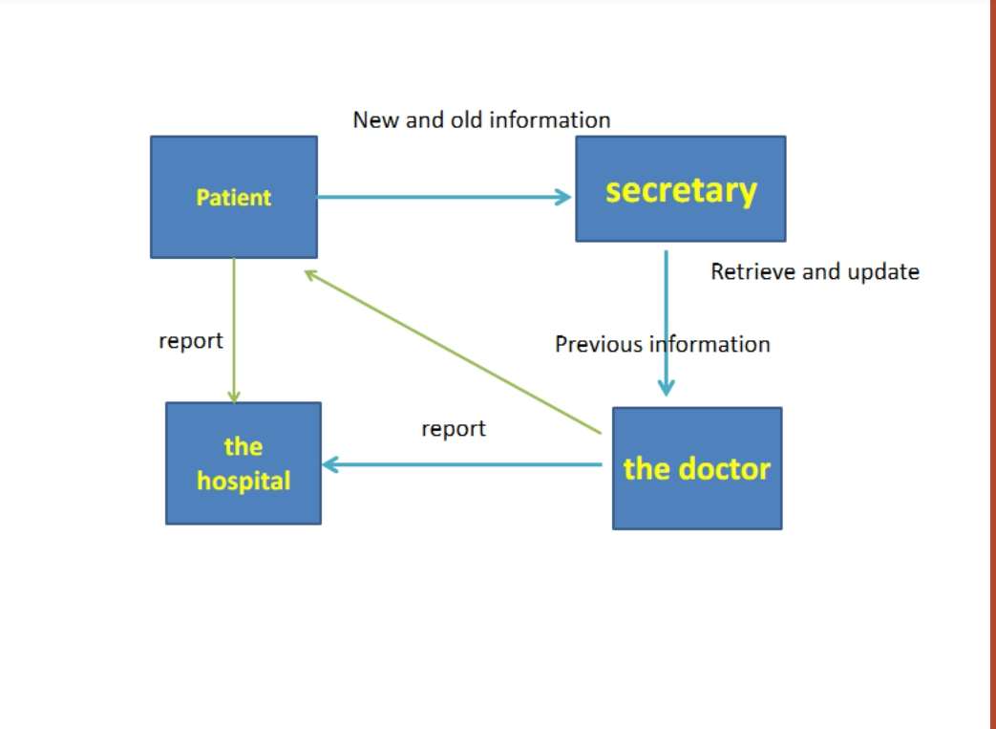
Figure (6) To create a database
Figure 5

We have also built simulations screen, by using the C # programming language, which we have previously demonstrated the great ability to linked between Sql databases and flexibility in work, as well as the touch of beauty of the system interfaces.

3-3 Discussion:
In this part of the research we will discuss the simulation screens that were built and the information that will be obtained from the patient and how to benefit from them.
Figure 6
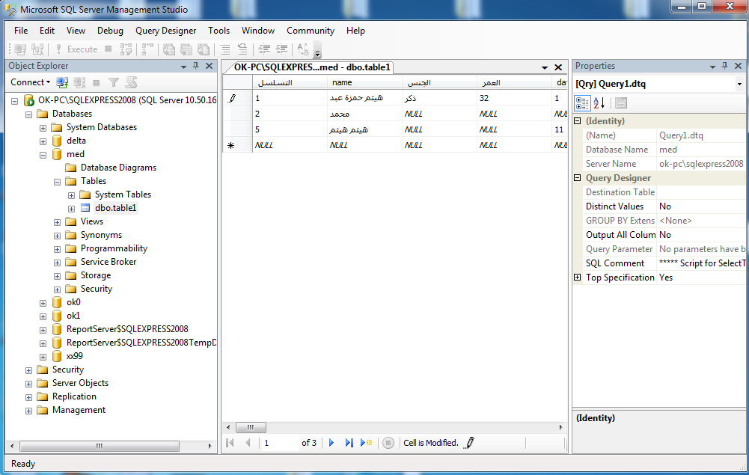

shows the main interface that will appear on the screen and is equipped with a password to secure system information.
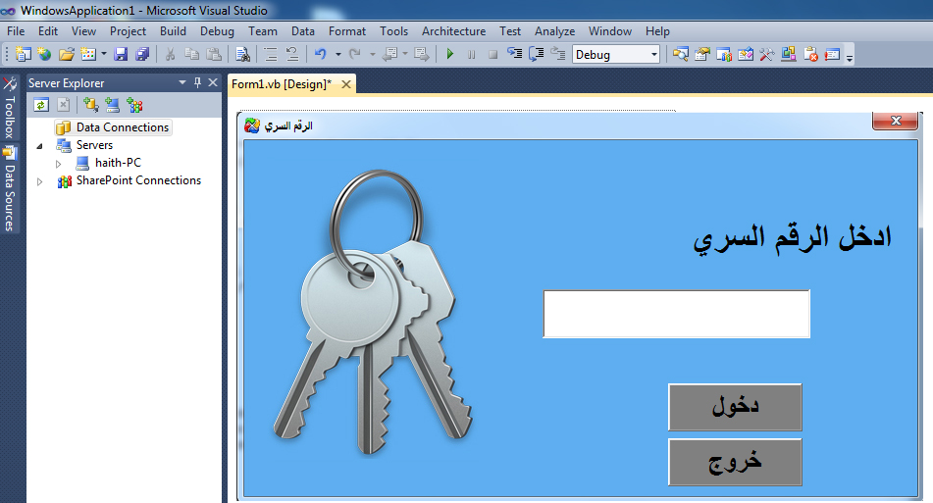
Figure 7

The system login screen is provided with a password
The figure (8) show when put incorrect word, An explanatory message appears stating that the password is incorrect.
Figure 8
show incorrect message when put incorrect word

Figure (9) shows the main screen, where the main screen of the application when you enter the correct password that was touched in the previous figure.
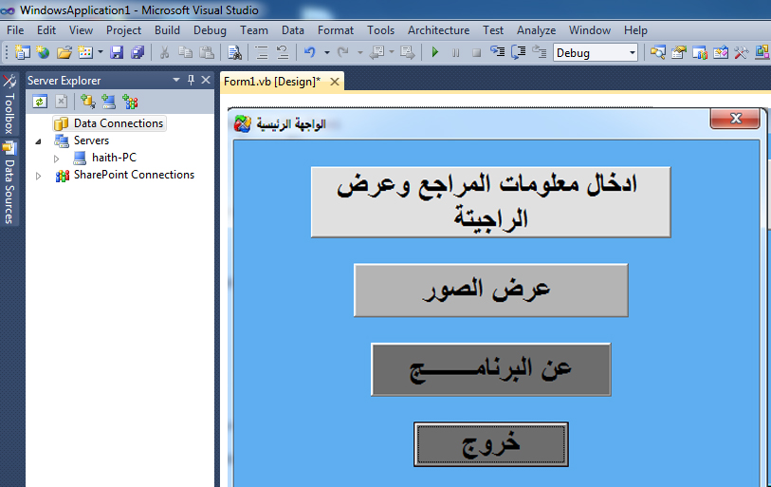
Figure 9
shows the main screen

We can move between program windows by hiding forms:
And showing forms:
The main window has four buttons, the first button when pressed. The window for inserting the patient's information and medical description appears. When the information is saved, the prescription automatically pops up:
First At the beginning we must connect the form to sql server:
- Go to the View menu item and select Database Explorer.

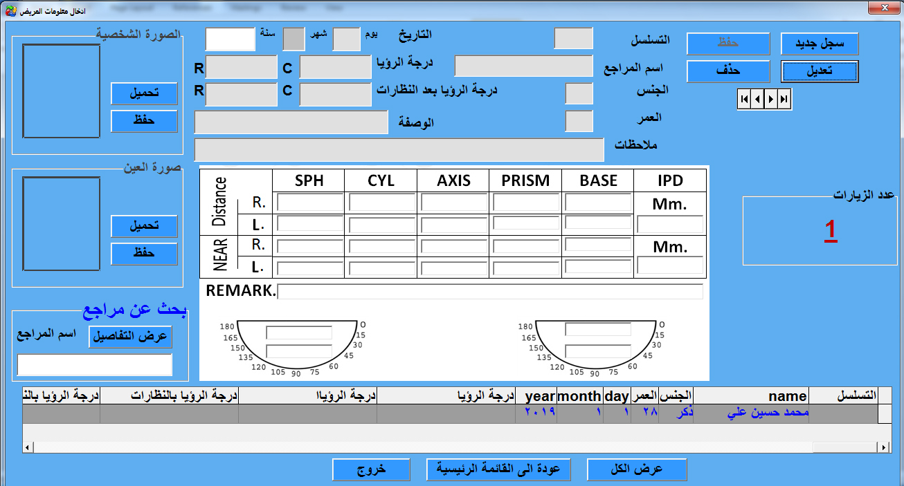
Figure ( 10 )
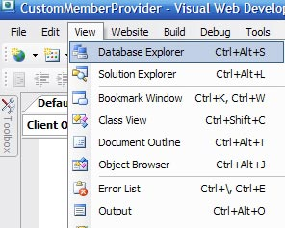
2- Depending on how you have your Visual Web Developer interface setup, go to the Solution Explorer, and at the bottom you will see a tab for Database Explorer. Click that. .
Figure ( 11 )
3-You will see the "Data Connections" available in the Database Explorer. We currently have none displaying.
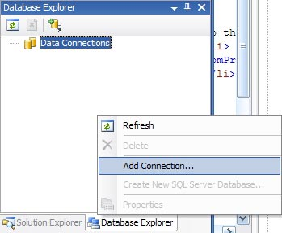
4- Right click in the Database Explorer area and select "Add Connection..." .

Figure ( 12 )
5- This will bring up the Add Connection dialog box. Select the "Change" button.
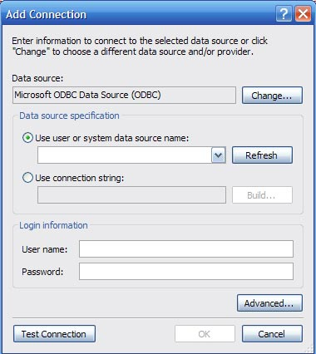
Figure ( 13 )

6- In our example, we are connecting to a SQL Server database, so select the "Microsoft SQL Server" Data source option as well as the ".NET Framework Data Provider for SQL Server" Data provider.
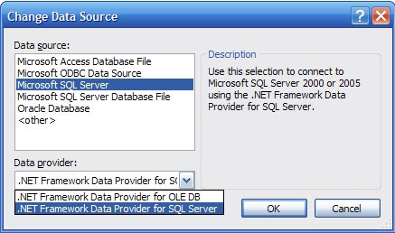

Figure ( 14 )
7- Select "OK" to return to the "Add Connection" dialog. Put in the IP address or server name for your database. In our case, we use Windows Authentication, but you may optionally input a User Name and Password and select "Use SQL Server Authentication." Use the drop down list to "Connect to a database" and "Select or enter a database name:" Select "Test Connection" to make sure you have it setup properly. Then "OK."

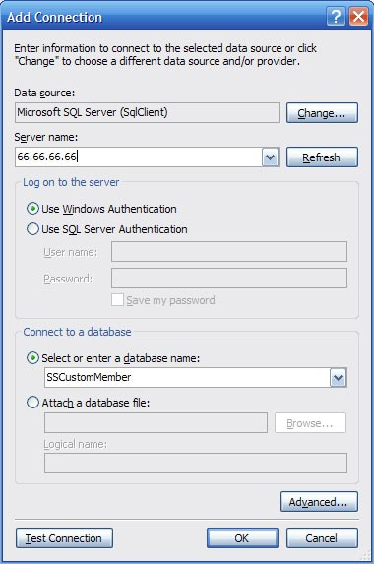

Figure ( 15 )
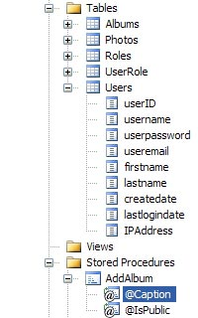
8- Now you may use the Database Explorer tab to view your tables and data.

Figure ( 16 )
We add additional codes:
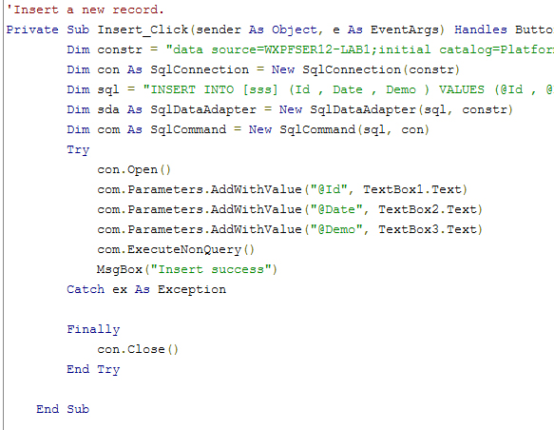
Figure ( 17 )

We add update the row codes:
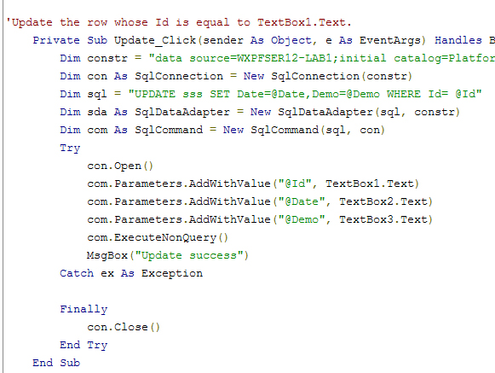
Figure ( 18 )

We add Delete the row codes:

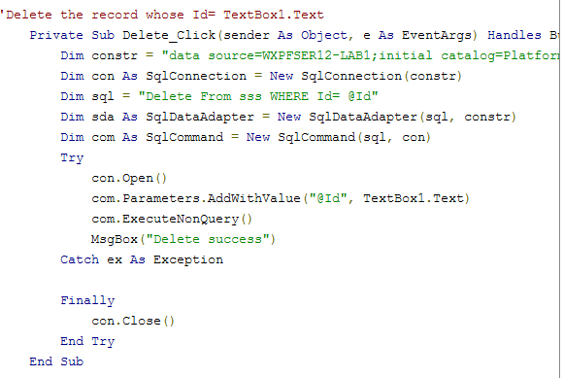
Figure ( 19 )

When we want to find a particular patient we use the code:
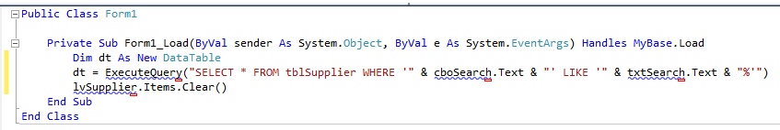
Figure ( 20 )

As for the code to upload images:
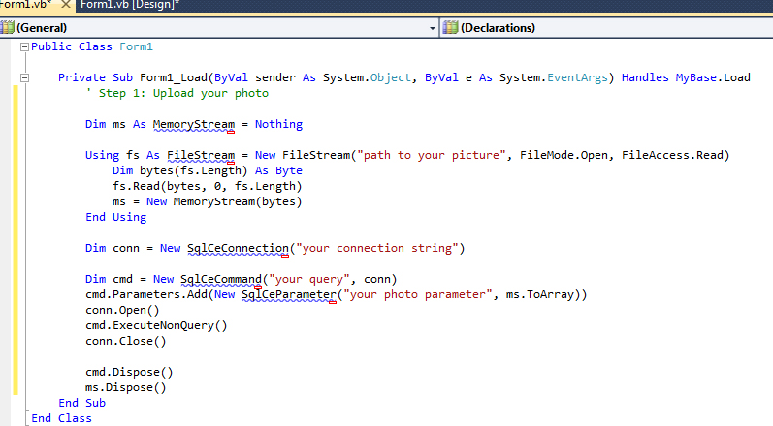
Figure ( 21 )

As for the code to save images:
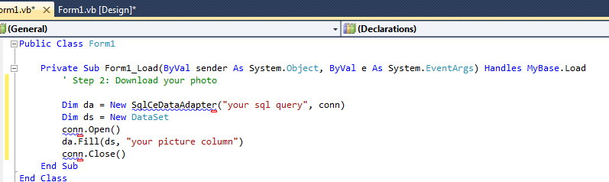
Figure ( 22 )

When the patient's information is saved or modified, the program automatically generates the prescription, containing all the medical information about the references and appropriate treatment solutions.
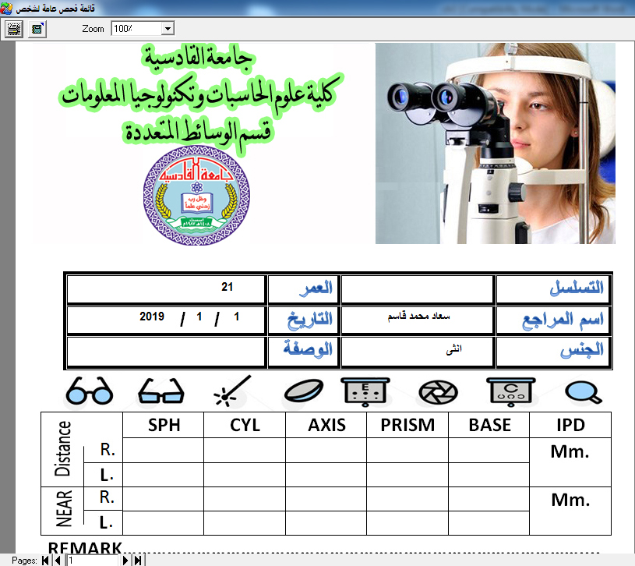
Figure ( 23 )

When you click on the second option of the program, a new patient search window will pop up where you can print the patient's eye or profile:
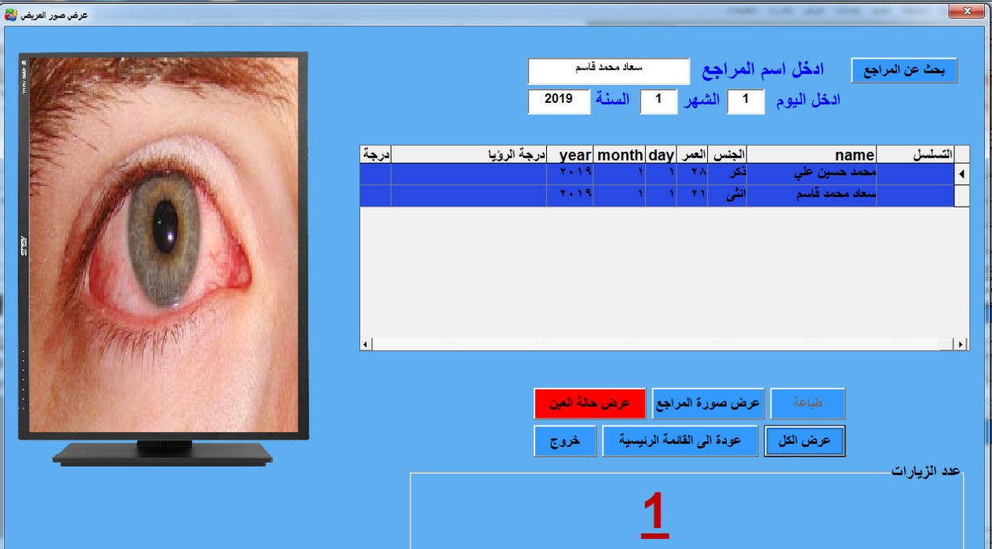
Figure ( 24 )

When we want to print picture we use the code:
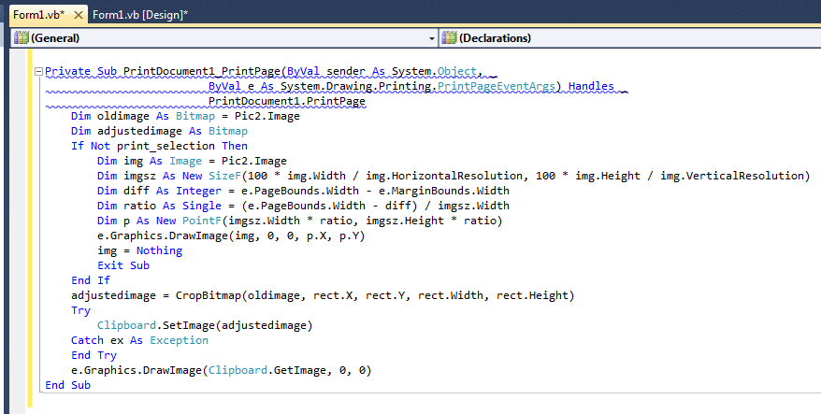
Figure ( 25 )

When the third option of the program is pressed, a new window will pop up for the students responsible for the design and implementation of the program, the name of the supervisor, the name of the university and the college:
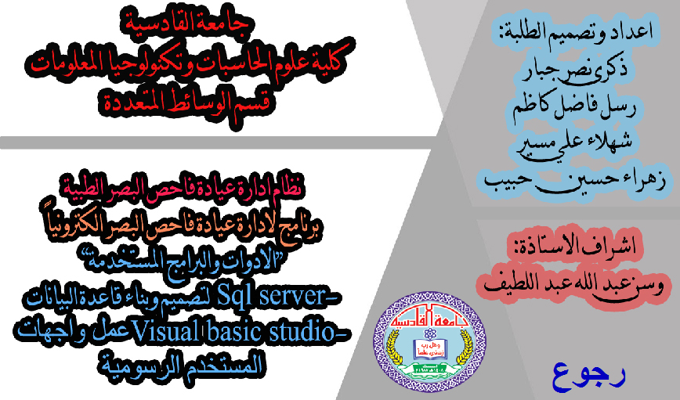
Figure ( 26 )

When you press the fourth option, you exit the program.

Chapter Four
Conclusion

Chapter Four

Conclusion

4-1 Abstract:
In the previous chapter, an eye clinic system was designed and we took into consideration all the basic paragraphs required in the system. In this chapter we will discuss the proposed system and review the results obtained as well as the recommendations resulting from the research.

4-2 Discussion
Where the system receives the information of the patient reviewed for the first time and stored information in the database and transferred to the physician responsible for the purpose of receipt and the addition of information resulting from the clinical examination and the next stage to determine the date of review as well as determine the treatment required of the patient and so. Patient information in the database can be retrieved once the name obtained Patien.
The basic result from the model is obtain an integrated management system for a private clinic for ophthalmology. Maintaining data and information in digital form is safer than traditional paper-based method quick access to patient information. Easy tracking development of patient medical condition. Get a prescription automatically when you enter patient data and symptoms.

4-3 Conclusions
The digital data retention system is more secure than traditional paper system where systems designed in digital format access to information faster than other traditional systems. The proposal system generate patient-specific recipes and patient reports in a smooth, fast and clear manner and Save, retrieve and follow up the patient's condition. But the program needs to be used over a period of time to identify the problems it may have.

4-5 Future Work
In the future work possibility of developing the program through online booking through the Internet. also possibility of developing the program by linking it to clinics and other medical hospitals. Finally possibility of developing the program through the work of a table or database of doctors or nurses. We hope that the program will be applied in all clinics so that patients' clinics are documented to avoid any complications.

Abbreviations

Term | Description
statistical and medical data | SMD
Database management system | DBMS
Universe of discourse | UOD
Internal Revenue service | IRS
Relational Database management system | RDBMS
Database Administrator | DBA
Open Databases connectivity | ODBC

References:
1-Elmasri & Navathe, fundamentals of database, sixth edition, Addison- Wesley ,2011.
2-Database Design for Mere Mortals: A Hands – on Guide to Relational Database Design” by Michael J Hernandez, 2015.
3-Database Management Systems -International Edition ,by Raghu Ramakrishnan, Johannes Gehrke, 2007.
4-Ms sql server tutorials point, Microsoft company, 2008.
5-Database Design and Relational Theory: Normal Forms and All That Jazz 1st Edition
6-by C. J. Date ,2012.
7-SQL QuickStart Guide: The Simplified Beginner's Guide To SQL Paperback – March 11, 2015
8-by ClydeBank Technology ,2013.
9-Professional Visual Basic 2010 and .NET 4 1st Edition
10-by Bill Sheldon (Author), Billy Hollis (Author), Kent Sharkey (Author), Jonathan Marbutt (Author), Rob Windsor (Author), GastÃ³n C. Hillar ,2014.
11-
US National Library of MedicineNational Institutes of Health Yao HH¹, Yamashita TS.,open acess, https://www.ncbi.nlm.nih.gov/pubmed/2591206 ,2019_4_5
12-Medical billing Accounting & appointment , open acess , scheduling Management Software https://clinic.qssite.com/برنامج-محاسبة-العيادات-الطبية/
13-open acess, https://www.acuvuearabia.com/eye-health/long-term-eye-conditions ,2019_4_5

[100] Importance of Careful Ophthalmologic Follow-Up of Premature Infants, Leonard B. Nelson, MD, MBA,Journal of Pediatric Ophthalmology and Strabismus. 2010;47(6):330, https://doi.org/10.3928/01913913-20101104-03, Posted November 1, 2010
[101] open source in [20/1/2019], http://vb4arb.com/vb/showthread.php?tid=24336

