Republic of Iraq
Ministry of higher Education and scientific Research
University of AL-Qadisiyah
College of computer science and Information Technology
Multimedia department

Online examination system
A project present to multimedia dep. College of science as a partial fulfillment of requirement for the degree of B.S.c in computer science.

BY
Alyaa Hasan Turki
Narjes Hadi Liftah
Duaa Ali Shueayb
Fatima Hasan Mohammed
SUPERVISED BY

M.s.c. Alaa Abid Muslam

م 2019 هـ 1440

بِسْمِ اللَّـهِ الرَّحْمَـٰنِ الرَّحِيم ِ
〖 قُل لَّوْ كَانَ الْبَحْرُ مِدَادًا لِّكَلِمَاتِ رَبِّي لَنَفِدَ الْبَحْرُ قَبْلَ أَن تَنفَدَ كَلِمَاتُ رَبِّي وَلَوْ جِئْنَا بِمِثْلِهِ مَدَدًا〗
صدق الله العظيم))
(سورة الكهف –الآية 109)

إهداء
إلى أمي وأبي
إلى أهلي وعشيرتي
إلى أساتذتي
إلى زملائي وزميلاتي
إلى الشموع التي تحترق لتضيء للآخرين
إلى كل من علمني حرفا
أهدي هذا البحث المتواضع راجياً من المولى
عز وجل أن يجد القبول والنجاح

أهدي هذا الجهد القليل الى جامعة القادسية كلية علوم الحاسوب وتكنولوجيا المعلومات|قسم الوسائط المتعددة وأتمنى لهم السعي في الخير والنجاح والله ولي التوفيق.

شكر وتقدير
الحمد لله رب العالمين والصلاة والسلام على أشرف الأنبياء والمرسلين سيدنا محمَّد وعلى آله وصحبه ومن تبعهم بإحسان إلى يوم الدين، وأما بعد..
فإني أشكر الله تعالى على فضله حيث أتاح لنا إنجاز هذا العمل بفضله، فله الحمد أولاً وآخراً.
ثم أشكر أولئك الأخيار الذين مدوا لنا يدَ المساعدة، خلال هذه الفترة، وفي مقدمتهم أستاذتي المشرفة على المشروع الأستاذة / ألاء عبد مسلم التي لم تدَّخر جهداً في مساعدتنا، وكانت تحثّنا على البحث، وترغِّبنا فيه، وتقوّي عزيمتنا عليه فلها من الله الأجر ومنا كل التقدير حفظها الله ومتّعها بالصحة والعافية.

ABSTRACT
Online examination system is a web-based examination system where examination is taken online i.e. through the internet or intranet using computer system. It is an effective solution for mass education evaluation.
We have developed an online examination system based on a Browser/Server framework using for the design, PHP, HTML, CSS and SQL SERVER.
Technology as we know today has come a long way in changing different aspect of lives and helping in human efficiency and accuracy. There is a growing need for educators and stakeholders to explore other means of assessment of students using different medium to help students.
Examination is the major and widely accepted use of measuring student ability and understanding of a subject initially taught to him/her. The use of Information and Communication Technology registering and administering examinations helps in attaining efficiency and error-free results and computation.
The whole implementation of the software was achieved using Source Based technologies such as App server, PHP, MySQL, JavaScript, Hypertext Markup Language and Cascading Style Sheet as template design.

List Of Contents

Contents | Title | Page No.
Chapter 1 | Review
1-1 | Introduction | 1
1-2 | The Aim of The Project | 2
1-3 | Matching | 3
1-4 | Fill-in-the-Blank | 3
1-5 | Objectives, Goals, Aims | 5
Chapter 2 | Online examination
2-1 | online examination | 7
2-2 | Purpose | 8
2-3 | PROBLEM | 8
Chapter 3 | Language
3-1 | A BRIFE HISTORY ABOUT SQL LANGUAGE | 9
3-1-1 | Data Definition Language | 10
3-1-2 | Data Processing Language | 10
3-1-3 | Data Control Language | 10
3-1-4 | Criticism about SQL Builder | 11
3-2 | PHP Language | 12
3-2-1 | A brief history of php | 12
3-2-2 | Usage of php | 12
3-2-3 | Use server-side | 13
3-2-4 | Use as a command line | 13
3-2-5 | Use a client area | 13
3-2-6 | Data types | 14
3-3 | HTML language | 14
3-3-1 | Start with a title | 16
3-3-2 | Add headings and paragraphs | 16
3-3-3 | Adding interest to your pages with images | 17
3-3-4 | Adding links to other pages | 18
3-4 | A little information about CSS | 19
3-4-1 | Features of CSS technology | 20
Chapter 4 | Interface of our works
Our works |  | 21
CONCLUSION |  | 26
References |  | 27

CHAPTER ONE
REVIEW

1-1. Introduction:
The e-exams project is one of the most important programs and systems In our daily life, because it adds to the development in the field of examinations provided by students. The advantages of the system is to get out of the paper routines and the trend towards technology and programming which is characterized by speed and high efficiency in the performance of the exam. Which shows the results for the student to
see their assessment. We have designed a program in the language of the Visual Basic .Net , as well as linking it to the database type Axis and contains the program on
many software interfaces and coordinated in coordinated colors and colors.
Contains a special interface to add questions whether it is the English language or computer exam ic3 and this is what the person responsible for the system and according to the powers given to him.
As well as contains a front to perform the task required either to enter the required exam or to show the results of the student and according to the ID or serial number, which is the key to the basis of student data retention.
The program also provides a interface to search for data, update and modify or delete data in the event of a problem or asked us to do so. The program can be developed in the future and linked to the Internet,as one of the advantages of the language of software used in the work is that it can connect to the network as well as the lifting of the database on the server and full use of the system on a wide.

1-2. The Aim of The Project:
1- Facilitate the examination process for students.
2- Speed in showing results to students.
3- Development of the routine reality in the performance of
examinations especially for universities.
4- Create an integrated database of questions.
5- Design an integrated exam system and link it to the database.

History has it that ancient China; was the first country in the world that implemented a nationwide standardized examination, which was called the “imperial examination”. The main purpose of this examination was to select able candidates for specific governmental positions.The imperial examination was established by the Sui Dynasty in 605 AD and was later abolished by the Qing Dynasty 1300 years later at 1905. England
adopted this examination system in 1806 to select specific candidates for positions in Her Majesty&#39;s Civil Service.

This examination system was later applied to education and it started to influence other parts of the world as it became a prominent standard (e.g. regulations to prevent the markers from knowing the identity of candidates), of delivering standardized tests.
There are three methods of examination: written examinations, oral examinations and physical fitness examination. In written examinations we have the multiple choice questions. Multiple choice questions have two sub categories. The first category is called True/False. This requires the student to choose all answers that are appropriate. True/False questions present candidates with a binary choice - a statement is either true or false. This method presents problems, as depending on the number of questions, a significant number of candidates could get one hundred percent (100%) just by guesswork, And should on average get fifty percent (50%). The second category is
called Best-Answer question [1]. This requires the student to only answer from a list of options. Other forms of questions in written examinations include:

1-3. Matching - a matching item is an item that provides a defined term and requires a test taker is to match identifying characteristic to the correct term.
1-4.Fill-in-the-Blank - a fill-in-the-blank item provides a student with identifying characteristics and requires the student to recall the correct term.
Examination as we know is one of the best methods of evaluating knowledge and grade student’s ability understanding of what he/ she was taught in the classroom. There have been various methods used for assessing students such as projects, pencil-written examination, presentations, assignments and oral examinations. Traditional Examination refers to a formal examination administered through question papers to which students respond in the form of written answers to a limited choice of previously unseen examination questions, set in advance and answered in examination centers where invigilators (examination supervisors) prevent communication between students and prohibit the use of notes or other revision aids.
There has been a growing interest in recent years in developing and using Computer based tests in educational assessment especially in Nigeria. The Joint Admission Matriculation Board (JAMB), the body responsible for admission into Nigerian University went a step higher in 2013 with the use of Computer based tests (CBT) software in conducting her examination.
It became a necessary and timely innovation to keep with technological trend. In the 90’s, when students sat for JAMB, it was kept on a pedestal of fear for most students but today it has become a norm in our educational sector.

The advantages of computers are well-known and apparent. They offer student the opportunity to improve their productivity and time management when answering questions. The standardization of test administration conditions is one of the benefits offered by computer-based testing (CBT).
No matter what the tests’ population size is, CBT helps students to set the same test conditions for all participants. It also improves all aspects of test security by storing questions and responses in encrypted databases and enables testers to create randomized questions and answers from vast question pools.
Moreover, offering different exam formats and the immediate presentation of different types of feedback, either to students or testers, are also some of the great advantages of CBT.
Computer based testing (CBT) or computer based assessment is seen as a catalyst for changes in pedagogical methods (OECD, 2010), It is seen as a catalyst for change, bringing about a transformation in learning, pedagogy and curricula in educational institutions (Scheuermann & Pereira, 2008).
In order to establish valid Computer based testing (CBT) the international Guidelines on Computer-Based and Internet-Delivered Testing (International Test Commission, 2004) state that equivalent test scores should be established for tests using the conventional paper-based mode and the new computer-based mode. This set of testing standards is supported by classical True-Score Test Theory (Allen & Yen, 1979), which is the basis of both computer-based and paper-based testing. According to this theory, someone who takes the same test in the two modes can be expected to obtain nearly identical test scores [2].

1-5.Objectives, Goals, Aims
- User-friendly systems are not only needed for the creator, but also for participants. “Intuitive” is key. One of the best examples is the software of the iPhone. It has a lot of options, but is still something you can figure out without needing a manual. Of course, an online examination system is different, but still has some similarities. Once an online examination system is not user-friendly, creators and participants will move on to another system. This is obviously something you don't want to happen.
- A responsive design is an approach where the web designer wants to reach an optimal web experience for a wide range of devices. A responsive site scales with the size of the screen without sacrificing the text readability or usability of the user interface.
- Multiple choice, fill in the blanks and free text. These are the options you can use with our online examination system. Having more than one options is necessary to check several types of knowledge. Not all examination can be checked with multiple choice questions.

- Do you want your exam for anyone or for a predefined group of users? The online exam can be made for people who are invited to the exam and have to log in with a username and password. If your exam is free for anyone, you can insert a link for making the exam.
- Having to check all answers is very time-consuming. So, having the answers checked automatically and instantly will eventually pay off. It’s less work for the creator of the exam and participants don’t have to wait too long for getting the results of their exams. Catching two birds with one stone.
- Having the results and statistics is nice to get a whole overview of the performances. Which users score best? On what kind of questions did users score low at? It’s all possible with our tool. And know what’s even better? Administrators can export the results and statistics to an Excel file. Conclusion
- In an evolving and technologically-driven world, the need for a computerized examination system in our secondary school cannot be overemphasized. The information system is an online examination system that delivers questions randomly set by the teachers to the student and generates the report of the results of students who take the examination as well as overall examination result summary.
- In this paper, a CBT system is developed and deployed in a secondary school (Hallmark College, Ibadan) using Component Based Software model. Using this model provided the CBT software with independent extensions, component market, interactions between components and reduced cost in deployment of the software. There are challenges involved in using CBSE as maintenance cost and timing to develop software components takes a big effort.
- Challenges encountered in traditional examinational mode which includes examination malpractices, low capacity examination venues, inadequate invigilators, inadequate examination materials, omission of student’s results and human error(s) during the marking / grading process will be automatically eliminated following the adoption of this system.
- The cost implication of conducting a mass-driven examination will become drastically and significantly reduced as there will be no need to print questions or answer booklets anymore. However, future research work should accommodate theory-based questions as opposed to only the multiple-choice and structured question formats that the CBT system currently accommodates. Also, provision for video-based e-assessment can be investigated.
- The Latin maxim ―QUIDQUID INITIUM HABET FINEM HABET‖ means ―WHATEVER HAS A BEGINNING HAS AN END‖.
- This research work is in its concluding stage. The importance of research work in academics cannot be overemphasized. It broadens the horizon of students in their area of studies with focus on the research topic.
- In this research work, we have developed an overall solution to the examination administration problem in CRUTECH. It provides a user friendly platform of multiple choice questions examination. It can be used for academic purpose, professional certifications, staff promotion examination, Post UTME entrance examination, etc.

CHAPTER TWO
Online
EXAMINATION

2-1. online examination
Online examination system is a web-based examination System where examinations are given online. Either through the internet or intranet using computer system. The main goal of this online examination system is to effectively evaluate the student thoroughly through a totally automated system that not only reduce the required time but also obtain fast and accurate results.

Keywords: PHP, web applications, examination systems, database, web server.
.....................................................................................................................................................

Today, Online Examination System is considered a fast developing examination method because of its accuracy and speed. It is also needed less manpower to handle the examination. Almost all organizations today, are managing their exams by online examination system, since it reduces student's time in examinations. Organizations can also easily monitor the progress of the student that they give through an examination [3]. As a result of this, the result is calculated in less time. It also helps diminishing the need for paper. Online examination project in PHP is very useful to learn it, According to today’s requirement Online examination system is significantly important to the educational institution to prepare the exams, saving the time and effort that is required to check the exam papers and to prepare the results reports. Online examination system helps the educational institutions to monitor their students and keep eyes on their progress. The best use of this system in Scholastic Institute and training centers because it helps in managing the exams and get the results in easy and an efficient manner. Until today the preparing for exams and preparing the results was performed manually, this required more time to complete [4].

Collects the answers, auto mark the submissions, and produce the reports for the test. EMS supports secure login, multi-instructor, and portability features. However, the other features: resumption capability, random question selection, random questions distribution, and random choices distribution are missing [5]. ArvindSingh, NirajShirke, KiranShette 2011:The project evaluates the examiners by using the online examination system concept. The exams will be totally customizable. This system will check results automatically basing on students answers. CBTS: Fagbenle et. al. (2013) developed a Computer Based Test System (CBTS). CBTS is a web-based online examination system developed to address issues such as lack of timing flexibility for automation candidates log-off upon expiration of allowed time, result integrity, guaranty, stand-alone deployment, need for flexibility, robustness, designed to support the examination processes and overcome challenges framing the conduct of examination, auto- marking, auto- submission , and generation report of examination result[6]
...................................................................................

2-2. Purpose:

_ This Web Application provides facility to conduct online examination worldwide.

_ It saves time as it allows number of students to give the exam at a time and displays the results as the test gets over, so no need to wait for the result. It is automatically generated by the server.

_ Administrator has a privilege to create, modify and delete the test papers and its particular questions.

_ User can register, login and give the test with his specific id, and can see the results as well.
.................................................................................................................

2-3. PROBLEM

STATEMENT Since the traditional have many drawbacks such as time consuming, Difficulty of analyzing the test manually, More observers are required to take exam of many students, Results are not accurate since calculations is done manually, The chance of losing exam's result is higher in current systems, Checking of result is time consuming since it done manually, Limitation of no of student can give examination at a time. With the development of information technology and use it in an orderly and properly helps to overcome the existing error in the manual system. Online examination system saves the exams information in a database, and this make it an easier way to give exam teachers can add theirs exams rules, and student can give exam in a totally automated system [7].

CHABTER THREE
LUNGUAGE

3-1. A BRIFE HISTORY ABOUT SQL LANGUAGE
Structural Query Language are programming non - procedural Non Language Procedural Language, which is so different from the usual programming languages such as C or Java, where languages other than procedural languages are specialized. [8] [9] [10] Therefore, the installation of SQL is a language for dealing with and controlling relational databases by dealing with data structures, data entry, deletion, sorting, searching, filtering, modification, etc.
In June 1970 publication of the British scientist Edgar Code scientific paper entitled "coherent model of data warehouses joint large data A Relational Model of Data for Large Shared Data Banks" which presented a model for the establishment and management of databases known as a form interconnected database Relational Database Model, According to this Form The data is kept in separate tables that are interrelated. The interoperable database model was a quick success among the specialists, but it was difficult to deal with this model through the familiar programming languages such as C and Peek, so the specialists sought to devise a new programming language that would be able to create databases and manipulate them according to the database model Interrelated. A group of researchers at IBM Labs Produced the first programming language to achieve this goal and called the name SEQUEL This term is abbreviation of the term Structured English Query Language but they quickly abandoned this name when they discovered that a brand of a British company working in the field of aviation and replaced by the name that has been used to date, SQL queries. IBM used the SQL installation to produce and distribute a number of interconnected database management systems such as System R, System / 38, SQL / DS, and DB2. But the most successful system was Oracle’s system Oracle introduced its first name in 1979. Since the invention of SQL in the early seventies, has undergone many modifications and development, and many companies and research institutions designed their own version of the installation of SQL queries, and to counter this position, the American National Institute of Standards American The National Standards Institute (ANSI) issued the first standard version of SQL Server 1987, which was known as SQL1987, followed by modifications and standard editions. Currently, the standard language is SQL2008.

SQL is composed of a number of reserved words, and these words can be divided according to the functions that you do to three main sections are:

• Data Definition Language (Data Definition Language (DDL))
• Data Processing Language (Data Manipulation Language (DML))
• Data Control Language (Data Control Language (DCL))
3-1-1.Data Definition Language (DDL)
Data Definition Language (the Data Definition are newer the DDL) is a set of reserved words that manage the objects in the database, whether Balanchine, modification or deletion of this group include the following reserved words:

- Modify the ALTER DATABASE database.
- Modify the table ALTER TABLE.
- Create a database CREATE DATABASE.
- Create INDEX search keys.
- CREATE TABLE CREATE TABLE.
- Delete the DROP DATABASE databases.
- Delete the DROP INDEX search keys.
- Delete the DROP TABLE table.
- Rename the table RENAME TABLE.
3-1-2. Data Processing Language (DML)
It is the language for dealing with the same data within databases from select, delete, update, or insert data.

3-1-3. Data Control Language (DCL)
It is the language of granting users certain powers such as:

- GRANT: used to grant users certain powers to perform certain tasks.
- REVOKE: Used to cancel the privileges granted by the previous order.
Users may be granted the following powers:

- CONNECT
- SELECT
- INSERT
- UPDATE
- DELETE
- EXECUTE
- USAGE
3-1-4. Criticism about SQL Builder
Many criticisms have been directed at SQL. All these criticisms revolve around the notion that SQL was designed as a non-procedural language intended for the programming of interconnected databases, which was achieved by SQL. However, some of its tools show a failure to achieve this idea. Many researchers have been working on these shortcomings, but critics have repeatedly argued that the fault of defaults is due to a defect in the basic design of constructional intelligence, a disorder that cannot be addressed because it is part of the core components of SQL.
My sql is the MySQL server. The following discussion covers these MySQL server configuration topics:
- Startup options that the server supports. You can specify these options on the command line, through configuration files, or both.
- Server system variables. These variables reflect the current state and values of the startup options, some of which can be modified while the server is running.
- Server status variables. These variables contain counters and statistics about runtime operation.
- How to set the server SQL mode. This setting modifies certain aspects of SQL syntax and semantics, for example for compatibility with code from other database systems, or to control the error handling for particular situations.
- Configuring and using IPv6 support.
- Configuring and using time zone support.
- Server-side help capabilities.
- The server shutdown process. There are performance and reliability considerations depending on the type of table (transactional or no transactional) and whether you use replication[9].
3-2. PHP Language
PHP ( a PHP : the Hypertext the Preprocessor, 'personal home page was a group of applications that are written using Perl Ramus called Personal Home Page Tools name ( "pre - processor super-text") is a scripting language designed primarily for use for the development and application programming Web It can also be used to produce stand-alone programs that have nothing to do with the web [4].
PHP is an open source language developed by a team of volunteers under the PHP license. It supports object oriented programming and its structural structure is very similar to the syntax of the C language, and it works on multiple operating systems such as Linux and Window.

3-2-1. A brief history of php
PHP first appeared in 1995 by Rasmussen Lierdorff, which was then called PHP / FI. In fact, it was not the programming language of its time. It was a collection of applications written using Perl. Ramus launched Personal Home Page Tools on these applications, More useful applications Rasmuss wrote a larger application using C language, where it was able to connect to the databases and it allowed users to develop simple dynamic site applications, Rasmuss chose to have the PHP / FI source code available to everyone so anyone could use it Improve them and participate in solving their mistakes Problems.

3-2-2.Usage of php

PHP is often used on a web server, can be used as a command-line interface or used to develop graphical user interface programs, PHP can be used under most web servers, it works on most operating systems, It provides its complete source chip where users can build and develop them to suit their needs.

PHP basically takes the file containing the PHP commands (. Php) as an input and outputs viewable data.

In the fourth version of PHP, you convert files written using PHP to bytecode to be processed by a Zend engine. In the fifth version, the language of PHP advanced very high technology and the last version of the fifth version is 5.5.9
3-2-3.Use server-side
In fact, PHP is designed to be used in terms of server and building interactive web applications. The building of Lamb has become very popular in the web industry as a safe, inexpensive and reliable web application. PHP referred to as a character P in LAMP as a programming language, next to Linux (L) as an operating system, Apache (A) as a Web server and MySQL (M) as a database management . It has also emerged as other builders Wamp replacing Linux with Windows (W), and Mamb replacing Linux with Mac or S (M).

PHP can be used with a large number of database management systems, and since it is available on a number of operating systems make it flexible to enable PHP to deploy.

3-2-4. Use as a command line
PHP also provides a command-line interface, so it can be used to develop a set of programs that facilitate administrative tasks for system administrators.

3-2-5. Use the client area
PHP provides graphical user interfaces such as GTECH + (via PHP-GTK ) and QT (via Qtel ), making non-web-related software development possible.

Grammar Composition
PHP executes only the <? Php> and <> tags. Anything outside of these two tags is printed directly and is not treated as a PHP code. This feature enables the insertion of PHP code into HTML code
Variables are prefixed with the dollar sign - $ - and it is not necessary to define the variable type, unlike function names and classes, the variables are sensitive to the state of the character, and to set its values ​​to the variable double quotes are used - "- or single" - or without any quotation marks so that The value in this case is one of the following:

Of the number of numbers in both floating numbers and correct numbers .
Of the quality constants.
Call one of the subroutines directly.
Call one of the subroutines across an object (Object).
PHP has three types of comments, / * * / which is used for multi-line, // and # comments, which are used for single-line comments.

3-2-6. Data types
PHP stores the numbers with a range depending on the processor you are working on. This range typically has 32 bits of integers, and the correct integers can be worth a tenth, eight or six. The real numbers are also stored with a processor- dependent range.

The PHP language also contains a Boolean type, which is called "Boolean", as in Perl the numbers larger or smaller than zero can be considered true, but zero can be considered false.
The null data type represents variables that do not contain the value, and the only value in this type of data is NULL.
Arrays support text and numeric indexes, arrays can contain elements of any type of data supported by PHP.

3-3. HTML language
is the markup language used to create and design pages and web sites , and is considered the language of the oldest languages and widely used in the design of web pages. HTML structure of the web page and give the browser the Internet and a description of how to display its contents, it is learned that this is a key title that paragraph and much more. HTML uses what is known as 'tags' to issue instructions to the browser. It is a special kind of text document that is used by Web browsers to present text and graphics. The text includes markup tags such as <p> to indicate the start of a paragraph, and </p> to indicate the end of a paragraph. HTML documents are often referred to as "Web pages". The browser retrieves Web pages from Web servers that thanks to the Internet, can be pretty much anywhere in World [11].

Many people still write HTML by hand using tools such as Notepad on Windows, or Text Edit on the Mac. This guide will get you up and running. Even if you don't intend to edit HTML directly and instead plan to use an HTML editor such as Netscape Composer, or W3C's Amaya, this guide will enable you to understand enough to make better use of such tools and how to make your HTML documents accessible on a wide range of browsers. Once you are comfortable with the basics of authoring HTML, you may want to learn how to add a touch of style using CSS, and to go on to try out features covered in my page on advanced HTML

p.s. a good way to learn is to look at how other people have coded their html pages. To do this, click on the "View" menu and then on "Source". On some browsers, you instead need to click on the "File" menu and then on "View Source". Try it with this page to see how I have applied the ideas I explain below. You will find yourself developing a critical eye as many pages look rather a mess under the hood!

For Mac users, before you can save a file with the ".html" extension, you will need to ensure that your document is formatted as plain text. For Text Edit, you can set this with the "Format" menu's "Make Plain Text" option.

This page will teach you how to:

Start with a title
Add headings and paragraphs
Add emphasis to your text
Add images
Add links to other pages
Use various kinds of lists
If you are looking for something else, try the advanced HTML page.

3-3-1. Start with a title
Every HTML document needs a title. Here is what you need to type:

<title>My first HTML document</title>
Change the text from "My first HTML document" to suit your own needs. The title text is preceded by the start tag <title> and ends with the matching end tag </title>. The title should be placed at the beginning of your document.

To try this out, type the above into a text editor and save the file as "test.html", then view the file in a web browser. If the file extension is ".html" or ".htm" then the browser will recognize it as HTML. Most browsers show the title in the window caption bar. With just a title, the browser will show a blank page. Don't worry. The next section will show how to add displayable content.

3-3-2. Add headings and paragraphs
If you have used Microsoft Word, you will be familiar with the built in styles for headings of differing importance. In HTML there are six levels of headings. H1 is the most important, H2 is slightly less important, and so on down to H6, the least important.

Here is how to add an important heading:

<h1>An important heading</h1>
and here is a slightly less important heading:

<h2>A slightly less important heading</h2>
Each paragraph you write should start with a <p> tag. The </p> is optional, unlike the end tags for elements like headings. For example:

<p>This is the first paragraph.</p>

<p>This is the second paragraph.</p>
Adding a bit of emphasis
You can emphasize one or more words with the <em> tag, for instance:

This is a really <em>interesting</em> topic!
3-3-3. Adding interest to your pages with images
Images can be used to make your Web pages distinctive and greatly help to get your message across. The simple way to add an image is using the <img> tag. Let's assume you have an image file called "peter.jpg" in the same folder/directory as your HTML file. It is 200 pixels wide by 150 pixels high.

<img src="peter.jpg" width="200" height="150">
The src attribute names the image file. The width and height aren't strictly necessary but help to speed the display of your Web page. Something is still missing! People who can't see the image need a description they can read in its absence. You can add a short description as follows:

<img src="peter.jpg" width="200" height="150"
alt="My friend Peter">
The alt attribute is used to give the short description, in this case "My friend Peter". For complex images, you may need to also give a longer description. Assuming this has been written in the file "peter.html", you can add one as follows using the longdesc attribute:

<img src="peter.jpg" width="200" height="150"
alt="My friend Peter" longdesc="peter.html">
You can create images in a number of ways, for instance with a digital camera, by scanning an image in, or creating one with a painting or drawing program. Most browsers understand GIF and JPEG image formats, newer browsers also understand the PNG image format. To avoid long delays while the image is downloaded over the network, you should avoid using large image files.

Generally speaking, JPEG is best for photographs and other smoothly varying images, while GIF and PNG are good for graphics art involving flat areas of color, lines and text. All three formats support options for progressive rendering where a crude version of the image is sent first and progressively refined.
3-3-4. Adding links to other pages
What makes the Web so effective is the ability to define links from one page to another, and to follow links at the click of a button. A single click can take you right across the world!

Links are defined with the <a> tag. Lets define a link to the page defined in the file "peter.html" in the same folder/directory as the HTML file you are editing:

This a link to <a href="peter.html">Peter's page</a>.
The text between the <a> and the </a> is used as the caption for the link. It is common for the caption to be in blue underlined text.

If the file you are linking to is in a parent folder/directory, you need to put "../" in front of it, for instance:

<a href="../mary.html">Mary's page</a>
If the file you are linking to is in a subdirectory, you need to put the name of the subdirectory followed by a "/" in front of it, for instance:
<a href="friends/sue.html">Sue's page</a>
The use of relative paths allows you to link to a file by walking up and down the tree of directories as needed, for instance:

<a href="../college/friends/john.html">John's page</a>
Which first looks in the parent directory for another directory called "college", and then at a subdirectory of that named "friends" for a file called "john.html".

To link to a page on another Web site you need to give the full Web address (commonly called a URL), for instance to link to www.w3.org you need to write:

This is a link to <a href="http://www.w3.org/">W3C</a>.
You can turn an image into a hypertext link, for example, the following allows you to click on the company logo to get to the home page:

<a href="/"><img src="logo.gif" alt="home page"></a>
This uses "/" to refer to the root of the directory tree, i.e. the home page.

3-4. A little information about CSS
Cascading Style Sheets (CSS ) is a language format for web pages are interested in designing websites specially designed to isolate formatting (colors - lines - buttons ....) the document written content (language , for example , HTML) applies to Colors, fonts, images and backgrounds used in pages, flexible and easy.

This technique means the overall appearance of web pages of colors, images and others. It can be added to the page in several ways, the best of which is external embedding by typing the CSS code in a separate file. It has now been developed into CSS3, which has been added to several wonderful additions that were not available in the previous version and was only completed with the Gaye Kiwi .

Launched by the World Wide Web Consortium, as a standard specification for describing the appearance of Web documents from font, color, and formatting setting

3-4-1. Features of CSS technology
CSS aims to separate the content of the pages from their appearance to give several benefits:
- Make the page simpler and only useful for it to include content, either format will be in the CSS style file.
- Make the page manageable to multiple browsers or screens and can handle each device (computer or even mobile phone) or browser separately and thus greater usability.
- Several features can be applied to each appearance that meets the needs of each reader. For example, it is possible to guarantee accessibility for people with special needs or to put several colors to suit different tastes.
- A style file can be included in multiple pages. Therefore, when you change the display format, you need to edit only one file, which means less time, and a larger, more comprehensive adjustment.

CHABTER FOUR
Interface of
Our work

Our works
- The beginning of the exam consists of two fields, one for the professor and the other for the students as in the figure (1.1) shown below
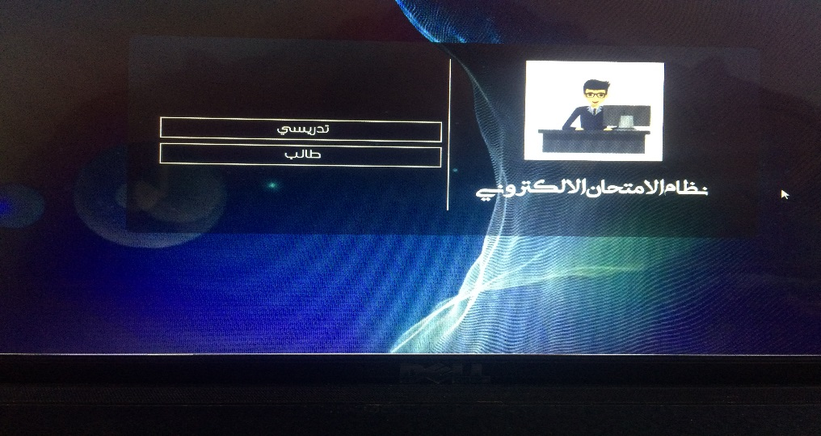
Figure (1.1)
- When you click on the Professor Field, the window appears as in the figure(1.2) below where the teacher is registered in the system

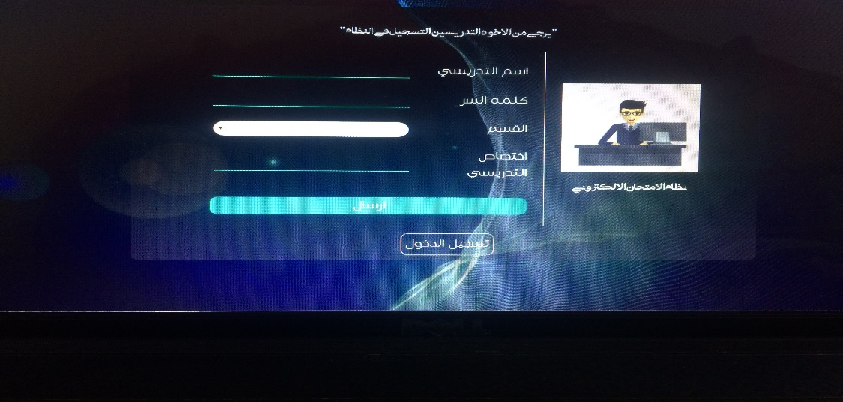
Figure (1.2)

- When you log in, you will see a window that contains three fields as shown in the figure (1.3) below and the first field to add test questions.
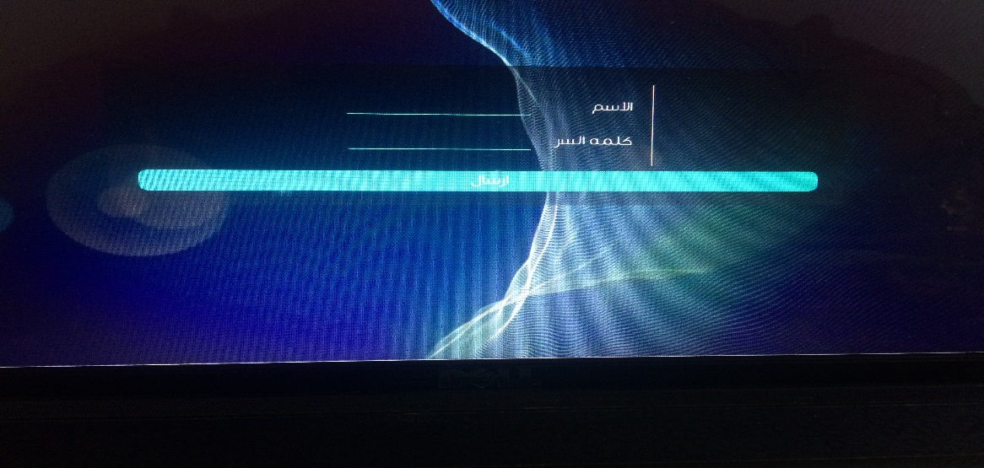
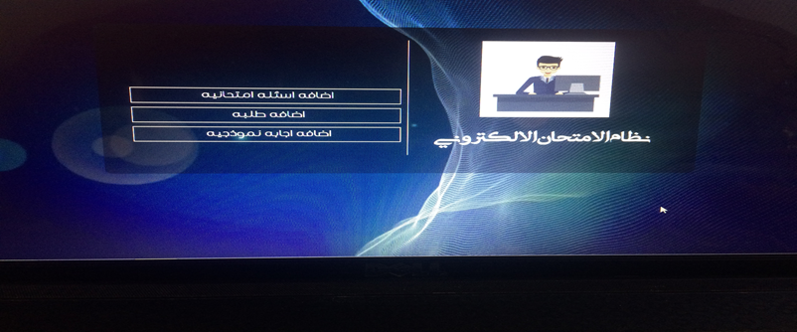
Figure (1.3)

- The first field is to add test questions and when click in it shows a window as in the figure (1.4) below and the second field of the addition of students and when the click in appears on the figure (1.5) below and the third field to add a typical answer and when click in shows the figure (1.6) below 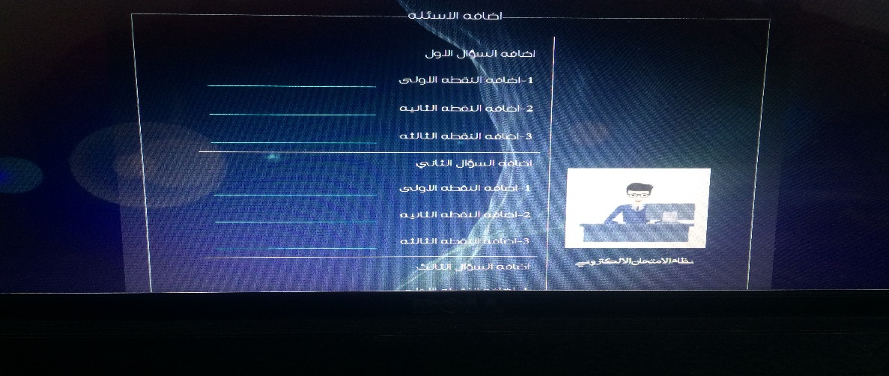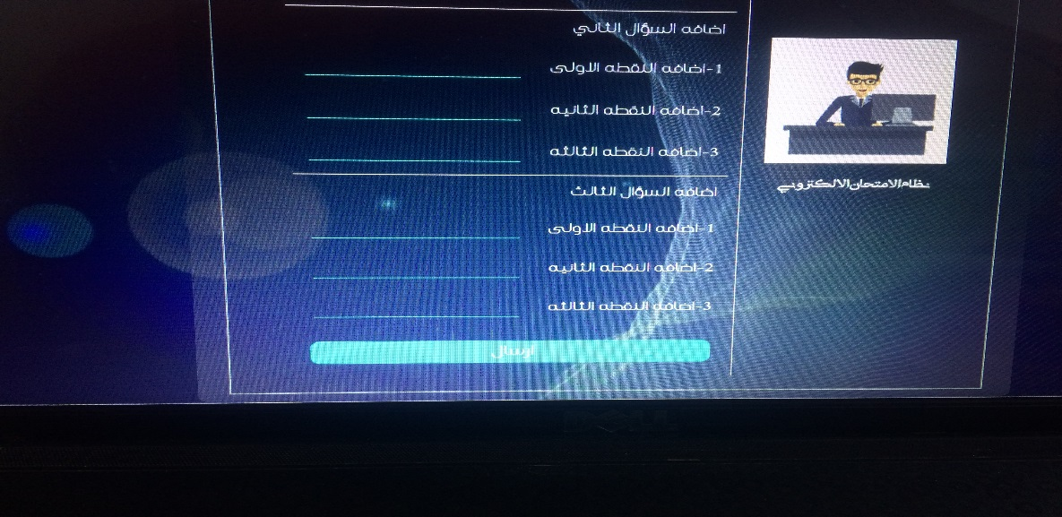
Figure (1.4)
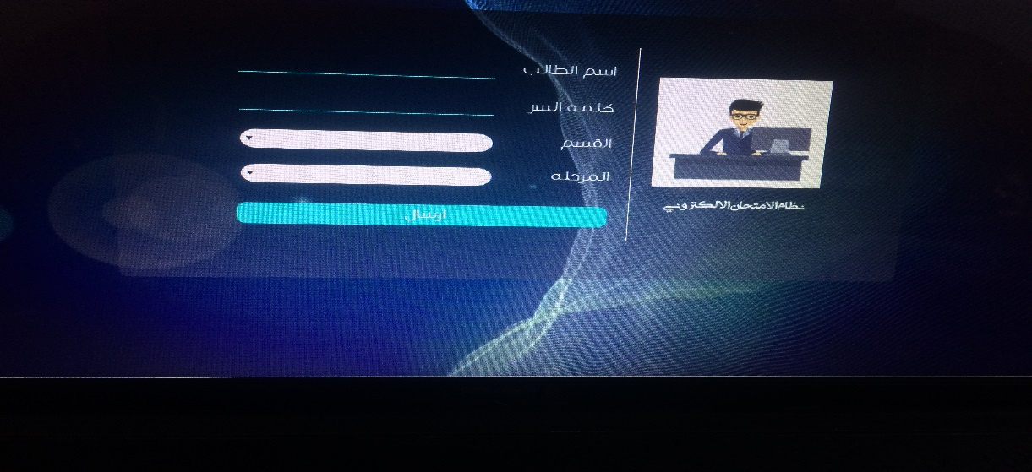
Figure (1.5)
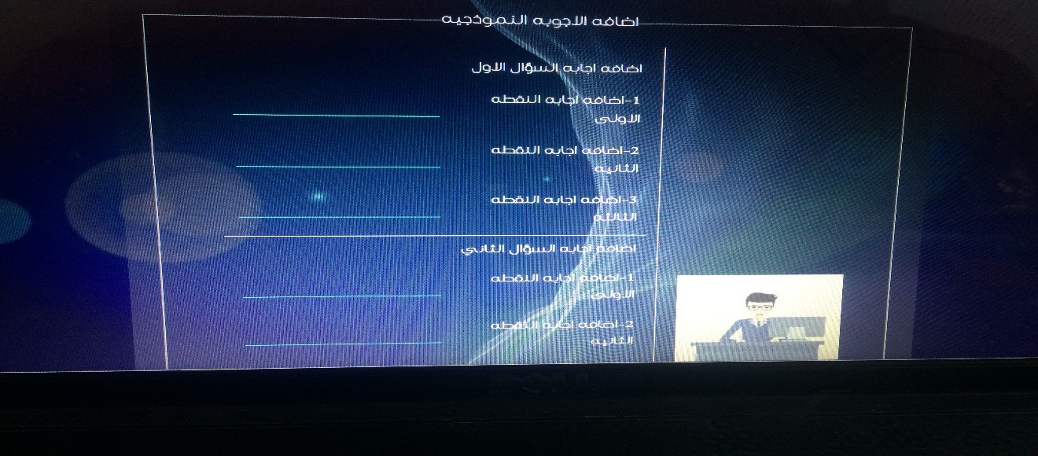
Figure (1.6)

- In the program start window, when you select the second field for the students, a window will appear, as shown in the figure(1.7) below, through which the student can enter the username and password to access to the exam as shown in figure(1.8)below.
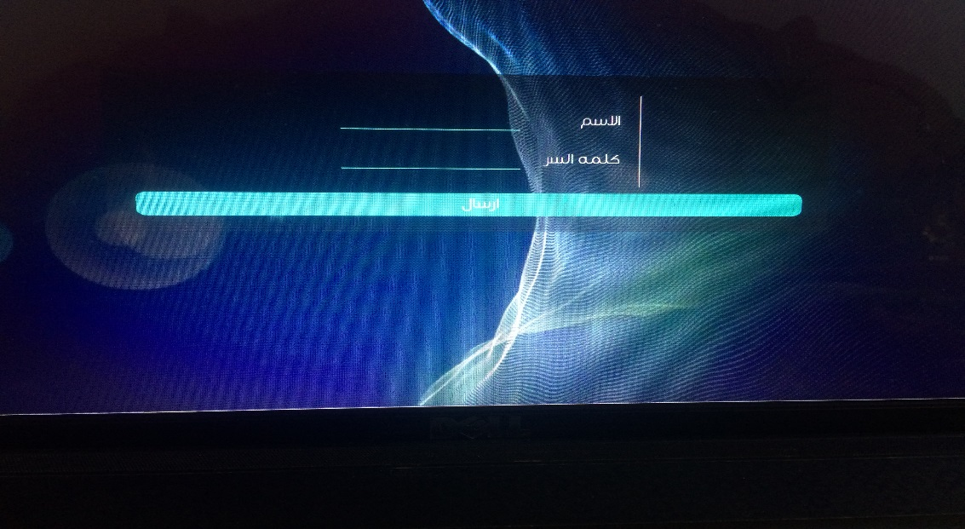
Figure (1.7)
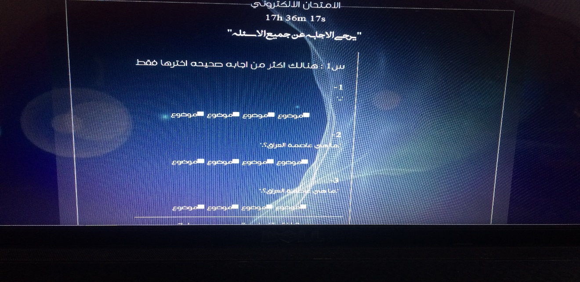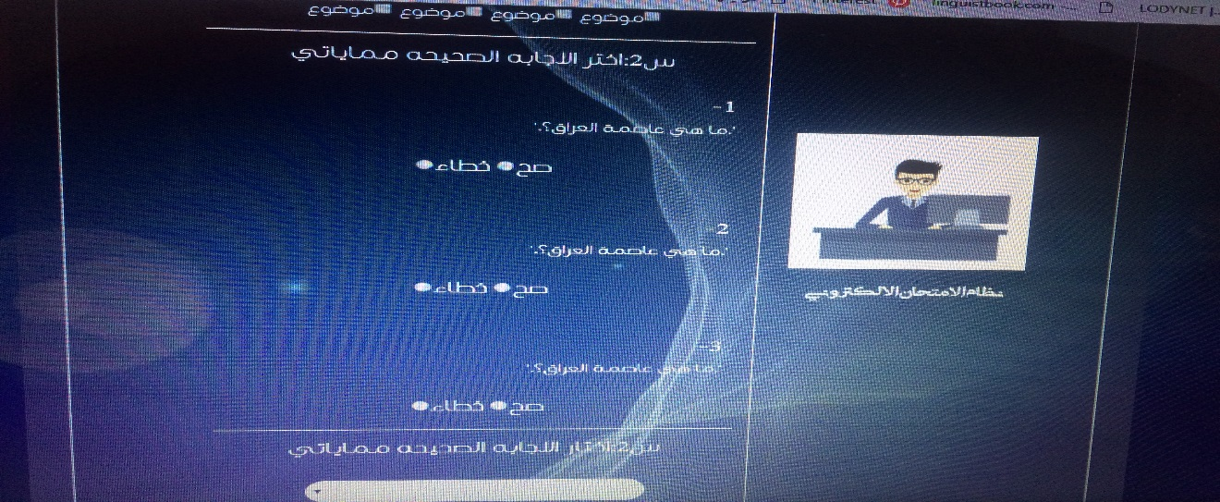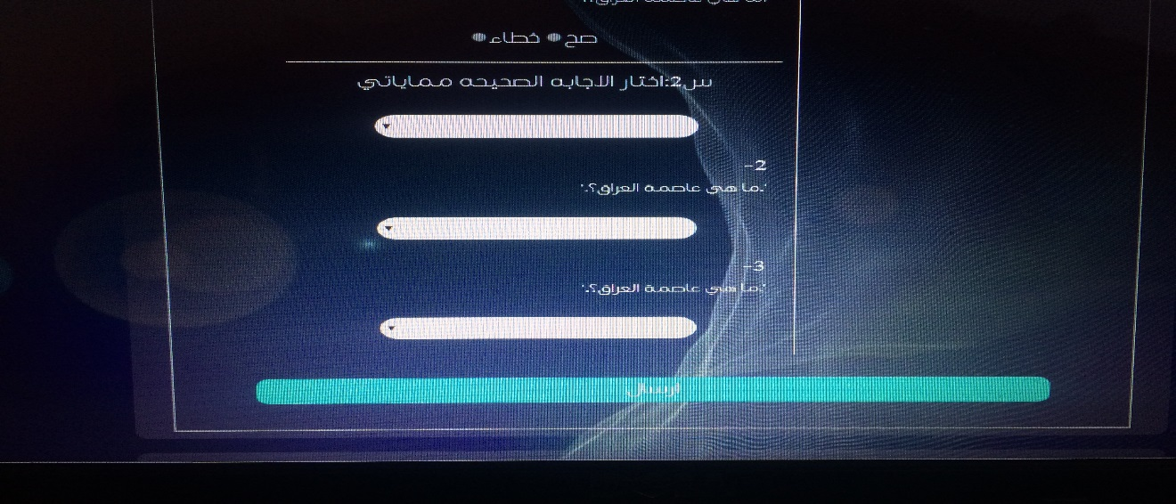
Figure (1.8)

CONCLUSION
Using an open source language gives us more flexibility, but at the same time it required more time to be programmed. The proposed Online Examination System (OES) can be easily adopted by universities and institutions in order to make the exam more secure and more flexible. The system is subdivided into two main subsystems (student and administrator) that are designed to give the system maximum benefit by demonstrating carefully each subsystem service. The administrator's functions are clearly identified to be able to manipulate user's information such as add (register), delete users and managing the exam materials and content such as add, delete questions, Thus the proposed system is easy and flexible because for future maintenance and development because each subsystem can be handled separately without influence on other system.

References
1- H.I. Naşcu, L. Jäntschi, "Multiple Choice Examination System 2. Online Quizzes for General Chemistry", Leonardo Electronic Journal of Practices and Technologies, Vol. 3, No. 5, pp. 26–36, 2004
2-T.M. Fagbola, A. digun, A.O. Oke, “Computer-Based Test (CBT) System for University Academic Enterprise Examination”. International Journal of Scientific and Technology Research, Vol. 2, No. 8, pp. 34–44, August 2013.
3 -SWeaver, D., et al. (2005). Evaluation: WebCT and the student experience. Evaluations and Assessment Conference.

4- Tate, L. (2002). "Using the interactive whiteboard to increase student retention, attention, participation, interest, and success in a required general education college course." Retrieved January 30: 2007.
5- Tallent-Runnels, M. K., et al. (2006). "Teaching courses online: A review of the research." Review of educational research 76(1): 93135.
6- Downing, D., et al. (2000). Dictionary of computer and Internet terms, Barron's Educational series.
7- Ainscough, T. L. (1996). "The Internet for the rest of us: marketing on the World Wide Web." Journal of consumer marketing 13(2): 3647
8-"Mimer SQL, Built on Standards" . Mimer SQL official website . Mimer Information Technology. 2009. Archived from the original on 03 May 2016.
9-"IBM PureData System for Analytics, Version 7.0.3" .
10-Reinsch, R. (1988). "Distributed database for SAA". IBM Systems Journal . 27 (3): 362-389. doi : 10.1147 / sj.273.0362.
11-"Introduction: What can PHP do?" . php.net . See it on 21 June 2016.
جمهورية العراق
وزارة التعليم العالي والبحث العلمي
جامعة القادسية
كلية علوم الحاسوب وتكنولوجيا المعلومات
قسم الوسائط المتعددة

نظام الامتحان الالكتروني

مشروع مقدم لقسم الوسائط المتعددة ,كلية علوم الحاسوب
لنيل شهادة البكالوريوس في علوم الحاسوب

اعداد
علياء حسن تركي
فاطمة حسن محمد
نرجس هادي لفته
دعاء علي شعيب

بأشراف
م.م. الاء عبد مسلم

م 2019 هـ 1440

