بسم الله الرحمن الرحيم

الحمد لله الذي بيده كل الخير وبه تتم كل الصالحات، سبحانه لا إله إلا هو، نحمده كثيراً، ونشكر فضله في كل وقت وحين، ونشهد أن خاتم الرسل سيدنا محمد عليه افضل الصلوات واتم التسليم، أما بعد،،نقدم لكم اليوم هذا البحث الهام جدا في علم (علوم الحاسوب)، وعنوان البحث (…)، ونحن نأمل ونطمع أن ينال إعجابكم جميعاً، ونتمنى من الله أن نكون قد وفقنا الله في تقديم وكتابة هذا البحث المتواضع، وهذا البحث يشمل كل المعلومات التي تطمح أن تجدها في أي بحث المختص بهذا العلم، ونرجو أن نكون حذنا على رضاكم عن هذا البحث، ونحن يشرفنا أن نستقبل اقتراحاتكم على هذا البحث، أو أي تعليق على البحث، ونعدكم أننا سوف نأخذ في الاعتبار كل توجيهاتكم وملاحظاتكم ،،،

بسم الله الرحمن الرحيم

(وقل اعملوا فسيرى الله عملكم ورسوله والمؤمنون)

صدق الله العظيم

الإهداء

إلهي لا يطيب الليل إلا بشكرك ولا يطيب النهار إلى بطاعتك.. ولا تطيب اللحظات إلا بذكرك.. ولا تطيب الآخرة إلا بعفوك.. ولا تطيب الجنة إلا برؤيتك
الله جل جلاله
إلى من بلغ الرسالة وأدى الأمانة.. ونصح الأمة.. إلى نبي الرحمة ونور العالمين..
سيدنا محمد صلى الله عليه واله وسلم
إلى من كلله الله بالهيبة والوقار.. إلى من علمني العطاء بدون انتظار.. إلى من أحمل أسمه بكل افتخار.. أرجو من الله أن يمد في عمرك لترى ثماراً قد حان قطافها بعد طول انتظار وستبقى كلماتك نجوم أهتدي بها اليوم وفي الغد وإلى الأبد.

والدي العزيز
إلــــــى ملاكي في الحياة.. إلــــــــى معنى الحب وإلى معنى الحنان والتفاتي.. إلى بسمة الحياة وسر الوجود
إلى من كان دعائها سر نجاحي وحنانها بلسم جراحي إلى أغلى الحبايب

أمي الحبيبة
إلى من بها أكبر وعليه أعتمد.. إلى شمعة متقدة تنير ظلمة حياتي..
إلى من بوجودها أكتسب قوة ومحبة لا حدود لها..
إلى من عرفت معها معنى الحياة

Abstract:
Today the word is moving towards the globalization in area of biometrics as an individual identification method. The techniques which are established for an identifying the individual using face as a biometric has become more importance in field of biometrics, in various application domains such as education, crime prevention, commerce, and biomedicine, the volume of digital data is increasing rapidly. The problem appears when retrieving the information from the storage media. Color image similarity systems aim to retrieve images from large image databases similar to the query image based on the similarity between image features. We present a color image similarity based on wavelet transform system that uses the color feature as a visual feature to represent the images. We use the images from the WANG database that is widely used for image similarity / retrieved performance evaluation. The database contains color images, so we use the RGB color space to represent the images. The color features are extracted through wavelet transformation and color histogram and the combination of these features is robust to scaling and translation of objects in an image. The proposed system has demonstrated a promising and faster retrieval method on a WANG image database.

Contents

Subject | Page
المقدمة | 1
الاية | 2
الاهداء | 3
Abstract: | 4
1.1. Digital Photo | 7
1.2.Image processing | 8
1.2.2.Digital Image Analysis can | 9
1.3.Image processing operations | 11
1.4.GUI (Graphical User Interface) | 11
2.1. Wavelet transform | 12
2.2. Types of wavelet transform | 13
2.2.1. Definition of the Continuous Wavelet Transform | 13
2.2.2. Discrete wavelet transform | 14
2.2.3. Haar wavelet | 15

2.3. A(digital) color image | 16
2.4. Color image representation | 16
2.5. Aim of project | 17
main interface | 17
LOAD DATASET | 18
browse for image | 19
Num of image returned | 20
image(S) similarity | 21
Conclusion | 23
References | 24

Introduction
1.1. Digital Photo: -
Is a representation of two –dimensional of images on a computer by zero (0) and one (1,0). Each digital image on computer consists of pixels the smallest unit in the image. Each image is a matrix containing rows and columns of pixels and larger the number of pixels the clearer the picture and the digital images are divided into:
- Binary image: A picture that contains only two white and black color and each pixels has either zero or one.
- Gray scale image: A black-and-white image with gray scale, whose intensity is represented by number from (0 to 255), where one represents the white color and intensity when 256, the color of this pixel is black and when this image represented by equal columns equivalent rows of pixel each pixel has 8 bytes that specify intensity from (0 to 255).
- Color image: the digital image that support color assigning three boxes in each pixel to determine the intensity of the three basic colors (red, green and blue) and each box contains 8 bit for writing, for example the intensity of the green may 0010000, that is, there are 24 bits per pixel, but some image may by only 8 bit and contain only 256 color. ^{[1]}
There are other ways to represent image such as that the image is represented as a function (f (x, y),.) and display digital images by GIF, BMP, JPEG, PNT, RAW and other (Valens, 1999, vetterli,1999).

[1] : [Alexander,J.C. (2012).lconic power: Materiality and meaning social life. New York: palgrave macmillan]
1.2.Image processing:
Image processing is a method to perform some operations on an image, in order to get an enhanced image or to extract some useful information from it. It is a type of signal processing in which input is an image and output may be image or characteristics/features associated with that image. Nowadays, image processing is among rapidly growing technologies. It forms core research area within engineering and computer science disciplines too. ^{[1]}
Image processing basically includes the following three steps:
- Importing the image via image acquisition tools;
- Analyzing and manipulating the image;
- Output in which result can be altered image or report that is based on image analysis.
There are two types of methods used for image processing namely, analogue and digital image processing. Analogue image processing can be used for the hard copies like printouts and photographs. Image analysts use various fundamentals of interpretation while using these visual techniques. Digital image processing techniques help in manipulation of the digital images by using computers. The three general phases that all types of data have to undergo while using digital technique are pre-processing, enhancement, and display, information extraction. ^{[2]}

[1] : [content. Taylorfrancis.com-JC Russ-2016]
[2] : [books.google.com-JRparker-2010]
The whole process of digital image application could be subdivided into three main activities:
- Image Acquisition which includes image detection and digitalization,
- Image Processing which includes image restoration and optimization, and
- Image Analysis which extracts information from the image, evaluates it and uses for various tasks.
Typical sequence of those functions are shown in below. This sequence of functions will normally be used when carrying out a typical image analysis procedure. A lot of specific tasks could be "programmed" based on this sequence of functions. For example, it could be used for monitoring the pathological changes in organs by evaluating biological slices, differentiation of white blood cells in blood smear analysis, material analysis by detecting and measuring percentage of inclusions in metal specimen, fertility analysis by analyzing kinetics of sperms, angiography analyses from the sequence of x-ray images after a contrast medium has been injected, macroscopic analyses of bacterial colonies in Petri dishes, and the like. Various individual functions could be linked together to form a complete image analyses task which could be then used for appropriate decision making, or which could be used for automatic formation of appropriate action. But to use optimally this new and amazing technology, the principles of image formation and acquisition, image processing and image analyses must be understood and known. The rest of this Introduction deals with some elementary information about these topics.
1.2.2.Digital Image Analysis can:
- visually enhance and optimize an image,
- prepare an image for quantitative analysis and measurement,
- eliminate artifacts in an image,
- automatically evaluate image analyses results;
- it gives objective, quantitative image evaluation and measurements,
- it increases accuracy of the measurements,
- it introduces standardization of measurement procedures,
- it increases speed at which the measurements can be carried out,
- it allows that all measurements could be repeated and checked, because analyzed image could be easily stored, and
- final measurement results could be automatically and easily evaluated, for example, using statistics and graphical representation. ^{[1]}
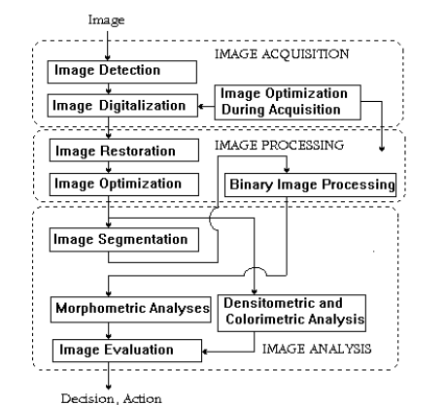

Sequence of functions in digital image analyses procedure

[1] : [DJ Soldat, P Barak, BJ Lepore - Journal of chemical education, 2009‏ - ACS Publications‏]
1.3.Image processing operations:
- Image enhancement.
- Image restoration.
- Color image processing.
- Multi-precision processing using wavelets.
- Compression pressure.
- Morphological processing.
- Segmentation or partition.
- Description and representation.
1.4.GUI (Graphical User Interface): -
is a new way to develop graphical user interface, which is suitable especially for those workers who are skillful in simulating in Matlab language but unskillful in VC interface development. This thesis firstly makes a brief introduction of basic features of Matlab/GUI, then expounds the GUI interface used in practical projects, and finally lists the interface developed by the author in other topics, so that to show that the new interface developing method is better than VC in dealing with data, especially in dealing with signals, and it has nice development potential.
Short for graphical user interface, a GUI is an interface that uses icons or other visual indicators to interact with electronic devices, rather than only text via a command line. For example, all versions of Microsoft Windows is a GUI, whereas MS-DOS is a command line. The GUI was first developed at Xerox PARC by Alan Kay, Douglas Engelbart, and a group of other researchers in 1981. Later, Apple introduced the Lisa computer with a GUI on January 19, 1983. ^{[1]}
[MT Klein, C Ibarra-Castanedo,XPMaldague… -Thermosense …,2008‏-[1] : spiedigitallibrary.org‏]
2.1. Wavelet transform:
The wavelet transform is one of the most important modern transformations used by researchers in many applications because of its advantages and characteristics that depend on statistical guesses and which play a major role in digital processing it also has the advantage of the being analyzing the signal or image to multiple levels of digital. this is one of the most important features used to strengthen the edges of digital image. ^{[1]}
The waveguide represents a variable analysis in terms of frequency window division oven time. Giving it strength in analysis compared to Fourier transform, as well as its advantage in taking meltier solution analysis.
The image is processed through the details of the analysis of the image to several levels and to a number of sub-images. It also has an advantage in its suitability for practical application on the digital computer and directly one of the most important applications in the field of digital image processing using waveguide.
is its application in strengthening the edges of digital image.
The waveguide represents a variable analysis in terms of frequency window division over time. Giving it strength in analysis compared to Fourier transform as Applications of wavelet transform the wavelet transform theory of conversion is of the modern theories presented as an alternative to Fourier transform, because it possesses a self-similarity feature, as well as its ability to represent milters solution analysis, marking it an effective tool in several applications such as audio compression. And computer graphics. Because of the wide range of processes and functions that can transform the waveform from its representation.

[1] : [Word Applied science journal, 2009, 647-653.]
Wavelet conversion has become the standard tool in signal and image processing applications. ^{[1]}

The application of wavelet conversion technology in the analysis of several types of signals and earthquake signals is the best choice because of its potential to analyze unstable phenomena.

2.2. Types of wavelet transform:
- Continues wavelet.
- Multi-resolution analysis.
- Discrete wavelet.
- Haar wavelet.

2.2.1. Definition of the Continuous Wavelet Transform:
Like the Fourier transform, the continuous wavelet transform (CWT) uses inner products to measure the similarity between a signal and an analyzing function. In the Fourier transform, the analyzing functions are complex exponentials, ejωt. The resulting transform is a function of a single variable, ω. In the short-time Fourier transform, the analyzing functions are windowed complex exponentials, w(t)ejωt, and the result is a function of two variables. The STFT coefficients, F(ω,τ), represent the match between the signal and a sinusoid with angular frequency ω in an interval of a specified length centered at τ. ^{[2]}
[1]: [International journal of computer sicence and information security (IJCSIS).9(6),2011,00.80_87]
[2] : [International journal of computer sicence and information security, (IJCSIS). 12(2), February 2014, pp.5-17]
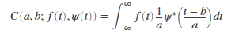
In the CWT, the analyzing function is a wavelet, ψ. The CWT compares the signal to shifted and compressed or stretched versions of a wavelet. Stretching or compressing a function is collectively referred to as dilation or scaling and corresponds to the physical notion of scale. By comparing the signal to the wavelet at various scales and positions, you obtain a function of two variables. The 2-D representation of a 1-D signal is redundant. If the wavelet is complex-valued, the CWT is a complex-valued function of scale and position. If the signal is real-valued, the CWT is a real-valued function of scale and position. For a scale parameter, a>0, and position, b, the CWT is:

where ∗ denotes the complex conjugate. Not only do the values of scale and position affect the CWT coefficients, the choice of wavelet also affects the values of the coefficients. By continuously varying the values of the scale parameter, a, and the position parameter, b, you obtain the cwt coefficients C(a,b). Note that for convenience, the dependence of the CWT coefficients on the function and analyzing wavelet has been suppressed.
Multiplying each coefficient by the appropriately scaled and shifted wavelet yields the constituent wavelets of the original signal.

2.2.2. Discrete wavelet transform:
In wavelet analysis, the Discrete Wavelet Transform (DWT) decomposes a signal into a set of mutually orthogonal wavelet basis functions. These functions differ from sinusoidal basis functions in that they are spatially localized – that is, nonzero over only part of the total signal length. Furthermore, wavelet functions are dilated, translated and scaled versions of a common function φ, known as the mother wavelet. As is the case in Fourier analysis, the DWT is invertible, so that the original signal can be completely recovered from its DWT representation. Unlike the DFT, the DWT, in fact, refers not just to a single transform, but rather a set of transforms, each with a different set of wavelet basis functions. ^{[1]}

2-D Discreet wavelet transform for image

2.2.3. Haar wavelet:
is a sequence of rescaled "square-shaped" functions which together form a wavelet family or basis. Wavelet analysis is similar to Fourier analysis in that it allows a target function over an interval to be represented in terms of an orthonormal basis. The Haar sequence is now recognized as the first known wavelet basis and extensively used as a teaching example.
As a special case of the Daubechies wavelet, the Haar wavelet is also known as Db1.
The Haar wavelet is also the simplest possible wavelet. The technical disadvantage of the Haar wavelet is that it is not continuous, and therefore not differentiable. This property can, however, be an advantage for the analysis of signals with sudden transitions, such as monitoring of tool failure in machines. ^{[2]}

2.3. A(digital) color image:
is a digital image that include color information for each pixel, For visually acceptable results.it is necessary ( and almost sufficient ) to provide three samples (color channels) foe each pixel ,which are interpreted as coordinates in same color space .the RBG color space is commonly used in computer display but other space as YCBCR,HSV and are often used in other contexts .a color image has three values (or channels) per pixel and they measure the intensity and chrominance of light ,the actual information stored in the digital image data is the brightness information in each spectral band. ^{[3]}

2.4. Color image representation:
A color image usually stored in memory as raster map. a two -dimensional array of small integer triplets ,or (rarely ) as three separate raster map ,one for each channel Eight bits per sample (24 bits per pixel )seem adequate for most uses ,

[1] : [international Journal of image processing ,6(2),2012,113-122 ]
[2][R.Wang.”Haartransform”.http://fsourier.eng.hmc.edu/e161/lectures/Haar/index.html , December 04,2008.]
[3] : [‘international Journal of computer science and information security,9(6),2011 , 125-133. .[14]H.B kekre’ tanuja sarode ‘ prachi natu]

but faint banding artifacts may still be visible in some smoothly varying image especially those subject to processing particularly demanding application may use 10 bits ape sample or more on the other hand ,same widely used image file for formats and graphics cards may use only 8 bits per pixel .i.e. only 256 different color .or 2-3 bits per channel .converting continuous –tone image like photographs to such formats requires dithering and yields rather and fuzzy result graphics cards that support 16 bit per pixel provide 65536 distinct color ,or 5-6 bit per channel this is resolution seems satisfactory for non –professional use, even without dithering.

2.5. Aim of project:
Color image similarity systems aim to retrieve images from large image databases similar to the query image based on the similarity between image features depending on wavelet transform.

main interface

(main interface) GUI Graphical user interface of the program
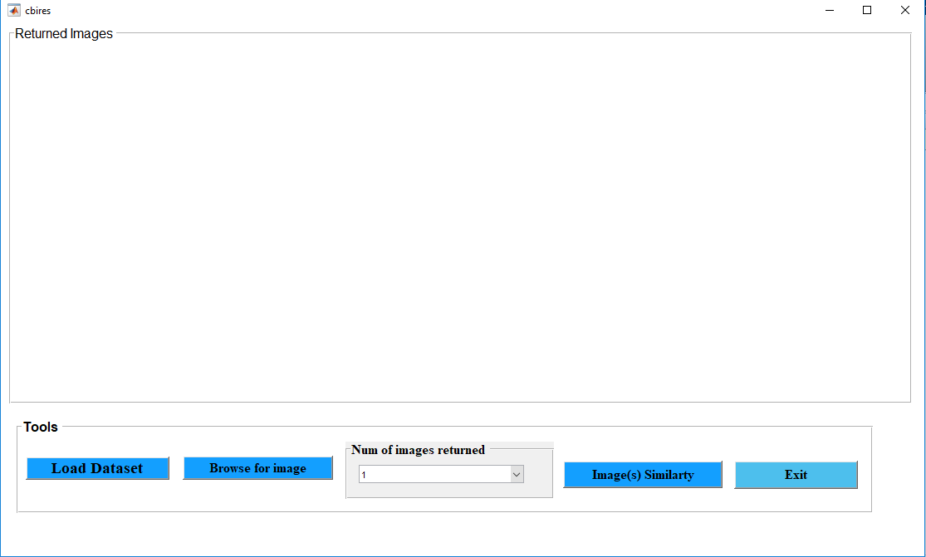

Consists of tools of program and graphical interface which gives easy interact with program where used the (GUI).
First Tools component (LOAD DATASET): -
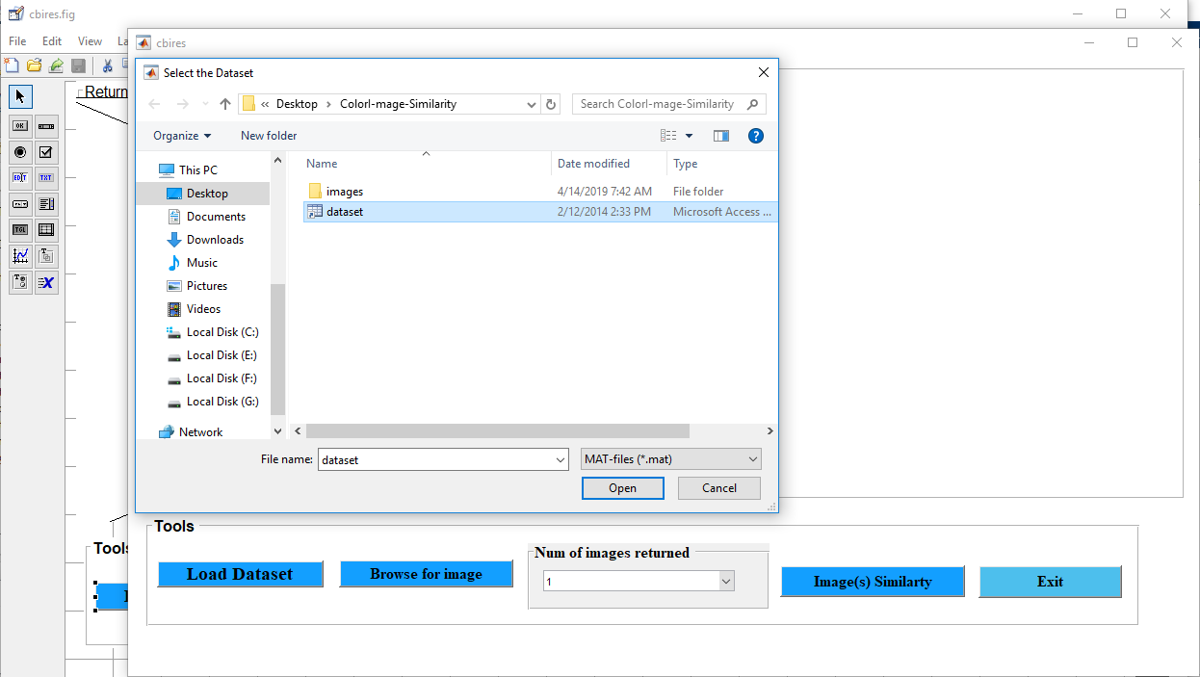

Click here

When the pressure on the (LOAD DATASET) it will give us help message (Dataset loaded Successfuly)

second tools component (browse for image): -

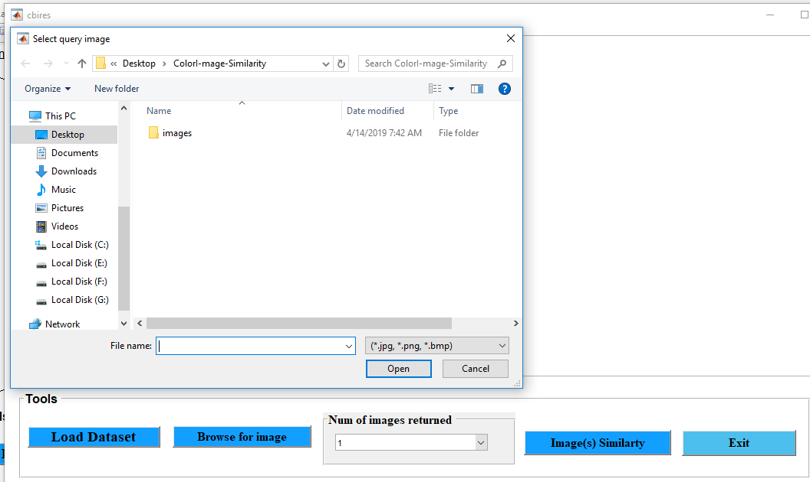

First

Second

When the emergence of window to the success of load dataset press the button browse to select an image checking characteristics of the image with the exists of the images to show the similarity among them.
We can, through the button (Num. of image returned) determine the number of image to show the similarities between them properties.

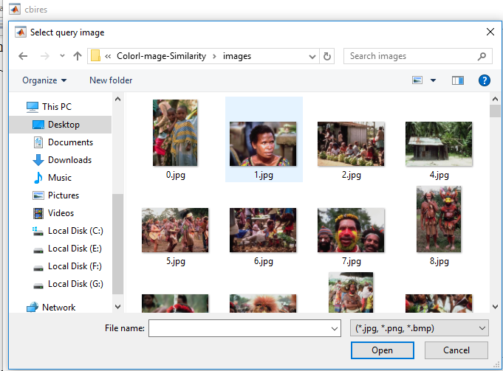
Third /Select of image

Num of image returned

Third tools component (image(S) similarity): -

In this stage, the image is filtered according to the selected images to extract the similar images within the characteristics that we specified when selecting the image previously to show us the results on the large the number of images to be shown, the less similar in terms of the existing characteristics.

in the end you can exit from the program by press the exit button.

Sample Code (Wavelet Transform)

function btnPlotPrecisionRecall_Callback(hObject, eventdata, handles)
% hObject handle to btnPlotPrecisionRecall (see GCBO)
% eventdata reserved - to be defined in a future version of MATLAB
% handles structure with handles and user data (see GUIDATA)

if (~isfield(handles, 'imageDataset'))
errordlg('Please select a dataset first!');
return;
end

% set variables
numOfReturnedImgs = 20;
database = handles.imageDataset.dataset;
metric = get(handles.popupmenu_DistanceFunctions, 'Value');

precAndRecall = zeros(2, 10);

for k = 1:15
randImgName = randi([0 999], 1);
randStrName = int2str(randImgName);
randStrName = strcat('images\', randStrName, '.jpg');
randQueryImg = imread(randStrName);

% extract query image features
queryImage = imresize(randQueryImg, [384 256]);
hsvHist = hsvHistogram(queryImage);
autoCorrelogram = colorAutoCorrelogram(queryImage);
color_moments = colorMoments(queryImage);
% for gabor filters we need gary scale image
img = double(rgb2gray(queryImage))/255;
[meanAmplitude, msEnergy] = gaborWavelet(img, 4, 6); % 4 = number of scales, 6 = number of orientations
wavelet_moments = waveletTransform(queryImage);
% construct the queryImage feature vector
queryImageFeature = [hsvHist autoCorrelogram color_moments meanAmplitude msEnergy wavelet_moments randImgName];

disp(['Random Image = ', num2str(randImgName), '.jpg']);
[precision, recall] = svm(numOfReturnedImgs, database, queryImageFeature, metric);
precAndRecall(1, k) = precision;
precAndRecall(2, k) = recall;
end

Conclusion:
The original image decomposed and compressed by the wavelet transform can retain its original features to the greatest extent. The wavelet transform is able to improve the speed of image retrieved and attain higher similarity rate effectively. The image comparison can offer a measurement for image similarity degree. Color image similarity systems aim to retrieve images from large image databases similar to the query image based on the similarity between image features depending on wavelet transform. For future work we can try to implement the neural network with wavelet transform.

References

[1] : [Alexander,J.C. (2012).lconic power: Materiality and meaning social life. New York: palgrave macmillan]
[2] : [content. Taylorfrancis.com-JC Russ-2016]
[3] : [books.google.com-JRparker-2010]
[4] : [DJ Soldat, P Barak, BJ Lepore - Journal of chemical education, 2009‏ - ACS Publications‏]
[5]:[MTKlein,CIbarraCastanedo,XPMaldague…Thermosense…,2008‏spiedigitallibrary.org]
[6] : [Word Applied science journal, 2009, 647-653.]
[7]: [International journal of computer sicence and information security (IJCSIS).9(6),2011,00.80_87]
[8] : [International journal of computer sicence and information security, (IJCSIS). 12(2), February 2014, pp.5-17]
[9] : [international Journal of image processing ,6(2),2012,113-122 ]
[10][R.Wang.”Haartransform”.http://fsourier.eng.hmc.edu/e161/lectures/Haar/index.html , December 04,2008.]
[11] : [‘international Journal of computer science and information security,9(6),2011 , 125-133. .[14]H.B kekre’ tanuja sarode ‘ prachi natu]

