Chapter one

Introduction
1.1 Scratch is a programming language that allows you to use code blocks to create animations, stories, musical instruments, games, and much more. It’s a bit like programming using Lego! The easiest way to start programming in Scratch is to use the online editor. ^{[1]}

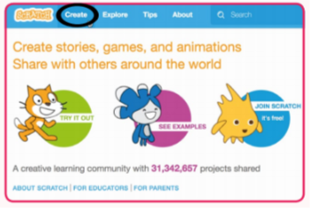
Figure1.1

There are lots of advantages to working online, but if you prefer to work offline (or don’t always have an internet connection), you can click Offline Editor at the bottom of the homepage to download Scratch instead. ^{[1]}
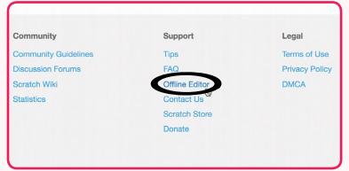
Figure1.2
But What Is Scratch, Anyway?
Scratch is a graphical programming language that you can use for free. By simply dragging and dropping colored blocks, you can create interac- tive stories, games, animation, music, art, and presentations. You can even upload your creations to the Internet to share them with Scratch program- mers from around the world. Scratch is designed for play, self-directed learning, and design. ^{[2]}
You’ve probably played a maze game before, but have you ever tried making one? Mazes can be tricky to complete, but they’re easy to program. In this chapter, you’ll create a game that lets the player guide a cat through a maze to reach its goal—a A green rectangle! You’ll learn how to move the cat with the keyboard and how to block its progress with walls. ^{[3]}

1.2 The Editor
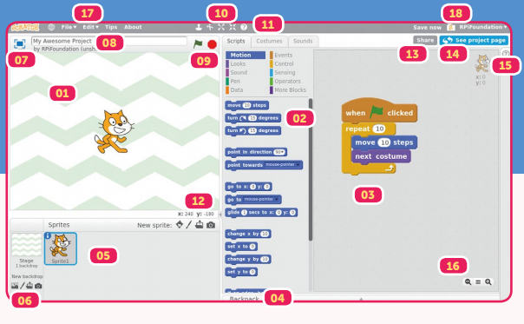
Figure1.3
01: STAGE

A project contains ‘sprites’ which you add code to. Sprites appear on the stage and can be coded to move around, make sounds, and do lots of other things.^{[1]}

02: BLOCKS PALETTE
Code blocks can be used to control your sprites and stage backdrop. All blocks are colour-coded, and can be found in the categories at the top of the blocks palette. ^{[1]}
03: SCRIPTS AREA

Drag blocks from the palette to this area and create scripts by clicking them together. ^{[1]}
04: BACKPACK Add

Scripts to your backpack to use them in other projects. ^{[1]}

05: SPRITE LIST
This shows all of the sprites in your project. You can click the blue information icon on any sprite to change its name and how it behaves. ^{[1]}
06: BACKDROPS

Change how your stage looks by adding new backdrops. ^{[1]}

07: FULL-SCREEN
Make your stage full -screen so that others can see your creation in its full glory. ^{[1]}
08: PROJECT NAME

09: START/STOP YOUR PROJECT

10: CURSOR TOOLS

Duplicate , Delete , Grow , and Shrink a sprite (by clicking an icon and then a sprite on the stage). Click the Block Help tool , then a block in the palette to learn more about it.^{[1]}
11: SCRIPTS/ COSTUMES/ SOUNDS TABS

Switch between coding your project, and adding costumes and sounds. ^{[1]}
12: MOUSE POINTER CO-ORDINATES

13: SHARE
If you have a Scratch account, you can share your projects with the community. ^{[1]}
14: SEE PROJECT PAGE

Add instructions and other notes to your project, and see how others in the community are interacting with it. ^{[1]}
15: TIPS

Get project tutorials, tips on using Scratch, and learn more about how each block works. ^{[1]}
16: ZOOM

17: MENU

Use the menu to load, save, and browse your projects, and access loads of other useful options. ^{[1]}

18: MY STUFF
This is where your projects are stored online.^{[1]}

Chapter two

The maze game

2.1 Introduction
To create the game maze in the program Scratch
First, we have to create a facade that is considered as a mater in the form of stages. Each model represents a specific part of the game
We will create five stages of mazes
This site provides us with the creation of a maze and according to the complexity,
We save the solution in a format for the same maze and there are several ways to create mazes like the drawing program in the same program Scratch
We created the required models we open the program Scratch from the Astig area in the program is adding New Block Drops to add the 5 models and then add the object player, which is centered on the game
To choose the character of the cat we go to New Spirit Here we have created an initial object for the game that is centered on player character and the path that follows.

2.2 Game programming

2.2.1 Player programming
We choose the event and choose the green flag start button.
We program the computer buttons (right, left, top, and bottom) to control the movement of the character.
We program each button separately.
- The left arrow
When you press the left arrow key, the player moves towards the 90-direction and changes the position X of the 2-digit and changes the next appearance that allows the player to move as if running
There are many obstacles to those movements

AS the flow chart down.

Leading towards the 90-direction

Left key

We change position X by -2

If he touches the black color

Change position x by 2

If it touches the level1 .false1

Go to
x=28, y=-168
If it touches the level1 .true2

Say I was wrong For 2s
س

Show –level-2-items
Go to
x=20, y=-168

Hide-level-1-items

Change the background to next level

The level1 .false1
A box represents a subject in a wrong stroke and it is in the same color as the background of the game. When the player moves in the wrong direction, he will touch the box and return to the starting position) I was wrong (
The level1.true1
Represented by a green box will be at the end of the stage, then the player arrived and touch will take us to the next stage
Hide-level-1-items
Represents the disappearance of the stage at the end
Show –level-2-items
This instruction shows the second stage
The black color
The walls of the maze, which is painted in black, where he has contact, stops the player
And so it remains level In proportion to the left arrow
As for the rest of the shares will be the same design, but the difference in angle (right arrow - share the top - bottom shares)
- Facilitates the player according to the correct direction of the maze

When you click on the banner flag

Make time = 0

If touched Bee

Go to x=30 , y-168

Make time = 0

If touched Ghost2

Go to x=30 , y-168

Make time = 0

If touched Baa

Go to x=30 , y-168

Make time = 0

When you click on the banner flag
By clicking on this tool you will run all the software components that are underneath it
Bee
One of the obstacles facing the player who is in the form of an insect where a specific path moves in the maze must be avoided and not touch it, if touched by the player back to the starting position
Ghost2
It also represents one of the obstacles faced by the player in the game and be in the form of a ghost where it disappears and appears in a specific path, the player must avoid and not touch him and if a touch back to the starting position
Baa
It also represents one of the obstacles facing the player in the game and be in the form of a bat where he flies over a specific path in the game so the player must avoid and not touch him and if a touch back to the starting position

Chapter Three

Backgrounds
3.1 The maze game consists of 7 wallpapers.

1. The main interface containing the name of the game (the maze) and the start button
2 - The second background of the first level of the game and be simplified and easy to a little because the degree of complexity is few
3- The second level of the game is more complex than the first level
4 - the third level of the game and be more complicated than the first and second levels, The fourth and fifth backgrounds represent the fourth and fifth levels of the game and be more complicated and difficult either the final background and the seventh is the face of the end where the message appears (you won) And then button back to the first background (Restart game)

Chapter Four

Conclusion & Future work

4.1 Future work
The game can be developed and made more stages and more complicated by putting children's ideas and implement them programmatically and make more obstacles and traps in the game.

4.2 Conclusion

1 - Teaching the programming language in an easy manner.
2- Developing children's skills.
3 - Does not require the writing of any programming terms.
4 - This language depends on the use of images and mix different types of media, including graphics, images, music and sounds to create programs.

References

[1] CC_Book_of_Scratch Writers: Rik Cross, Tracy Gardner Illustrator: Timothy Winchester • Design: Critical Media Editor: Phil King • Sub Editor: Nicola King
Publisher: Russell Barnes • CEO: Eben Upton
[2] Super Scratch Programming Adventure 2014, The LEAD Project
[3] Scratch Programming Playground Writers: Al sweigart Year of Publication 2018

Abstract

One of the most important games in the language of the scratch, where developing the abilities of children in thinking, it is aimed at children to develop their ideas and energies. They make the child think quickly to choose the right path to get to the end and choose the right path to cross the next stage and overcome obstacles and traps located inside the maze. And develop its programmable capabilities by programming computer buttons to move the character.

