republic of Iraq

Ministry of Higher Education and Scientific Research
University of AL-Qadisiyah

College of Computer Science and Information Technology
Smart Healthcare Monitoring System Using Wearable sensors

By
Student name
Sajad Faisal Sharef
Adyan Majed Abd Alkadim
Walaa Safaa Abd Alhussin
Samer Jassim Abd

Supervisor
Assist Prof Dr. Ali Mohsin Al-Juboori

A graduation project submitted to the Multimedia department in partial fulfilment of the requirements for the degree of Bachelor in Information Technology in Multimedia

April - 2019

Abstract
Technology become essential part in our living nowadays, it influence the way we live and work positively. In computer science, there are two term are widely spared and got researcher focus, these are Ambient assisted living (AAL) and Internet of Things (IoT). The first term means the concept of generating new living environments that combining social environment with latest technology to produce products and services that significantly enhance the quality of our living. While the second term is the platform, where AAL can be constructed, IoT is internet framework that enable developer to connect several devices, systems and technology all together. People will have more control in controlling the environment they live or work in remotely. In addition, more data resources will be available to get the advantages of involving it in data processing activates to get better decisions. AAL and IoT, These two terms are widely spread and get the focus of many companies and researchers. However, no much products in the industry meet these field requirements and aim.
The rapid growth of IoT is changing our lifestyle, due to the fast drop in IoT components costs that allow people to invest new technologies in their houses and offices design, establishing smart home and smart cities. Warble sensors technologies and Advance IoT have the potential to improve our day-by-day systems such Healthcare systems. In fact, raising the efficiency of healthcare infrastructures is one of the vital goals of our modern society.
Nowadays, people are substantially care about their healthcare and interested in constantly measuring their physical activities anywhere at any time using various healthcare and fitness trackers devises. In this research will introduce a system that meet the requirements of AAL and IoT, which can effectively help in monitoring older and disable people wile in their home and work.

Acknowledgement
The author wish to express his sincere gratitude and appreciation to Assist Prof Dr. Ali Mohsin Al-Juboori for all his supports, guidance and supervision given throughout the project. We had weekly meeting to discuss the progress and the target we need to achieve from the project. Thus, the comments were given to me from him are helpful helps me to be more productive in my research.

Table of Contents
Chapter 1: Introduction 4
1.1. Research Introduction 4
1.2. Problem Background 4
1.3. Project Aim. 5
1.4. Project Objectives. 5
1.5. Project Rationale 6
1.6. Research Motivation 7
1.7. Expected Outcomes 8
Chapter 2: Theoretical 9
2.1. Introduction 9
2.2. Healthcare System Requirements Background 9
2.3. Healthcare Sensors 10
2.4. Related Work in the field 11
2.5. Methodology Plan 13
2.6. Software Engineering Requirements 13
2.7. System Analysis & Design 14
2.8. Requirements & Resources 14
Chapter 3: System Requirements 15
3.1. Introduction 15
3.2. Elicitation Activities 15
3.2.1. Analysis 15
3.3. System Requirements Specification 16
3.3.1. Performance Requirements 16
Chapter 4: Design & Implementation 18
4.1. System Architecture Design 18
4.2. SHMS Business Object Notation (BON) 19
4.3. Patients System 20
4.3.1. Arduino and Heart Rate Sensor 20
4.3.2. Arduino and Temperature Sensor 22
Chapter 5: Conclusion & Future work 26
5.1. Conclusion 26
5.2. Future Work 26
References 27

Chapter 1: Introduction

Research Introduction
Healthcare become one of the growing research topic nowadays due to the word growing publication and especially elderly people who need more care [1, 2]. However, healthcare costs rising and the quality decreasing. Monitoring people healthcare anywhere at any-time constantly via monitoring devices and fitness trackers become essential [3].
The rapid growth of IoT is changing our lifestyle, due to the fast drop in IoT components costs that allow people to invest new technologies in their houses and offices design, establishing smart home and smart cities. Warble sensors technologies and Advance IoT have the potential to improve our day-by-day systems such Healthcare systems. In fact, raising the efficiency of healthcare infrastructures is one of the vital goals of our modern society.
Technology become essential part in our living nowadays, it influence the way we live and work positively. In computer science, there are two term are widely spared and got researcher focus, these are Ambient assisted living (AAL) and Internet of Things (IoT). The first term means the concept of generating new living environments that combining social environment with latest technology to produce products and services that significantly enhance the quality of our living. While the second term is the platform, where AAL can be constructed, IoT is internet framework that enable developer to connect several devices, systems and technology all together [4]. People will have more control in controlling the environment they live or work in remotely. In addition, more data resources will be available to get the advantages of involving it in data processing activates to get better decisions [5]. AAL and IoT, These two terms are widely spread and get the focus of many companies and researchers. However, no much products in the industry meet these field requirements and aim.

Problem Background
Governments and healthcare organizations spend millions of pounds every year to provide high quality of services in healthcare sectors. Monitoring patient’s vital signs such as temperature, blood pressure and heart rate is one of the major aspect of healthcare system [6] and continuous nursing to patients is not possible in hospitals because it cost effective. Until recent patients are monitored manually in clinics and hospital for some days then a reports created to keep patients records for future use by doctors or emergency if any abnormal condition take place [7]. In the new lifestyle, combining multiple technologies such as smartphone application, wearable devices and sensors to monitor patient’s status and physical activity are widely accepted by people across the world. The new technologies are capable to provide patients physiological data from their locations to remote physicians in real-time [7, 8]. To be more precise nowadays data such as ECG tests, Blood oxygen saturation and Blood glucose level can be measured via wearable devices and transmitted from patents locations to their doctors in just few seconds, which enable doctors and patients to communicate remotely.
Nowadays people are substantially care about their healthcare and interested in constantly measuring their physical activities anywhere at any time using various healthcare and fitness trackers devises. Such as Jawbone and Fitbit [3]. Surveys proceed in Europe and United States [2] indicate that patients prefer to get their treatment and healthcare in their homes rather than hospitalized. Monitoring patients remotely has several advantages to improve healthcare, such as elevate doctors and patients’ availabilities and reduce clinical visits that lead to drop in costs. In addition, in case of older and disable people or patients’ lives in remote area, monitoring them remotely can helps to avoid any potential threat on patient’s status.
Providing such a system that can monitors people physiological activity regularly could have the advantage of detecting diseases in its early stages [1]. Especially with the case of older and disable people who is much likely to have disorder in their physiological data [2]. Early detection of diseases prevents worsening patient’s status especially with some diseases such as cancer.
Thus developing smart health environment to improve healthcare systems has become one of the research focuses. However, building a system that can track people and patient’s physiological data to detect any disorder or diseases is growing felid, in this work the author attempt to deliver a Smart Healthcare Monitoring System (SHMS), which accumulate patient’s physiological data via wearable sensors and transmitted to cloud databases for data analysing and processing. Thus, any detection of disorder in patient’s data in the system will be report it to patient’s doctors and hospital.

Project Aim.
The fundamental aim of this project is to develop a complete Smart Healthcare Monitoring System (SHMS). The system should monitor patients, elderly people and disable people in their home and work. SHMS will monitor physiological data (e.g., Blood glucose level, Blood oxygen saturation, skin temperature and heart rate), analyses the data and detects any abnormality, report it to patient’s doctor and other parties in charge (i.e., hospitals).
In addition, the proposed solution has the potential to improve current healthcare systems and reduce clinical treatment costs significantly by reducing number of patients visiting clinics and hospitals. Also, this system will help people in detecting diseases on is early stages. Moreover, SHMS helps patients living in countryside, away from hospitals and doctors monitoring their healthcare easily and effectively.

Project Objectives.
In order to successfully achieve the aim of this project, the following objectives must be fulfilled:
- Objective for literature review and Information Collection:
- Investigation about the problem domain.
- Collecting basic information about patient’s illness and physiological data.
- Wearable sensors types, requirements and barriers.
- Accumulate information about current, previous and similar systems.
- Information about user’s expectation for new system requirements.
- Challenges, issue and barriers might come across in the project.
- Available technology to be consider for the proposed system development.

- Objective for gathering Software Engineering Requirements:
- Investigate system activities extracting events and action taken by the system.
- Investigate the performances requirements for the system.
- Data analysis, Overlapping, protections and transformation.
- Access level and authentications.
- Hardware and software requirements.
- Investigate the appropriate programing language for the developed system.
- Implementation techniques and enhancements.

- Objective for System Analysis and System Design processes:
- Extracting system functions, class and attributes.
- Analysing the designing the required functionalities for the developed system.
- Refine the system requirements.
- Investigate the development of the Graphical Users Interface Design (GUI). Include style and barriers design.

- Objective for the Implementation stage:
- Search about suitable hardware for measuring heartrate, such as pulse sensor. Also the type of output analogue or digital.
- Appropriate board(s) for resaving sensor reading. Board must be compatible with sensor output.
- Explore the suitable programing language for the mobile application.
- Examine the different platforms and code that give better output.

- Testing Strategies:
- Creating test strategies for the developed system.
- Considering testing the new system as it expected to work in a real-world environment.
- Documenting test results.

- System Evaluation:
- Investigate system performance to insure SHMS achieving the requirements and project aim. Also looking on the cost, latency, scalability and usability.

Project Rationale
The Smart Healthcare Monitoring System (SHMS) is to improve the efficiency of healthcare in our modern society by providing more reliable and convenient healthcare system to patients. Successful implementation to this project could have the potential to protect people life, in addition to the significant drop of healthcare costs by reducing the clinical monitoring and emergency cases. SHMS is mainly to monitor physiological data gathered from patients and creating data record that will be stored in cloud databases, where it will be available for doctor use at any time in anywhere.
The system has three layers that work to achieve system tasks. Each layer has it is own requirements and technique. Briefly, the system starts from data gathering from the patient side, transfers data to cloud databases where data will refine and analysis to provide pure information about patient situation, and ultimately doctors in hospital platform will monitor these data. The main layers and components of each layer described below.
- Wearable devices (Patients Layer): A wearables and smartphone sensors will connect to patient’s body to collect physiological data. Such sensors measuring data (Blood glucose level, Blood oxygen saturation, skin temperature and Heartbeats rate) essential in this project, different type of sensors available [1, 6, 7, 9]. Monitoring these symptoms in patient’s body is very important, as any abnormal result in these four parameters could potentially end up with a serious disease. For instance, drop of oxygen level in human body cues a Sleep apnea, which lead to death. In addition, abnormal blood pressure causes a kidney disease or diabetes. The sensors send all data to patient’s smartphone via Bluetooth [9] to be sent to cloud databases via patients smartphone. Moreover, the sensors will operate to measure and send the data regularly without patient noticing to make them more comfortable. Due to time constraint for this project a simulated sensor or assumption data will be use to perform system.

- Monitoring Website (Hospital Layer): This will be hospital platform to monitor patients’ records by doctors, in addition to the reports provided by the system, from the cloud, upon abnormal changes in patient’s data. Data synchronization in the website should be in real-time [7, 12, 13] to keep doctors with up to date data about patient’s status, also help paramedic to take early action in case of emergency before the situation getting worse and prevent hospitalization.

Research Motivation
Research motivation come through my interest about our society, living facilities in general, and our healthcare in particular. Healthcare services in our modern societies become capable to meet the need of individuals because, on one hand, the significant growth of population year by year, on the other hand, healthcare investment in new technologies to handle these populations are limited.
Moreover, I and other people are substantially care about our healthcare and interested in constantly measuring our physical activities anywhere at any time using various healthcare and fitness trackers devises such the new smart watches. In addition, we care about our older and disable people healthcare, if we left them for alone for a period. Therefore, it is became essential to engage the technologies such as healthcare sensors and wearable with our healthcare services, in order to have a safe and convenient environment for everyone to live in.
My knowledge in this field, start from previous researches in mobility Health (mhealth), which is the concept of improving our healthcare services to support remote healthcare monitoring and treatments. I hope that at the end of this research achieve the aim of this project and produce complete system that able to look after people health and help them to live in a convenient healthcare environment.

Expected Outcomes
Upon successful completion for the SHMS, the proposed solution should be able to provide an effective patients and doctor remote monitoring system. To be more precise the system will be able to measure, analyse patient’s data in their locations, and inform their doctors or the emergency (In case of emergency) if something abnormal with the data detected by the system. Therefore, the expected outcomes of this project will be three main components:
- Mobile application for patients.
- Cloud databases able to store and analyse patient data.
- Website, accessible by authorised doctors. Support runtime data synchronization.
- Complete documentation for theoretical and practical part of the research.
In the project rationale section above, a complete illustration given about the system layers, and how system parts are connected. However, below flowchart (Figure 1) show an overview of the expected workflow of SHMS.
Start

Get Patients Data
Normal Data
Data Analysis

Abnormal Data
Alert Notification

End

Figure 1: SHMS Performance Overview

Chapter 2: Theoretical

Introduction
The invasions of new technology in our life, and its ability to enhance our daily roles lead to researches focuses. Improving healthcare systems gaining significant attention by researcher to improve healthcare strategies. Researches on patients remote monitoring are increasing due to increase in healthcare costs [13, 14] and the significant increase of population aging [4, 7, 13]. Therefore, developing new technology to solve healthcare issues became one of growing fields. In this chapter will investigate several recent researches and related works to the proposed solution ware inducted.

Healthcare System Requirements Background
Healthcare solution are carefully designed because it crucial and involve dealing with patients life, thus, developing an effective healthcare monitoring system several factures need to consider such as data availability, consistency and protection. However, the main feature that needs to be implement in such a system dealing with people healthcare is runtime data synchronization [13, 15]. More precisely, when authorized people monitoring patient’s data, it need to be updated in the same time it being send from patients warbles devices.
Healthcare system relies on several approaches to transfer patient’s data from one platform to another. Some of these approaches can be internally, when data is already on one of the system platforms will sent in a secure channel to other platforms. While other approaches require their party, which can be a hardware to collect these data and send it to system platform, this device will be called system getaway [6].
The basic gateways performance is to accumulate data from sensors or any warble devices that measure patient’s physiological data then send it to databases such as cloud databases, thus in this instance gateway can call bridging point. For instance, the UT-GATE [16], is provide data monitoring for original source such as sensors, this gateway cab use at home or hospitals. In addition, there are other components that can be use as gateway such as Raspberry Pi, Arduino or patients smartphones [1, 7, 13, 15]. However, there are great number of microcontroller and microprocessor available in the market, which can be use to achieve this task of the gateway such as ESP8266. Moreover, gateways performance, the new direction of this technology is to enhance these getaways to become more effective in the system by reducing data traffic on the databases by analysing these data and transfer only healthy and important data for the system instead of sending all data [17].
Wireless sensor network (WSN) is the core of the intelligent healthcare system, where use meanly to collect physiological data [11, 14, 18] from patient body. There are different type of sensor use in healthcare monitoring, each sensor has one role [13] for instance, Pulse sensor use to measure heart rate [14], BMP180 sensor measuring blood pressure [14] and ADS1292R sensor use for both ECG and respiration [13, 14]. These sensors provide data from patients body, these output data either analogue or digital data format. Thus, sensors are connect to appropriate gateway that able to read these data and send it to databases.
In this research, Arduino Uno and patient’s smartphone will be use as gateway to prove the concept of the proposed solution. However, healthcare solutions must have elasticity design, to be adapt with growth of the system, and hardware components must be improved continuously, due to the fact that hardware components are enhanced rabidly these days.
Finally, Security measurements should be considering when dealing with people, data from data storing to data transformation. Healthcare databases sever from external and internal threats such as employees and hackers [19]. One of the research solution to solving these issues is privacy preserving cloud [20]. The solution was develop based on encrypting and decrypting techniques of data in the cloud rather than using the traditional solution of limiting the accessibility of patient’s data.

Healthcare Sensors
Healthcare medical data are collection through several warless sensor, these healthcare sensors are wildly use nowadays [4, 7, 9, 11, 13, 14, 18]. However, the different collaboration between these sensors and different systems to with each other can have the potential to develop enhanced systems, which will influence our life in positive way.
In work related to sensors in healthcare system, in this work [8], multiple sensors measuring various values such as heart rate and skin temperature are connected to network through data aggregator such as smartphone. Then the data transmitted from patient’s location to central data centre such as hospital databases. The data analysis in this for this project has three layers, data storage, visualization and analysis, shown in (figure 2). Moreover, a machine learning has been used in this work to equip data analysis process with new variables cloud be related to the processes of patients data to make right decisions.
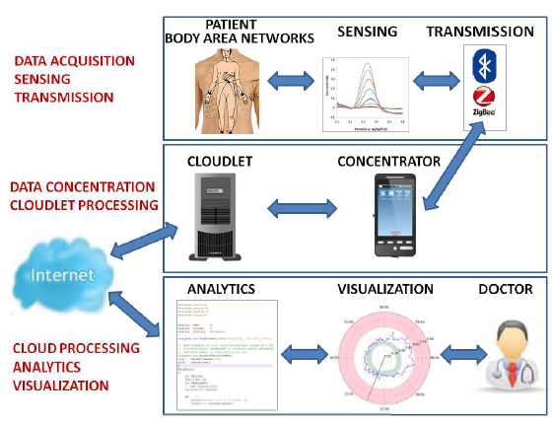

Figure 2: Remote monitoring Components, based on IoT-Cloud architecture [8]
In this paper [14] a collection of physical data such as blood pressure (BMP180 sensor), heart rate (Pulse sensor) and ECG (ADS1292R sensor). Which is collected using different type of WSN stated. Sensors ware connected to Raspberry Pi to send physical data in real time, this technique strength the usability of the system. Moreover, the authors mentioned that using such a system that is able to provide the communication between patient and doctor, sending the right data to doctor and receiving prescript from doctor can reduce the number of visit to doctors and hospital [4, 14, 18], Which lead to the advantage of reducing costs significantly.
The combination of wireless sensors network (WSN) [14] and radio frequency identification (RFID) used to propose a smart hospital system (SHS) [11] in addition to smartphone through a protocol call (COAP)/IPv6. The system responsibilities are to collect data about patients for both environmental and physiological. The SHS architecture shown in (figure 3).
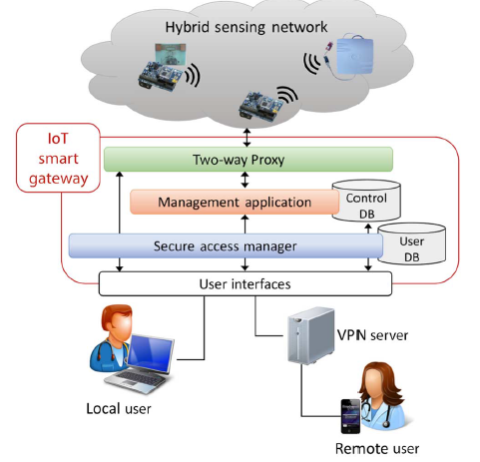

Figure 3: SHS architecture [11]
WonedRing is wearable sensor developed to detect and analyse user’s activities [5]. The sensor use for elderly people to monitor their activities in daily bases and send it to their supporters such as family member, doctor or neighbour to know information about their health status to be safe living independent. The system challenges were to solve the issues of recognize the activity of the user such as walking, eating, running, brushing and so on. Also, finding a useful information from monitoring user activities and deliver these data to the authorised party. User’s activities are stored in databases then the system filter these activities to get useful data and share it with supporters. Camera also can be use as sensor to provide information about user’s activities, a micro camera used in this work [21] to identify abnormal movement or behaviour of objects in front of the camera. However, the authors of Wondering [5] stat that is inconvenience to install number of cameras and restrict users to be in that range of camera coverage. In addition, this may assault user’s confidentiality.

Related Work in the field
Improving healthcare using Raspberry Pi, is another work to help in remote monitoring, in this work [6] authors focused on monitoring one parameter which is ECG sign. The Raspberry Pi was use as getaway to collect the ECG data from different wearable machines and send it to the databases. Therefore, any change in the data the Raspberry Pi will update the databases using MySQLdb. In addition, a wireless network (GSM) used to send alert to doctor in case of emergency. The data will available to access by the authorised people through website.
One of the smart home experiments to produce a smart environment for healthcare in [2], presented a cloud based smart home call CoSHIE. This system is to collect physiological data through warble sensors. The authors use a non-invasive sensor to gather information about patient’s daily activities. The case study in this work prove that this approach is effective to collect contextual information to study patient’s behavioural changes and recovery processes at their homes. The sensor collects data and sends it to cloud via home getaway. CoSHIE cloud has number of layers the hybrid storage that includes the relational (MySQL) and non-relational (NoSQL) databases. The authors intended to sort data such as name, sex, diagnosis, fluid intake and Spo2. All sensors data stored in the non-relational databases, while other information in the relational databases.

Mobile phone (Smartphones) gateway to Monitoring blood pressure level via keep in touch (KIT) [4], this work use a close loop data transferring by connecting the mobile phone based in Java to website that make all data accessible by everyone to monitor the blood pressure level. Testing blood pressure using Breakout barometric pressure sensor [14], where diastolic and systolic ware measured, if the result of testing ware out of the normal rang which is 120/80 mm Hg, then these data recorder and reported to doctor to take an action [4, 14].
Another example of using patients smartphones as gateway communicate with a wearable sensor for healthcare monitoring architecture [3]. This system developed to monitor patients through sensor impeded on users mobile or wearables such as heart rate sensor in the new smart watches. In this work, a solution for filtering the overload data (Data provided by the sensor), constructed through databases querying facility. Sensor Network Query Processor (SNQP) and Sensor Network Query Language (SNQL) use to improve data acquisition for sensor network databases [22, 23]. SNQL and SNQP have different role, the first query language support applications software advance expressiveness, while the query processor provides adequate algorithm for data accumulation from sensors.
Using Arduino as getaway [7] connected to sensors in patients body to get different data. The concept of the system is same to detecting changes in the received data in the backend and send massage if something wrong. Using the combination of ada boosting and Naive Bayes algorithm from remote sensing. The authors examine the algorithm by monitoring patient’s data manually for few days, and then collected to check with data gained from the sensors. In this study, Arduino was attach to patient bod and connected to Wi-Fi for data transformation. This cannot be the best practice interim of Arduino hardware size and accuracy in kept connected to the Wi-Fi. The data monitored in this work is heart rate, RR, BG and BP without mentioning the type or technologies to measure these data.

Methodology Plan
The methodology plan for this project will be divided into sections, according to the main stages of the project processes. With the aim of effective planning of every phase of the project, the author intended to use number of techniques to indicate the method, workflow and expected outcome of each stage. The procedures and techniques will be use during the development of SHMS grouped under the main heading in (Figure 4).

Figure 4: Methodology Steps

Software Engineering Requirements
To successfully achieve the aim of this project, full understanding about the problem domain and requirements are required. The information gained in this section will be the fundamentals for the workflow over the next stages. Therefore, data will be very critical and need to be well investigated and addressed. To do so, the author intend to do the following procedures:

Requirements Elicitation Procedures
In this section, the author will investigate in the problem domain to gather all the related information to address system features, issues, preference and performance during this stage. The result of this section will be use in the system analysis chapter, in order to convert the gathered information into requirements to SHMS. The output of this section will be critical, as it will be use in the upcoming stages to identify the system functionalities and design requirements, which eventually use for system implementation.

System Requirements Specification
The information (scenario) provided in the previous section will be the core of this section, as all requirements for the SHMS in term of design and functionalities will be demonstrate here. The main three parts of this stage, is to address the following points:
- Design Constraints.
- Functional Requirements.
- Performance Requirements: (In Term of Reliability, Speed, Usability and Capacity).

System Analysis & Design
Every system has its own requirements and specifications, which ware investigated and addressed in the system requirements section. However, to transfer these requirements into functional system, the requirements information should categorise into logical sections that will be use during the implementation. Due to the importance of this section, few methods and tools proposed to use in this section to analyse the scenario of the SHMS.

Textual Analysis
In this stage, the developer will indicate the required classes, methods and attributes by extracting adjectives, verbs and nouns from the SHMS scenario provided in the previous section. Thus, nouns will be referring to classes, while verbs referring to method or operation. This stag important to get the first draft of the system operations and attributes required in the system developments stages. However, the output of this stage will be use in the upcoming sections to refine the data and get only the helpful information that can use in the implementation stages.

Significant Event Analysis (SEA)
This is the first step for successful completion of the SHMS prototype, where will be extracting a list of system events or activities, in addition to classes and attributes required to associate with it to operate each event. This stage start from using the output of the textual analysis by taking each verb (Which refer to operation or event) and validate the verb to consider as system function, also gathering data that can be use in this action. It is important to highlight classes and attributes that will be use more frequently in order to make global definition over the system developments for them, in order to avoid data redundancy, which may slow down the performance of the system.

Requirements & Resources
To successfully complete this venture, number of software and hardware requirements are required during the development of SHM system. Below list, show the essential requirements:
- Full excess to recent papers and books.
- Appropriate software development environment for system platforms implementation.
- Sensors to collect patient’s physiological data (Can be a simulated sensor to provide data).
- Pulse Sensor.
- Arduino Uno.
- Breadboard, LED, jumper wires (MM, MF and FF).
- Laboratory and Online recourse will be required for technical support.

4

Chapter 3: System Requirements

Introduction
To successfully achieve the aim of this project, full understanding about the problem domain and potential solution requirements are required. In this section, the author will investigate in to gather information related to the implementation of the system; will address system features, issues and preferences. The information gained in this section will be the fundamentals for the workflow over the next stages. Therefore, data will be very critical and need to be well investigated and addressed. The first section will address system platforms requirements, then the following section refine and categorize these requires as functional and non-functional requirements.

Elicitation Activities

Analysis
This section aims at accumulating information about healthcare systems specification and requirements, as well as to analysing the finding of the Literature Review, chapter two and other resources is been investigated. Therefore, in this section providing a detailed explanation of the requirements for this project. To successfully implementing smart healthcare monitoring system, it is important to collect accurate and valid information about technologies and equipment’s available in the market, these details will be essential in the system development stage. Therefore, the author divided the finding into sections, from user’s layers to hospitals layers as follow shown in (Figure 1).

Figure 1: Layer of Requirements
Patients or user layer contain several components to measure patients physiological data, these components are connected to gateway in order to accumulate these data and push it to database. Effective monitoring system to patients and their activity require a correct data and information about patient’s activities [4, 6, 11, 13]. In this project, the focus on collecting four physiological data from patient’s body, these physiological data are patient’s symptoms data, which is Heartrate, and body temperature.
Detecting and monitoring these symptoms at the right time allow doctors to provide the appropriate treatments to elevate emergency and save patient’s life. In this research, the porotype will measure patient’s heartrate through pulse sensor, while the other symptoms data will assume that a home monitors devices used to measure them and enter the results to the system through patient’s application, due to the limitation of sensors availability in the faculty. However, research about sensors types that dose the symptoms measurements has been done already; the table below (Table 2) shows the type of sensors that use to measure the above symptoms.
SYMPTOMS | SENSOR | DESCRIOPTION
Heart Rate | Pulse Sensor [24] | Measure the heart beat frequency in cardiac cycle.
Skin Temperature | Temperature probe [13] | Measure patient body ability to dispose heat.
Table 1: Symptoms Sensors Type

The data collected from sensors for filtering and processing, the data accumulation can be through Bluetooth, Wi-Fi, Arduino or Raspberry pi [3, 6, 13, 15, 18]. In addition, users will have a mobile app installed on their smartphones to keep and monitor their records and able to interact with hospital side in case of emergency. Users will be able manually feed the system with their symptoms records using different healthcare monitoring devices.
The symptoms data will be stored in database for analysis processing. After collecting the data it is obvious to have huge amount of data stored to the data bases, some of these data is directly helpful to patients conditions, while some data are unwanted [3]. Therefore, these data will be abort from the system to save databases space as well as to improve the performance of the system by providing only helpful data. The following steps is process these data to check for the abnormality. Therefore, is essential to make list with normal and abnormal values of the symptoms will be monitor in this project, the table below (Table 3) content symptoms and their normal and abnormal values.
Table 2: Symptoms Range
SYMPTOMES | NORMAL | ABNORMAL
Heart Rate | 60 – 100 per minute | <60 OR >100
Skin Temperature | 97 – 99 F | <97 OR >99

Detecting these changes is important and it is the core requirement for the SHMS to monitor patient’s status continuously. To improve the usability of the system the overall normal range of the symptoms need to present. In addition, accumulating and suggestion list of common diseases that resulted from data changing in one or more symptoms data that cues the disorder in patient’s physiological activities.

System Requirements Specification

Performance Requirements
Smart healthcare monitoring system (SHMS) require smart performance requirements. To produce efficient system that meet user’s requirements, all system functionalities will be design to meet specific criteria that judge the operation of the system. There are six major performance requirements must be considering in this project to boost user experience. The below points elaborate the main performance requirements of this venture.

Accuracy
SHM System require high accuracy to detect and transfer user’s data. Due to the sensitivity of data required for monitoring and analysing, it is important keep the accuracy of the system high in term of delivering and presenting these data. As data, will be use to evaluate patient’s circumstances in term of illness diagnosis and treatments, therefore it is very critical data is accurate and up to date to save patients live and prevent any serious illness might appear. To achieve this, database design will be cheerfully design and implemented to oved data overloading and data overlapping.

Speed
In term of speed requirement to perform the action is very essential for this project. Data synchronization from different system platforms is required in real-time; in other word reduce the time losing during the action of receiving and transforming the data. For instance, the action of transferring the data from patient’s smartphone to database perform in just few seconds. Operations of read and write into the database will be well managed to avoid time consuming that lead to speed loss. Doing so will significantly improve user experience the usability of the system.

Capacity
The system will be develop for patients monitoring, therefore the capacity of the system must be big enough to handle large groups of members. However, the performance of the system must work effectively with individual users similarly in peak-time without any limitation, such as access issues or data recording delay and so on. For large city with large number of user’s groups, it is recommend having cloud databases, which is more reliable in term of data management such as data maintenance and data backup to prevent user’s data loss in case of system crashing and avoid server downtime.

Reliability
For successful SHM system, the expected working times is 24hours seven day a week to insure user’s satisfactions and safety. However, any system is subject to failure and/ or maintenance, therefore the potential downtime for the system under whatever circumstances will not take more than few hours, due to the critical functionalities of the system. In addition, alternative platform must be activate to overtake the role of the system until it back to usual performance.

Usability
Improving system usability by effective designing for the user’s interfaces and more interactive system. To be more precise clear graphical user’s interface design presenting system components and understandable text with instruction how effectively take advantage form system functionalise. As the current system target patient and older people, it important to carefully choose colours and image that helps in recognising the events. In addition, errors handling and accurate instructions how to alleviate input errors, also informing users wither action performed successfully or unsuccessful. Implementing these features will have the potential to improve user experience and system efficiency.

Chapter 4: Design & Implementation

System Architecture Design
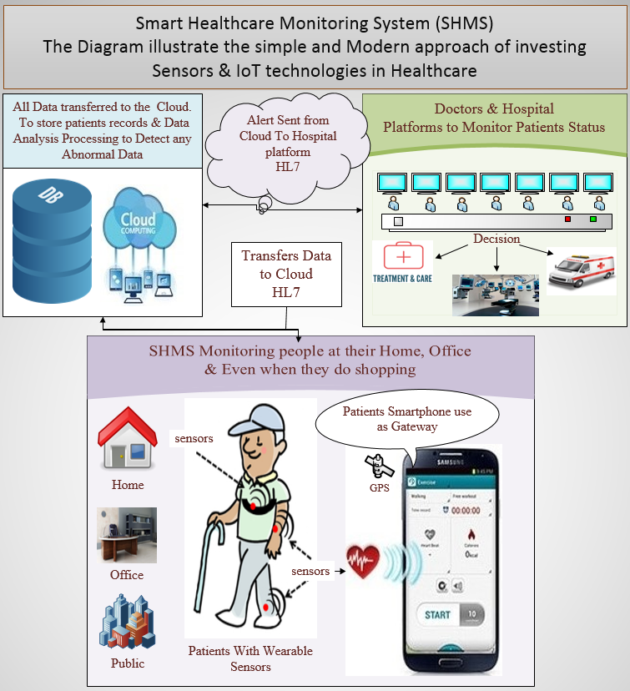
The Smart Healthcare Monitoring System (SHMS) is to improve the efficiency of healthcare in our modern society by providing more reliable and convenient healthcare system to patients. Successful implementation to this project could have the potential to protect people life, in addition to the significant drop of healthcare costs by reducing the clinical monitoring and emergency cases. SHMS is mainly to monitor physiological data gathered from patients and creating data record that will be stored in cloud databases, where it will be available for doctor use at any time in anywhere. The below diagram (Figure 1) represents the primary elements to develop in SHMS.
Figure 1: High-Level Overview of SHMS System Architecture

SHMS Business Object Notation (BON)
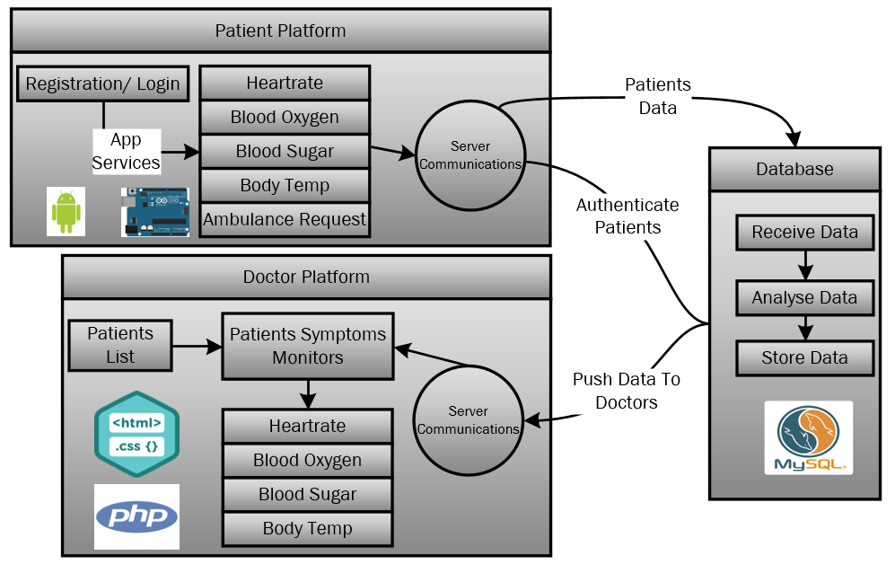
In this part of the design process, the system architecture constructed with the aid of BON diagram to get better understanding to the developed system. In (Figure 2) very simple and powerful diagram to represent the main stages of the system instructions.
Figure 2: BON Diagram

Patients System
The focus of the implantation is on patient’s side of the development; Therefore, Arduino UNO and few sensors are used to implement patients monitoring system. The following sections explain the main functionalities of this platform with few screenshots to the connectivity of the equipment’s.

Arduino and Heart Rate Sensor
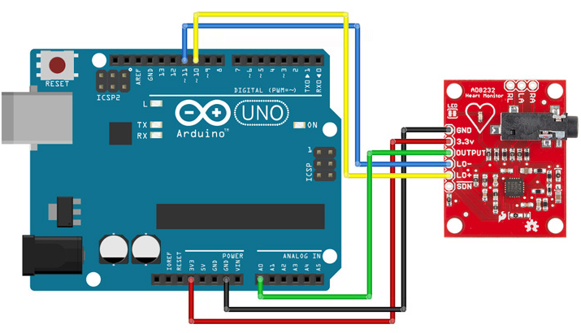
Heart Rate Sensor has been used to measure patient’s heartrate. Sensor measure heartrate through optical heartrate tool, the output data will be analogy data. Therefore, Arduino has been used with the pulse sensor to get the reading of the sensor. The following (Figure 4) shows the connections between the sensor and the Arduino UNO.
Figure 4: Heart Rate Sensor Connection

Pin Configuration of the sensor to the board is illustrated in the table below:
Board Label | Pin Function | Arduino Connection
GND | Ground | GND
3.3v | 3.3v Power Supply | 3.3v
OUTPUT | Output Signal | A0
LO- | Leads-off Detect – | 11
LO+ | Leads-off Detect + | 10
SDN | Shutdown | Not used

The Arduino code to receive and send sensor data written using Arduino Software (IDE). The programing language for the IDE is C/C++. The sensor data has some noise due to the low quality of the sensor has been use. However, some advanced code uses to avoid some of the noise. Nevertheless, the sensor result is not the focus of this system and/or the research as it is prototype to prove the concept of monitoring patients remotely. The output of the sensor will be plotted on the Arduino serial as per Figure 5 and 6
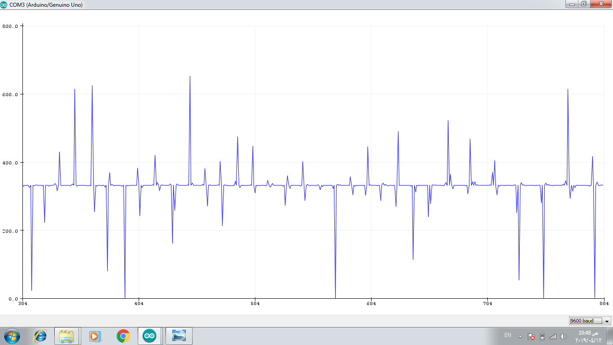

Figure 5: Heart rate monitoring via sensor
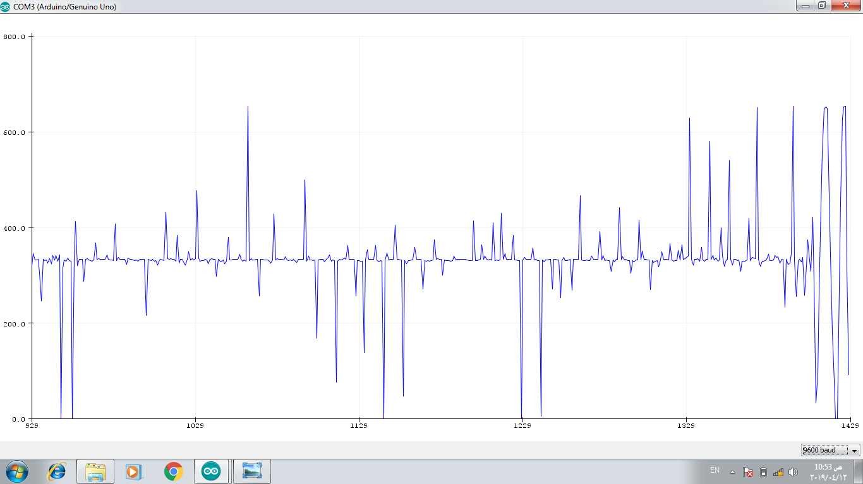

Figure 6: Heart rate monitoring via sensor

4.3.2. Arduino and Temperature Sensor
In this section we are going to interface the MLX90614 Module with Arduino UNO so that we can print the Object temperature and Ambient temperature of the place. The pins configuration of it is simple because it uses I2C communication system, which means that we are going to use 2 pins and after we supply a 3.3v connect the hardware as shown on the pictures Figure 16. The output of the temperature sensor shown in the Arduino serial as per Figure 7. And live representation as per Figure 8 and 9 and 10
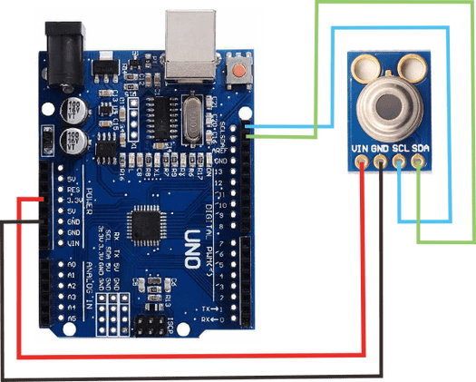

Figure 7: Temperature Sensor Connection

Figure 8: Reading the temperature in normal conditions

Figure 9: Read the degree of temperature when the source of heat is rounded
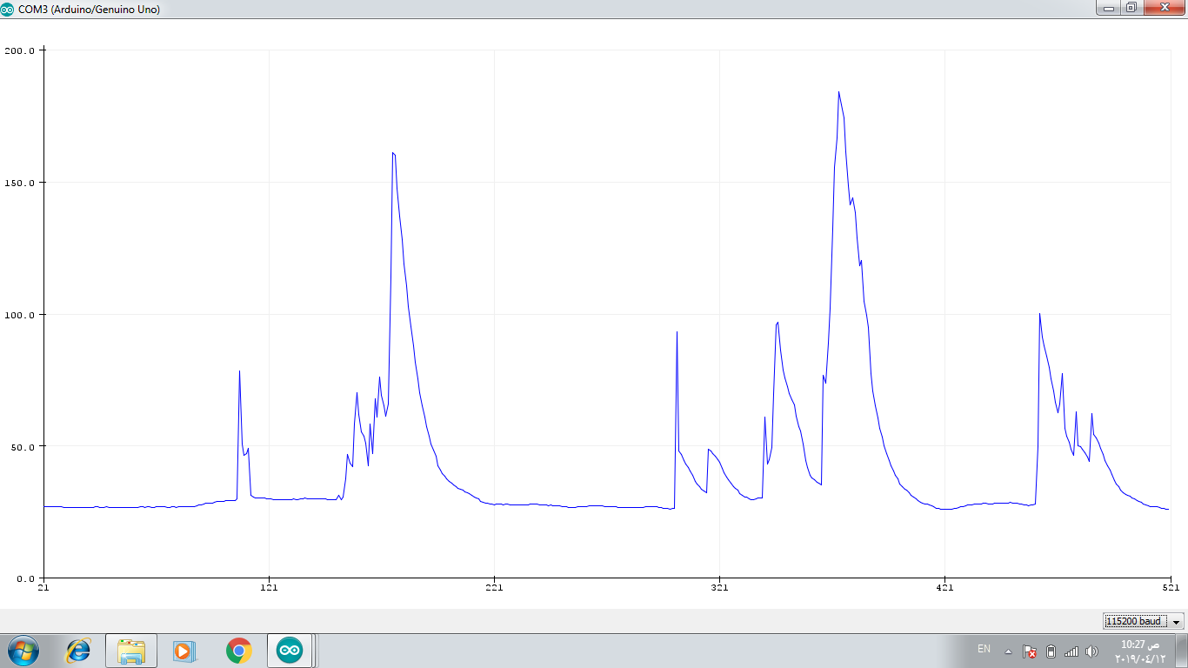
Figure 9: Temperature indicator In normal conditions, when the source of temperature is close we see the height of the indicator

Chapter 5: Conclusion & Future work

5.1.Conclusion
Investing in technologies that improving healthcare domain is growing field in both research and industry. Due to the growing population and the fact that our societies has growing aging societies that relies on the assisted living in their home and work, the traditional healthcare services and technology become very limited and cost effective compared to what new technologies are capable of. One could argue, that the reason behind this lies with the poor quality of healthcare provided in today’s society.
The smart healthcare monitoring system (SHMS) solution that has been proposed to meet the demand of producing an effective solution, which can highly contribute to provide older and disable people the comfortable environment to live independently without the fear of any emergency or critical healthcare situation. Briefly, the proposed prototype accumulate patient’s physiological data via wearable sensors and transmitted to cloud databases for data analysing and processing. Thus, any detection of disorder in patient’s data in the system will be report it to patient’s doctors and hospital. The testing clearly demonstrates that the proposed prototype for the SHMS was well implement, as system performance and outcomes was as expected.
Over all, despite the fact that many challenges occur during the project processes, the system were successfully carried and effectively produce SHMS prototype that meet the requirements of the research focus. Thus this healthcare solutions have a big future and it will have good impact on improve our living and life style significantly.

5.2.Future Work
Future developments and enhancements for the proposed system are wide, due to system requirements and performance. For instance, the system can be extended to monitor more than two symptoms for one patient, or apply an artificial intelligence and/or machine learning concepts to predict the best and ideal requirements for patients upon their previous data. Moreover, adding the flavours of artificial intelligence and machine learning to data analysis it will boost the performance of the decisions making process for systems by which it will help in found and predicting illness on its early stages.

References
[1] S. Patel, H. Park, P. Bonato, L. Chan, and M. Rodgers, "A review of wearable sensors and systems with application in rehabilitation," J Neuroeng Rehabil, vol. 9, p. 21, Apr 20 2012.
[2] P. Minh, Y. Mengistu, D. Ha Manh, and S. Weihua, "Cloud-Based Smart Home Environment (CoSHE) for home healthcare," in 2016 IEEE International Conference on Automation Science and Engineering (CASE), 2016, pp. 483-488.
[3] L. Chanhee, K. Taehun, and S. J. Hyun, "A data acquisition architecture for healthcare services in mobile sensor networks," in 2016 International Conference on Big Data and Smart Computing (BigComp), 2016, pp. 439-442.
[4] A. Dohr, R. Modre-Opsrian, M. Drobics, D. Hayn, and G. Schreier, "The Internet of Things for Ambient Assisted Living," in 2010 Seventh International Conference on Information Technology: New Generations, 2010, pp. 804-809.
[5] Y. Zhou, D. Vongsa, Y. Zhou, Z. Cheng, and L. Jing, "A Healthcare System for Detection and Analysis of Daily Activity Based on Wearable Sensor and Smartphone," in 2015 IEEE 12th Intl Conf on Ubiquitous Intelligence and Computing and 2015 IEEE 12th Intl Conf on Autonomic and Trusted Computing and 2015 IEEE 15th Intl Conf on Scalable Computing and Communications and Its Associated Workshops (UIC-ATC-ScalCom), 2015, pp. 1109-1114.
[6] M. S. D. Gupta, V. Patchava, and V. Menezes, "Healthcare based on IoT using Raspberry Pi," in 2015 International Conference on Green Computing and Internet of Things (ICGCIoT), 2015, pp. 796-799.
[7] S. Dudakiya, H. Galani, A. Shaikh, D. Thanki, R. A. Late, and S. E. Pawar, "Monitoring mobile patients using predictive analysis by data from wearable sensors," in 2016 International Conference on Electrical, Electronics, and Optimization Techniques (ICEEOT), 2016, pp. 332-335.
[8] M. Hassanalieragh et al., "Health Monitoring and Management Using Internet-of-Things (IoT) Sensing with Cloud-Based Processing: Opportunities and Challenges," in 2015 IEEE International Conference on Services Computing, 2015, pp. 285-292.
[9] D. Nienhold, R. Dornberger, and S. Korkut, "Sensor-Based Tracking and Big Data Processing of Patient Activities in Ambient Assisted Living," in 2016 IEEE International Conference on Healthcare Informatics (ICHI), 2016, pp. 473-482.
[10] M. Lan et al., "WANDA: an end-to-end remote health monitoring and analytics system for heart failure patients," presented at the Proceedings of the conference on Wireless Health, San Diego, California, 2012.
[11] L. Catarinucci et al., "An IoT-Aware Architecture for Smart Healthcare Systems," IEEE Internet of Things Journal, vol. 2, no. 6, pp. 515-526, 2015.
[12] P. Gupta, D. Agrawal, J. Chhabra, and P. K. Dhir, "IoT based smart healthcare kit," in 2016 International Conference on Computational Techniques in Information and Communication Technologies (ICCTICT), 2016, pp. 237-242.
[13] A. Pantelopoulos and N. G. Bourbakis, "A Survey on Wearable Sensor-Based Systems for Health Monitoring and Prognosis," IEEE Transactions on Systems, Man, and Cybernetics, Part C (Applications and Reviews), vol. 40, no. 1, pp. 1-12, 2010.
[14] J. Chauhan and S. Bojewar, "Sensor networks based healthcare monitoring system," in 2016 International Conference on Inventive Computation Technologies (ICICT), 2016, vol. 2, pp. 1-6.
[15] R. Kumar and M. P. Rajasekaran, "An IoT based patient monitoring system using raspberry Pi," in 2016 International Conference on Computing Technologies and Intelligent Data Engineering (ICCTIDE'16), 2016, pp. 1-4.
[16] A. M. Rahmani et al., "Smart e-Health Gateway: Bringing intelligence to Internet-of-Things based ubiquitous healthcare systems," in 2015 12th Annual IEEE Consumer Communications and Networking Conference (CCNC), 2015, pp. 826-834.
[17] T. N. Gia, M. Jiang, A. M. Rahmani, T. Westerlund, P. Liljeberg, and H. Tenhunen, "Fog Computing in Healthcare Internet of Things: A Case Study on ECG Feature Extraction," in 2015 IEEE International Conference on Computer and Information Technology; Ubiquitous Computing and Communications; Dependable, Autonomic and Secure Computing; Pervasive Intelligence and Computing, 2015, pp. 356-363.
[18] V. Shnayder, B.-r. Chen, K. Lorincz, T. R. F. F. Jones, and M. Welsh, "Sensor networks for medical care," presented at the Proceedings of the 3rd international conference on Embedded networked sensor systems, San Diego, California, USA, 2005.
[19] V. Casola, A. Castiglione, K. K. R. Choo, and C. Esposito, "Healthcare-Related Data in the Cloud: Challenges and Opportunities," IEEE Cloud Computing, vol. 3, no. 6, pp. 10-14, 2016.
[20] C. Esposito, A. Castiglione, and K. K. R. Choo, "Encryption-Based Solution for Data Sovereignty in Federated Clouds," IEEE Cloud Computing, vol. 3, no. 1, pp. 12-17, 2016.
[21] Y. Wang, D. Wang, and F. Chen, "Abnormal Behavior Detection Using Trajectory Analysis in Camera Sensor Networks," International Journal of Distributed Sensor Networks, vol. 10, no. 1, p. 839045, 2014.
[22] L. Mottola and G. P. Picco, "Programming wireless sensor networks: Fundamental concepts and state of the art," ACM Comput. Surv., vol. 43, no. 3, pp. 1-51, 2011.
[23] S. R. Madden, M. J. Franklin, J. M. Hellerstein, and W. Hong, "TinyDB: an acquisitional query processing system for sensor networks," ACM Trans. Database Syst., vol. 30, no. 1, pp. 122-173, 2005.
[24] E. Abe, H. Chigira, K. Fujiwarai, T. Yamakawa, and M. Kano, "Heart rate monitoring by a pulse sensor embedded game controller," in 2015 Asia-Pacific Signal and Information Processing Association Annual Summit and Conference (APSIPA), 2015, pp. 1266-1269.

