Abstract

The frequent availability of digital data such as audio, images and videos became possible to the public through the expansion of the internet. Digital watermarking technology is being adopted to ensure and facilitate data authentication, security and copyright protection of digital media. It is considered as the most important technology in today’s world, to prevent illegal copying of data. Digital watermarking can be applied to audio, video, text or images. This paper includes the detail study of watermarking definition and various watermarking applications and techniques used to enhance data security.
In the next search we will look at: What is the digital watermark, the digital watermark types, some of its most important applications, we show what DWT, we speak of the Matlab as the language used in this research we add watermark to a particular image .

Introduction

Digital watermarking is the act of hiding a message related to a digital signal (i.e. an image, song, video) within the signal itself. It is a concept closely related to steganography, in that they both hide a message inside a digital signal. However, what separates them is their goal. Watermarking tries to hide a message related to the actual content of the digital signal, while in steganography the digital signal has no relation to the message, and it is merely used as a cover to hide its existence. Watermarking has been around for several centuries, in the form of watermarks found initially in plain paper and subsequently in paper bills. However, the field of digital watermarking was only developed during the last 15 years and it is now being used for many different applications ⁽¹⁾ .

Digital watermarking

A digital watermark is a kind of marker covertly embedded in a noise-tolerant signal such as an audio, video or image data. It is typically used to identify ownership of the copyright of such signal. "Watermarking" is the process of hiding digital information in a carrier signal; the hidden information should, but does not need to, contain a relation to the carrier signal. Digital watermarks may be used to verify the authenticity or integrity of the carrier signal or to show the identity of its owners. It is prominently used for tracing copyright infringements and for banknote authentication .
Digital image watermarking techniques stand on embedding a host image with information which is called watermark, then the watermarked image will be transmitted, and can be extracted at the receiver. There are two kinds of detection types at the receiver. The first type is called blind watermarking, because the detector doesn’t need the original cover image to detect the watermark. The second type is called non-blind and it needs the original cover image to extract the watermark .
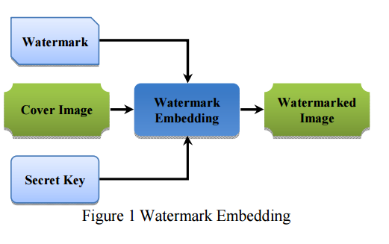
In Figure 1, which represents sender, the Watermark is embedded into the Cover Image with the Secret Key that ensures the security of watermarking process. The output is the Watermarked Image ⁽²⁾ .

Type of watermarking algorithm

There are mainly two types of watermarking algorithms: visible watermarking and invisible watermarking. For invisible watermarking, the watermark should be perceptually transparent and robustness. For visible watermarking, the watermark should be perceptually visible and robustness. The objectives of visible and invisible watermarks are summarized as table .
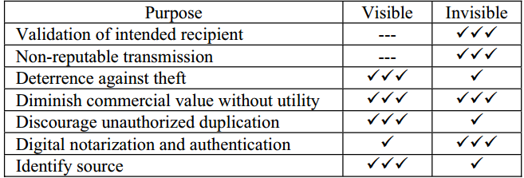
Visible watermarks V.S In visible Watermarks

In traditional visible watermarking and invisible watermarking, watermarking is performed by embedding a digital watermark signal into a digital host signal resulting in watermarked signal. Distortion is introduced into the host image during the embedding process and some applications, such as medical and military, are sensitive to the embedding distortion and prohibit permanent loss of signal visible watermarking causes greater distortion than that of invisible watermarking ⁽³⁾ .

Figure 2:visible watermark

Figure 3:Invisible watermark

Application

A - Copyright protection :
Digital watermarking can be used to identify and protect copyright ownership. Digital content can be embedded with watermarks depicting metadata identifying the copyright owners .
B - Broadcast monitoring :
Over the last few years, the number of television and radio channels delivering content has notably expanded. And the amount of content flowing through these media vehicles continues to grow exponentially. In this highly fragmented and fast changing market, knowing the real broadcast reality has become critical for content owners, copyright holders, distributors and broadcasters .
C - Fingerprinting :
Fingerprints are the characteristics of an object that tend to distinguish it from other small objects. As in the applications of copyright protection, the watermark for finger printing is used to trace authorized users who violate the license agreement and distribute the copyrighted material illegally. Thus, the information embedded in the content is usually about the customer such as customer's identification number .
D- Image and content authentication:

In an image authentication application the intent is to detect modifications to the data. The characteristics of the image, such as its edges, are embedded and compared with the current images for differences. A solution to this problem could be borrowed from cryptography, where digital signature has been studied as a message authentication method. One example of digital signature technology being used for image authentication is the trustworthy digital camera .
E- Document and Image security:
Consider documents and images that are generated in support of a major product launch. Corporate communications professionals face significant challenges in managing these assets through very complex sales and marketing channels. Images and documents are distributed to remote offices, agencies, distributors, dealers and more, and must be managed to ensure confidential information is not leaked before the launch date.
F- Communication of ownership and objects:
Digital content continues to proliferate as today's consumers seek information and entertainment on their computers, mobile phones and other digital devices. In our cyber culture, digital has become a primary means of communication and expression. The combination of access and new tools enables digital content to travel faster and further than ever before as it is uploaded, dispersed, viewed, downloaded, modified and repurposed at breathtaking speed. Whether you are a global media corporation or a freelance photographer, the ability to communicate your copyright ownership and usage rights is essential ⁽⁴⁾.

DWT In Digital Image Watermarking

Compared to spatial domain techniques ,frequency-domain watermarking techniques proved to be more effective with respect to achieving the imperceptibility and robustness requirements of digital watermarking algorithms . Commonly used frequency-domain transforms include the Discrete Wavelet Transform (DWT ) .
However, DWT has been used in digital image watermarking more frequently due to its excellent spatial localization and multi-resolution characteristics, which are similar to the theoretical models of the human visual system. Further performance improvements in DWT-based digital image watermarking algorithms could be obtained by increasing the level of DWT .
A discrete wavelet transform (DWT) is any wavelet transform for which the wavelets are discretely sampled . It is useful for processing of non-stationary signals. In transform small waves which are called wavelets of varying frequency and limited duration are used as mother wavelet .Wavelets are created by translations and dilations of a fixed function called mother wavelet. The DWT splits the signal into high and low frequency parts. The high frequency part contains information about the edge components, while the low frequency part is split again into high and low frequency parts. The high frequency components are usually used for watermarking since the human eye is less sensitive to changes in edges .
In two dimensional applications, for each level of decomposition, we first perform the DWT in the vertical direction, followed by the DWT in the horizontal direction. After the first level of decomposition there are 4 sub-bands: LL1, LH1, HL1, and HH1. For each successive level of decomposition, the LL sub band of the previous level is used as the input. To perform second level decomposition, the DWT is applied to LL1 To perform third level decomposition, the DWT is applied to LL2 band which decompose this band into the four sub-bands – LL3, LH3, HL3, HH3. This results in 10 sub-bands per component . LH1, HL1, and HH1 contain the highest frequency bands, while LL3 contains the lowest frequency band ⁽⁵⁾ .
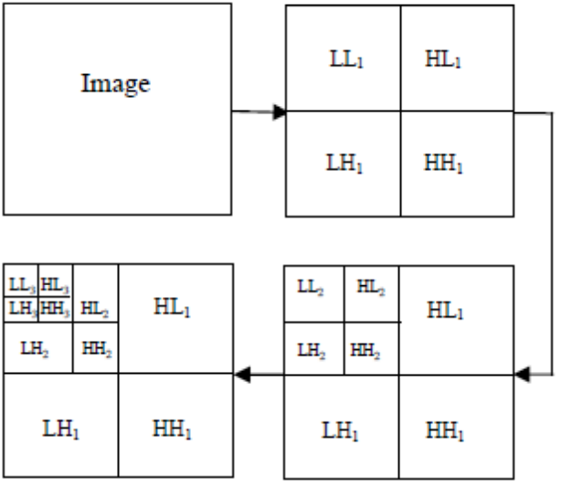
3 level DWT of IMAGE

The language used

The watermark is one of the applications that uses Matlab, but in the beginning we have to clarify what the Matlab is :
MATLAB is a high-performance language produced by Mathworks. It is one of the most important programming languages ​​used today and many of it is used for technical computing with strong commands and syntax. It is used for many purposes siiuch as mathematics and arithmetic, data analysis, algorithm development, modeling motivation and prototyping. Data analysis and image processing are some of the most important and fundamental topics in the watermark.
The name MATLAB stands for MATrix LABoratory. MATLAB was written originally to provide easy access to matrix software developed by the LINPACK (linear system package and EISPACK (Eigen system package) projects .
MATLAB is a high-performance language for technical computing. It integrates computation, visualization, and programming environment. Furthermore, MATLAB is a modern programming language environment: it has sophisticated data structures, contains built-in editing and debugging tools, and supports object-oriented programming. These factors make MATLAB an excellent tool for teaching and research .
MATLAB has many advantages compared to conventional computer languages (e.g).,(C, FORTRAN) for solving technical problems. MATLAB is an interactive system whose basic data element is an array that does not require dimensioning. The software package has been commercially available since 1984 and is now considered as a standard tool at most universities and industries worldwide .
It has powerful built-in routines that enable a very wide variety of computations. It also has easy to use graphics commands that make the visualization of results immediately available. Specific applications are collected in packages referred to as toolbox. There are toolboxes for signal processing, symbolic computation, control theory, simulation, optimization, and several other fields of applied science and engineering ⁽⁶⁾.

Watermark Embedding
In this process 2D DWT is performed on the cover image that decomposes the image into four sub-bands: low frequency approximation, high frequency diagonal, low frequency horizontal and low frequency vertical sub- bands. Similarly 2D DWT is performed on the watermark image that has to be embedded into the cover image. Here we have used Haar wavelet. The technique used for inserting watermark is alpha blending. The decomposed components of cover image and watermark are further multiplied by a particular scaling ⁽⁷⁾ .

Add watermark code

%input image is watermarked with a key having mean=0&variance=1
clc;
clear all;
close all;
img= imread('C:\Users\ali alfrazdak\Desktop\home.jpg'); %Get the input image
img= rgb2gray(img); %convert to gray scale image
img =double(img);
c =0.01; %Initiates the weight of watermarking
figure,imshow(uint8(img));title('Original Image');
[p q] =size(img); %Generate the key
n =awgn(img,4,3,'linear');
N =imabsdiff(n,img);
figure,imshow(double(N)),title('key');
[Lo_D,Hi_D,Lo_R,Hi_R] = wfilters('haar'); %optain the flters associated with haar
[nca,nch,cv,ncd] = dwt2(img,Lo_D,Hi_D); %compute 2D wavelet transfor
%Perform the watermarking
y = [ca nch;cv ncd];
Y = y + c*abs(y).*N;
p=p/2;q=q/2;
for i=1:p
for j=1:q
nca(i,j) = Y(i,j);
ncv(i,j) = Y(i+p,j);
nch(i,j) = Y(i,j+q);
ncd(i,j) = Y(i+p,j+q);
end
end
%Sisplay the watermarked image
wimg = idwt2(nca,nch,ncv,ncd,Lo_R,Hi_R);
figure,imshow(uint8(wimg));title('Watermarked Image');
diff = imabsdiff(wimg,img);
figure,imshow(double(diff)); title('Differences');

Automated code work

- We are entering the Matlab program .
- We enter the required image and the picture is the logo of the University of Qadisiyah.

The logo of the University of Qadisiyah
- The image is converted from colored to grayscale (a grayscale or greyscale image is one in which the value of each pixel is a single sample representing only an amount of light, that is, it carries only intensity information).
- give Initiates the weight of watermarking and a key ( whose existence is optional is either that Be Secret or Public ) .
- The Haar wavelet algorithm is applied to obtain a watermark image .
- The final figure shows the difference between the original image and the image using the watermark .
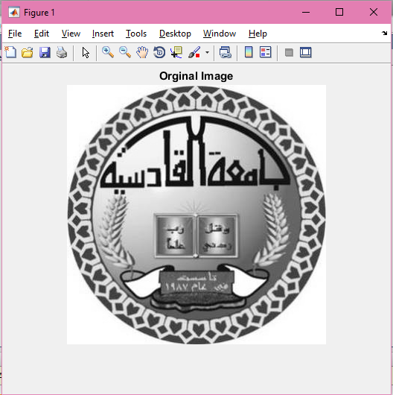

Original Image

Key

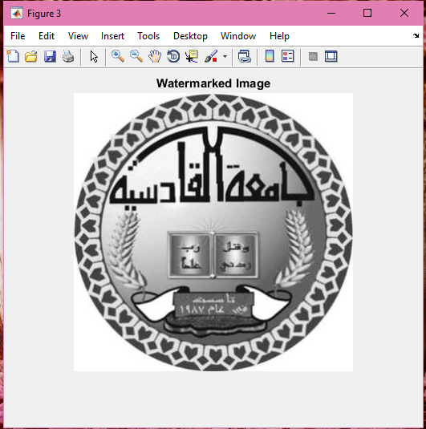

Watermarked Image

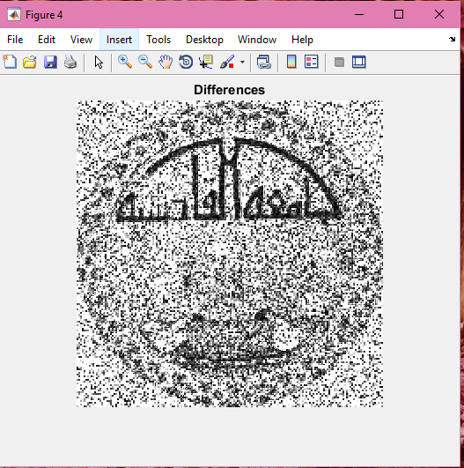

Differences

Sources

1- Introduction \ Digital Watermarking \ Melinos Averkiou . 2- Digital watermarking \ Properties of Digital Image Watermarking \ Mohammad Abdullatif , Akram M. Zeki, Jalel Chebil , Teddy Surya Gunawan \ 2013 IEEE 9th International Colloquium on Signal Processing and its Applications, 8 - 10 Mac. 2013, Kuala Lumpur, Malaysia .
- Type of watermarking algorithm \ Lossless Visible Watermarking \ Shu-Kei Yip, Oscar C. Au, Chi-Wang Ho, Hoi-Ming Wong , Department of Electrical and Electronic Engineering The Hong Kong University of Science and Technology Clear Water Bay, Hong Kong .
- Application \ Digital Watermarking Applications and Techniques \ Aaqib Rashid MCA (Kashmir University) M.Phil Computer Science (Dr). C.V Raman University\ International Journal of Computer Applications Technology and Research Volume 5–Issue 3, 147-150, 2016, ISSN:2319–8656 .
- DWT In Digital Image Watermarking\ Digital Watermarking Algorithm using DWT Technique \ Sumedh P. Ingale1, Prof. C. A. Dhote2 ¹Prof. Ram Meghe Institute Of Technology and Research, Badnera, Amravati Sant Gadgebaba Amravati University, Amravati, Maharashtra, India –444701 ²Prof. Ram Meghe Institute Of Technology and Research, Badnera, Amravati .Sant Gadgebaba Amravati University, Amravati, Maharashtra, India – 444701 \ IJCSMC, Vol. 5, Issue. 5, May 2016, pg.01 – 09 .
- The language used \ INTRODUCTION TO MATLAB FOR ENGINEERING STUDENTS \ David Houcque Northwestern University \ (version 1.2, August 2005 ) .
- Watermark Embedding \ INTRODUCTION TO MATLAB FOR ENGINEERING STUDENTS \ David Houcque Northwestern University \ (version 1.2, August 2005 ) .

Conclusion

Watermark – An image, a logo or a content which is inserted on a photo for a thought process to get it secure, upgrade marking, speak to trademark and additionally organization name behind it .
It is the most widely recognized approach to get your photographs ensured while posted online and the most advantageous and demonstrated approach to step up your organization marking by variation your watermark in organization name, logo, trademark, copyright .
Matlab was used as the software language and the Matlab language is the high-performance language of technical calculations, combining guesswork and programming in an easy-to-use environment . Learn English in mathematics, mathematics, science in industry, MATLAB is a method of choice for high-speed, rapid development and analysis .

Index
Abstract 1

Introduction 2
Digital watermarking 2
Type of watermarking algorithm 3
Application 5
DWT In Digital Image Watermarking 7
The language used 8

Watermark Embedding 10
Add watermark code 10
Automated code work 11
Sources 15
Conclusion 16

