Environmentally Friendly Preparation of Zinc Oxide, Study Catalytic Performance of Photodegradation by Sunlight for Rhodamine B dye
Muhammed A. Al bedairy¹* Hassan A. Habeeb Alshamsi²
¹Department of Chemistry, College of Education, University of Al-Qadisiyah, Diwaniya, Iraq
²Department of Chemistry, College of Education, University of Al-Qadisiyah, Diwaniya, Iraq
Email: muhammadchem87@gmail.com ; Tel. +9647716777886,

ABSTRACT:
This study includes the photocatalytic degradation of Rhodamine B (Rh.B) employing a heterogeneous photocatalytic process by using ZnO nanoparticles that was prepared by green sol-gel process .The structural, morphological, and its optical properties of ZnO Photocatalyst was studied using different characterization techniques such as X-ray diffraction (XRD), field emission scanning electron microscopy (FE-SEM), The influencing factors studied were the amount of the catalyst, the concentration of dye and pH on photocatalytic degradation of Rhodamine B. The experiments were carried out by irradiating the aqueous solutions of dyes containing photocatalysts with Sunlight. The rate of decolorization was estimated from residual concentration spectrophotometrically. Similar experiments were carried out by varying pH (3–11), amount of catalyst (0.25–2.0 g/L) and initial concentration of dye (5–50 mg/L). The experimental results indicated that the maximum degradation (71%) of dyes was achieved using ZnO photocatalyst at pH 10 after 240 min.
KEYWORDS:
Environmentally friendly, ZnO, Photodegradation, Rhodamine B, Sunlight
INTRODUCTION:
Pollution problem is getting worse day by day, so Researchers are looking for ways to get rid of this problem. Among the most common contaminants are dissolved dyes in industrial wastewater from textile¹ and paper mills². Synthetic dyes are extensively used for dyeing and printing in textile industries. Over 10,000 dyes with an once a year production over 10⁵ metric tons worldwide are commercially available and about 50% among them are azo dyes³. It is estimated that approximately 15% of the dyestuffs are lost in the industrial effluents during manufacturing and processing operations⁴. Color is usually the first contaminant to be recognized in wastewater. Many dyes may be decomposed into potential oncogenic amines under anaerobic conditions in the environment⁵. There are many ways for pollutant elimination such as adsorption on activated carbon⁶, reverse osmosis ⁷, ultrafiltration ⁸, and ozonation ⁹ etc. Photodegradation is also one of the most important technologies used in the disposal of pollutants in industrial wastewater. Researchers want to use natural resources available to obtain the energy needed for the degradation of dyes in industrial wastewater, the most important source of natural energy is sunlight that consists of about 5–7% UV light, 46% visible light and 47% infrared radiation¹⁰. Photocatalytic oxidation of various harmful organic dyes in industrial wastewater has been carried over ZnO semiconductor oxides under UV light irradiation¹¹. Research is now focused on to achieve high photocatalytic efficiency with ZnO¹² especially with sunlight. Zinc oxide can be prepared in more than one way, each method has its own conditions that determine product characteristics, preferably use environmentally friendly methods. Green chemistry is generally accepted as “the design, development, and implementation of chemical processes and products to reduce or eliminate substances hazardous to human health and the environment” ¹³. There has been an explosive growth in the field of green chemistry both in preparing green Nanocatalysts ¹⁴ as well as green conditions during catalysis of industrially important reactions. Preparing green Nanocatalysts refers to manufacturing the nanocatalysts using green solvents or processing the nanocatalysts so that they are finally dispersed in green solvents. Green nanocatalysis refers to doing the catalytic reaction in green solvents and rather by the use of green nanocatalysts for these reactions¹⁵. According to the fourth principle of Anastas’ and Warner’s 12 principles of green chemistry "Chemical products should be designed to preserve efficacy of function while reducing toxicity,”¹⁶, should of course also be applied to the synthesis of Nanocatalysts ¹⁷. This is typified by the synthesis of nontoxic ZnO nanoparticle catalysts^{18,19}.
MATERIAL AND METHODS:
Materials
Zinc acetate, potassium hydroxide were obtained from B.D.H Company, Rhodamine B dye, were supplied from Sigma-Aldrich. All materials were used directly without further purification.
Instruments
UV-vis spectrophotometer double beam PC 1650 SHIMADZU, UV-vis spectrophotometer 780 Sunny China, The crystalline character of the solid has been identified by X-ray diffraction (XRD) analysis using a D/Max 2,550 V diffractometer with Cu Kα radiation (λ = 1.54056 Å) ( Japan), and the XRD data were collected at a scanning rate of 0.03 s^{–1} for 2θ in a range from 10° to 80°, The morphology of prepared materials was noted by field emission scanning electron microscopy (FE-SEM ) with (MIRA3 TESCAN - Czech), The optical band gap Eg was projected from the UV-Vis-NIR diffuse reflectance spectroscopic (UV-Vis-NIR DRS) determined in a wavelength range from (200 - 1100) nm with UV-1800 UV-VIS Spectrophotometer from SHIMADZU, pH meter (Sartorius, Germany), 100 mL Teflon-lined autoclave.
Preparation of ZnO
In a typical synthesis, of ZnO nanoparticles is carried out by sol-gel process, at 80-90Cº. Solution of zinc acetate Zn(CH₃COO)₂ was prepared by dissolving 2.195 g of zinc acetate in 100ml distilled water, and stirred in ambient atmosphere. Potassium hydroxide KOH 1.122g is dissolved in 10 ml distilled water and was added to the above solution drop wise under continuous stirring. After few minutes solution turn into jelly form and a milky white solution was obtained, the mixture was then further heated for 3 h at 80-90Cº without stirring. The resulting suspension was centrifuged to retrieve the product, and the mixture was washed with distilled water and then the powder was dried at 70 Cº overnight and determined in terms of their structural, morphology and optical properties ^{20,21}.
Photo-catalytic Degradation Experiment
ZnO was added to 100 ml of Rhodamine-B dye solution and it is undergo irradiation by sunlight. After adding the catalyst and stirrer it at a constant speed. The samples were taken at different times. Before the irradiation, the dye catalyst suspension was kept in the dark with steering for 90 min to ensure an adsorption-desorption equilibrium. The solution was separated from the catalyst by the centrifuge. Measure the absorbance of each sample, absorption spectra were recorded and rate of decolorization was seen as far as change in power at λ_{max} of the colors. The decolonization efficiency has been ascertained as equation 1:
$Efficiency \left(\%\right)=\frac{C_{o}-C}{C_{o}}X100\%$ …………………………… (1)
Where C_{o} is the initial concentration of dye and C is the concentration of dye after photo irradiation. Similar experiments were carried out by varying the pH of the solution (pH 3-11), concentration of dye (10 - 100 mg/L) and catalyst loading (0.25-2.0 g/L), pH of aqueous solution was adjusted with 0.1M H₂SO₄ or 0.1M NaOH.

RESULT AND DISCUSSION
X-ray diffraction
XRD pattern of synthesized ZnO nanostructures by sol-gel reaction at 90°C is shown in Figure (1) All peaks of the obtained product are corresponding to the cubic structure of ZnO reported in many research works ²¹⁻²³. The detected peaks are at 2θ values of 32.0253, 34.6686, 36.4966, 47.7734, 56.8286 and 63.0893 corresponding to the following lattice planes: (100), (002), (101), (102), (110) and (103) respectively.

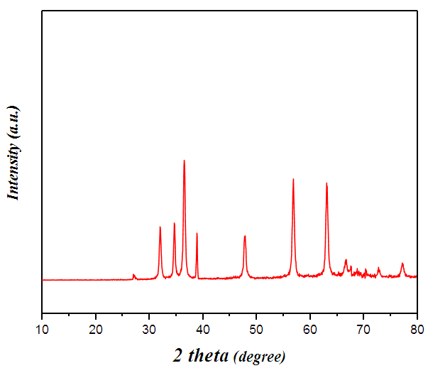
Fig.1: . X-rays diffraction spectra of ZnO nanocrystals

FE-SEM
The surface morphology of catalyst is one of the important parameters that impact on the photocatalytic efficiency. the nanoparticles were investigated by FE-SEM image as shown in Figure (2) The FE-SEM images shows that the ZnO particles were formed in a very uniform manner in the form of cubes and a few of them appeared spherically.

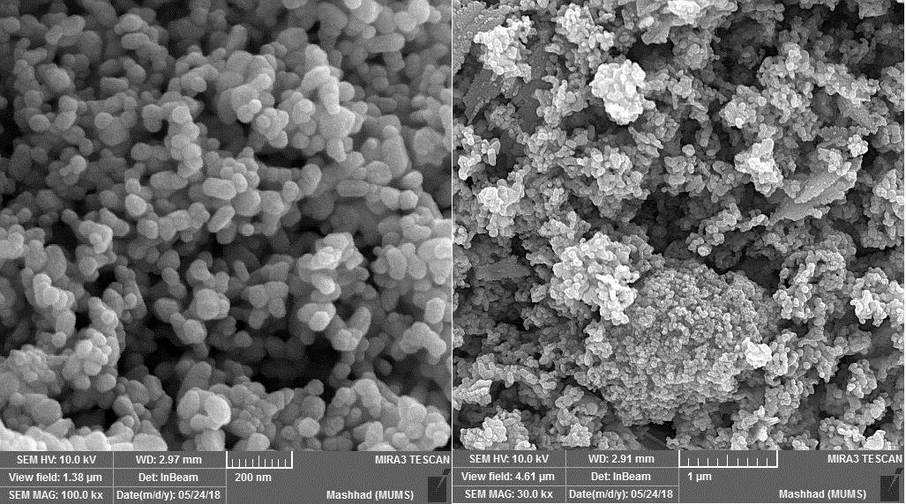

Fig.2: FE-SEM image of ZnO nanoparticles.

UV–vis diffuse reflectance spectra (DRS)
The properties of semiconductor nanoparticles are strongly size dependent. It is well known that the nano-scale systems show interesting properties, for example, increasing of the semiconductor band gap due to electron confinement ²⁴. The UV-vis diffuse reflectance, (Tauc’s plot) of synthesized ZnO was shown in Figure (3), The calculated band gap energy for synthesized ZnO is 3.39 eV, The determination of optical band gap is obtained by Tauc’s equation ²⁵.

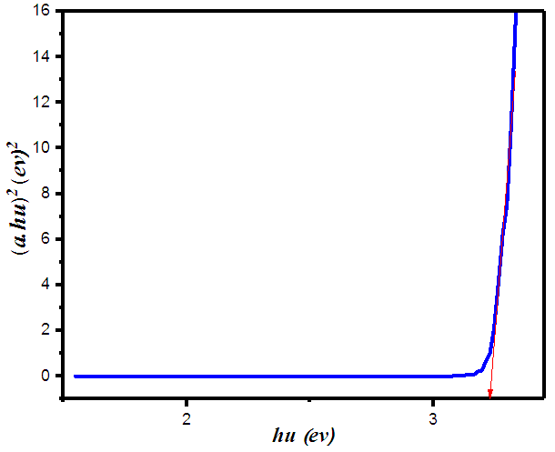
Fig. 3: band gape energy (Tauc’s plot) of ZnO.

Decolorization of dye by ZnO photocatalyst:

Adsorption of the dyes on ZnO-photocatalyst
Degradation of the dyes occurs predominantly on the photocatalyst surface ²⁶. In order to investigate the adsorption behavior of Rhodamine B, the suspension was prepared by mixing 100 ml of dye solutions 20 mg/L with fixed photocatalyst ZnO amount (1 g/L) at 35 C°, natural pH of Rhodamine B. The suspensions were kept for different times in the dark under shaking for 120 min. The absorbance measured at the $λ$_{max}553 nm to determine the concentration of dyes. The experimental results are shown in Figure (4) from the results, it was noticed that the adsorption equilibrium under 20 mg/L initial concentration was reached at about 60 min of equilibration time.
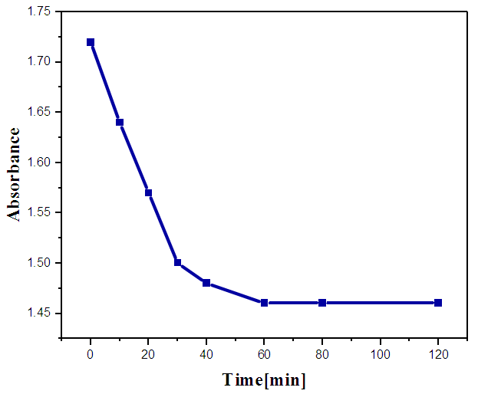
Fig.4 : Time of adsorption equilibrium ((dye concentration 20 mg/L and catalyst amount 0.8 g/L, 35C°)

Photocatalyst loading
The experiments were carried out by varying ZnO photocatalyst amount from 0.25 to 2.0 g/L for dye solutions of 20 mg/L at natural pH of Rhodamine B. The decolorization efficiency for various photocatalysts amount for Rhodamine B has been depicted in Figure (5). It is observed that rate increases with increase in catalyst amount and becomes constant above a certain level then will be decreased . The optimum photocatalyst amount for decolorization efficiency of dye is 0.8 g/L. The reasons for this decrease in decolorization efficiency at given time it aggregation of catalyst particles at high concentrations causing a decrease in the number of surface active sites ^{27,28} and increase in light scattering of catalyst particles to decrease in the passage of irradiation through the sample ^{29,30}.

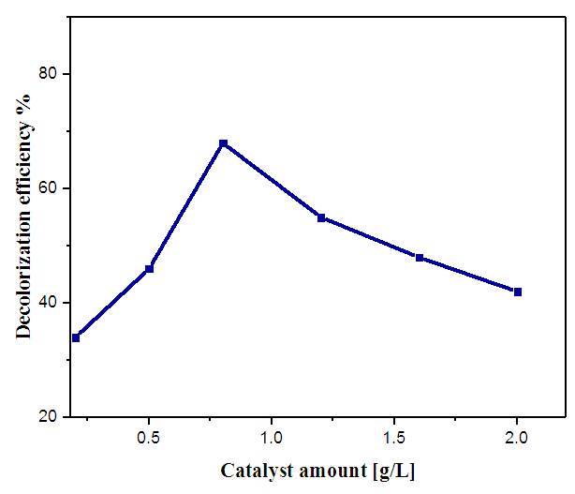
Fig.5 : Effect of catalyst dose on decolorization efficiency (dye concentration 20mg/L, natural pH, irradiation time 240 min, 35C°)

Effect of pH
Wastewater containing dyes at different pH therefore it is important to study the effect of pH on degradation efficiency of dye ²⁹, the amphoteric behavior of most semiconductor oxides influences the surface charge of the photocatalyst ³¹. The effect of pH values on the degradation efficiency is studied in the pH range 3–11 at the dye concentration 20 mg/L and catalyst amount 0.8 g/L, 35C°. Figure (6) illustrated the results of the decolorization efficiency after 240 min irradiation with different pH values (3,5,7,9 and11) It can be observe increase in the decolorization efficiency of Rhodamine B with increase of the pH value from 3 up to 11, exhibiting maximum efficiency at pH 10, This behavior could be explained by pH_{pzc} of the material, as well as the molecular nature of the dyes, the zero point charge of ZnO equal to 9.0, Therefore photocatalysts surface is positively charged below pH_{zpc}, whereas it is negatively charged when pH > pH_{zp}.

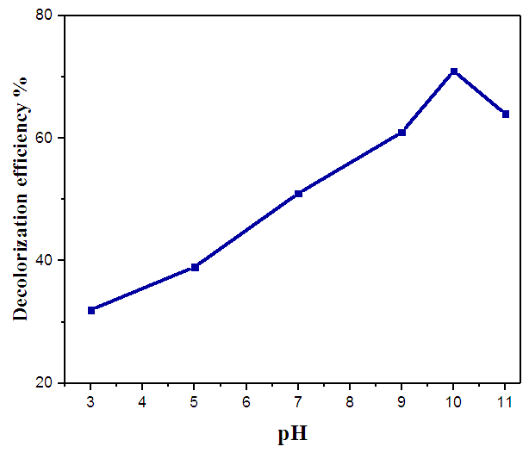
Fig.6: Effect of pH (dye concentration 20 mg/L, catalyst amount 0.8g/L, irradiation time 240 min, 35C°)

Effect of initial dye concentration
The results reported that the initial dye concentration effects the degradation efficiency strictly. With the increase of initial dye concentration, the degradation efficiency decreases remarkably ²⁷. The negative effects of the initial dye concentration are attributed to the competency between dye and OH⁻ ion adsorption on the surface of catalyst. The adsorption of dye reduces the OH⁻ ion adsorption, which results in the reduction on the formation of hydroxyl radicals ³². The rate of degradation relates to formation of OH radicals, which is the critical species in the degradation process. At the same time, as the initial dye concentration increases, the path length of photons entering the solution decreases ³³. Hence in the solution with constant catalyst concentration, the formation of hydroxyl radicals that can attack the pollutants decreases, thus leading to the lower decolorization efficiency. Figure (7) shows the effect of initial dye concentration on degradation efficiency by varying the initial concentration from 5 to 50 mg/L with the constant ZnO catalyst loading (0.8 g/L) and pH 10.
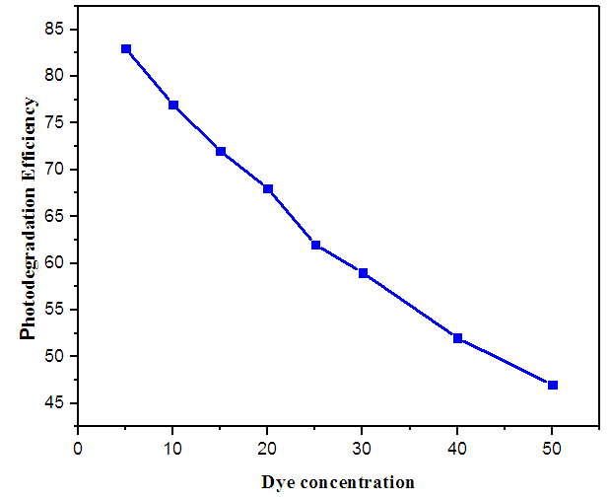
Fig. 7: Effect of dye concentration on decolorization efficiency (catalyst dose 0.8 g/L, pH 10, irradiation time 240 min , 35C°)

Kinetic of photodegradation
Figure (8) shows a typical UV-Vis spectrum of Rhodamine B solution during photo-irradiation time (dye conc.10 ppm, pH10, catalyst amount 0.8 g/L, T= 308K°). The absorption peaks, corresponding to dye, diminished and finally disappeared under reaction which indicated that the dye had been degraded. No new absorption bands appear in the visible region. The spectrum of Rhodamine B in the visible region exhibits a main band with a maximum at 553 nm. Figure (9) shows the kinetics of disappearance of Rhodamine B for an initial concentration of 20 ppm at pH10, catalyst amount 0.8 g/L. The results show that the photodegradation of the dye in aqueous ZnO can be described by the first order kinetic model, ln(C₀/C) = kt, where C₀ is the initial concentration and C is the concentration at any time, t. The semi logarithmic plots of the concentration data give a straight line.

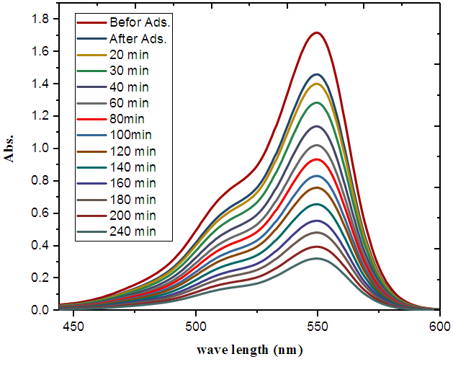
Fig.8: Absorption spectra of aqueous solution of Rhodamine B at different times (catalyst amount 0.8g/L, dye conc. 20 ppm, pH 10, T= 308K°)

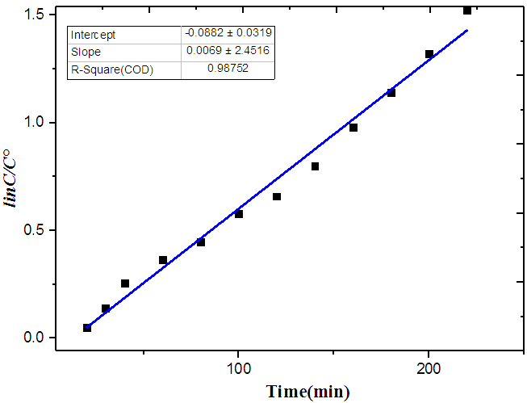
Fig.9: Kinetic analysis of Rhodamine B under optimized conditions (catalyst amount 0.8g/L, dye conc. 20mg/L, pH 10, T= 308K°)

CONCLUSION
In this study, Photocatalytic degradation of Rhodamine B dye has been investigated using ZnO photocatalyst. The following conclusions have been obtained about photodegradation:

- Photocatalytic degradation process is more suitable for low concentration of the pollutants.
- Photocatalytic degradation process is more suitable with low concentration of photocatalyst.
- Photocatalytic degradation process is more suitable with pH more than 9.

REFRANCES
1. Poulios I, Tsachpinis I. Photodegradation of the textile dye Reactive Black 5 in the presence of semiconducting oxides. Journal of Chemical Technology & Biotechnology: International Research in Process, Environmental & Clean Technology. 1999;74(4):349-357.
2. Greenwood D. Water-soluble non-reactive triazinyl mono-azo dye for ink jet printing. Google Patents; 1988.
3. Bauer C, Jacques P, Kalt A. Photooxidation of an azo dye induced by visible light incident on the surface of TiO2. Journal of Photochemistry and Photobiology A: Chemistry. 2001;140(1):87-92.
4. Reife A, Reife A, Freeman HS. Environmental chemistry of dyes and pigments. John Wiley & Sons; 1996.
5. Stylidi M, Kondarides DI, Verykios XE. Pathways of solar light-induced photocatalytic degradation of azo dyes in aqueous TiO2 suspensions. Applied Catalysis B: Environmental. 2003;40(4):271-286.
6. Namasivayam C, Kavitha D. Removal of Congo Red from water by adsorption onto activated carbon prepared from coir pith, an agricultural solid waste. Dyes and pigments. 2002;54(1):47-58.
7. Nataraj S, Hosamani K, Aminabhavi T. Nanofiltration and reverse osmosis thin film composite membrane module for the removal of dye and salts from the simulated mixtures. Desalination. 2009;249(1):12-17.
8. Purkait M, DasGupta S, De S. Removal of dye from wastewater using micellar-enhanced ultrafiltration and recovery of surfactant. Separation and purification Technology. 2004;37(1):81-92.
9. Koch M, Yediler A, Lienert D, Insel G, Kettrup A. Ozonation of hydrolyzed azo dye reactive yellow 84 (CI). Chemosphere. 2002;46(1):109-113.
10. Rehman S, Ullah R, Butt A, Gohar N. Strategies of making TiO2 and ZnO visible light active. Journal of hazardous materials. 2009;170(2-3):560-569.
11. Akyol A, Bayramoğlu M. Photocatalytic degradation of Remazol Red F3B using ZnO catalyst. Journal of Hazardous Materials. 2005;124(1-3):241-246.
12. Alshamsi HA, Chessab AM. Photo Catalytic Degradation of Reactive Blue 4 Dye using Hydrothermal Synthesized ZnO Nanoparticles. Journal of Global Pharma Technology. 2018.
13. Anastas PT, Warner JC. Green chemistry: theory and practice. Green chemistry: theory and practice: Oxford University Press; 2000.
14. Glaser JA. Green chemistry with nanocatalysts. Springer; 2012.
15. Narayanan R. Synthesis of green nanocatalysts and industrially important green reactions. Green Chemistry Letters and Reviews. 2012;5(4):707-725.
16. Anastas PT, Warner JC. Green chemistry: theory and practice. Vol 30: Oxford university press Oxford; 2000.
17. Eckelman MJ, Zimmerman JB, Anastas PT. Toward green nano: E‐factor analysis of several nanomaterial syntheses. Journal of Industrial Ecology. 2008;12(3):316-328.
18. Alshamsi HA, Hussien BS. Hydrothermal Preparation of Silver Doping Zinc Oxide Nanoparticles: Studys, Characterization and Photocatalytic Activity.
19. Mirjafary Z, Saeidian H, Sadeghi A, Moghaddam FM. ZnO nanoparticles: An efficient nanocatalyst for the synthesis of β-acetamido ketones/esters via a multi-component reaction. Catalysis Communications. 2008;9(2):299-306.
20. Ashtaputre SS, Deshpande A, Marathe S, et al. Synthesis and analysis of ZnO and CdSe nanoparticles. Pramana. 2005;65(4):615-620.
21. Bhakat C, Singh PP. Zinc oxide nanorods: synthesis and its applications in solar cell. Int J Mod Eng Res. 2012;2:2452-2454.
22. Ramimoghadam D, Hussein MZB, Taufiq-Yap YH. Synthesis and characterization of ZnO nanostructures using palm olein as biotemplate. Chemistry Central Journal. 2013;7(1):71.
23. Lepot N, Van Bael M, Van den Rul H, et al. Synthesis of ZnO nanorods from aqueous solution. Materials Letters. 2007;61(13):2624-2627.
24. Brus L. Quantum crystallites and nonlinear optics. Applied Physics A. 1991;53(6):465-474.
25. Tumuluri A, Naidu KL, Raju KJ. Band gap determination using Tauc’s plot for LiNbO3 thin films. Int. J. Chem. Tech. Res. 2014;6(6):3353-3356.
26. Chakrabarti S, Dutta BK. Photocatalytic degradation of model textile dyes in wastewater using ZnO as semiconductor catalyst. Journal of hazardous materials. 2004;112(3):269-278.
27. Mijin D, Radivojević J, Jovančić P. Photocatalytic degradation of textile dye CI Basic Yellow 28 in water by UV-A/TiO2. Chemical Industry and Chemical Engineering Quarterly. 2007;13(1):33-37.
28. Melo R, Neto EB, Moura M, Dantas TC, Neto AD, Oliveira H. Removal of direct Yellow 27 dye using animal fat and vegetable oil-based surfactant. Journal of Water Process Engineering. 2015;7:196-202.
29. Kansal S, Singh M, Sud D. Studies on photodegradation of two commercial dyes in aqueous phase using different photocatalysts. Journal of hazardous materials. 2007;141(3):581-590.
30. Daneshvar N, Salari D, Khataee A. Photocatalytic degradation of azo dye acid red 14 in water on ZnO as an alternative catalyst to TiO2. Journal of photochemistry and photobiology A: chemistry. 2004;162(2-3):317-322.
31. Filipponi L, Sutherland D. Nanotechnologies: principles, applications, implications and hands-on activities. Publications Office of the European Union, Luxembourg. 2013.
32. Regulska E, Małgorzata Bruś D, Karpińska J. Photocatalytic decolourization of direct yellow 9 on titanium and zinc oxides. International Journal of Photoenergy. 2013;2013.
33. Pouretedal H, Kadkhodaie A. Synthetic CeO2 nanoparticle catalysis of methylene blue photodegradation: kinetics and mechanism. Chinese Journal of Catalysis. 2010;31(11-12):1328-1334.

