Medical Image Processing

**1**

Chapter one

**1.1 Introduction**

Image processing is concerned with the development and use of mechanisms and algorithms for processing digital images. The objectives of image processing vary widely, the most important of which will be discussed briefly in this post. The process of processing images is one of the building blocks and pillars of the vision of the computer, where the primary treatments are done as the improvement of the image or the proportion of the important parts of them or extract the characteristics of them before embarking on subsequent processes, such as the recognition of goals in the image or measurement sizes.

Instants of images provide efficient local descriptors and have been used extensively in image study applications. Instants are able to provide invariant measures of form. The search indicates to use many processing operations on MRI brain scan to detect Brine Cancer by de-noise, limits and observe any different changes occur in Brain form and size.

This is referring to improve image quality, increase visibility of details, help in the diagnostic and accurate information in medical case [1].

Digital medical photos a digital image that is very similar to the images we take every day, regardless of how we get it. All that applies to the digital image applies to the medical image with the difference that the errors of algorithms in the medical field may lead to the patient is life. Importance of medical images: -

* Removal of the need for diagnostic surgery prior to therapeutic surgery.
* Early detection of tumors.
* Assistance for early detection of diseases and accurate diagnosis.
* Surgery assistance (tumor removal).

Medical image processing is the more the challenge and emerging jurisdiction now a day. processing of MRI image is one of the part of this specialization. The proposed strategy to detect & extraction of brain tumor from patients MRI scan images of the brain. This style includes with some noise remove jobs, segmentation and morphological processes which are the basic concepts of image processing. Detection and extraction of tumor from MRI clear images of the brain this is complete by using MATLAB software [2]. Image processing has gained an important role in the medical specialization, which has become the importance of increasing in medical diagnosis, where there are medical imaging techniques, including: -

1. Computerizeal tomography (ct) x_ray.
2. Ultrasound.
3. Digital x_ray angigraphy (dsa) x.
4. functional magnetic resonance imaging (fmri). and magnetic resonance imaging (mr).

We will use only the (MRI) technique. The (MRI) That imaging magnetic resonance imaging measures water or photon density in tissues and for EEG imaging PET images from MR images can be recorded for the same form to obtain physiological information regarding anatomical structures. Medical image processing is one of the most important topics in image processing. fragmentation of medical images is the main and difficult task of any medical image system that helps specialists make difficult medical decisions. Medical images taken from medical devices contain noise and are not fully accurate, so the image processing principles were used to remove noise from processed images [3]. Figure (1.1**)** is show Magnetic Resonance Imaging.



Figure (1.1): Magnetic Resonance Imaging.

**1.2** Aim Of Project

The main aim of this project is to detect and segment the tumor part from human brain to be easy for specialist as a doctor to use it as tools to help them. One of the medical imaging applications is segmentation of tumor part and diagnosis. as it requires the use of the computer In this process the accuracy is high as it relates to human life, as well as its great use in medical institutions for being Human diagnostics greatly improve especially since the error rate should be as low as possible, and this improvement results from The double vision of medical images leads to a better diagnosis of tumor, but the double Images are very expensive, so having good software, which helps doctors in medical institutions, is an urgent need Special days. The aim of this study is to propose an innovative way to detect brain tumors in magnetic resonance imaging images application design capable of handling high-noise images by de noise that are described as complex So a program that is able to overcome these difficulties, enables the doctor to see healthier, clearer images Which improves the performance of automated diagnostics and its overall reliability.

Image Segmentation

**2**

Chapter Two

**2.1 Introduction**

In the last years, the progress in information technology and telecommunications have acts as motivational methods or methods for significant updates in the department of health care. These technological progressions have had a particularly strong impact in the of specialization medical imaging, where film radiographic techniques are gradually being creation by digital imaging methods, and this has submitted pushing force to the update of integrated hospital information systems and integrated tele radiology services networks which support the digital transmission, storage, retrieval, analysis, and translation of distributed multimedia patient records .One of the many added-value services that can be submitted over an integrated tele radiology services network is being able to high-performance computing facilities in order to execute computationally intensive image analysis and visualization business.

In this project, a method was proposed to divide brain images and locate tumors in brain images. It is a suggested method with a set of steps to find the different sections from the rest of the image clips. Then perform some initial operations to create the image and insert it into an algorithm. The process is done by converting it to a grayscale image. The image is then conversion to a binary image. The result of this method is that the algorithm is able to classify the MRI images into healthy and unhealthy images (which has a tumor). The proposed singular value decomposition method proved that it is sensitive to the changes into the MR images and produce good result in classification of the human brain MR images. the sensitivity, specificity and accuracy is also developed. the future work is to increase the SVD classification accuracy by increasing the training database. The method of treatment that is done on the images of the magnetic resonance of the brain and the discovery of brain cancer by observing and determining any significant change in the shape and size of the natural brain. this is done by comparing the image entered with the natural image of the size of the brain. In mismatch, processes. Including the removal of impurities using filter filters. Then the sections are classified for the purpose of extracting features from them and comparing them with the original image and determine the location of the tumor. The single value decomposition method (SVD) provides speed and ease, and this indicates improved image quality, increased clarity of details that assist in diagnosis, and accurate information in medical care.

Start

MRI image

Preprocessing

Tumor segmentation

Algorithms

Threshold

Watershed

End

Figure (2.1): flow chart of MRI segmentation .

We will flow this strut as shown in figure (2.1) as a project flowchart starting from preprocessing and Tumor segmentation and Algorithms for MRI image.

**2.2** Image Segmentation

Image Segmentation Is the process of dividing image into several parts. This is typically used to identify objects or other relevant information in digital image. There are many different ways to perform image segmentation That include: -

1. Threshold methods such as 0tsu's I.
2. Color _based segmentation such as K-means clustering.
3. Transform methods such as watershed segmentation.
4. Texture method such as texture filters.

An effective approach to performing image segmentation includes using algorithms tools, and a comprehension environment for data analysis, visualization, and algorithm development. There are three methods exists of segmentation: -

* Snakes (Gradient Vector Flow).
* Level Set Segmentation.
* Watershed Segmentation.

The goal of this work is to design an automated tool for brain tumor quantification using MRI image data sets. This work is a small and modest part of a quite complex system [4].

Segmentation division an image into distinct areas that it is consisting of each pixel with similar features. To be meaningful and useful for image analysis and interpretation, the regions must be strongly linked to depicted objects or attributes of benefit. Fragmentation of significance is the first phase from low-level image processing transforming (a greyscale or color image) into one or more other images to high-level image description in terms of attributes, objects, and scenes. The success of image analysis depends on reliability of segmentation, but an accurate division of the image in general is a very challenging problem. The segmentation techniques are either (contextual or non-contextual). The last take no account of spatial relationships between attributes in the image and the of group pixels, that together on the foundation of some global features, (For example grey level or color). Contextual techniques additionally take advantage of these relationships, (pixels set together with similar grey levels) and spatial locations close [1].

**2.3** Image Segmentation Techniques

Image segmentation algorithm determine region boundaries in an image. You can explore different approaches to image segmentation including multilevel automatic threshold iterative approaches such as fast marching and active contours, and color _based and intensity-based methods. All of these techniques can be explored interactively in the segmentation app [1].

The classification of segmentation techniques- intensity-based segmentation:

1. Thresholding.
2. Edge-based segmentation.
3. Region-based segmentation [5].

**2.3.1** Thresholding Method

Thresholding is from the simplest non-contextual segmentation technique. With a single threshold, this is converts a greyscale image or color image into a binary image considered as a binary region map. The binary map consisting of two possibly disjoint areas, one of them include pixels with input data values smaller to the threshold and another relating to the input values that are inside or above the threshold. The previous and last region are usually labeled with zero (0) and non-zero (1) labels, respectively. segmentation of the image, that is depends on image feature being threshold and on how the threshold is chosen, in General, the non-contextual threshold that's may involve two or more thresholds that meaning more than one threshold as well as produce more than two types of regions such that domains of input image signals related to each region kind are divided with thresholds. The question of threshold is that how to determine automatically the threshold value. Image segmentation by threshold is an easy but strong approach for segmenting images that's having light objects on dark background. Threshold technique is the foundation on image space areas (i.e. on characteristics of image). Threshold process transform a multilevel image into a binary image i.e., it selects occasion threshold T, to divide the image pixels into several regions and separate objects from background. That any pixel (x, y) is considered as a portion of object if its density is more than or equivalent to threshold value (i.e., f (x, y) ≥T), else pixel belongs to background. For every selection of threshold value, that there are exist two types of threshold methods (global and local threshold). When T is fixed, the approach is called global threshold else than it is called local threshold. Global threshold methods can failure when the background light is unequal. In local threshold, many thresholds can be used to compensation for unequal light. Threshold chosen is typically it can have done interactively however, it is possible to extraction automatic threshold selection algorithms. Limited of threshold method is that, only two classes that are generated, and it cannot be used to multichannel images. In addition, threshold does not take into account the spatial characteristics of an image due to this it is sensitive to noise, as both of these artifacts corrupt the histogram of the image, making separation more difficult. Figure (2.2) is show Segmentation image using threshold method.

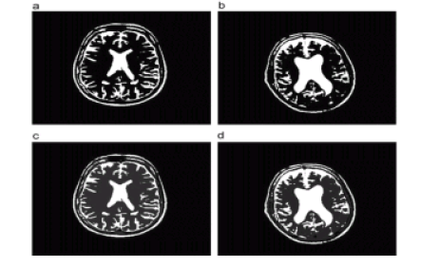

Figure (2.2): Segmentation image using threshold method.

Generally, a "good" complete segmentation must satisfy the following criteria

1. All pixels have to be assigned to regions.
2. Each pixel has to belong to a single region only.
3. Each region is a connected set of pixels.
4. Each region has to be uniform with respect to given predicate .
5. Any merged pair of adjacent regions has to be non-uniform [1].

**2.3.2 Watershed Segmentation**

Use watershed segmentation to separate touching objects in an image. The watershed transform is often applied to this problem. The watershed transform finds "catchment basins" and "watershed ridge lines" in an image by treating it as a surface where light pixels are high and dark pixels are low.

Segmentation using the watershed transform works well if you can identify, or "mark," foreground objects and background locations. Marker-controlled watershed segmentation follows this basic procedure:

1. Compute a segmentation function. This is an image whose dark regions are the objects you are trying to segment.
2. Compute foreground markers. These are connected blobs of pixels within each of the objects.
3. Compute background markers. These are pixels that are not part of any object.
4. Modify the segmentation function so that it only has minima at the foreground and background marker locations.
5. Compute the watershed transform of the modified segmentation function[5].

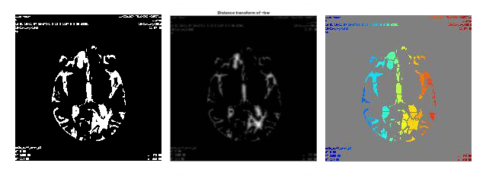

Figure (2.3) Image produced by the method of watershed.

**2.4** MRI Database

The main concept of the database containing the images used in our project is a collection of medical images (magnetic resonance imaging) obtained by Dr. Zuhair Khafaji specialized in neurological diseases and through the computer center in the magnetic resonance department at Diwaniyah Teaching Hospital. Of cases diagnosed by the doctor that contain brain tumor and other conditions of the disease and there is no brain tumor. This is an example of a case of a person with a brain tumor. Figure (2.3) is show a person with a brain tumor.

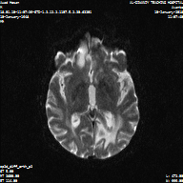

Figure (2.3): A person with a brain tumor.

Practical part

**3**

Chapter Three

**3.1 Introduction**

In the practical part, we will discuss implementation by using matlab under windows environment

The system consist the following:

1. Preprocessing part.
2. Segmentation part.

**3.1.1 Preprocessing part**

The preprocessing algorithm, techniques, and operators are used to perform initial processing that makes the primary data reduction and analysis task easier. They include operations related to extracting regions of interest, performing basic mathematical operations on images, simple enhancement of specific image features, color space transforms and data reduction in both resolution and brightness. Preprocessing is a stage where the requirements are typically obvious and simple, such as the removal of artifacts from images, or the elimination of image information that is not required for the application.

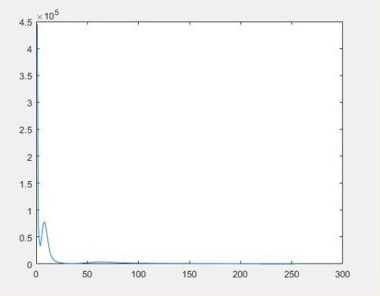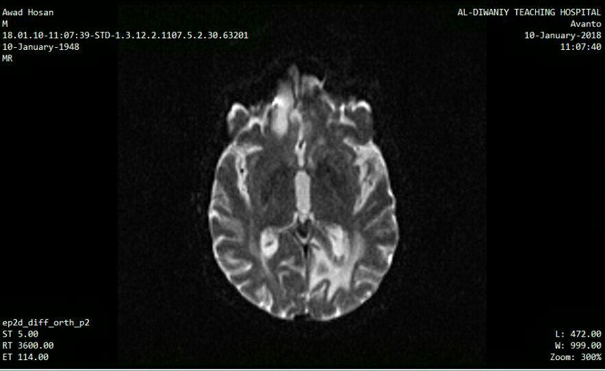

Figure:(3.1)A picture of a person is brain via the (MRI image) contains noise with work histogram for image.

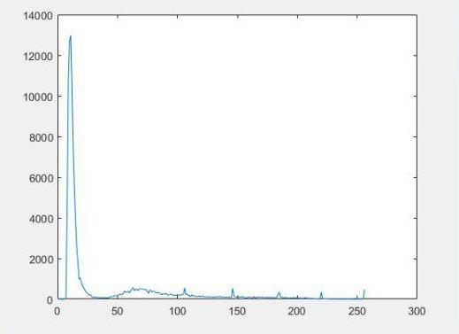

Figure (3.2) A picture of a person is brain via the (MRI image) free noise with work histogram for image.

**3.1.2 Segmentation**

Image segmentation is the process of dividing image into several parts that it is consisting of each pixel with similar feature. This is typically used to identify objects or other relevant information in digital image.

There are many different ways to perform image segmentation

We will used three ways.

This ways is:

1. Thresholding method.
2. watershed segmentation.
3. Threshold + watershed

**3.1.2.1 Thresholding Method**

Thresholding is the simplest non–contextual segmentation technique. With a single threshold, this is transforms a grayscale image or color image into a binary image considered as a binary region map [1].



Figure (3.3) Original image.

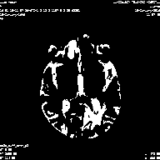

Figure (3.4) the image after the work threshold.

**3.1.2.2 Watershed Segmentation**

Is one of the methods of segmentation passes through three stages .The first phase deals with binary image as input to the method and the second phase is the transition of ~ bw image stores the results of the stages in the label and in the third stage is converted to the label rgb.

Bw1=sqrt((x-center1).^2+(y-center2)).^2<=radiue;

Bw2=sqrt((x-center2).^2+(y-center2)).^2<=radius;

Bw=bw1|bw2;



Figure (3.5) Image produced by the method of watershed.

Conclusion and Future work

**4**

Chapter Four

**4.1 Conclusion**

In this work, we introduce the introduction about image processing techniques specially the segmentation techniques. Our data set (MRI ) image collected form Al-Dewaniyah teaching hospital , section of MRI . The image collected from 10 patients most of them has tumor. As a practical work the MRI brain images prepressing to enhance the noise like salt and pepper, then apply segmentation with two different techniques Threshold and watershed transform of all brain images. the medical data has collected as a DICOM data and converted into BMP image using MICRODICOM software then take it as a color image consist of three layer red , green and blue used these images as a input to first techniques threshold (global and adaptive) and the output import to watershed transformation.

**4.2 Future work**

In the future we will work on diagnoses of human brain tumor as the follow:

1. Use more than two algorithms for segmentation.
2. Use Gabor filter as a features of each image.
3. Using Principles component analysis PCA to reduce the redundancy of features.
4. Using ANN to train the software to classify the healthy and unhealthy images.

**References**

[1] Israa Akram Fadhil , Medical Image Processing to Detect Brain Cancer, University of Baghdad / College of Arts /Unit of Media and Information, Iraqi Journal of Information Technology, Volume VII-issue 1-year2015.

[2] Dr. A. S. Bhalchandra, Brain Tumour Extraction from MRI Images Using MATLAB, International Journal of Electronics, Communication & Soft Computing Science and Engineering, Volume 2, Issue 1.

[3] Mohammad N. D. Dr. Manar Y. K. Dr. Dhuha B. A. Brain Tumors Segmentation Based On Genetic Algorithms, University of Al Mosul 22-23, The first practical conference for information technology, December 2008.

[4] Rajeev Ratan A, Sanjay Sharma B, S. K. SharmaC, Brain Tumor Detection based on Multi-parameter MRI Image Analysis, Department of E & IE, Apeejay College of Engineering, Sohna, Gurgaon, Haryana, India, ICGST-GVIP Journal,Volume (9), Issue (III), June 2009.

[5] From Brian Morse, <http://morse.cs.byu.edu/650/home/index.php> .

[6] Nidahl K. El Abbadi1 , Neamah E. Kadhim2, Brain Tumor Classification Based on Singular Value Decomposition, University Of Kufa, International Journal of Advanced Research in Computer and Communication Engineering, Vol. 5, Issue 8, August 2016.