University of Al- Qadisiyah
Computer Sciences Department

Study of Wavelet Functions of Discrete Wavelet Transformation in Image Watermarking
Research presented to the Department of Computer Sciences as part of attainment bachelor's degree in computer Sciences technology requirements
by
Shahad shakir jabir
Taghreed Nasser Hussein
Inas Ali Hussein

supervision
Rana Jumah Sarih

Dedicate
Thanks
We must and we move past our steps in the university life of the pause and go back to the years we spent in the university campus with the esteemed our professors who have given us so much great efforts in building tomorrow's generation to send the nation again
Before we offer our deepest gratitude and appreciation and love to those who carried the message holiest in life
To those who paved the way for us science and knowledge
All our Teachers Distinguished .......

CONTENT
Chapter one: introduction Discrete Wavelet Transformation in Watermarking?

Chapter two: Type of Discrete Wavelet Transformation in Watermarking

Chapter three: Practical application in matlab
Chapter four: Basic theory behind the project
Chapter five: Results and Conclusion

Chapter One:
What is Discrete Wavelet Transformation in Watermarking?

1. Introduction
In the modern vast era of digital media, there is dramatically increase in the volume of digital data transmission. This digital data may be text, audio, images, and video. Various signal processing techniques are used to transmit this raw data in terms of electronic media. These signal processing techniques are used to secure the data transmission and make real time transmission possible. Security of the data being transmitted against fraudulent activities is the main concern, and a lot of research in this area is carried out by researchers since past decade. One way to secure the digital data is to add watermark or signature within the content of digital media and extract this watermark or signature at the receiver end to validate the authenticity of the data, this process is called as digital watermarking.
Digital watermarking is a method whereby information can be invisibly embedded into digital media. Later the watermark can be extracted and used for authentication and verification of ownership. This embedded information should ideally be robust against common signal manipulations such as the addition of random noise, digital-to-analog conversion, and intentional attacks to remove the embedded watermark.
Digital watermarking plays an important role in protecting copyrights in digital media (images, audio and video). Copyright infringement or copyright violations can be detected or checked using watermarking [1]-[3]. The main aim of this paper is to examine various available wavelet techniques used in the field of image watermarking. Image watermarking can be defined as the process of embedding the watermark or signature image into the original image (cover image).
Image watermarking is broadly classified into two categories: Spatial domain watermarking and transform-domain watermarking [4]. Watermark can be embedded in the spatial domain of an image by changing the pixel values. In spatial domain the pixel values of the cover image are varied to embed the watermark into
the cover image. As the variations in the pixel values causes degradation in the cover image. So, the spatial domain watermarking is used only in rare cases in which the image quality is not of forth importance. The transform domain schemes which are based on the mathematical transformations embed the watermark by modulating the frequency coefficients in a transformed domain.
The various transform domains commonly used are discrete cosine transform (DCT), discrete Fourier transforms (DFT), discrete wavelet transformation (DWT) [5]-[7]. Transformed domain watermarking schemes produce better results than spatial domain watermarking scheme [8].
In the next sections of paper, Discrete wavelet transform, wavelets are discussed which are used in transform domain watermarking systems.
2. Discrete Wavelet Transform
Discrete Wavelet transform (DWT) is a mathematical tool for hierarchically decomposing an image [7]. This transform is based on wavelets which are of varying frequency. The transform of a signal is just another way of representing the signal; it does not change the information content present in the signal. The Discrete wavelet transform provides a time-frequency representation of the signal. DWT is the popular technique which is used for image watermarking and image compression applications with excellent visual quality of the processed image. The basic idea of discrete wavelet transform in image processing is to decompose the image into sub-image of different spatial domain and independent frequency sub-bands. After the cover image has been DWT transformed, it is decomposed into four frequency parts (LL, LH, HL, and HH) as shown in Fig. 1. LL is the low frequency sub-band which contains the approximation of the original image. HL represents the high frequency sub-band which contains the horizontal details of the image. LH represents the high frequency sub-band which contains the vertical details of the image. HH represents the high frequency sub band of the diagonal image.
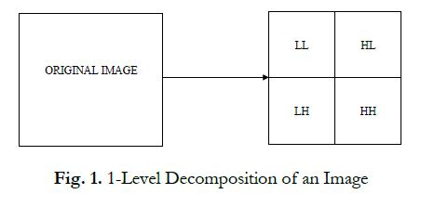
DWT can be decomposed up to N levels. In the 2nd level decomposition the sub-band LL will be decomposed into four sub-bands and so on.

2.1. Decomposition Process
In the decomposition stage of the image, the image is high and low-pass filtered along the rows and the results of each filter are down-sampled by two. Fig. 2 shows one decomposition step of the two dimensional gray scale image using DWT.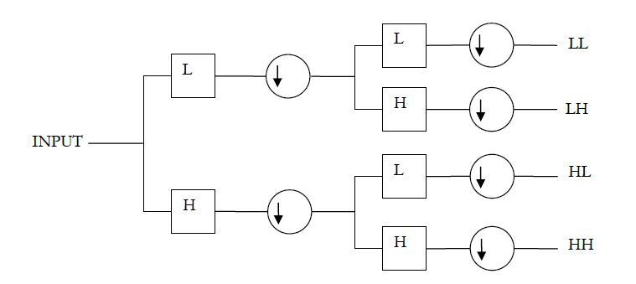
Fig. 2 shows one decomposition step of the two dimensional gray scale image using DWT.
2.2. Reconstruction Process
The reconstruction process using IDWT is shown in Fig. 3. Reconstruction means obtaining same image from the four sub-frequency bands. In this the information from four sub-bands is up-sampled and then filtered with the corresponding inverse filters using the columns. The two results are added and then again up-sampled and filtered with the corresponding inverse filters. The results from each step are added to form the original image.
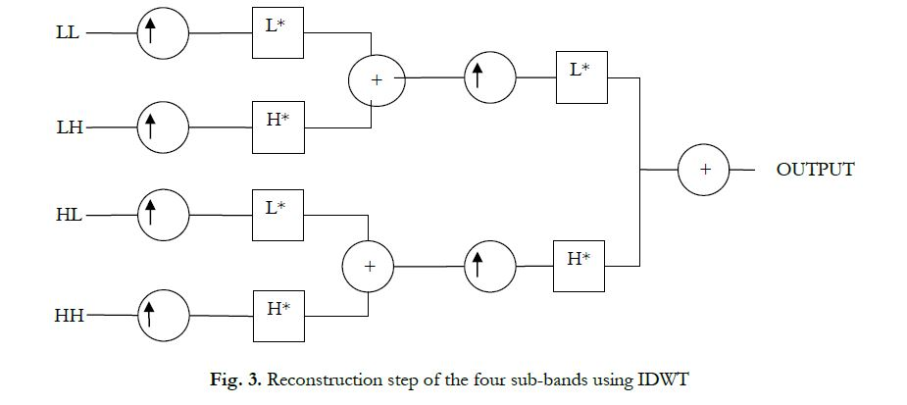

Several types of wavelets used to decompose the image are; Haar, Daubechies, symlet, Coiflet which are discussed in the following sections.

3. Wavelets
Wavelets are the functions that satisfy certain mathematical requirements and are used in representing data or other functions [9]. DWT uses different types of functions that are used as the mother wavelet for wavelet transformation. Wavelets families are divided into two categories, orthogonal and Bi-orthogonal. The various wavelets associated with DWT are:
• Haar,
• Daubechies,
• Symlet,
• Coiflet.
3.1. Haar Wavelet
Haar wavelet is the one of the oldest and simplest wavelet. Haar wavelet is discontinuous, and resembles a step function. Haar wavelet is called as the mother of all wavelets as it produces all wavelet functions used in transformation through translation and scaling functions. Fig. 4 shows plot of Haar wavelet in MATLAB.

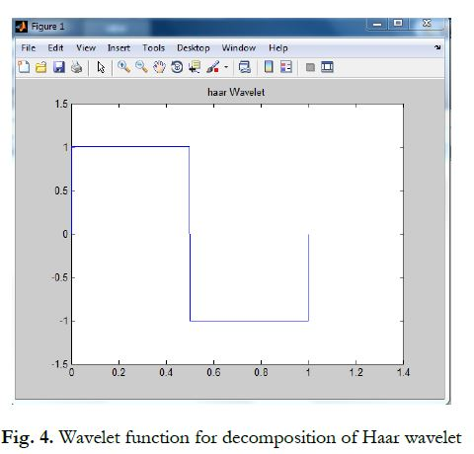

3.2. Daubechies Wavelet
Daubechies wavelet was invented by Ingrid Daubechies [10]. The names of Daubechies family wavelets are written as dbN, where N is the order, and db is the surname of the wavelet. Daubechies wavelets are orthogonal wavelets which makes discrete wavelet analysis practically possible. The main characteristics of dbN family are compactly supported wavelets with external –phase and highest number of vanishing
moments for a given support width. Db1 is same as Haar wavelet, generally these are considered as same wavelet. The graphical plot of the Daubechies wavelet function is shown in Fig. 5.
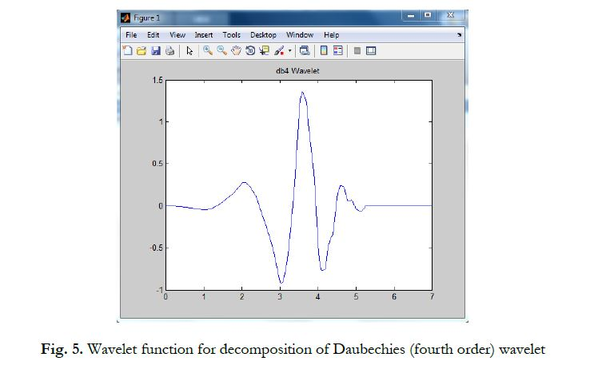

3.3. Symlet Wavelet
Symlet wavelets are formed by modification of symmetry of Daubechies wavelets and the properties of symlet wavelets are almost same as that of Daubechies wavelets. These are the symmetrical wavelets so named as symlet wavelet. Symlet wavelets are written as SymN where N is the order. The graphical plot of the Daubechies wavelet function is shown in Fig. 6.
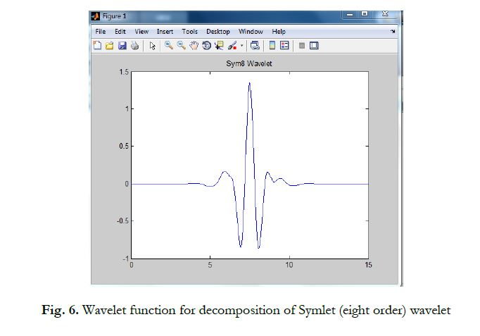

3.4. Coiflet Wavelet
Coiflet wavelets are compactly supported wavelets with highest number of vanishing moments for a given support width. In CoifN, N is the order. In some literature it is written as 2N. Coiflet wavelets are more symmetric than that of dbN’s. The graphical plot of the 5th order Coiflet wavelet function is shown in Fig. 7. Coif5 refers to the 5th order.
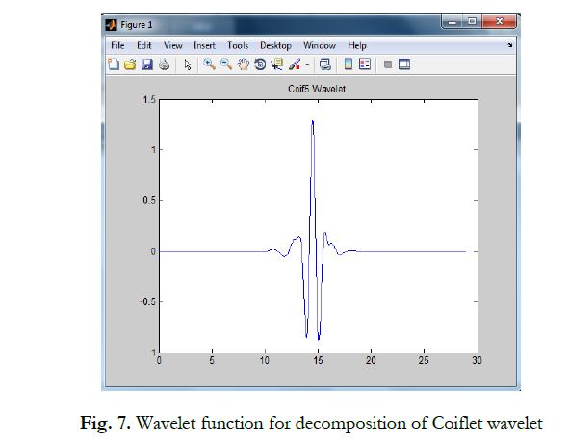

Chapter two:
Type of Discrete Wavelet Transformation in Watermarking

Type Of DWT
.Digital data may be text, audio, images, and video. Various signal processing techniques are used to transmit this raw data in terms of electronic media so in this section will be explain the type of DWT

- Digital Image Watermarking Using 3 level Discrete Wavelet Transform

In this paper a digital image watermarking based on 3 level discrete wavelet transform (DWT) is presented & compare it with 1 & 2 levels DWT. In this technique a multi-bit watermark is embedded into the low frequency sub-band of a cover image by using alpha blending technique. During embedding, watermark image is dispersed within the original image depending upon the scaling factor of alpha blending technique. Extraction of the watermark image is done by using same scaling factor as for embedding. Performance of method for different value of scaling factor is analyses & compare with 1& 2 levels DWT method by using statistical parameters such as peak-signal-to-noise-ratio (PSNR) and mean square error (MSE).Keywords: List four to six keywords which characterize the article.
1. Introduction
Due to the advancement of digital multimedia tools the storage and distribution of multimedia content is become very easy. Issues on security have emerged and there is a vital need for protecting the digital content against counterfeiting, piracy and malicious maniple. Watermark--A visible or invisible signature embedded inside an image to show authenticity or proof of ownership. The hidden watermark should be inseparable from the host image, robust enough to resist any manipulations while preserving the image quality. Thus through watermarking, intellectual properties remains accessible while being permanently marked. This digital signature approaches use in authenticating ownership claims and protecting proprietary hidden information, discourage unauthorized copying and distribution of images over the internet and ensure a digital picture has not been altered.
Watermarking adds the additional requirement of robustness. An ideal watermarking system however would embed an amount of information that could not be removed or altered without making the cover object entirely unusable. So, watermarking is mainly prevent illegal copy or claims the ownership of digital media.[2] There are four essential factors which make watermarking effective are: Robustness: Watermark should difficult to remove or destroy. It is a measure of immunity of watermark against attempts to image modification and manipulation like compression, filtering, rotation, collision attacks, resizing, cropping etc. Imperceptibility: quality of host image should not be destroyed by presence of watermark. Capacity: It includes techniques that make it possible to embed majority of information. Blind watermarking: Extraction of watermark from watermark image without original image

Digital watermarking is a very developing field and used in various applications which have been proved to be successful. The digital watermarking has been applied in a number of image processing techniques. The aim of every application is to providing security of the digital content. The digital watermarking applications are Broadcast Monitoring [3], Digital Fingerprinting [4], Transaction Tracking [5], Copyright protection [6], Temper Detection [7], Data Hiding [8] and Content Authentication [9] etc.
Every digital watermarking technique includes two algorithms: one as the embedding algorithm and other as the detecting algorithm. These two processes are same for all the type of watermarking techniques. Figure 1 shows the watermark embedding process in which the watermark is embedded in the cover image by using the embedding algorithm. And Figure 2 shows the watermark detection process in which the embedded watermark is recovered by using the detection algorithm.
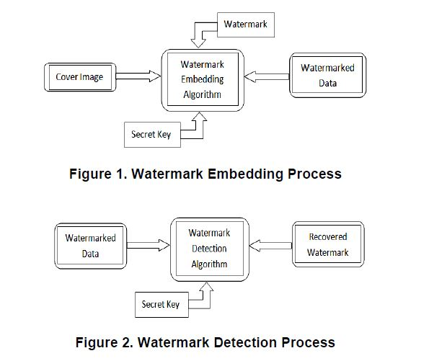

2. Digital Image Watermarking Working
Digital Watermarking is a technique which is used in the digital signal processing of embedding hidden information into multimedia data. This information is not usually visible, only dedicated detector or extractor can seen and extracts that information. Digital Image Watermarking use digital image for embedding the hidden information, after embedding the watermarked image is generated and the watermarked image is more robust against attacks.
Figure 3 shows the stages of digital watermarking. Basically working of digital image watermarking can be divided in three stages [10]:
2.1. Embedding Stage
The embedding stage is the first stage in which the watermark is embedded in the original image by using the embedding algorithm and the secret key. Then the watermarked image is generated. So the watermarked image is transmitted over the network.
2.2. Distortion/Attack Stage
In this stage, when the data is transmitted over the network. Either some noise is added with the watermarked image or some attacks are performed on the watermarked image. So, our watermarked data is either modified or destroyed.
2.3. Detection/Retrieval Stage

In the detection stage, the watermark is detected or extracted by the dedicated detector from the watermarked image by applying some detection algorithm and by using secret key. In addition to this, noise is also detected.
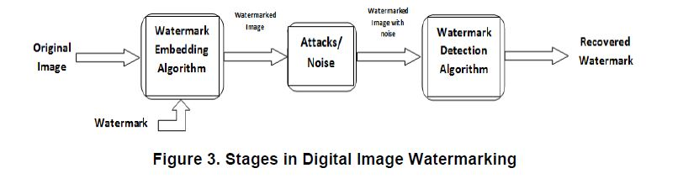
3. Digital Image Watermarking Techniques
In the field of digital watermarking, digital image watermarking has attracted a lot of awareness in the research community for two reasons: one is its easy availability and the other is it convey enough redundant information that could be used to embed watermarks [11]. Digital watermarking contains various techniques for protecting the digital content. The entire digital image watermarking techniques always works in two domains either spatial domain or transform domain. The spatial domain techniques works directly on pixels. It embeds the watermark by modifying the pixels value. Most commonly used spatial domain techniques are LSB. Transform domain techniques embed the watermark by modifying the transform domain coefficients. Most commonly used transform domain techniques is DCT,
DWT and DFT. For achieving the robustness and imperceptibility, the transform domain techniques are more effective as compare to the spatial domain. We further elaborated these two domains and its techniques.

3.1. Spatial Domain Watermarking
The spatial domain represents the image in the form of pixels. The spatial domain watermarking embeds the watermark by modifying the intensity and the colour value of some selected pixels [12]. The strength of the spatial domain watermarking is
✓ Simplicity.
✓ Very low computational complexity.
✓ Less time consuming.

The spatial domain watermarking is easier and its computing speed is high than transform domain but it is less robust against attacks. The spatial domain techniques can be easily applied to any image. The most important method of spatial domain is LSB.
Least Significant Bit (LSB):
The LSB is the simplest spatial domain watermarking technique to embed a watermark in the least significant bits of some randomly selected pixels of the cover image. Example of least significant bit watermarking [12]:
Image:
10010101 00111011 11001101 01010101….
Watermark:
1 0 1 0…..
Watermarked Image:
10010101 00111010 11001101 01010100…..
The steps used to embed the watermark in the original image by using the LSB [13]:
1) Convert RGB image to grey scale image.
2) Make double precision for image.
3) Shift most significant bits to low significant bits of watermark image.
4) Make least significant bits of host image zero.
5) Add shifted version (step 3) of watermarked image to modified (step 4) host image.

The main advantage of this method is that it is easily performed on images. And it provides high perceptual transparency. When we embed the watermark by using LSB the quality of the image will not degrade. The main drawback of LSB technique is its poor robustness to common signal processing operations because by using this technique watermark can easily be destroyed by any signal processing attacks. It is not vulnerable to attacks and noise but it is very much imperceptible.

Limitations of spatial domain watermarking:
The spatial domain watermarking is simple as compared to the transform domain watermarking. The robustness is the main limitation of the spatial domain watermarking. It can survive simple operations like cropping and addition of noise.
Another limitation of spatial domain technique is that they do not allow for the subsequent processing in order to increase the robustness of watermark.
3.2. Transform Domain Watermarking

The transform domain watermarking is achieving very much success as compared to the spatial domain watermarking. In the transform domain watermarking, the image is represented in the form of frequency. In the transform domain watermarking techniques, firstly the original image is converted by a predefined transformation. Then the watermark is embedded in the transform image or in the transformation coefficients. Finally, the inverse transform is performed to obtain the watermarked image [14]. Most commonly used transform domain methods is Discrete Cosine Transform (DCT), Discrete Wavelet Transform (DWT) and Discrete Fourier Transform (DFT).
3.2.1. Discrete Cosine Transform: Discrete Cosine Transform (DCT) used for the signal processing. It transforms a signal from the spatial domain to the frequency domain. DCT is applied in many fields like data compression, pattern recognition and every field of image processing. DCT watermarking is more robust as compared to the spatial domain watermarking techniques. The main steps which used in DCT [11]:
1) Segment the image into non-overlapping blocks of 8x8.
2) Apply forward DCT to each of these blocks.
3) Apply some block selection criteria (e.g. HVS).
4) Apply coefficient selection criteria (e.g. highest).
5) Embedded watermark by modifying the selected Co-efficient.
6) Apply inverse DCT transform on each block.

In DCT, for embedding the watermark information, we divide the image into different frequency bands. In Figure 4 FL denotes the lowest frequency component of the block, while FH denotes the higher frequency component and FM denotes the middle frequency component which is chosen as the embedding region. The Discrete cosine transform achieves good robustness against various signal processing attacks because of the selection of perceptually significant frequency domain coefficients.
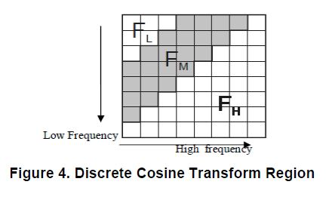
3.2.2. Discrete Wavelet Transform: Discrete wavelet transform (DWT) of the image produces multi resolution representation of an image. The multi resolution representation provides a simple framework for interpreting the image information. The DWT analyses the signal at multiple resolution. DWT divides the image into high frequency quadrants and low frequency quadrants. The low frequency quadrant is again split into two more parts of high and low frequencies and this process is repeated until the signal has been entirely decomposed.
The single DWT transformed two dimensional image into four parts: one part is the low frequency of the original image, the top right contains horizontal details of the image, the one bottom left contains vertical details of the original image, the bottom right contains high frequency of the original image. The low frequency coefficients are more robust to embed watermark because it contains more information of the original image [2]. The reconstruct of the original image from the decomposed image is performed by IDWT [16].
The digital wavelet transform are scalable in nature. DWT more frequently used in digital image watermarking because of its excellent spatial localization and multi resolution techniques. The excellent spatial localization property is very convenient to recognize the area in the cover image in which the watermark is embedded efficiently.
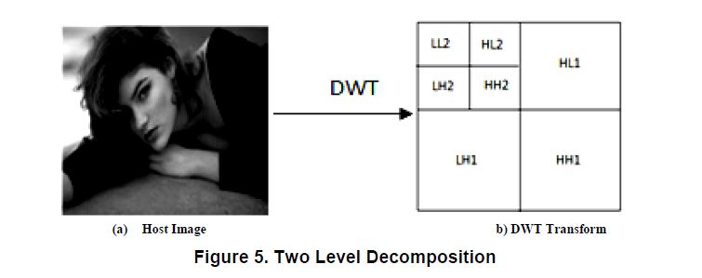

3.2.3. Discrete Fourier Transform: Discrete Fourier Transform (DFT) offers robustness against geometric attacks like rotation, scaling, cropping, translation etc. DFT decomposes an image in sine and cosine form. The DFT based watermark embedding techniques are divided in two types: one is the direct embedding and the other one is the template based embedding.
According to the direct embedding technique the watermark is embedded by modifying DFT magnitude and phase coefficients. The template based embedding technique introduces the concept of templates. A template is structure which is embedded in the DFT domain to estimate the transformation factor. Once the image undergoes a transformation this template is searched to resynchronize the image, and then the detector is used to extract the embedded spread spectrum watermark [11].

2-DWT–Based AUDIOWATERMARKING: FEATURES, APPLICATIONS AND ALGORITHMS
This paper considers desired properties and possible applications
of audio watermarking algorithms. Special attention is given to
statistical methods working in the fourier domain. It will present a
solution of robust watermarking of audio data and reflect the security
properties of the technique. Experimental results show good
robustness of the approach against MP3 compression and other
common signal processing manipulations. Enhancements of the
presented methods are discussed.
1. INTRODUCTION
Along with the rapid growth of Internet, the transmission of audiovisual media becomes easier. It
leads to the problems regarding copyright protection. Among them, copyright protection is the
primary concern and the hotspot of international area in recent areas. Digital product information
hiding and digital watermarking technology is generated on this basis and developed along with
the protection of copyright; this technology is widely used in protecting the copyright of image,
audio and video by means of extracting or detecting the watermark for its various application
including copyright protection, broadcast and publication monitoring, authentication , copy
control. Audio watermarking should satisfy the following features. They are as following:
I. Imperceptibility: The digital watermark should not affect the quality of original
audio signal after it is watermarked.
II. Robustness: The embedded watermark data should not be removed or eliminated
by unauthorized distributors using common signal processing operations and
attacks.
III. Capacity: Capacity refers to the numbers of bits that can be embedded into the
audio signal within a unit of time.
IV. Security: Security implies that the watermark can only be detectable by the
authorized person.
In this paper, we propose a new watermarking technique using Discrete Cosine Transformation
(DCT) for audio copyright protection. The watermarks are embedded into the selected peaks of
the highest energy segment of DCT coefficients. Experimental results indicate that the proposed
watermarking method provide strong robustness against several kinds of attacks such as noise
addition, re-sampling, re-quantization and so on and achieves Bit Error Rate (BER) almost zero.
In addition, our proposed method achieves SNR (signal-to-noise ratio) values ranging up to 29
dB.
The rest of the paper is organized as follows: Section 2 provides a brief description of previous
works related to audio watermarking. Section 3 introduces traditional Arnold transformation.
Section 4 introduces our proposed watermarking method including watermark embedding process
and watermark detection process. Section 5 and 6 discusses the performance of our proposed
method in terms of imperceptibility and robustness. Finally, section 7 concludes this paper.
2. RELATED RESEARCH
A significant number of watermarking techniques have been reported in recent years in order to
create robust and imperceptible audio watermarks. Lie et al. [1] propose a method of
watermarking system for audio signals in the time domain. This proposed algorithm uses
differential average-of-absolute-amplitude relations. In which samples are kept in group and each
group of audio samples uses to represent one-bit information. This method also uses the low
frequency amplitude modification technique so that it can scale the amplitudes in selected
sections of samples. In [2], authors propose a blind audio watermarking method which inserts
watermark into audio signal in the time domain. For watermark detection, the strength of the
audio signal modifications is limited by the necessity for producing an output signal. The
watermark is generated using a key. The watermark embedding also depends on the amplitude
and frequency of audio signal so that it minimizes the audibility of the watermarked signal. In [3],
authors explain a blind watermarking method which inserts watermarks into Discrete Cosine
Transform (DCT) coefficients using quantization index modulation method. In [4], authors
propose a blind audio watermarking method by using adaptive quantization against
synchronization attack. In addition the multiresolution characteristics of discrete wavelet
transform (DWT) and the energy compression characteristics of discrete cosine transform (DCT)
are combined in this method. It also improves the transparency of digital watermark. Watermark
is then inserted into low frequency components using adaptive quantization according to human
auditory system (HAS). In [5], authors propose a watermarking method in cepstrum domain for
audio signal in which a pseudo-random sequence is used as a watermark. The watermark is then
weighted in the cepstrum domain according to the distribution of cepstrum coefficients and the
frequency masking characteristics of human auditory system (HAS). In [6], authors propose a
blind watermarking system which takes the advantages of the attack-invariant feature of the
cepstrum domain and error-correction capability of BCH code to increase the imperceptibility and
robustness of audio watermarking. In [7], authors propose a survey of watermarking systems

3- THEORETICAL BACKGROUND
2.1 Classification
Many techniques of audio watermarking algorithms can be grouped into three categories[4]:patchwork in the frequency domain, echo hiding in the time domain and spread spectrum. Based on their embedding domain, watermarking algorithms can also be classified [1]. In time domain watermarking system, watermark is directly embedded into audio signal. Wide range of time domain embedding techniques for digital audio signal such as Least Significant Bit (LSB) alteration, Echo addition and phase coding methods have been developed [2].
In time domain algorithms, watermark is embedded without any transformation & watermark can be easily destroyed. Implementation of these methods is very easy & requires less computation. The watermark signal is shaped before embedding. This enables the system to maintain the audibility of the original audio signal. The robustness of the time domain algorithm is poor. Hence most of the research work is focused on transform based watermarking techniques. Because the audio signal sampling frequency is low, and the human auditory system (HAS) is more sensitive than the human visual system (HVS), so the amount of information to be embedded in the audio signal is much less than in the visual media [4][5][6].
Transform domain audio watermarking technique take the advantage of frequency masking property of Human auditory system. Transforming audio signal into frequency domain enables watermarking system to hide the watermark into perceptually significant component of an audio signal. It gives high robustness against signal processing operations. This technique includes the use of discrete cosine transform (DCT), Discrete Fourier Transform (DFT), and discrete wavelet transforms DWT. Transforming audio signal from time domain to frequency domain enables watermarking system to embed the watermark into perceptually significant part of a signal. This will develop the technique with a high robustness.
In spatial domain, the watermark can be embedded directly into a digital media and modified its values [1] [5].
The choice of the algorithm depends on several factors: the type of cover audio, the computational complexity of the algorithm and the application.
A basic classification of watermarking technique [7] is given by Fig.1. Speaking of digital image watermarking, watermarks can be divided into two main groups – visible and invisible watermarks. The visible one, like different logos and usually images that are superimposed upon a still picture or a moving picture. Visible watermarks are more robust against image transformation. Other, an invisible watermark is an embedded image which cannot be perceived with human’s eyes. Only electronic devices (or specialized software) can extract the hidden information to identify the copyright owner. Invisible watermarks are used to mark a specialized digital content (text, images or even audio content) to prove its authenticity. These digital watermarks are created by embedding extra information, commonly in the form of digital patterns, into the computer files containing the images or sounds to be protected. The use of a fragile watermark is important when one wants to verity if the protected media was tampered with or not. Robust watermarking is designed to provide proof of ownership.
Depending upon the requirement of original signal at the receiver, watermarking schemes are classified as blind, semi-blind and non-blind [1]. Blind scheme require only the secret key(s), semi- blind scheme require secret key(s) and the watermarking bits and non-blind scheme require both the original signal and the secret key(s) for watermark embedding.
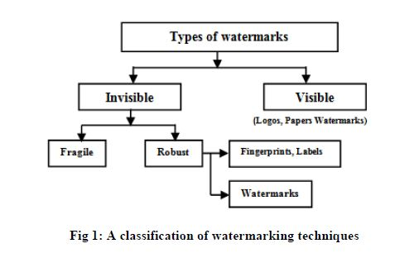
Static watermarks are those which do not change regardless of who opens and processes the watermarked document. They are used in the same as those on the banknote. Static watermarks also be used for copy preventing. Dynamic watermarks in the physical world were created by affixing a seal to a document, or stamping it. These kinds of watermarks are used to identify the institution or individual associating them with the authenticity of the document. Dynamic watermarks may be used as a form of copy resisting.

2.2 Transform Basics
In this section, the DWT and SVD transforms [2] has been described.
Discrete Wavelet Transform
Wavelets are functions defined over a finite interval and having an average value of zero [1].Wavelet transform is used to represent any function as a superposition of a set of wavelet or basic functions.

3-Digital Video Watermarking Using 4-level
DWT
Abstract - Due to the extensive use of digital media applications, multimedia security and copyright protection
has gained tremendous importance. Digital Watermarking is a technology used for the copyright protection of digital applications. In this paper, a comprehensive approach for watermarking digital video is introduced. We propose a hybrid digital video watermarking scheme based on Discrete Wavelet Transform (DWT) and Principal Component Analysis (PCA). PCA helps in reducing correlation among the wavelet coefficients obtained from wavelet
decomposition of each video frame thereby dispersing the watermark bits into the uncorrelated coefficients. The video frames are first decomposed using DWT and the binary watermark is embedded in the principal components of the low frequency wavelet coefficients. The imperceptible high bit rate watermark embedded is robust against various attacks that can be carried out on the watermarked video ,such as filtering, contrast adjustment, noise addition and geometric attacks .Keywords:- Digital video; binary watermark; Discrete Wavelet Transform; Principal Component Analysis.
I. INTRODUCTION
The popularity of digital video based applications [1]is accompanied by the need for copyright protection to prevent illicit copying and distribution of digital video. Copyright protection inserts authentication data such as ownership information and logo in the digital media without affecting its perceptual quality. In case of any dispute, authentication data is extracted from the media and can be used as an authoritative proof to prove the ownership. As a method of copyright protection, digital video watermarking [2, 3] has recently emerged as a significant field of interest and a very active area of research. Watermarking is the process that embeds data called a watermark or digital signature into a multimedia object such that watermark can be detected or extracted later to make an assertion about the object. The object maybe an image or audio or video. For the purpose of
copyright protection digital watermarking techniques must meet the criteria of imperceptibility as well as robustness against all attacks [4-6] for removal of the watermark. Many digital watermarking schemes have been proposed for still images and videos [7]. Most of them operate on uncompressed videos [8-10], while others
embed watermarks directly into compressed videos [8,11]. The work on video specific watermarking can be further found in [12-15]. Video watermarking introduces a
number of issues not present in image watermarking. Due inherent redundancy between video frames, video signals are highly susceptible to attacks such as frame averaging, frame dropping, frame swapping and statistical analysis. Video watermarking approaches can be classified into two main categories based on the method of hiding watermark bits in the host video. The two categories are: Spatial domain watermarking where embedding and detection of watermark are performed by directly manipulating the pixel intensity values of the video frame. Transform domain [16-18] techniques, on the other hand, alter spatial pixel values of the host video according to a pre-determined transform and are more robust than spatial domain techniques since they disperse the watermark in the spatial domain of the video frame making it difficult to remove the watermark through malicious attacks like
cropping, scaling, rotations and geometrical attacks. The commonly used transform domain techniques are Discrete Fourier Transform (DFT), the Discrete Cosine Transform(DCT), and the Discrete Wavelet Transform (DWT).In this paper, we propose an imperceptible and robust video watermarking algorithm based on Discrete Wavelet Transform (DWT) [19-25] and Principal Component Analysis (PCA) [26-28]. DWT is more computationally efficient than other transform methods like DFT and DCT. Due to its excellent station- frequency localization properties, the DWT is very suitable to identify areas in the host video frame where a watermark can be embedded imperceptibly. It is known that even after the decomposition of the video frame using the wavelet transformation there exist some amount of correlation between the wavelet coefficients. PCA is basically used to hybridize the algorithm as it has the inherent property of removing the correlation amongst the data i.e. the wavelet coefficients and it helps in distributing the watermark bits over the sub-band used for embedding thus resulting in a more robust watermarking scheme that is resistant to almost all possible attacks. The watermark is embedded into the luminance component of the extracted frames as it
is less sensitive to the human visual system (HVS).The paper is organized as follows. Section II contains the watermarking scheme. Section III contains the experimental results and finally Section IV gives the conclusion
Fig. 5 and Fig. 6 show the watermarked video frame after the addition of gaussian noise and ‘salt and pepper’ noise respectively. Fig. 7 shows the effect of carrying out video frame rotation by an angle of 5 degrees. Fig. 8 shows the watermarked video frame after resizing first by a factor of half followed by a factor to 2 to return it to its original size. Fig. 9 shows the cropped video frame. Figures 10-14 show the effect of applying gamma correction (variance 0.5), contrast adjustment and automatic equalization. Fig. 14 and Fig. 15 show the resultant video after applying sharpening filter and median filter (3×3 box filter) respectively. The following table shows the value of the data collected from the watermarked video after performing the various attacks as shown previously.

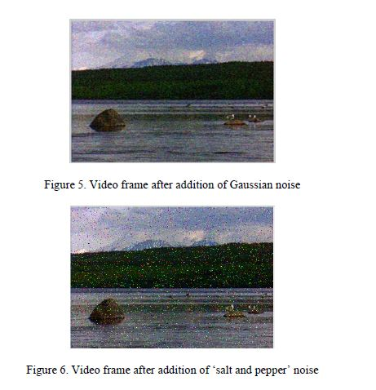
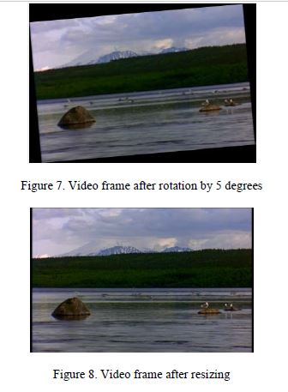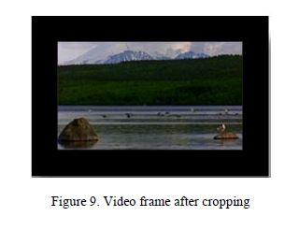

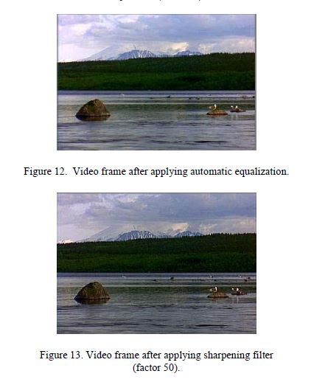
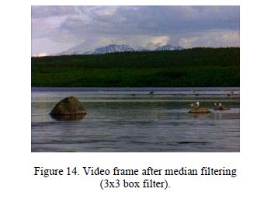
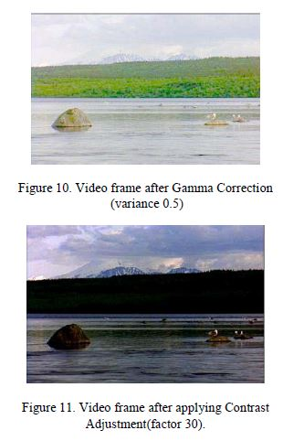
Frame dropping: Frame dropping means dropping one or more frames randomly from the watermarked video sequence. If we drop too many frames, the quality of the watermarked video will decrease rapidly. In our experiment, we only drop one frame randomly. Due to embedding the same watermark into each frame, it will not affect the extraction of the watermark completely from attacked watermarked video by frame

Frame swapping: Frame swapping means switching the order of frames randomly within a watermarked video sequence. If we swap too many frames, it will degrade the
video quality. We have extracted all the watermarks from the video after frame swapping.
Frame averaging: Since the frames are watermarked with the same information, the watermarked videos are not subject to the risk of watermark estimation by frame averaging since the watermark signal gets amplified on averaging.

Chapter three: Practical application in matlab

Watermarking algorithm
Therealizedalgorithm,calledWM2.0,isawatermarkingnotblindalgorithm,whichembedswatermarksignalsinto high-frequencysub-bandsdiscretewavelettransform(DWT)coefﬁcients,accordingtotheHVSdirectives[6].Itmakes apre-processingoftheimagedepictingitintocomponentvalueofcolormodelhue,saturation,value(HSV)andresizing the value matrix in accordance with the parameters and mathematical base conditions of DWT. Wavelet function and DWT level decomposition are ﬁxed, respectively, depending on image features and image resize. In the embedding process, watermark signal and DWT coefﬁcients to be watermarked are chosen depending on the statistic function values of the image. In the detection process, original image and watermarked image (likely different from the output image of the embedding process because of JPEG compression or any attacks) are synchronized comparing statistic functionvaluesofageometricintervalofbothimages;thecorrelationbetweenthewatermarkedDWTcoefﬁcientsand the watermark signal is calculated according to the Neyman–Pearson statistic criterion which determines a detection threshold minimizing the probability of missing detection to a given probability of false alarm.WM2.0 is an evolution of a previous algorithm version, WM1.0, described in [1]. In WM1.0 watermark signal and detection threshold were constant values chosen by means of experimental considerations, thus they were not depending on statistic image features. The experimentation has been accomplished on images, in high and low resolutions, building a real and commercial database. This algorithm has been implemented in Matlab 6.x using the wavelet and statistic toolbox.
Pre-processing of the image
It is widely accepted today that robust image watermarking techniques should largely exploit the characteristics of the HVS, for more effectively hiding a robust watermark [5,16]. HVS considerations indicate that the eye is less sensitive to noise in those areas of the image where brightness is high or low. For this reason, in this step, ﬁrst we compute the value plane from HSV model of the original image I. Three fundamental considerations indicate us to apply the wavelet transform not on the whole value matrix of the original image, but on its sub-matrices: the ﬁrst reason is that, in this way, the watermark can well cover the whole image; the second reason is that DWT requires that the associatedsub-imagematrixmusthaveorderpowerof2;andthethirdreasonisthatthehostimagescanhavedifferent dimensionswhentheybelongtorealmultimediagalleries.Then,inthisstep,wesplitvaluematrixoftheoriginalimage
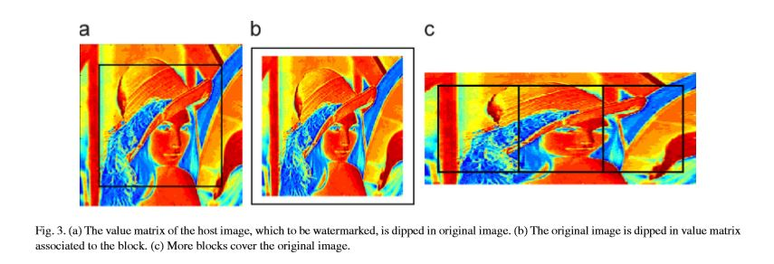
Fig.3.(a)Thevaluematrixofthehostimage,whichtobewatermarked,isdippedinoriginalimage.(b)Theoriginalimageisdippedinvaluematrix associated to the block. (c) More blocks cover the original image.
I, into non-overlapping squared blocks. It is important to deﬁne a criterion to compute the blocks to be watermarked. InWM2.0 we apply the following rule, let r be the number of rows and c be the number of columns of I: • if c/r <2, then each block is a matrix whose order power of 2 is nearer to the longest dimension of the original image (typically, we have one block, Fig. 3(a) or (b)). If the order of the matrix associated to the block is greater than the longest dimension of the original image, we apply the pixel values of the ﬁrst and last rows, and of the ﬁrst and last columns; • if c/r2,then each block is amatrixwhoseorderpowerof2isnearertothelowestdimensionoftheoriginalimage (typically, we have more blocks, Fig. 3(c)). In this way, on each block we apply the embedded/detection scheme described in the next sub-sections. In experimentation cases typically computed have been of one block with an associated matrix with order 256, or more blocks with an associated matrices with order 128.
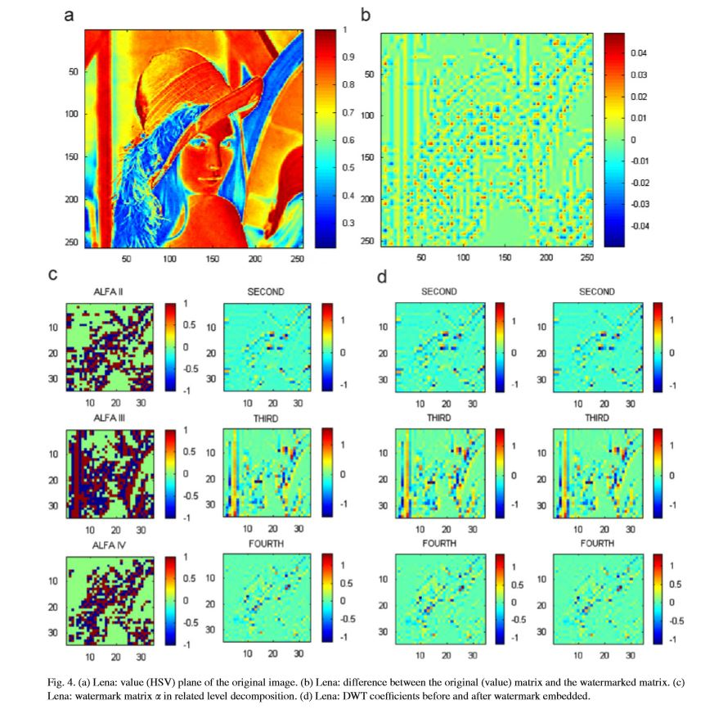
Fig. 4. (a) Lena: value (HSV) plane of the original image. (b) Lena: difference between the original (value) matrix and the watermarked matrix. (c) Lena: watermark matrix in related level decomposition. (d) Lena: DWT coefﬁcients before and after watermark embedded.

Program code in matlab

%Input image is watermarked with a key having Mean = 0 & Variance = 1
clc;clear all;close all;
img = imread('home.jpg'); %Get the input image
img = rgb2gray(img); %Convert to grayscale image
img = double(img);
c = 0.01; %Initialise the weight of Watermarking
figure,imshow(uint8(img)),title('Original Image');
[p q] = size(img);
%Generate the key
n = awgn(img,4,3,'linear');
N = imabsdiff(n,img);
figure,imshow(double(N)),title('Key');
[Lo_D,Hi_D,Lo_R,Hi_R] = wfilters('haar');%Obtain the fiters associated with haar
[ca,ch,cv,cd] = dwt2(img,Lo_D,Hi_D); %Compute 2D wavelet transfor
%Perform the watermarking
y = [ca ch;cv cd];
Y = y + c*abs(y).* N;
p=p/2;q=q/2;
for i=1:p
for j=1:q
nca(i,j) = Y(i,j);
ncv(i,j) = Y(i+p,j);
nch(i,j) = Y(i,j+q);
ncd(i,j) = Y (i+p,j+q);
end
end

%Display the Watermarked image
wimg = idwt2(nca,nch,ncv,ncd,Lo_R,Hi_R);
figure,imshow(uint8(wimg)),title('Watermarked Image');

diff = imabsdiff(wimg,img);
figure,imshow(double(diff));title('Differences');

Chapter four:
Basic theory behind the project

Basic theory behind the project

The basic idea in the DWT for a one dimensional signal is the following. A signal is split into
two parts, usually high frequencies and low frequencies. The edge components of the signal are
largely con_ned to the high frequency part. The low frequency part is split again into two parts of
high and low frequencies. This process is continued an arbitrary number of times, which is usually
determined by the application at hand. Furthermore, from these DWT coe_cients, the original
signal can be reconstructed. This reconstruction process is called the inverse DWT (IDWT). The
DWT and IDWT can be mathematically stated as follows. Let

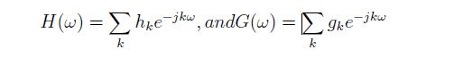

Advantages of DWT
1- No need to divide the input coding into non-overlapping 2-
D blocks, it has higher compression ratios avoid blocking
artifacts
2- Allows good localization both in time and spatial
frequency domain
3- Transformation of the whole image introduces inherent
scaling
4-Better identification of which data is relevant to human
perception higher compression ratio
5-Higher flexibility: Wavelet function can be freely chosen

Chapter five:
References and Conclusion

4. Conclusions
In this paper, different wavelet functions have been discussed. Haar is the mother wavelet of all other wavelets, as all other wavelets are derived from Haar wavelet by translation and scaling functions. Db1 is similar to Haar wavelet. Properties of these wavelets are compared in Table I. The wavelets are chosen based on their shape and their ability to analyze the signal in a particular application. The final choice of optimal wavelet in image watermarking application depends on image quality and computational complexity.
References
[1] I. J. Cox and M. L. Miller, "The first 50 years of electronic watermarking," in Proc. IEEE Int. Workshop Multimedia Signal Processing, Cannes, France, 2001, pp. 225-230.
[2] R. B. Wolfgang, C. I. Podilchuk and E.J. Delp , "Perceptual watermarks for digital images and video," in Proceedings of the IEEE , vol.87, no.7, Jul 1999, pp.1108-1126,
[3] M. Barni , C. Podilchuk , F. Bartolini and E. Delp, "Watermark embedding: Hiding a signal within a cover image", IEEE Commun. Mag., vol. 39, no. 8, 2001, pp.102 -108.
[4] C. C. Lai and C. C. Tsai, “Digital image watermarking using discrete wavelet transform and singular value decomposition,” IEEE Trans. on Instrum. Meas., vol. 59, no. 11, 2010, pp. 3060-3063.
[5] M. Barni, F. Bartolini, A. D. Rosa and A. Piva, "Optimum decoding and detection of multiplicative watermarks," IEEE Trans. Signal Process, vol. 51, no. 4, 2003, pp.1118 -1123.
[6] A. Briassouli and M. G. Strintzis, "Optimal watermark detection under quantization in the transform domain," IEEE Trans. Circuits Syst. Video Technol., vol.14, no.12, 2004, pp.1308-1319.
[7] A. Nikolaidis and I. Pitas, “Asymptotically optimal detection for additive watermarking in the DCT and DWT domains,” IEEE Trans. Image Process, vol. 12, no. 5, 2003, pp. 563–571.
[8] A. K. Ray, S. Padhihary, P. K. Patra and M. N. Mohanty, “Development of a new algorithm Based on SVD for image watermarking,” Computational Vision and Robotics, Springer India, 2015, pp. 79-87.
[9] A. Graps, “An introduction to wavelets," IEEE Computational Science & Engineering, vol.2, no.2, 1995, pp.50-61.
[10] I. Daubechies, “The wavelet transform, time-frequency localization and signal analysis," IEEE Trans. Inform. Theory, vol. 36, 1990, pp.961 -1005.
[11] M. Vetterli and C. Herley, “Wavelets and Filter Banks: Theory and Design,” IEEE Trans. Signal Processing, vol. 40, no. 9, 1992, pp. 2,207- 2,232.

