Republic of Iraq
Ministry of Higher Education and Scientific Research
University of Qadisiyah
College of Computer Science and Information Technology

DESIGN AND IMPLEMENTATION OF
NETWORK ADDRESS TRANSLATION
(NAT)

A graduation project is submitted to the computer science department in partial fulfillment of the requirements for the degree of Bachelor in computer science.

BY
ATAB ABDUL_MONEIM AHMED

SUPERVISOR
DR.MUSTAFA RADIF

SUPERVISOR CERTIFICATION

I certify that the preparation of this project entitled
NETWORK ADDRESS TRANSLATION (NAT) ,
Prepared by ATAB ABDUL_MONEIM AHMED ,
Was made under my supervision at General computer science branch of University of Qadisiyah department in partial folfillment of the requirements for the degree of Bachelor of science in computer science.

Signature:
Name: (Supervisor)
Date:

DEDICATION

Give every word with its meanings
You trees of tenderness..
You songs for homeland..

Give these letters and their meanings
Letters grown for your presence
I grew up near you
And grew up under the sun to meet you
And lined up for your eyes
You alone give it.

Gives my works for my parents ...

ACKNOWLEDGMENTS

First of all , I would like to thank the head of our department for his outstanding support, guidance and encouragement during our studies I would also like to express our gratitude and appreciation for all the assistance and guidance provided to us.
I would like to thank our family, especially my parents, for their encouragement, patience and assistance over the years.
We are forever indebted to our fathers, who have always kept me in their prayers.
I would like to extend my thanks and gratitude to Professor (A.l. Salam Allawi Hussein).
I would like to extend my thanks and gratitude to the esteemed and distinguished professor for all his efforts in encouraging me and helping me to guide me towards the best. The esteemed professor.
I thank all my friends who supported me and my colleagues in my academic career and offer them all my gratitude.

ABSTRACT

After increasing the proportion of users of the Internet and the need of each user to the IP address of his own Internet connection while IPV4 no longer meet these needs due to poor distribution , resulting in a lack of availability of public IP address for each user .
A solution called network address translation or so_called( NAT). This solution we can simply from if we had to impose a company of 10 people using the Internet in their work, before this solution had to buy public IP of the isp for each individual to be able to use Internet at the same time . With this solution , we can only buy one public IP that everyone uses . .
Here is the main idea behind the use of NAT , which is the separation between the IP addresses used in the private network located at work or home, and the IP addresses used on the Internet. Thus there will be two types of IP addresses: :
Private IP : This is the IP address used to distinguish the devices within the privatenetwork .We select this address freel,although there are standards that we preferto abide by ,one condition is not to repeat the same address for two devices within the network , or repeat the address with another address in another network or even with An online address will not affect anything.
Real IP : is the address used on the Internet , and distributed real IP addresses available for use across countries and then cities within countries in a manner similar to the distribution of telephone number. .

TABLE OF CONTENTS

Title Page ...............................................................................................................1
Supervisor Certification...........................................................................................2
Dedication..............................................................................................................3
Acknowledgments..................................................................................................4
Abstract..................................................................................................................5
List of Figures..........................................................................................................7
List of Tables...........................................................................................................8
References..............................................................................................................9
1.Chapter 1: INTRODUCTION
1.1 Introduction....................................................................................................11
1.2 Computer Networks........................................................................................11
1.3 Types of Computer Networks..........................................................................13
1.4 Advantage of Computer Networks................................................................15
1.5 IP Class.........................................................................................................16
2.Chapter 2: Technology of NAT
2.1 What is NAT?...................................................................................................22
2.2 Advantages of NAT..........................................................................................23
2.3 Disadvantages of NAT......................................................................................23
2.4 Types of NAT...................................................................................................24
2.5 How to use NAT?.............................................................................................25
3.Chapter 3: Configuration
3.1 Configuration of NAT.......................................................................................28

LIST OF FIGURES

Figure 1.1 TYPES OF COMPUTER NETWORKS.....................................15
Figure 1.2 IP ADDRESSES.....................................................................21
Figure 2.1 STRUCTURE NAT.................................................................27
Figure 3.1...........................................................................................29
Figure 3.2...........................................................................................30
Figure 3.3...........................................................................................31
Figure 3.4...........................................................................................32
Figure 3.5...........................................................................................33
Figure 3.6...........................................................................................34
Figure 3.7...........................................................................................35
Figure 3.8...........................................................................................36

LIST OF TABLES

Table 1.1 PRIVATE IP & PUBLIC IP.......................................................20

REFERENCES

[2]. behrouz a. Forouzan (2007),data communication and networking, page 44 edited .
[3]. paul zandbergen, "Types of Networks:LAN, WAN, PAN, MAN, EPN, WLAN, SAN & VPN" study.com, retrieved 23-01-2017 . edited.
[4]. laura barnes (11-02-2016),"A brief history of computer networking", visually, retrieved 23-01-2017 . edited.
[5]."the Advantages (Benefits) of Networking",TCP/IP guide,reteieved 23-01-2017 . edited.
[6]. http://www.cisco.com/warp/public/556/8.html) by Aaron Balchunas (aaron@routeralley.com).
[7]. © 2014 − 2015 Cisco Systems , Inc. All rights reserved. Terms & Conditions | Privacy Statement | Cookie Policy | Trademarks of
Cisco Systems, Inc.
[8]. http:// www.ics.uci.edu/~magda .by Magda El Zarki, (PDF).
Prof. of CS , Univ. of CA, Irvine [9]. www.arin.net ,
www.tech_wd.com/wd/2012/06/07/ipv6_4/by
[10] .http://tools.ietf.org. , aftab-tekdad.hubpages.com ,

GLOSSARY

Definition | Abbreviation
Network address translation | NAT
Internet protocol | IP

CHAPTER 1 : INTRODUCTION
Packet Tracer is a express-stand visible emulation agent intended by (Cisco Systems)that allows users to make network topologies and fake contemporary computer networks.The software allows users to emulate the disposition of ci_ _sco routers and switches using a strained command line interfac .
In increment to spurious certain portion of computer networks,Packet Tracer can also be used for communion.As of Packet tracer 5.0,Packet tracer uphol_ _ding a multi-user .
System that cement multiple users to connect multiple topologies together over a computer network . ^{[6]} Packet tracer also allows instructors to make action that students have to entire .[1],Packet tracer is overwhelmingly used in pedagogical accuracy as a learning assistance . ^{[7][8]}Cisco Systems appeal that Packet Tracer is helpful for network workout .
1.2 COMPUTER NETWORKS
Computer network is a regulation for communication two or more devices using a connection system technology to interchange datum,exchequer and data obtainable to the network such as (A printer ) or ( application software) of any type, as well as allowing direct communication between user . In generally , the study of computer networks is one of the department of communication banner. [4][5]

History of network development :
The computer networks went through a long timeline until they reached the flow period era , and they persistent with their different kinds and appointment and technological mechanization in the evolution and advance . Data tran_ _sportation pace became large.The types of cables used to connect devices and networks vary , The timeline for computer networks can be abstract as follows: [4] [5] [3] .
1.1934 : this year was the beginning of the so _ called search engines and hyperlinks;this was by belgian paul othelle ,who aimed to collect all the information and spread it around the world .
2. 1940 : george spitz – one of the fathers of the computer , through history – began using an electrical device to send orders to a number of new york computers using telegraph lines.
3.1950 : this year saw the emergence of the concept of networks , and the link between the various devices in the world of communcations and computer , and the first attempts to connect the devices are the connection between military radar devices.
4.1964 : American Airlines, in partnership with IBM , launched the SPARE system to connect computers to each other using telephone lines.Researchers at dartmouth college developed the dartmouth sharing system , and a year later used a computer to direct telephone calls at the research lnstitute massachusetts lnstitute of technology.
5.1965 : Thomas Marrell and Lawrence Roberts created the first wide net_ work (WAN).
6.1977 : in this world , some commercial services were developed using networks, Via a protocol (X.25).
7.1980 : Network protocol that regulate communication and data transmission over computer networks.
8.1991 : this year, domestic broadband lines were launched.
9.1996 : Dr.Brent invented a 56K modem.
10.2000: domestic (ADSL) lines used to connect households to the internet have emerged after six years, the number of users has reached 13 Million .
11.2005: cloud storage. [3][4][5] .

1.3 TYPES OF COMPUTER NETWORKS

LAN (Local Area Network). **
** WAN (Wide Area Network).
** PAN(Personal Area Network).

A_ Local Area Network (LAN) :
A Local Area Network (LAN) is a network that is limited to a comparatively small area. It is generally restricted to a geographic area such as a writing experimenter, School, or Premises. computers connected to a network are ingeneral classified as servers or workstations . Servers are ingeneral not used by humans directly , but rather run continuously to supply " services" to the other computers (and their human users) on the network. Services provided can include printing and faxing , software hosting , file stock pilling and involvement , me_ _ssaging , data storage and recovery , entire arrival control (security) for the network's resources, and many others.[2] .

B_ Wide Area Network (WAN) :
Wide Area Networks (WANs) connect networks in larger geographic areas , such as Florida, the United States of America , or the world. dedicated transoceanic cabling or satellite uplinks may be used to connect this kind of universal network.using a WAN, schools in Florida can transmit with places such as Tokyo in a matter of seconds, without paid tremendous phone bills. Two users a half-world apart with workstations equipped with microphones and a webcams might teleconference in real time. a WAN is complex. It uses multiplexers, bridges, and routers to connect domestic and metropolitan networks to universal connection networks like the Internet. To users, yet , a (WAN) will not show to be much different than a (LAN).[3][4]

C_ Personal Area Network (PAN) :
A personal area network (PAN) is a computer network used for data transport among devices like : Computers , Telephones , Tablets and personal digital aid . (PANs ) can be used for connection among the personal devices themselves ( interpersonal communication), or for knitter to a higher level network and the Internet ( An uplink ) where one major device pick up the function as internet router. a PAN may be transfer over wired computer buses like : (USB) and (FireWire) .[4]
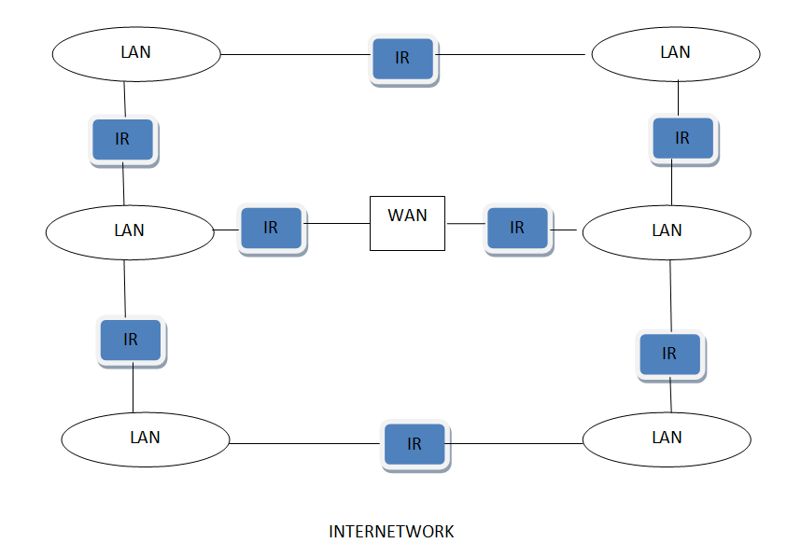 FIGURE(1_1)
TYPES OF COMPUTER NETWORKS

1.4 ADVANTAGES OF COMPUTER NETWORKS
Computer Networks are among the most originative of the world's progress and Technological advances because of their speedy and simple interchange of information and data . The Benefits of untold networks are : [5]
1_ Link different kinds of devices and computers in the network to each other, like : Printers, Projectors (Data:show); to keep the prices of these high devices, and to cement all network users to use.
2_ participate to decrease the time and potential desired to transmit data between different network devices, without the need to use other wherewithal of transfer and stock pilling , by placing data in the database ; to allow users to incoming the network to the information they need within the provision o f specific particular and score .
3_ Relate Computers to the internet , allowing incoming to and access to a lot of amount of information on the internet.[3]

1.5 IP Class
In the universes of telecommunication and the internet there are public protocols to transact between the devices and servers to guarantee the liaison correctly and access information swift and correctly one of these protocols is the protocol(IP) . and the word(IP) is a shortcut to the word Internet Protocol. The assignment of this protocol afford each device number or a particular address (( to illustrate the notion as an example of each of us a phone number of his own , , To send a message to ahmed must know his number and send to that number so as not to go to the message mohammed is the wrong person ...)) also in the world of the internet there is the same idea .... So he can incoming the internet with his own address called ip address [2]
There are two IP Class :
A_IPV4 (Internet Protocol).
B_IPV6 (Internet Protocol).

1.IPV4 :
IP address consists of (32 )bits and divides into four boxes of numbers each box contains a number from (0 to 255 ) and thus their sum is (256 )each of these fields is called (octave) , which is the number (8). Each cell contains any number from (2 ^ 1 )to (2 ^ 8) (Two S-8) .. the major form of the iP address is the following: (xxxx) where x diverge from (0 to 255) .. this permit us to afford addresses to (4.3 billion people) ,.. but with the expansion of wherewithal of communication and the prevalence of internet enlightenment...., the number of people extract the world has increased significantly, which procure to the admittance into permeation of these addresses .. it was indispensable to rummage a new way to mannerism it a reference that gives us more extant than the entrails with the swelling number of subscribers who sink the internet every day.[2]

2.IPV6 :
The problem was that they were working on the creation of a new version of the Internet Protocol, known as (IPv6) or (IPv6), which provides a very large number of addresses ((about 340 trillion trillion)) this version uses (128 bits )for one address (for example :on new titles: (2001: 1234: 5678: 9: 1: 2: 3: 4)) and thus providing a large number of addresses, which gives us a large space to dilate our applications linked to the internet. The person has more than (5000 ) addresses presently .. which solve many of the problems confrontation him a lot of companies and foundation in the use of iP address and one mutual for all the devices of the company to arrival the internet through the protocol( NAT) ... and only a different but consolidated domestic address in the internet.[2]

What are the effects of this release or how will it affect me?

You will not feel any change in your Internet connection, browsing or ordinary use of the internet ...,, unless your modem, network device or operating system does not upholding this new kind of address.[3][2]
Note: Mostly all operating systems, browsers and computers support (IPv6).

finally :

The new version of this protocol will greatly benefit the volume leap in the number of devices connected to the internet like: (Mobile phones and home control systems and Mobile devices like: IPad and Galaxy Tab and much more),, which permit us to evolve rapidly towards the expansion of intelligent systems connected to the internet and remote control.[2]

TYPES OF IP ADDRESS :
Private IP: addresses are intended to be used on private networks such as home and office networks. They are the same as public iP addresses at a protocol level, however they differ organizationally. These addresses can only be used within a single conduct which means that they are not to be used on the extensive Internet.[6][7]

The IP ranges for private addresses are –
class A: Start address – (10.0.0.0 ) End Address – (10.255.255.255).
class B: Start address – (172.16.0.0) End Address – (172.31.255.255).
class C: Start address – (192.168.0.0) End Address – (192.168.255.255).

Public IP : addresses include all other iP addresses which do not include any of the private IP addresses pawned by internet regular groups. it can be accessed over the Internet. a device is only accessible within a local area network by using a (private iP) address. Yet , if one of the devices in (LAN) wants to be accessible over the Internet, then in that situation this device must be connected to the Internet by using a (public IP) address.

**Private IP addresses protect addresses as two or more autonomous networks can have same private iP addresses assigned to different computers. thus, public iP addresses are adequate on the internet. on the other hand, private iP addresses are powerless on the Internet.[7]

Comparison between Public IP and Private IP address:[7]
 | Public IP Address | Private IP Address
Defintion | used for identification of a home network to the outside world | used for identification of a network device inside the home network
Uniqueness | it is unparalleled throughout the entire Network | Two or more separate networks can have same private iP addresses assigned to different computers
Example | 202.60.23.1 | 192.168.0.3
Usage | used on the internet or other (WAN) | used on a (Local Area Network) ; for computers not directly connected to the Internet

TABLE (1_1 ) PRIVATE IP & PUBLIC IP

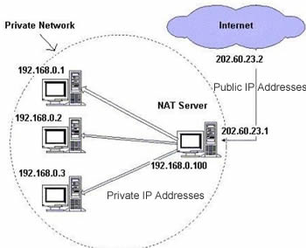
FIGURE (1_2) IP ADDRESSES

CHAPTER 2 : TECHNOLOGY OF NAT

2.1 What is NAT ?
** NAT is a router assignment where IP addresses ((and perhaps port numbers )) of iP datagrams are replaced at the frontier of a private network
**NAT is mode that cement hosts on private networks to communicate with steward on the Internet.
**NAT is run on routers that connect private networks to the public internet , to replace the (iP address-port couple )of an iP packet with another ip address_port pair .[9]

**NAT (network address translation) is a technicality to overlay multiple clients behind one router . (Kristian Kohntopp) expound the technology very well in his treatise.[9]

&& Network address translation : is one of those scarce information technology buzzwords that does precisely what its name reveal.in this situation ,it interpret one network address into another network address.the most bronchial use for (NAT)is to connect an internal network to the internet. the increase of hosts that now connects to the internet is occasion a deficiency of IP addresses , so (NAT) is a key tool for connecting corporate networks using(private IP addresses)to the Internet.since cisco provides the extent of the routers that connects to the internet ,we're going to sh_ ow you how to set up(NAT)using the cisco internetwork operating system ((IOS))[10]

2.2 ADVANTAGES OF NAT
In addition to the convenience and low cost of network address translation, the lack of full-duplex communication may in some cases be seen as an advantage rather than as a insufficiency,.. network address translation means depend on one device in the network to commence any connection with hosts outside the network,., which prohibit any pernicious activity institute from outside the network from accessing the devices within it. this can progress the reliability of local systems by stopping thread. many Firewalls that use network address translation use this quarter as a key element in their work.
The uttermost avail of network address translation is a feasible settlement to address vacuum exhaustion problems for (IPv4) address leisure. networks that prerequisite to have (IP) addresses of class((B / C) IP) addresses can now be attached to the internet under (IP (many home networks do this)).[9]

2.3 DISADVANTAGES OF NAT
Users backwards paths that interpret the network address do not have real end_to_end connectivity and can not engage in some internet protocols. services that demand the habit of Non_Network ((TCP)) connections or Non-State protocols ((UDP)) ,can be jagged. unless the Network address translation process conduct definite actions to prop the protocol,, the incoming packets will not be ambidextrous hook up its point within the Network. some protocols can deal with a exclusive layer of Network address translation between ineffectual clients (Eg, Inoperative Fashion ), with the help of the application layer Gateway, but defeat when both systems are detach from internet with a Network address translation layer.[10]
close pertain is a key rubic in the Internet. Influx internet documents are deem a network address translation infringement of express_pertain ,, but network address translation has an efficacious turn . a Fantastic anxiety is the use of (IP) address translation in (IPv6), where many stylers reckon that (IPV6) has been found to abolish the need to translate the Network address.
some (ISPs) only stock their customers with ("local" IP addresses). therefore,, these customers are obliged to extract the internet through a Network address translation layer. this is what some say by saying that such Companies do not provide internet service precisely.[10]

***MAIN USES OF NAT :
1. compile of iP addresses.
2. supporting transmigration between Network service providers.
3. iP renounce.
4. cargo balancing of servers.

2.4 TYPES OF NAT
There are total fundamentally Three types of NAT :
A.static NAT.
B.dynamic NAT ((DNAT)).
C.port Address Translation ((PAT)).

But very few Network Engineers also reckon that (NAT) can be of below types :
*NAT which amend only iP addresses.
*NAT which alter iP addresses and port numbers.
*NAT that use a single iP address.
*NAT that dynamically appropriate iP addresses to flux.
A.Static NAT : a harmonious mapping between a real and chart iP addr_ ess.permit functioning in two directions bypassing practice.
B.Dynamic NAT : a group of real iP addresses are chart to a (ordinarily junior ) group of chart iP addresses ,, on a first come , first served foundation .only the authentic host can launch transit .

C.Dynamic Port Address Translation (PAT) : a group of real iP addresses are mapped to a single iP Address using a unparalleled exporter . executor of that iP Address.[7]

2.5 HOW TO USE NAT ?
** ultimately, (NAT) allows a single device , like a router, to act as an mandatary between the internet ((or Public Network)) and a Local Network (or Private Network), which means that only a single unrivaled iP Address is desired to symbolize an whole group of computers to anything outside their Network [10] .

configure NAT :
In order to configure conventional ( NAT), you need to make at least one mediator on a router ((NAT outside)) and another interface on the router ((NAT inside)) and a set of essentials for interpret the iP Addresses in the packet headers ((and payloads if coveted )) need to be configured. So as to configure (Nat practical interface (NVI)) , you need at least one interface configured with (NAT) cement straight with the same series of principles .[9]

A.The order in which the cooperation are processed using (NAT) is based on whether a packet is going from the inside Network to the outside Network or from the outsid Network to the inside Network. inside to outside translation subsist after routing, and outside to inside translation happen before routing.

B.Nominated expression are used to set apart the distinct ( NAT) addresses:
1.Inside Local : the fixed iP address particular to an inside client
backwards a NAT_qualify device ((usually a Private Address)).
2.Inside Global : the address that differentiate an Inside client to the
outside world ((ordinarily a Public Address)). ultimately, This is the
dynamically or statically_assigned Public Address assigned to a Private
client.
3.Outside Global : the address assigned to an outside client ((commonly a Public Address)).
4.Outside Local : the address that characterize an outside client to the
Inside Network. Predominatingly , This is the same address as the outside global.
Yet, it is on occasion substantial to construe an outside ((commonly Public)) address to an Inside ((generally Private)) Address.[8][9]

$$ For naivety , it is mostly passable to accomplice (global) Addresses
with (Public) Addresses, and (local) Addresses with (Private) Addresses.
Yet , recollect that (Public_to_Public) and (Private_to_Private) translation is as yet conceivable . inside clients are within the Local Network, while outside clients are exterior to the Local Network. [9] .

NOTE:
Using (NAT) to connect to the internet allows you to:
1.use only one Public, registered IP Address for internet access for many thousands of Private iP Addresses at your site.
2.alteration internet service furnisher ((ISPs)) facilely , without readdressing the plurality of clients on your Network.
3.hide the identity of clients on your Local Network backwards the single Public iP Address to protect outside clients from easily targeting them [9].

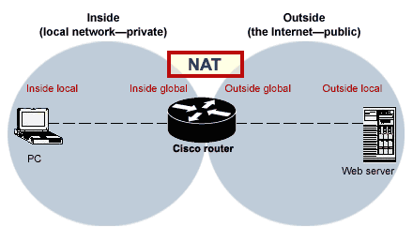
FIGURE (2_1) structure NAT

***We will discuss how to use the net in detail and how it works in the third chapter .

CHAPTER 3 :
This chapter includes how to apply a technique to a network or between a set of networks designed and composed of a set of devices and routers This research includes several steps to apply this technique in a network of devices .

HOW TO CONFIGURATION OF NAT :

Step 1 :
We design an internal and external network consisting of a number of devices (or a set of different networks), in case the networks are pre-designed, we directly apply this technology to them using Cisco routers .

Step 2 :
We connect the devices in the internal network of a router type of Cisco through one of the ports of this router, and then we define the devices associated with the router by giving specific addresses for each specific device and address of the gateway whi_ ch is connected to each device with the router in the network .

Step 3 :
Define the router named IP address and connect it through these addresses to each gateway with the other router in the external network and make sure that all the d_ evices in these networks linked to the correct form and there is a connection betwe_ _en them by opening the implementation interface for each device . As shown in the figure below :

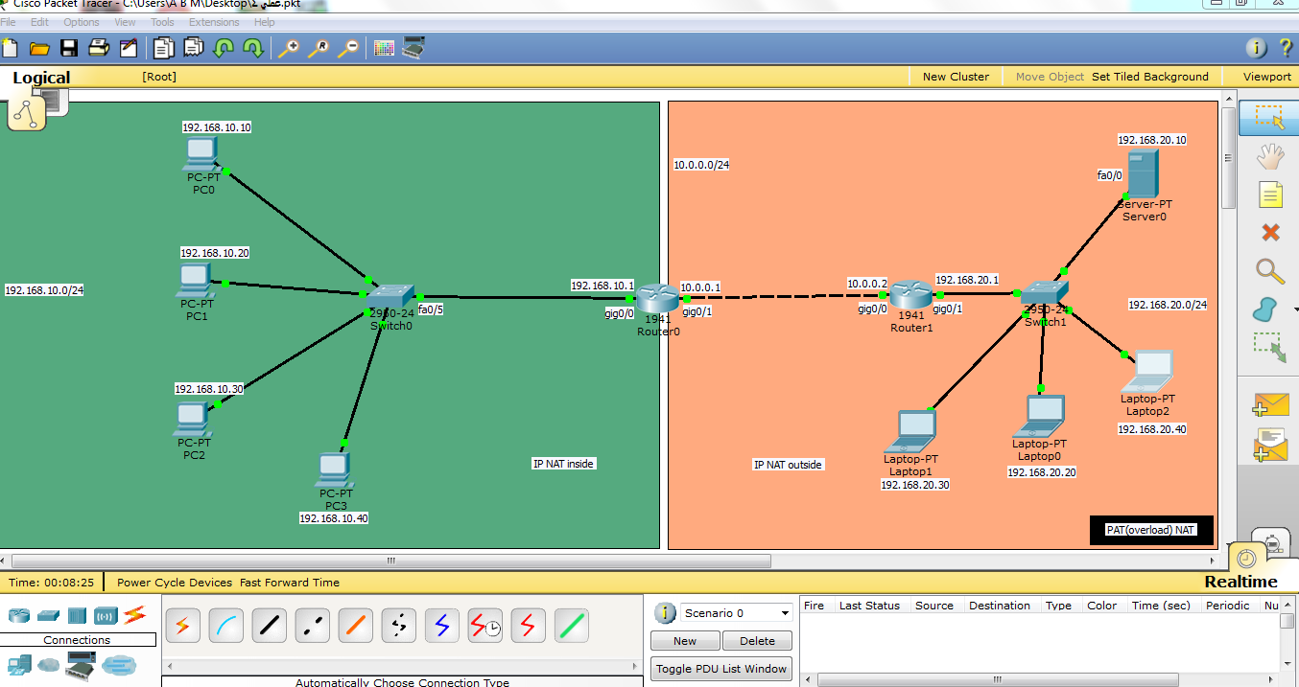
figure (3_1)

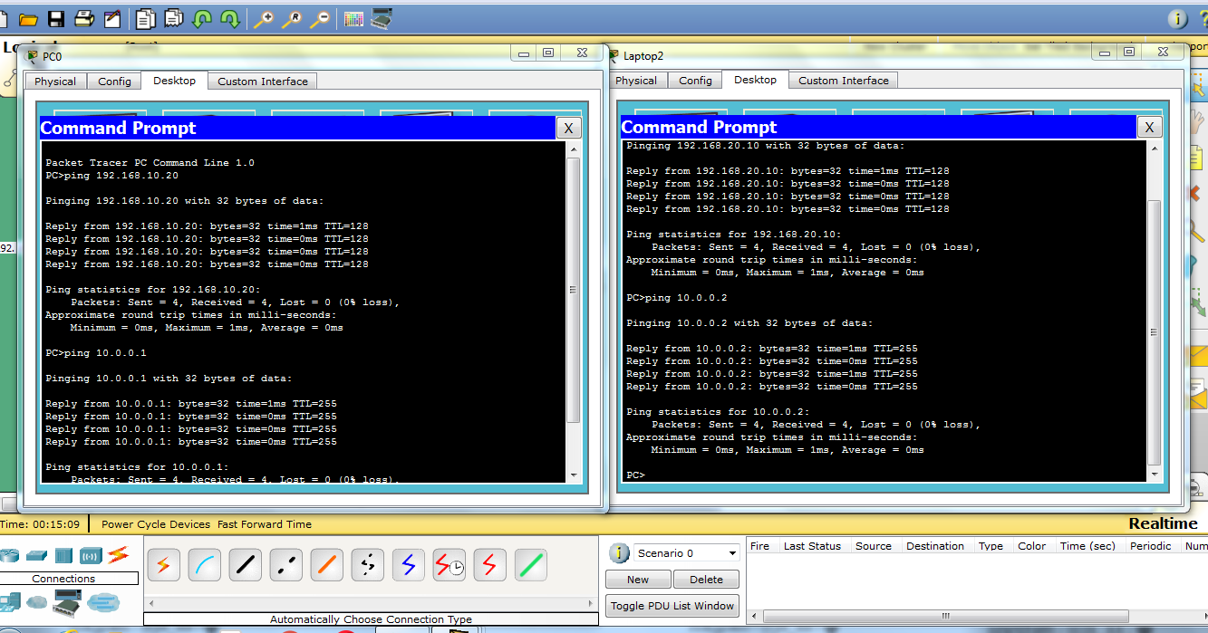
figure (3_2)

Step 4 :
In this step , we start the process of writing the code of the routers so that we can process the translation of any message sent from any device on those networks and through Cisco routers to the Internet world , as shown in the figure below , ( how to configuration of Cisco router).

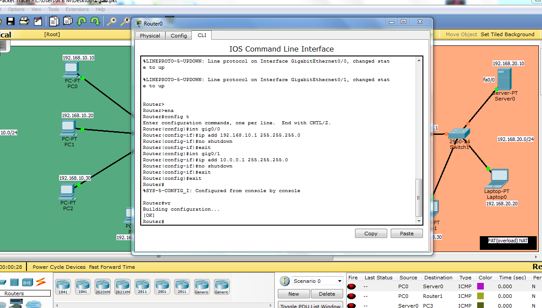
figure (3_3)

Step 5 :
After the Cisco router setup phase,we take the step of defining the router portals by making the first router gateway ( which is located in the internal network ) an entry gateway and the other gateway is an exit gateway to the external network (at this stage the outside address is the first router address located in our network Internal).

Step 6 :
Then , in the same way, we configure the other router located in the external network which is connected to the server, as shown in the following figure :

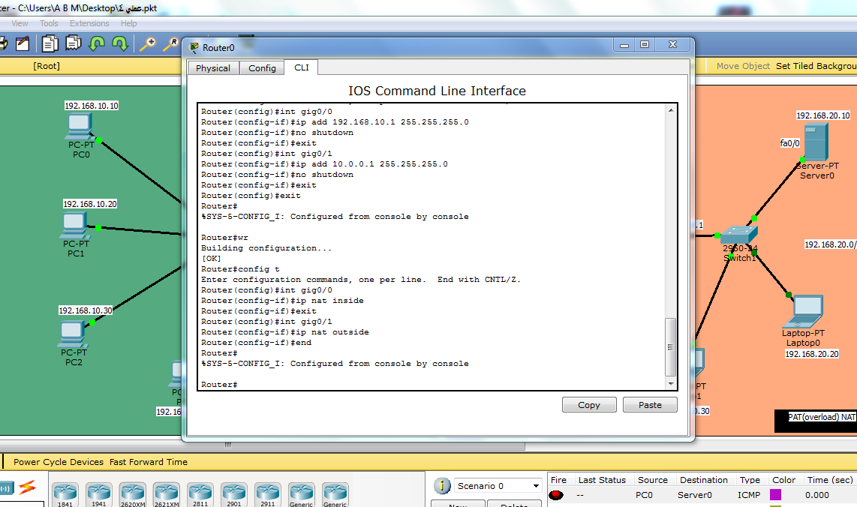
figure (3_4)

Step 7 :
After writing the program commands in the routers and to ensure the definition of all devices and router gates we send a message from one of the internal network devices to the server and write the code show ip nat translations to see how to translate the address of that message by the router.

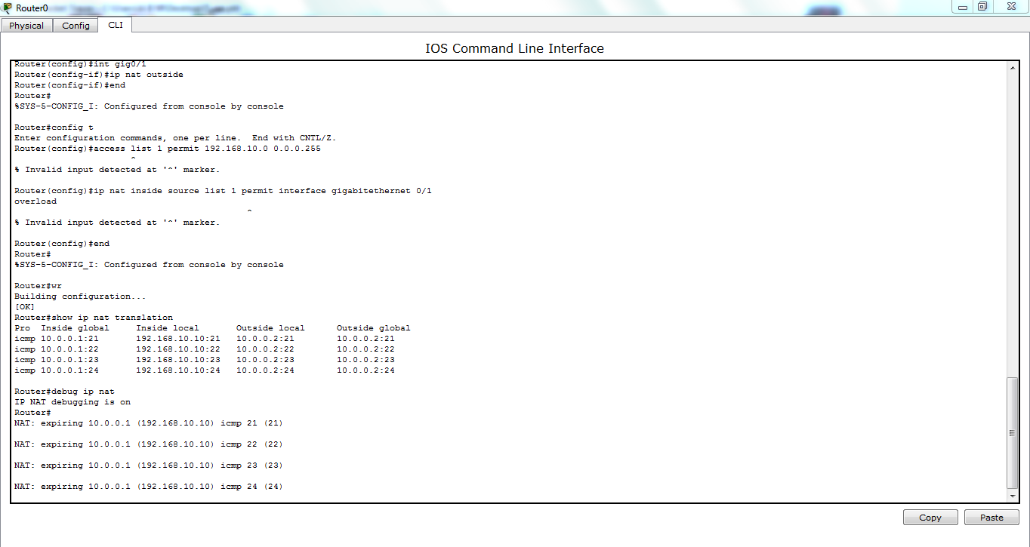
figure (3_5)

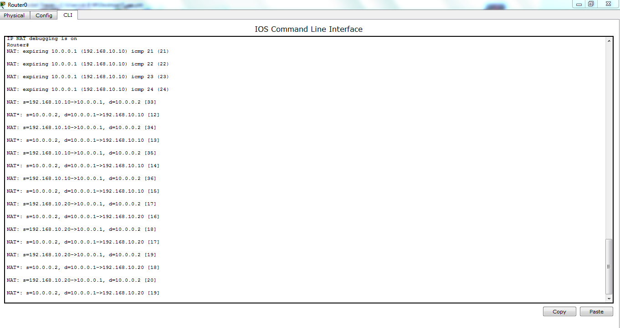
figure (3_6)

$$ Cisco translation routers are completed here, as shown in the following figure
(Translate the address of the device in the internal network).

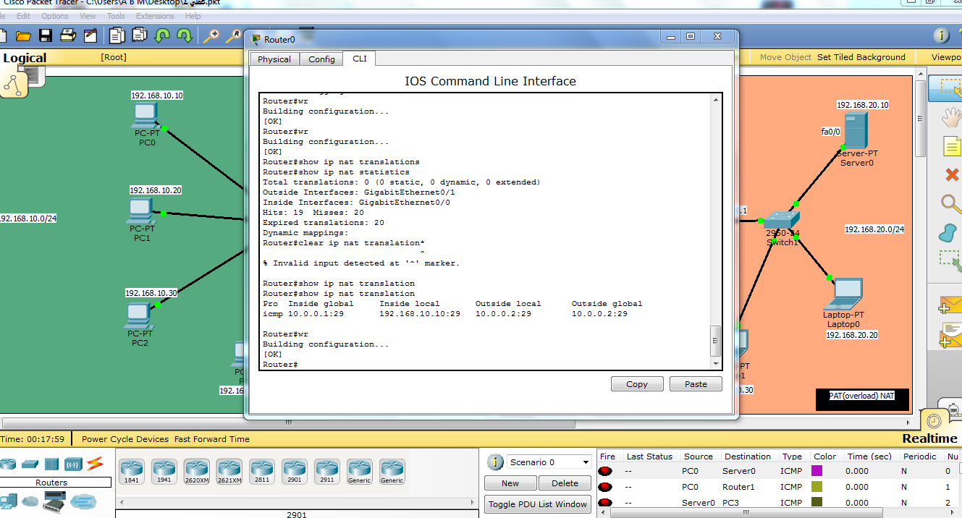
figure (3_7)

** After these steps , , the Cisco router completed the process of translating the addresses of the devices connected to it from any internal network to the external network(server)and using a single general address(converting a set of addresses in the internal networks to show the address of the general one to the external network).

&& In this way, a technical translation of the web address is done using the type of pat (Overload).

ACCESSORIES :

The appendix is attached to the figure (3_2) and (3_3).

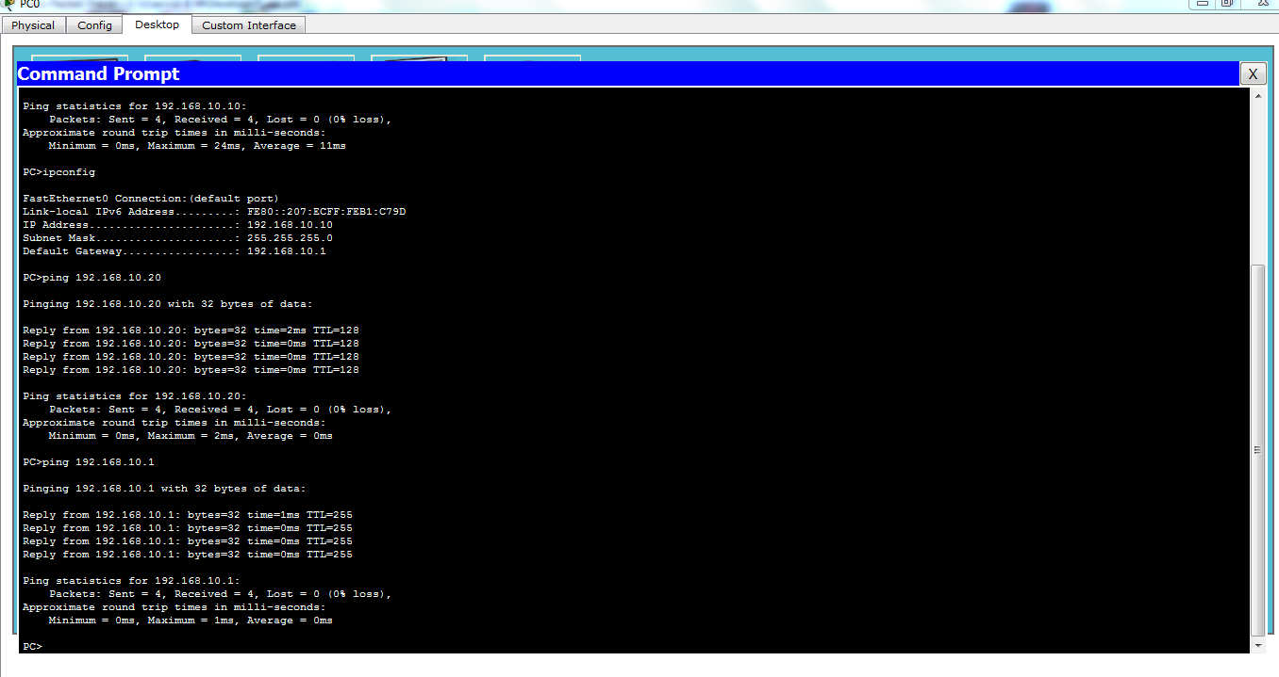
figure (3_8)

