Abstract

The objectives of this system is to design, implement and develop a home security system that could be applied in homes, companies, offices and small businesses. Smart home system using wireless sensor network technology save human life and helps to take care of the very old people easier who lives alone. Smart Home is the integration of technology and services through home networking for better quality of living. Furthermore, it is built to reduce rubbery and avoid attacks that been increased in the last years over the word, as well as ease monitoring process to the property when it’s owner away. That security systems are designed to alert the user of expected risks as number of systems have been evaluated to do the same job with different scope and participate components. We develop that system to gain different expectations compared with others while this system will help the police for instance to gather much related information to the unwanted person. Due to the captured photo as well as the video and the data of the intrusion that might help as well. The outcomes of the system summarize in the following “the owner enable the system inside this property and let the device do the job as it configured to do. Basically, sensing human movements around the room will turn on the used camera based on that to capture photo and video to the attacker. From the other side the owner even when he is away from home but he has an internet connection he will be able to receive photos and videos to the his device (smart phone) to take an urgent action to save his property. Obviously, the system works by underneath software that do most of the major functions on this security system whereas, the software has been written using number of various programing languages such us Java programing language and python for most of the software implemented on the Raspberry and the rest of the components used. In this paper we present that work compared with other systems that used completely advanced components while we can employ the simple equipment(Internet of things) to do the same job as we get the same level of security that provided by the advanced systems. As we planned to compare number of the marketing systems with our built security system later on this document.

1.0 Introduction

The importance of home security has increased in recent years. Due to the illegal entrance and stealing process that been rapidly increased by time and over the world. Consequently, people have seen a trend in the increasing need for home security system.Safety alarms are designed to alert the user of danger as number of systems have been evaluated to do that job with various components and sensors. However, very often and particularly the most efficient systems use wireless technologies for a faster and more economical installation. Today, home security system manufacturers as well as alarm monitoring services provide multi ways for users to monitor their home’s security system when they are away from their home online via internet. [1].
In this paper we present a particular home security system with particular features, there are many home security systems available with high level of security but it still cost lots of money. Therefore, we designed this project to fill this gap by presenting a system with a high security level and a low cost. We tend to divide the project for three important areas “the remote controlling side”, “Home controlling Centre” and “Safety kit”. That properly clarify the idea of the project as it shows in the next paragraph.[2].

1.2 Project Idea (Problem Statement)

Illegal entrance has been increased recently therefore, it becomes important to create a security system that can use by all peoples even those who have a tight budget. Since the security system start widely implement, it developed with expensive components and most of them cannot work with WI-FI and that because of the chosen sensor and the common ZigBee technology which is implemented widely in the past few years. Moreover, existing systems placed such an expensive device, big, and cannot control from far distance. In this system we try to found other’s weak nesses and get a proper solution for it. That was the reason behind this system, we try to solve number of the previous problems.[2].

The idea of our project comes from a combining of many existing used ideas and security systems while expose these ideas to generate new different one. However the security system is quite simple and functional. It provide security system consist from simple device and quite cheap compared with other systems are using nowadays. Hence we would like to enhance a security system with basic sensor that is, it’s small, cheap, suitable from small spaces and ideal for human
entrance detection. As we choose to use (Internet of things) as a client and server device because it’s small and not too expensive as it provides lots of choices. [2].
One more device that placed in this system is a camera which is obsoletely necessary to complete the job whereas, it’s able to capture photos with very code resolution from far distance and its small size so the thief cannot recognize it’s on the air, that can add more security to the system. We have gathered the device and make a set of components which are simply gives what we planned to have from the first step of the project and shows the final result of the system which well discussed later on in this paper[3].

1.3 Project Outcomes (solutions)

We tend to get a reasonable outcomes for this stage while it can manage and develop later on to improve the weaknesses of that system after implementing it. The most essential outcome are summarize in three outcomes[4].:

- Building a successful running application that connected to system's platform via Wi-Fi connection. The application connect to the system from far distance.
- The second outcome is taking photo to the person clear enough to be recognize .
- The third outcome is the owner is going to receive a massage in his e-mail at the same time when the intrusion happen that help to make urgent action by the owner and save the day .

2.1 Aim & Objectives

2.1.1 Aims
The aim of the paper is to investigate a cost effective solution that will provide controlling of Home appliances remotely and will also enable home security against intrusion in the absence of home owner. This projects aims to evaluate a system with low budget and convenience level of security that can support the police to notify the malicious person sooner with the provided evidence for instance the taken photo. Furthermore, proposes a system that allows user to be control home appliances ubiquitously and also provide security on detection of intrusion via SMS.
2.1.2 Objectives
The objectives of this project are:

1- Evaluate a new security system that fill some of the existing systems gaps and find a scientific solutions to some of the existing problems. Most of the security systems are using component with high features and expensive device to get the required specification. However, in this project we try to make the same specification for our project but with less cost device and such a simple components.

2- Implement a system that meet user’s requirement in order to make it commercially required.

We goal to build a system fits what ordinary people looking for and with reasonable budget,

such that save people’s money and provide a convinced production for their homes.

3- Employ some of the current technologies. Utilize technologies and smart phones and include its services in this system will facilitate the work. Peoples would like to take the shortest way to achieve their goals with effortless therefore, we do make the system working by mobile application so, they can enable and disable system easily.

4- Propose new services and performs new operations in Raspberry PI (RPI) device and other ingredient such as RPI camera and PIR motion sensor. And the most serious object of having this security system is to keep a potential burglar away from homes, companies, offices and so on and avoided any expected danger

5- Apply some of the existing technologies such as WIFI connectivity, smart phones, mobile applications which are keep people follow the way they interesting in to control their houses from far distance. In addition, automate home so that user can take advantage of the technological advancement

2. 3 System Analysis

At the beginning security system needs for secure device that work dependently in separate groups. We can divide the system to three important phases should be prepared before starting the design. To analyze home security system actually it’s better to split it up to three section as it explained next:

Room’s Monitoring System: - Home security systems principle works depending on some equipment are sense to the human intrusion in order to keep the house out of robbery and save people life in most cases. Therefore, we are going to use each of follows hardware[9]:

- Raspberry Pi (One devise for each room). The Raspberry pi is a small device work like a computer that could be connect to monitor or TV and using mouse, keyboard. Its capable device that use by people in different age and learn from it. It’s very fixable device can do the same deed as computer. It’s very small device and not very cheap to buy and use in these types of projects as it’s important to determine the cost of each component and for the Raspberry pi is approximately £28.
- The parts are listed below[9]

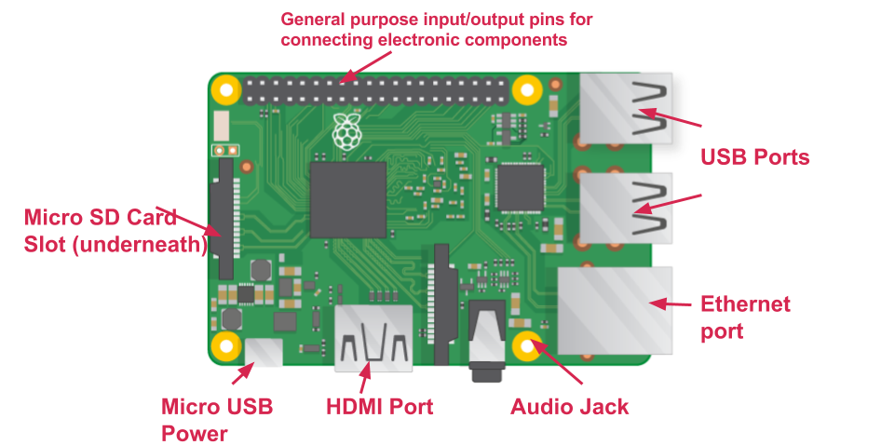
Figure 1 Raspberry pi3 parts

- USB ports — these are used to connect a mouse and keyboard. You can also connect other components, such as a USB drive.
- SD card slot — you can slot the SD card in here. This is where the operating system software and your files are stored.
- Ethernet port — this is used to connect the Raspberry Pi to a network with a cable. The Raspberry Pi can also connect to a network via wireless LAN.
- Audio jack — you can connect headphones or speakers here.
- HDMI port — this is where you connect the monitor (or projector) that you are using to display the output from the Raspberry Pi. If your monitor has speakers, you can also use them to hear sound.
- Micro USB power connector — this is where you connect a power supply. You should always do this last, after you have connected all your other components.
- GPIO ports — these allow you to connect electronic components such as LEDs and buttons to the Raspberry Pi.
- Raspberry pi Camera (One camera cover the whole room, so one camera is enough for every room). This camera is working with all Raspberry pi modules. It’s connected easily to a camera port into the raspberry pi. RPI Camera has number of features listed below[9]:-
- 5MP sensor,

- Wider image, capable of 2592x1944 stills, 1080p30 video and so forth.

- Small and light

- Specifications

- 1080p video supported

- CSI(Camera Serial Interface)

- Size: 25 x 20 x 9 mm

- Very light, ~ 3g

- Compatible with Raspberry Pi A+, B, B+/2.

- It costs about £28.
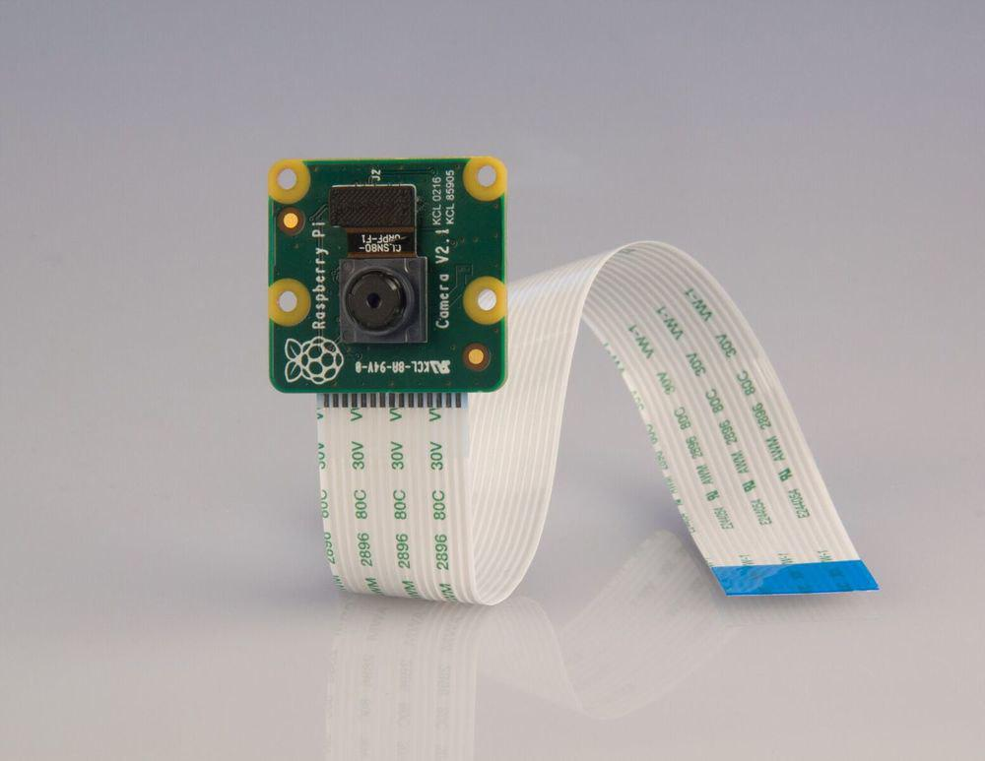

Figure 2 Raspberry pi Camera
- PIR motion sensor (One or more in the single room). PIR sensors are more complicated than other sensors dye to its multiple variables that affect the sensors input and output. The PIR sensor has two slots, each slot is made of a particular material that is sensitive to IR. When the sensor is completely idle, both slots detect the same amount of IR, the combine amount radiated from the room or walls or outdoors. When a person passes by, it first intercepts one half of the PIR sensor, which causes a positive differential change between the two halves. When the warm body leaves the sensing area, the reverse action happens, and the sensor generates a negative differential change. And that what is detected.
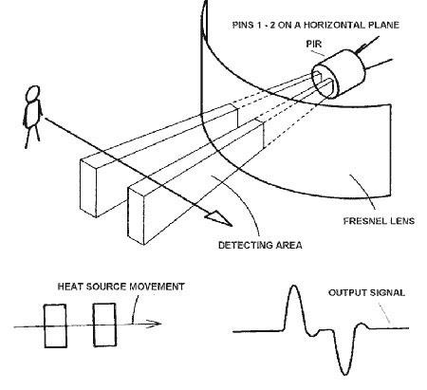
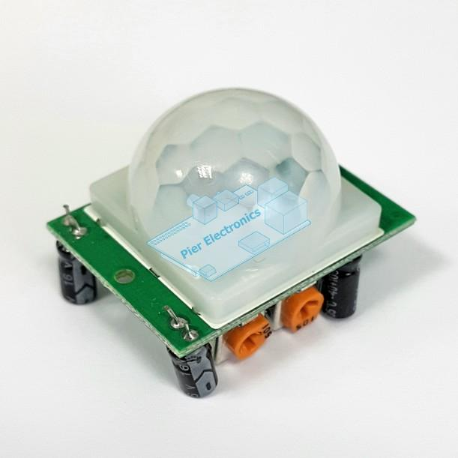

Figure 3 How PIR motion sensor detect things
PIR motion sensor is made from sealed metal can improve not only movements but also noise and temperature and some other things. PIR sensors are vary only in price and sensitivity as it very easy to setup and configure using Python programming language, it’s not the only possible one but it’s the most popular one utilized to switch this sensor. PIR sensor have three pins one pin will be ground, another will be signal and the final one will be power. Power is usually 3-5VDC input but may be as high as 12V. An easy way of prototyping with PIR sensors is to connect it to a bread data base board and start configure it and place it to projects. We can summarize some features to the PIR motion sensor [5]

- Small in size

- Sensitive for movements/temperature and noise.

- Idea to use with Raspberry Pi and Arduino

- Its cost about £3.

- Easy to connect and setup.
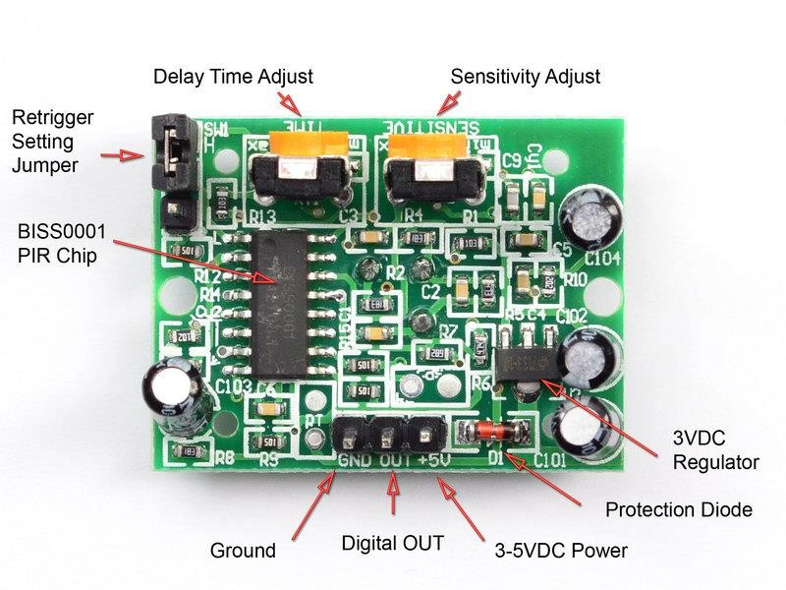

Figure 4 PIR motion sensor specification

- Breadboard: - Breadboard is a plug-in Breadboard with 830 connection tie-points. It has 4 power rails. Solderless Breadboard are suitable for developing and testing new circuits because it’s so flexible and parts can be easily inserted and removed. The BB830 has a 630 tie-point IC-circuit area plus four 50 tie-point power rails. It is made of ABS plastic, with a printed giving numbers and letters for columns and rows. The internal contacts are made from phosphor bronze with a plated nickel finish. As it has peel able adhesive tape which is provided for attaching it to a surface and. Finished projects can be moved to a BR1 Solder able PC Breadatabaseoard to make them permanent. As its costs approximately £1.80[5] .
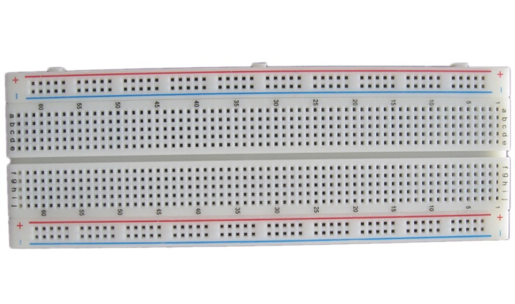

Figure 5 Breadboard
- Access point: - Access point is important to exchange data between the Raspberry PIS. The access point that proposed in the figure 7 provides some of the features are shown in the table below[8].

Brand | TP-LINK
Item Weight | 236 g
Product Dimensions | 13 x 3.3 x 19.3 cm
Item model number | TL-WR841N
Series | TL-WR841N
Computer Memory Type | DRAM
Cost | £19.48
Wireless Type | 802.11bgn
Number of Ethernet Ports | 4
Wattage | 8 watts
Operating System | Yes
Software Included | Yes

Above tools are used in order to complete room’s monitoring system. Mainly, the raspberry pi used to contain scripts are running the rest of the device. While, the Camera is capturing photos in the room and recording clips of video. In addition, software run into raspberry pi to control each of the other device. Below list shows what type of software used and programing languages. Each of the above mentioned programing languages is runs different program as it will explain in the implementation section[2].

- Python programming language

3.1 Safety Kit
It consist of (Raspberry pi, Raspberry pi Camera, PIR motion sensor). The main purpose to combine these three components together is to do a series of function that dependently works on each other’s result. The security system consist of mechanical and electronical device which are integrated to complete system’s functions[2].

- Raspberry Pi 3

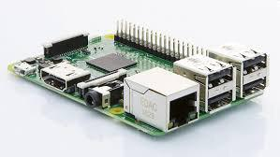

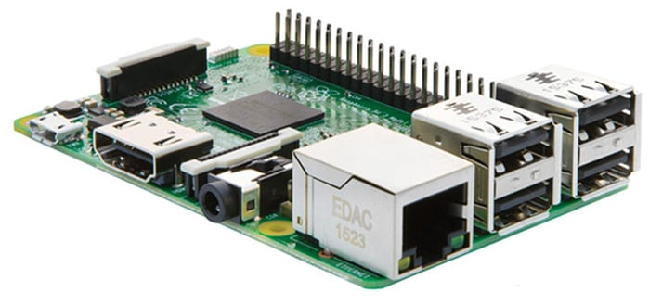

Figure 6 Rasbperry Pi 3

The raspberry pi3 is shown in figure 6, provides convinces functions such as connecting other device and send their data through the internet. This model was chosen because it fits the system requirements for instance it’s not too expensive to buy, small in size, provides many choices and technical operations, it’s quite flexible device and not easily wear out. For all previous features that device was the best choice compared with other available electronic device. There is an major issues that RPI response on, once the system turn on, raspberry pi will connect to the home network as both of the PIR motion sensor and the camera will starting on however, the camera will not physically turned on because its working based on the PIR motion sensor’s data. Whenever, the intrusion happen the PIR motion sensor will send consecutively motion to the raspberry pi, then the raspberry pi will turn on the camera and start taking photos. The last thing that raspberry pi do is collecting all these data as well as images and send them via WI-FI to the home control center (server). The previous functions just done through this small device which is programmed to do that by “main.py” program. It’s implemented to do all previous various operation into the raspberry pi and consecutively. [2] .
- PIR Motion Sensor

PIR motion sensor that shows in figure 3, is utilized to detect human movements into home’s rooms. The sensor works based on the electrical configuration that parts of the electronic circuits. When movements occurs the sensor will sense this movements and send them to the raspberry pi in the safety kit. The instruction will be send from raspberry pi to the camera to switch it on and captured photos with non-disturb or sound so the attacker cannot escape from the home before the police arrives. We can say that the technology of PIR motion sensor makes it too sensitive to the movements as it small, cheap, low power and staple therefore, it was chosen amongst all other sensors to sense human detection in this system. What is importance to notes that PIR motion sensor has been programed using python language as its program has been evaluate to get data when the intrusion happen and do send an identified statement refers to the intrusion state to the raspberry pi3 .

- Raspberry PI camera

Tis model of performs cameras is the most suitable for raspberry pi, it has been developed to work with raspberry pi in particular. The camera model is very popular and familiar as it tine in size so that it suited small spaces. In addition, it’s quite reasonable in price compared with the other models. The major operation is obviously taking pictures to the unwanted people when the system is enabled. Ones people passed by the PIR motion sensor rang, sensor will send a simple identifier to the raspberry pi to make it knows about the illegal entrance. The raspberry pi will turn on the camera and allow it for capturing photos. After that, these captured photo would be saved to the client raspberry pi to be send then to the server in the control center. In this project and especially for this system we enforced the camera to switch only if there is unwanted people at home and that to save its power and not to flood the server with unwanted pictures. [6].

3.2 Control Center
The control center is the brain of the system, it includes only RPI (raspberry pi) which is control all the rest of device as doing the essential operations in the system. As shown in figure 1, it used to receive all sensed data and captured photos from each client raspberry pi at home. There is possibility to keep these data into its DATABASE and make smart decisions such us Sending Email and Sending SMS via WI-FI over the internet to the owner smart phone. Data into server raspberry pi will retrieve at any time its need to be send[9].

3.3 Safety kit Implementation
3.3.1 Hardware Connection

First step of implementation is building the circuit shows below figure 13, the raspberry pi will be the brain of the kit where all other devices connected to it. PIR motion sensor has been connected to the Raspberry PI. There are two ways to do that either connecting the sensor straight away to the raspberry Pi pins or connected the sensor to the breadatabaseoard which is linkedthe Raspberry pi itself . In this case and for that system, the sensor connected to the raspberry pi using breadatabaseoard as it illustrate in figure 7[9].
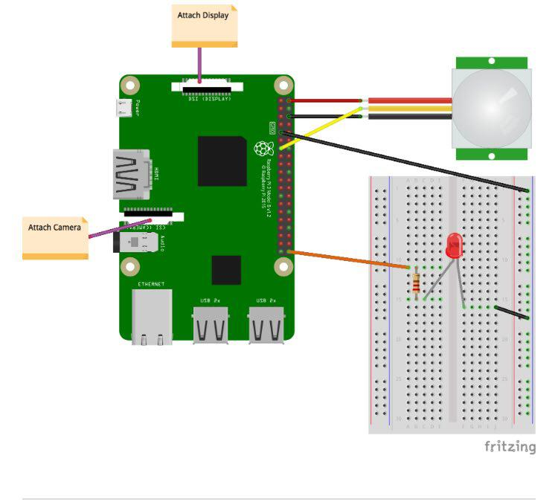

Figure 7 Safety kit Circuit

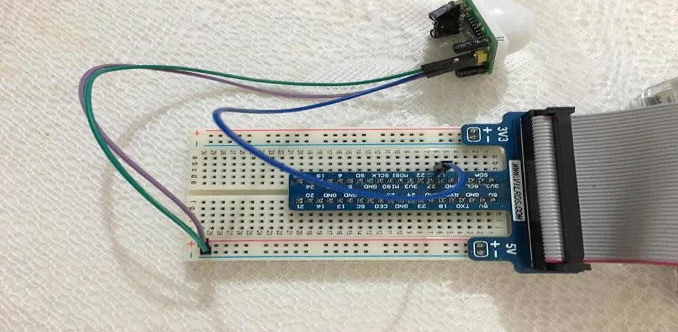

Figure 8 PIR motion sensor connected to the Raspberry pi

We have connected the PIR sensor 3-pins to the Raspberry pi bread databaseeoard which is connected to the raspberry pi. To constructed the circuit as following:-

• Linked a ground pin to the ground/negative rail on the Breadboard. Green cable in figure 7

• Linked a 5v pin to the positive rail on the Breadboard. Purple cable in figure 7.

• Linked a GND pin to 17 rail on the Breadboard. Blue cable in figure 7.

Specific software has been written and implemented into the raspberry pi inside client department on the system. This software obviously sense human movements in the place and send it to the raspberry pi via port 11 on the board for this project and it can be any other GBIO pin. This pin is the output that transfer data from the sender to the raspberry pi to read then. PIR motion sensor needs no more than 5V power to work as it shows in the picture this power comes from the Raspberry pi and supply the sensor. Connecting raspberry pi with the PIR motion sensor is part of build the safety kit in the system and evaluate “monitoring section” of this project.

The second step to complete the safety kit is connecting the camera to the camera port on to the raspberry pi. Improving security and prepare compatible system need a camera to capture photos to the attacker through the attack and complete client department on to the system. Below screen shows in figure 8 how raspberry pi camera placed on the raspberry pi’s camera port.

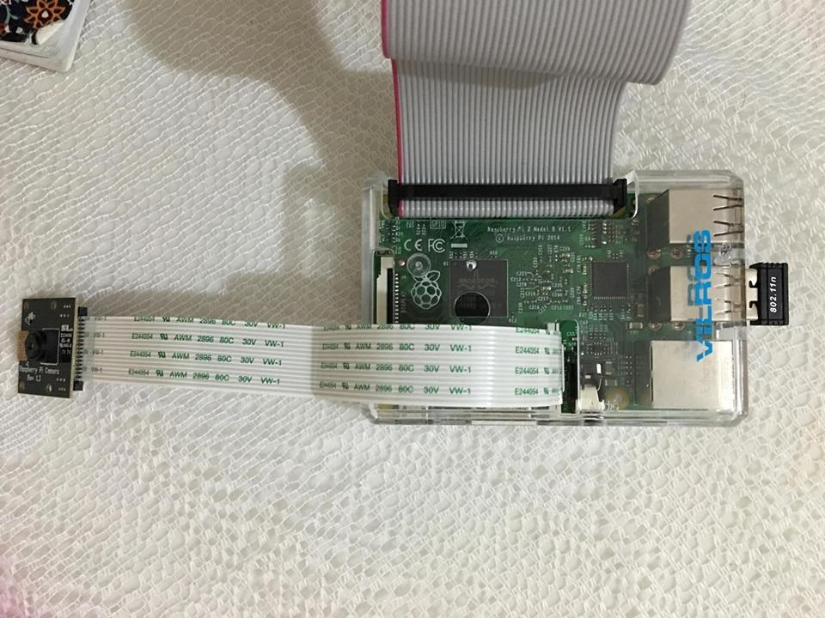

Figure 9 raspberry cover

3.3.2 software Implementation (Algorithm)

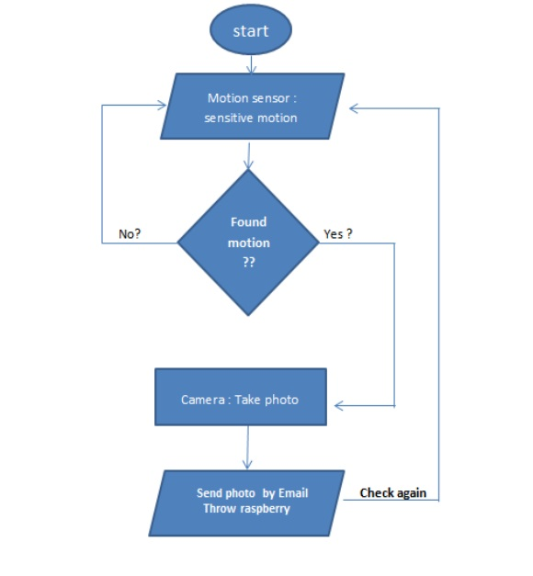

Figure 10 algorithm software

3.4 VNC

What is VNC Connect?
VNC Connect is the latest version (6+) of our cross-platform remote access software for personal and commercial use. It utilizes VNC technology to connect you to a remote computer anywhere in the world, watch its screen in real-time, and take control. Our founders are the original inventors of VNC, and twenty five years’ experience has gone into our award-winning software. Depending upon the subscription you choose, you can add device access, instant support, or both. These capabilities represent different ways of connecting to remote computers, to meet different needs, though once connected you get the same intuitive and responsive screen sharing experience. VNC Connect is designed to replace multiple products or modules from other providers with one solution that’s easy to integrate, license, manage and secure. This means it’s simpler to roll out to your entire organization, extending the benefits of remote access beyond the IT team.

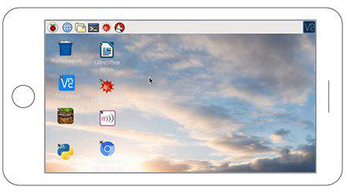

Figure 11 VNC viewer

VNC Connect consists of two apps, VNC Server and VNC Viewer:
- VNC Server enables you to connect to your Pi from a desktop computer or mobile device, watch its screen in real-time, and exercise control as though you were sitting in front of it.
- VNC Viewer enables you to connect to and control a desktop computer (or another Pi) from your Pi, should you want to.
Setting up your Raspberry Pi
VNC Connect is included with Raspbian but you still have to enable it.
First, run the following commands to make sure you have the latest version of VNC Server and VNC Viewer:

- sudo apt-get update
- sudo apt-get install realvnc-vnc-server
- sudo apt-get install realvnc-vnc-viewer

If you’re already using an older version of VNC Server, restart it. If not, and you’re already booted into the PIXEL desktop, select Menu > Preferences > Raspberry Pi Configuration > Interfaces and make sure VNC is set to Enabled.
Alternatively, run the command sudo raspi-config, navigate to Advanced Options > VNC and select Yes.
From now on, VNC Server will start automatically every time you boot your Raspberry Pi. See how to stop VNC Server.

- By default, VNC Server remotes the graphical desktop running on your Raspberry Pi. However, if your Pi is headless (not plugged into a monitor) or not running a graphical desktop, VNC Server can still give you graphical remote access using a virtual desktop.

Getting connected to your Raspberry Pi
There are two ways to connect; you can use either or both. Please make sure you’ve downloaded our VNC Viewer app to computers or devices you want to control from.

Establishing a direct connection
Direct connections are quick and simple providing you’re joined to the same private local network as your Raspberry Pi (for example, a wired or Wi-Fi network at home, school or in the office).

- If you’re connecting over the Internet, it’s much safer and more convenient to establish a cloud connection.
- On your Raspberry Pi, discover its private IP address by double-clicking the VNC Server icon on the taskbar and examining the status dialog:
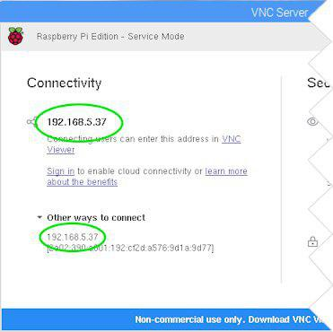
Figure 12 VNC server

- On the device you will use to take control, run VNC Viewer and enter the IP address in the search bar:

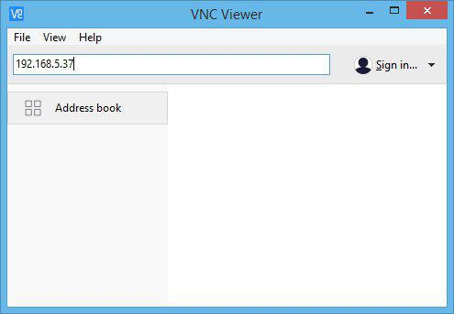
Figure 13 VNC viewer (IP address )
Establishing a cloud connection
Cloud connections are convenient and encrypted end-to-end, and highly recommended for connections over the Internet. There’s no firewall or router reconfiguration, and you don’t need to know the IP address of your Raspberry Pi, or provide a static one.

You’ll need a RealVNC account; it’s completely free to set up and only takes a few seconds. We’ll give you a special version of our Home subscription that enables both cloud and direct connectivity, and also in-session features such as system authentication, file transfer, printing and chat.

- You can apply your Home subscription to five Raspberry Pis and/or desktop computers in total. Please note you revert to the standard feature set for Windows, Mac and Linux desktop computers.

- Sign up for a RealVNC account by entering your email address in the box on this page, and following the instructions.

- On your Raspberry Pi, select Licensing from the VNC Server status menu, choose Sign in to your RealVNC account, and enter your new account email and password:

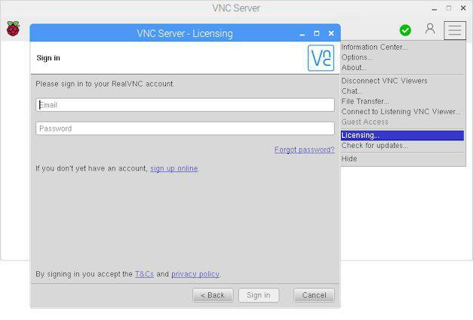
Figure 14 Sign In Account

- On the device you will use to take control, run VNC Viewer and sign in using the same account credentials.

- In VNC Viewer, a connection to your Raspberry Pi automatically appears under the name of your team. Simply tap or double-click to connect:
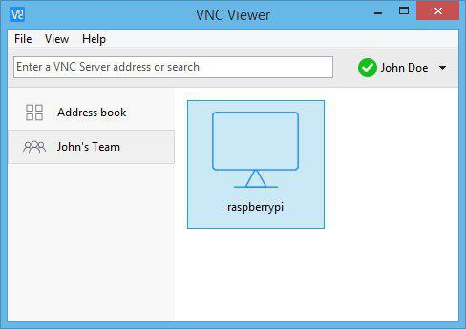
Figure 15 VNC interface

Authenticating to VNC Server
To complete either a direct or cloud connection you must authenticate to VNC Server. Enter the user name and password you normally use to log on to your user account on the Raspberry Pi.
By default, these credentials are pi and raspberry, but hopefully you’ll have changed them to something more secure by now!

Creating and remoting a virtual desktop
If your Raspberry Pi is headless (that is, not plugged into a monitor) or embedded in a robot, it’s unlikely to be running a graphical desktop.

VNC Server can run in Virtual Mode to create a resource-efficient virtual desktop on demand, giving you graphical remote access even when there is no actual desktop to remote. This virtual desktop exists only in your Raspberry Pi’s memory:
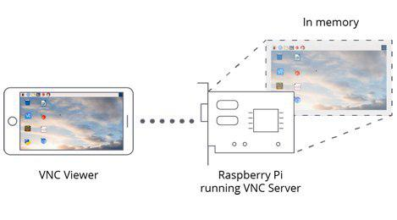

Figure 16 method connected

4. Test and Result
4.1 when The raspberry not sense any motion
Figure 17 interface when no motion

4.2 when the raspberry find motion
4.2.1 When sensor sense motion

Figure 18 interface when sense motion

4.2.2 checking zip file from E-mail

Figure 19 The interface of E-mail

5. Conclusions and future work
5.1 Conclusions
In the conclusion, we can say the project had worth to be complete whereas, it full with knowledge and new security feature can be manage easily and make new reliable system. The issue has chosen to figure out a new way of protection and security using simple device, low cost and comprehensible coding. Overall, there are some features added to our system which might make it more flexible, reliable, secure and thorough. Whereby the most obvious once is It can be put into everywhere including schools, hospitals, offices and companies not only homes. We summarize the investigated features in the following statements:-

Tools used are quite cheap, accurate and easy to set up.

Provide SMS alert whereas, the user receive an alerting massage on his cell phone.

Involve modern technology and android environment to build special application can control the property remotely.
Participated WIFI connection to link client with the server in the system environment.

The overall cost is not exceed £130 and that quit cheap compared with other security system.
The used equipment are too small so they will not take a place at the property as it suitable to
keep it out of the room design.
It’s very small to be notice from the attacker, can add some more security feature to the system.

Future investigation can added to the system and solve some of its problem that might find from the daily practical use. In the future the system for instant can work faster than present, Introduce the cost by replacing Raspberry pi model for someone cheaper. Moreover, for future investigation the designer can modify the application a bit more and add more advance feature to it. Overall, that system is secure enough even the equipment is not advanced however, it provide such an impressive result that can be marketing and employ with any property.

5.2 future work
1. Send message to the mobile phone using SIM card number

2. Send a video to the E-mail

3. verify the object in the capture Image

4. verify the face of person that moving

5.connect more than one sensor in different location

References

- Armando Roy Delgado, R. P. a. V. G., n.d. Remote-Controlled Home Automation Systems with Different. s.l., Centre for Applied Internet Research (CAIR),.
.

- BytematkHosting, n.d. Raspbian. [Online] Available at: https://www.raspbian.org/ [Accessed 14 1 2016].

- K.Padmanabhan, R. G. R. T. S., n.d. Some Problems & Methods For Remotely Controllable. India, University of Chennai,.

- Mainwaring, A. D. P. J. S. R. A. J., 2002. Wireless sensor networks for habitat monitoring. New York, NY, USA: ACM New York, NY, USA.

- Mansour H. Assaf1, R. M. S. R. D. 4. E. M. P. V. G. a. S. B., 2010. Sensor Based Home Automation and Security System. Bangladesh, IEEE.
- Min-Xiou Chen, Y.-C. C., 2010. Supporting Home Security System in OSGi Platform. Taiwan,, IEEE.
- Naresh P Jawarkar, V. A. A. L. D. T., 2008. Micro-controller based Remote Monitoring using. JOURNAL OF NETWORKS,, Volume 3

- R.Kavitha, D. G. M. N. D. N. N., (2012). Smart Home Sysems Using Wriless Sensor Network A comparative Analysis. jifactor, 3(ssue 3), pp. 94-103.

- Santoso Budijono1, J. A. M. A. N. N., 2014. Design and implementation of modular home security system with, s.l.: EDP Sciences.

